## Delete Item

**BEFORE DELETING ANYTHING - DELETING AN ITEM WILL DELETE ALL OF IT’S SUBITEMS.**

**IF YOU WANT AN ITEM TO NOT APPEAR ON THE SITE, BUT DO NOT WANT TO DELETE IT, JUST UNPUBLISH THE ITEM INSTEAD.**

Select a menu from the list of menus:

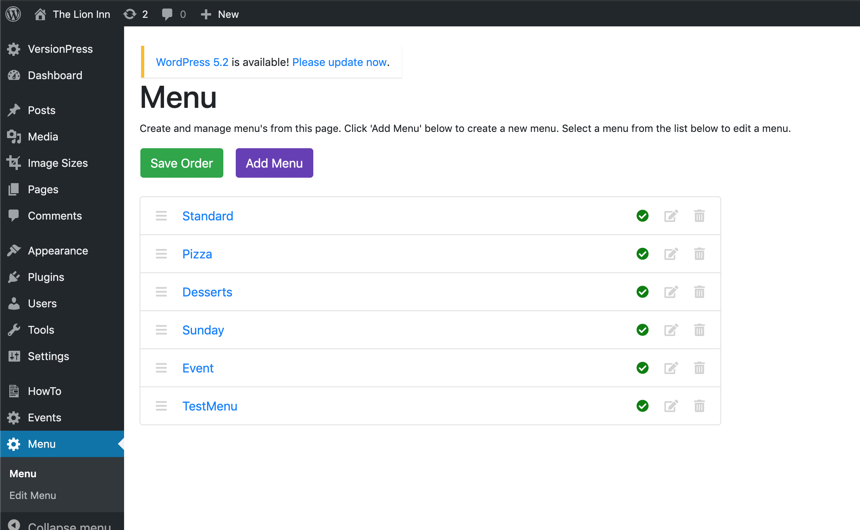

I will select ‘TestMenu’. You should then be on the ‘Edit Menu’ page and see the menu’s sections, items and subitems:

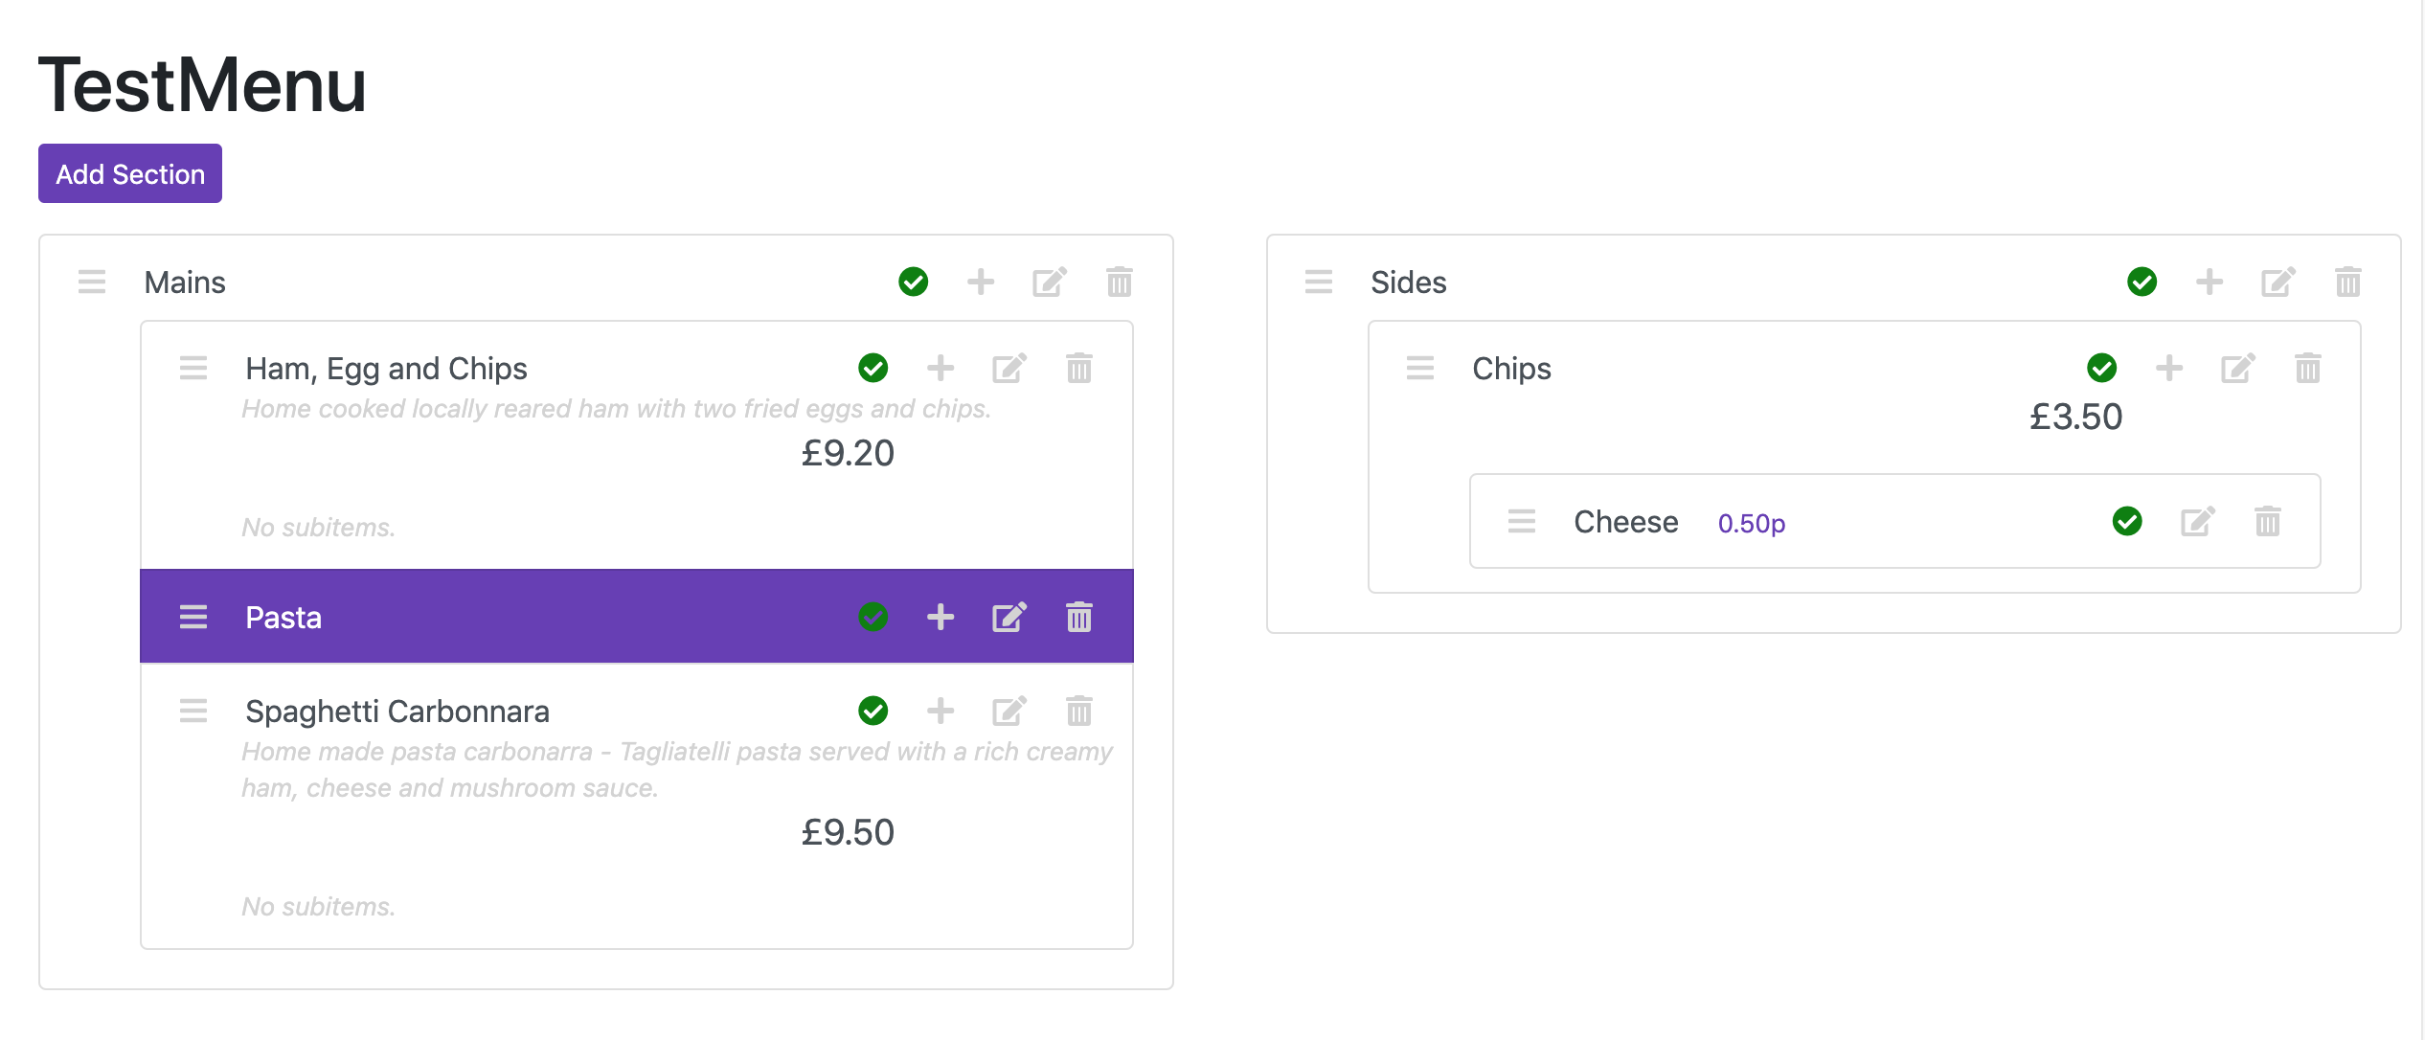

To delete an item, click the ‘Delete’ icon for it. You should then see this screen:

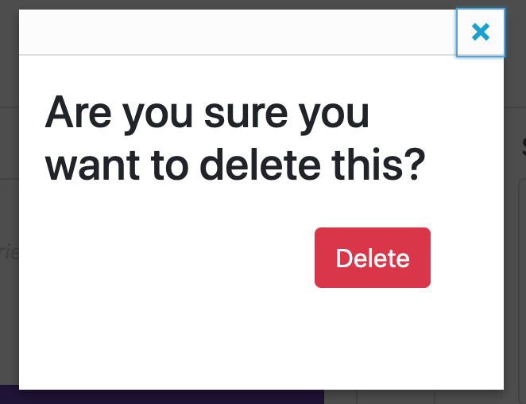

Click ‘Delete’. You will then see that the item does not appear in the list anymore:

