## Delete Menu

**BEFORE DELETING ANYTHING - DELETING A MENU WILL DELETE ALL OF IT’S SECTIONS, ITEMS AND SUBITEMS.**

**IF YOU WANT A MENU TO NOT APPEAR ON THE SITE, BUT DO NOT WANT TO DELETE IT, JUST UNPUBLISH THE MENU INSTEAD.**

Click ‘Menu’ on the left-side bar to bring up the list of menus:

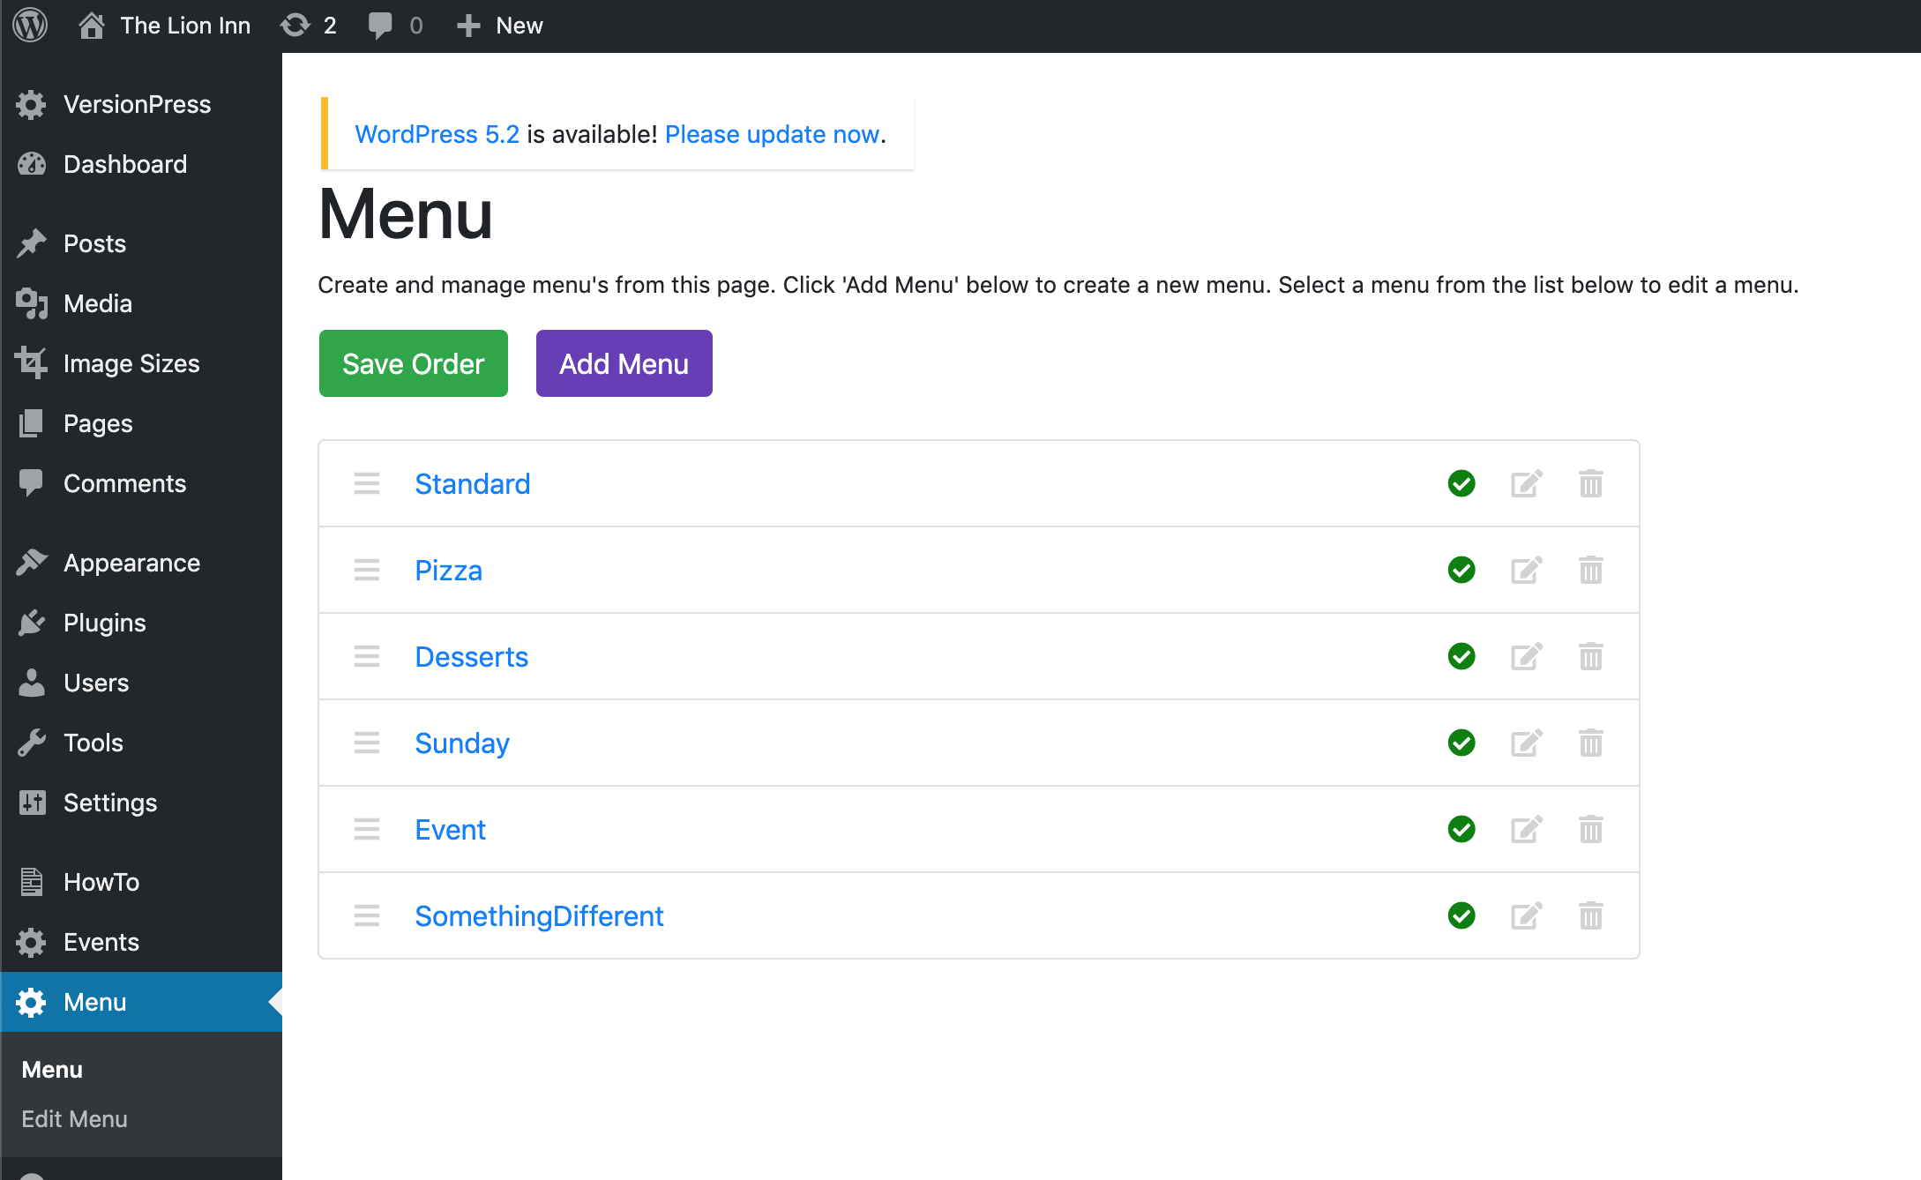

To delete a menu, click *this* icon.

If you hover your mouse over *this* icon, you will see ‘Delete:

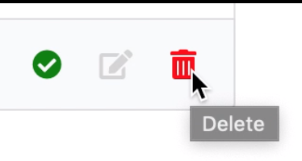

Click this icon, and you should see this screen:

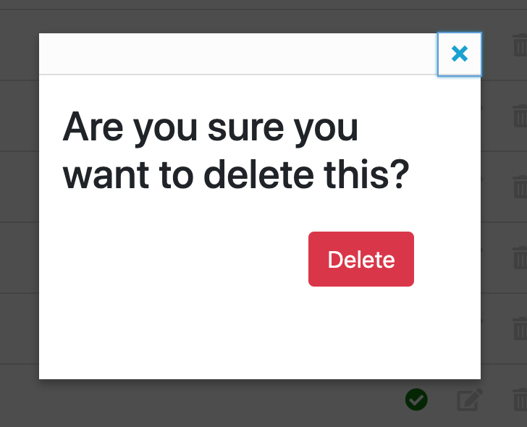

Click ‘Delete’. You should now see that the menu has been deleted:

