## Delete Section

**BEFORE DELETING ANYTHING - DELETING A SECTION WILL DELETE ALL OF IT’S ITEMS AND SUBITEMS.**

**IF YOU WANT A SECTION TO NOT APPEAR ON THE SITE, BUT DO NOT WANT TO DELETE IT, JUST UNPUBLISH THE SECTION INSTEAD.**

Select a menu from the list of menus:

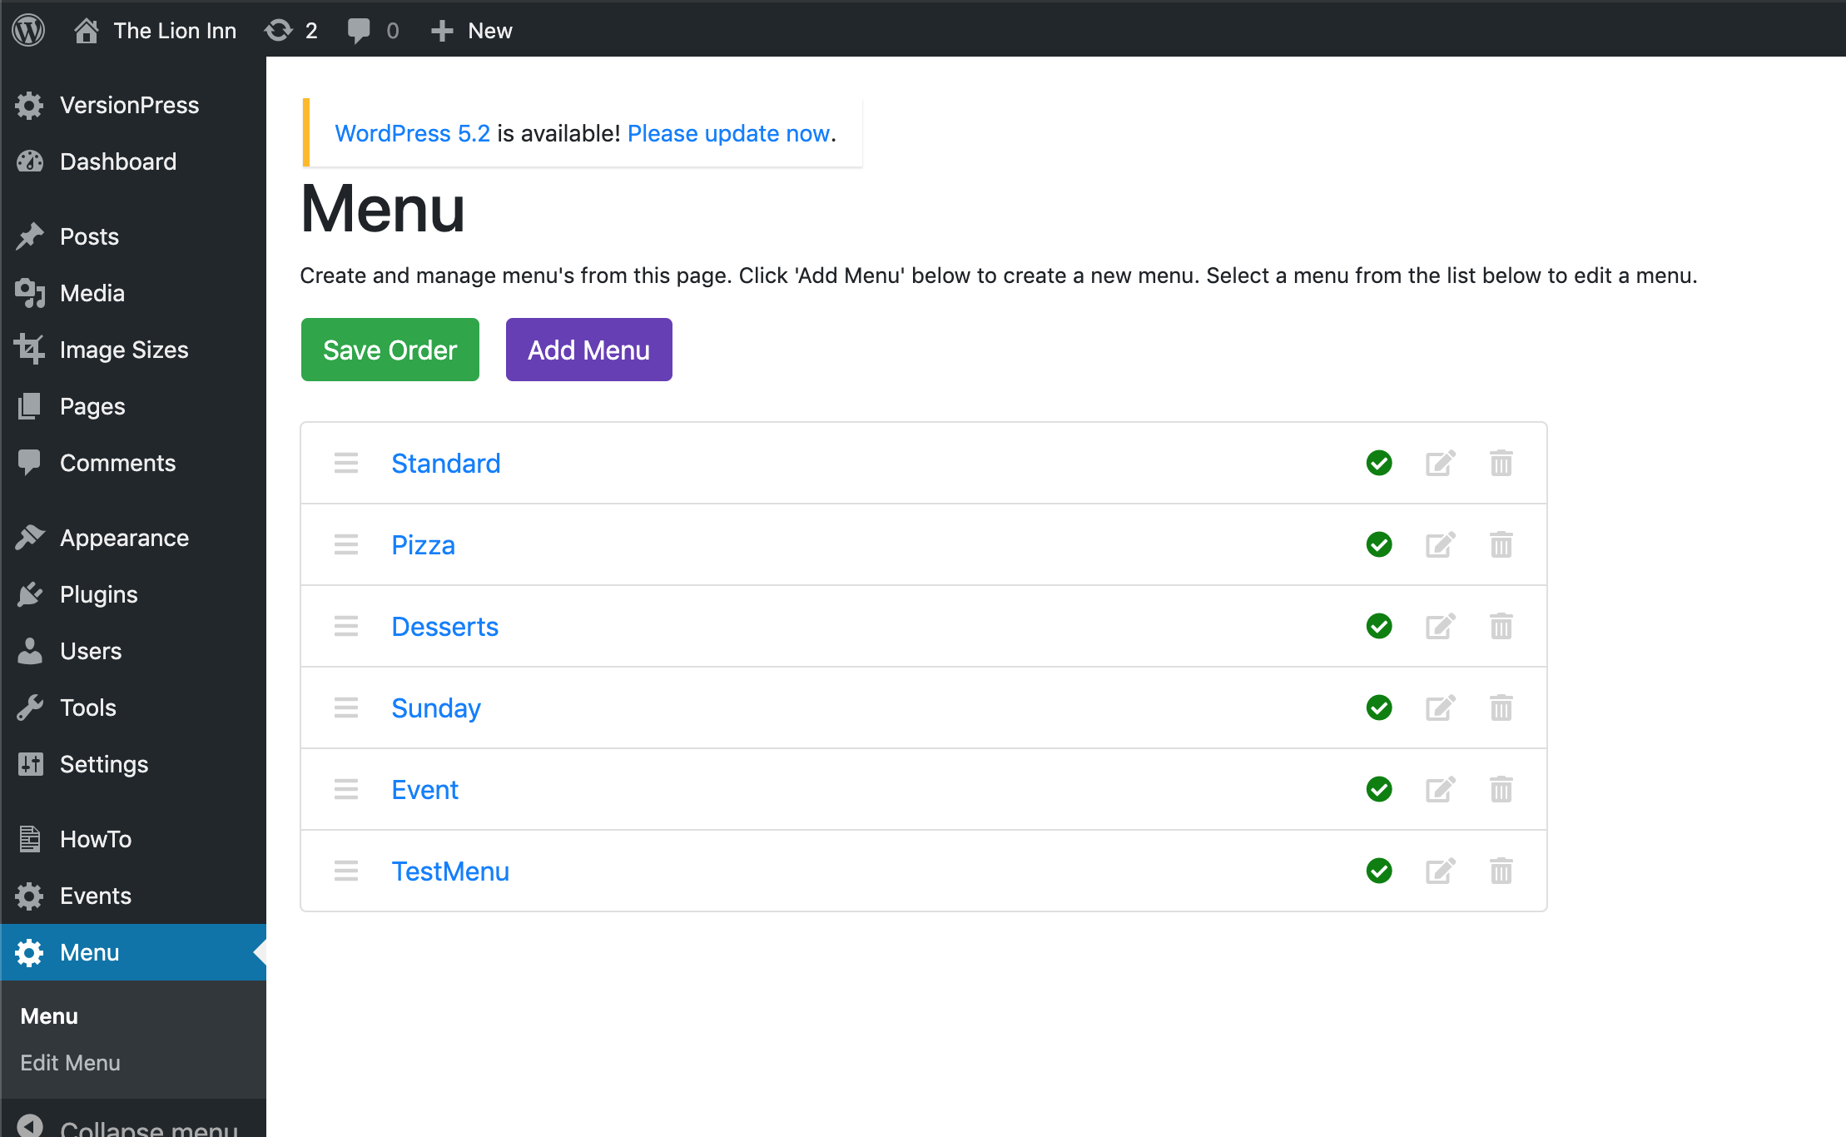

I will select ‘TestMenu’. You should then be on the ‘Edit Menu’ page and see the menu’s sections, items and subitems:

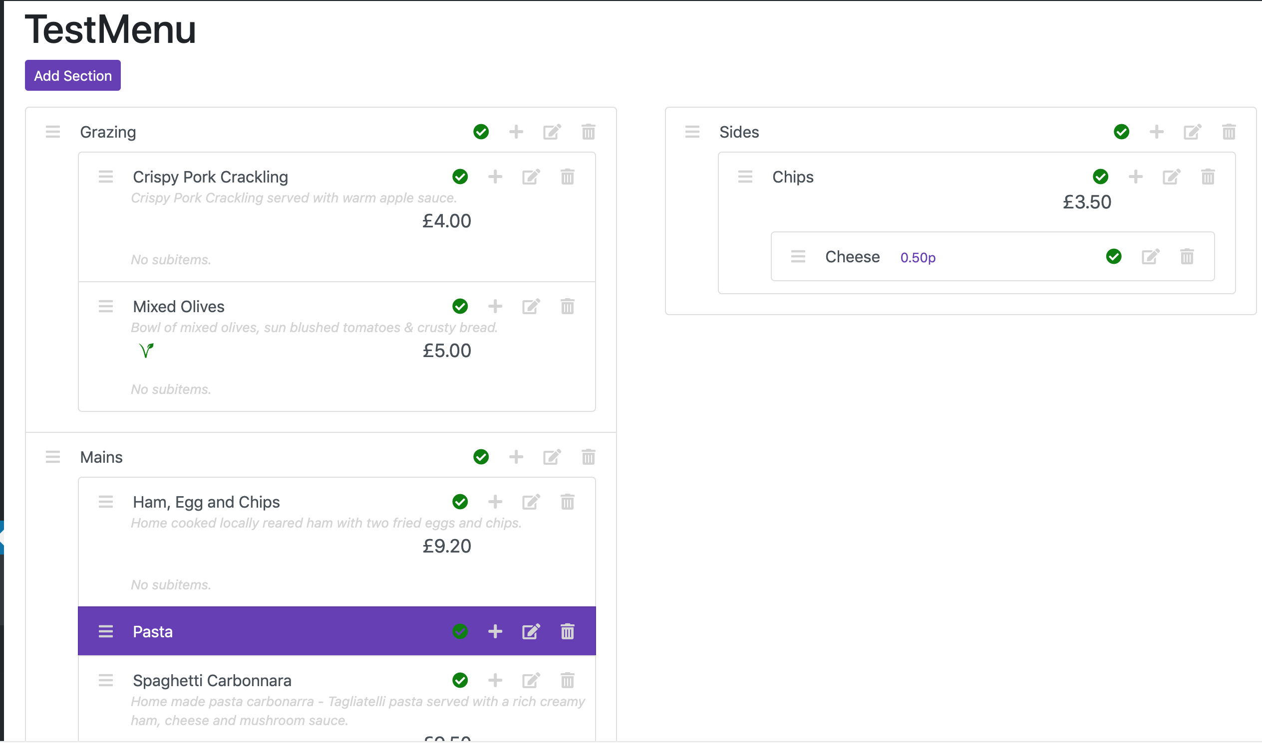

*You will see the title ‘Edit Menu’ at the top of the screen. I have scrolled down so that I can get as much of the menu in as possible.*

To delete a section, click the ‘Delete’ icon for a section:



You will then see this screen:

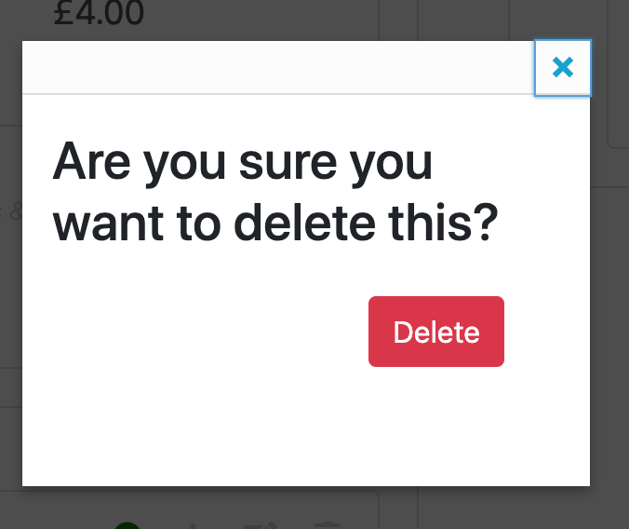

Click ‘Delete’. You will then see that the ‘Grazing’ section (or whichever section you deleted) has disappeared from the list:

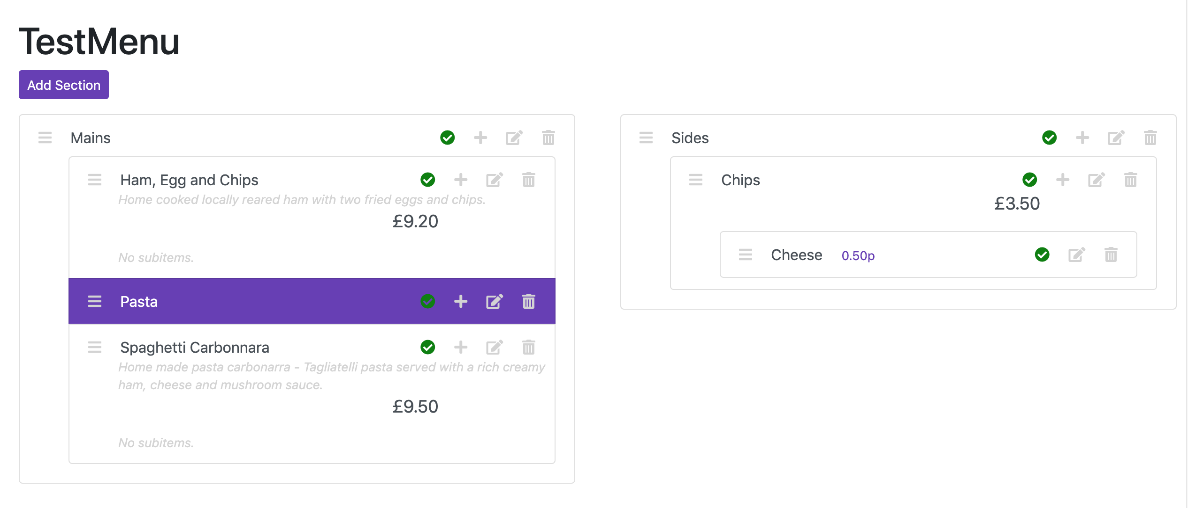

**Note that all of its items have been deleted as well.**