## Delete Subitem

**IF YOU WANT A SUBITEM TO NOT APPEAR ON THE SITE, BUT DO NOT WANT TO DELETE IT, JUST UNPUBLISH THE SUBITEM INSTEAD.**

Select a menu from the list of menus:

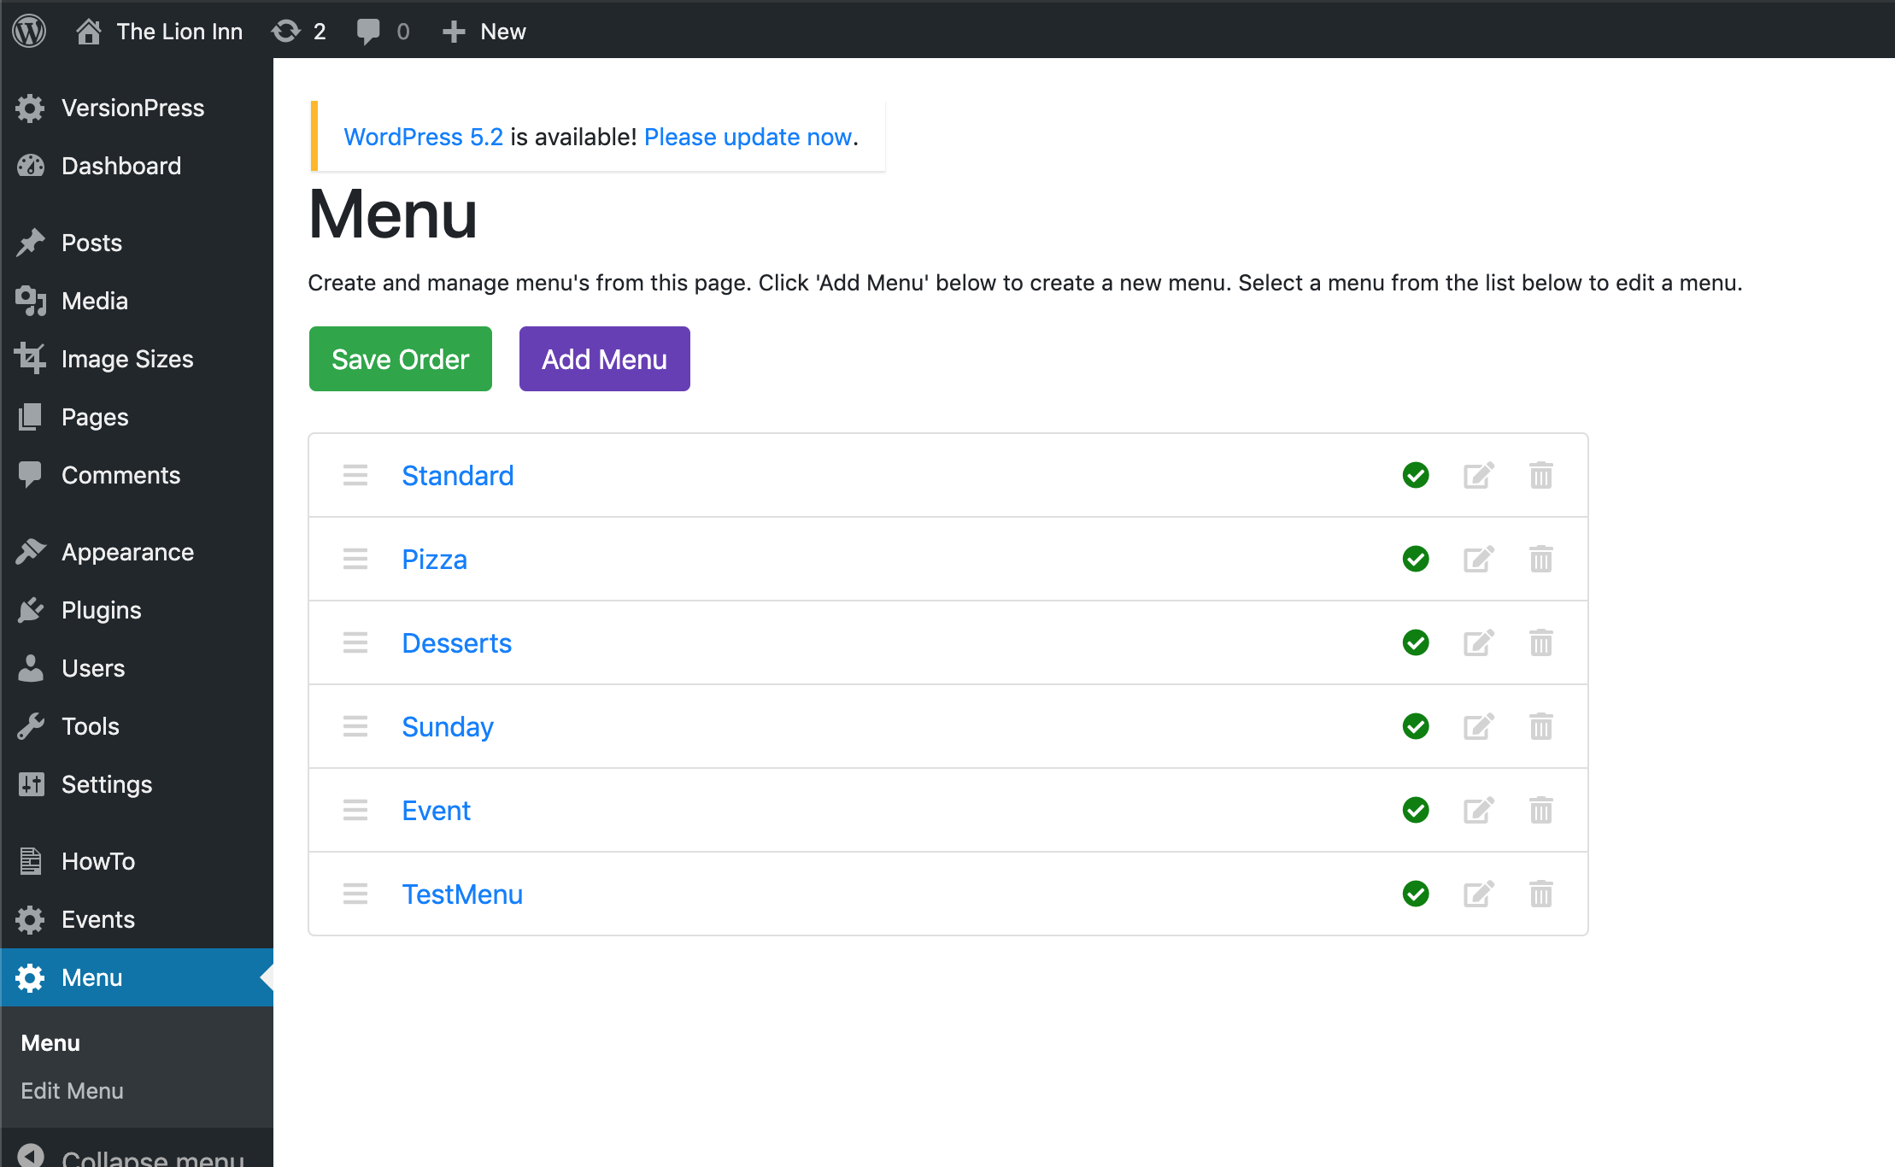

I will select ‘TestMenu’. You should then be on the ‘Edit Menu’ page and see the menu’s sections, items and subitems:

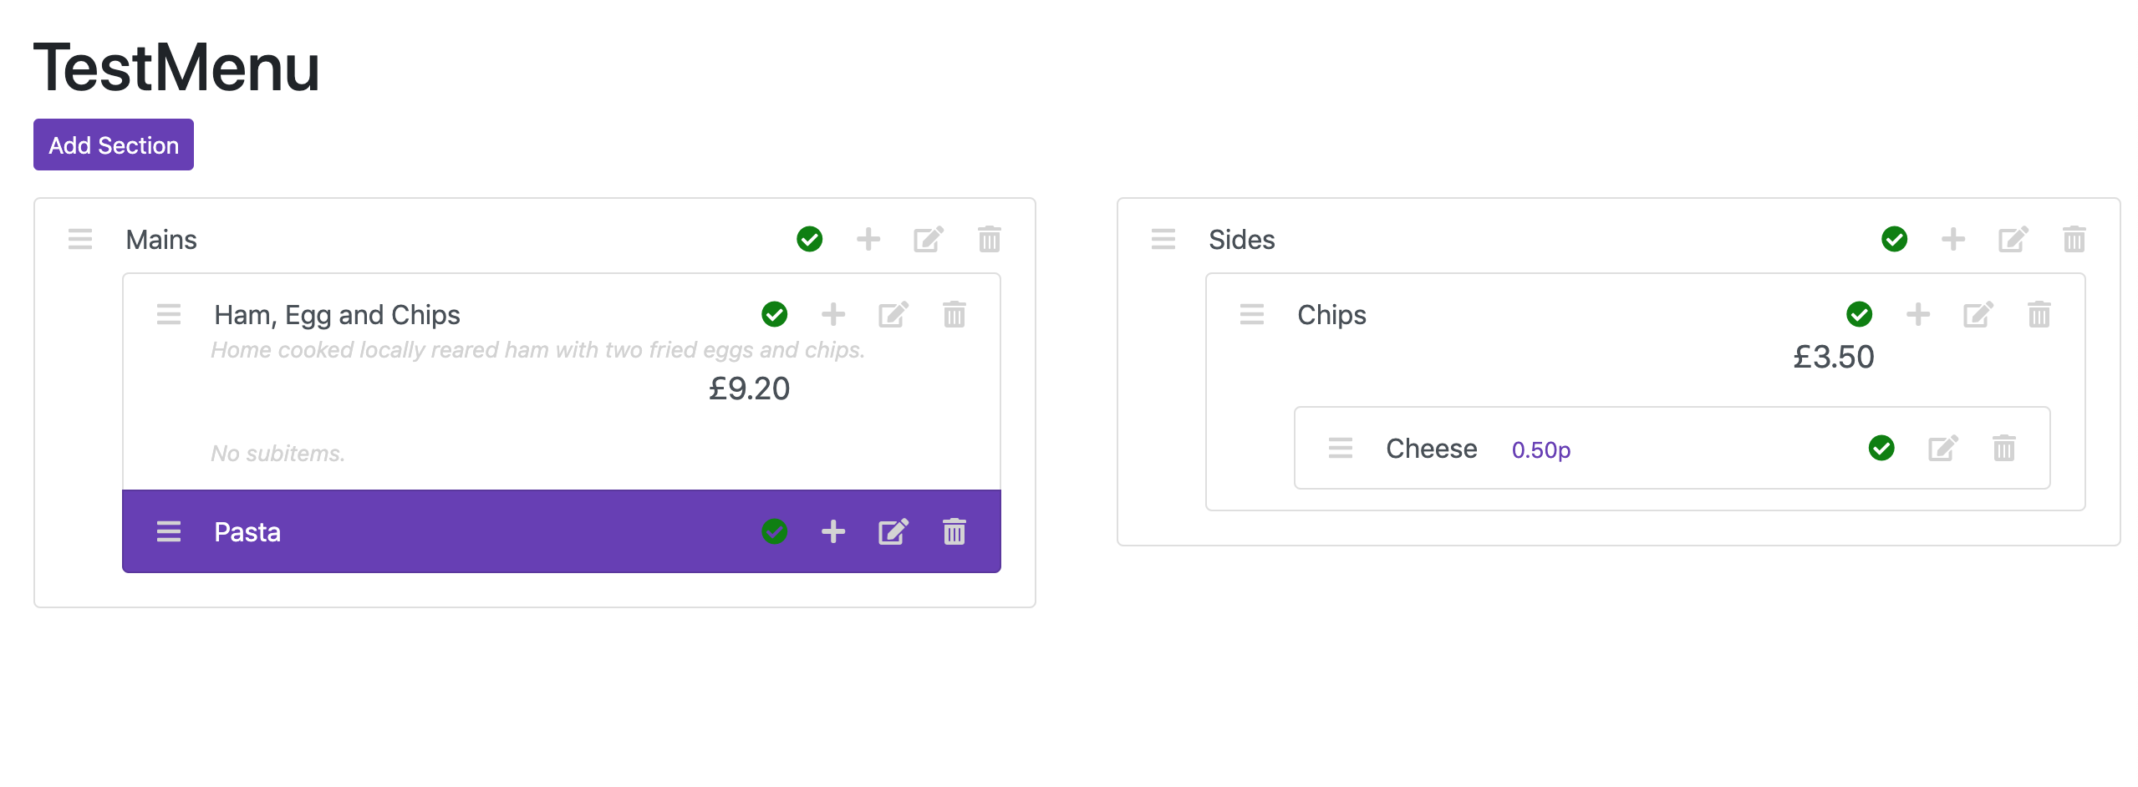

To delete a subitem, click the ‘Delete’ icon for it. You should then see this screen:

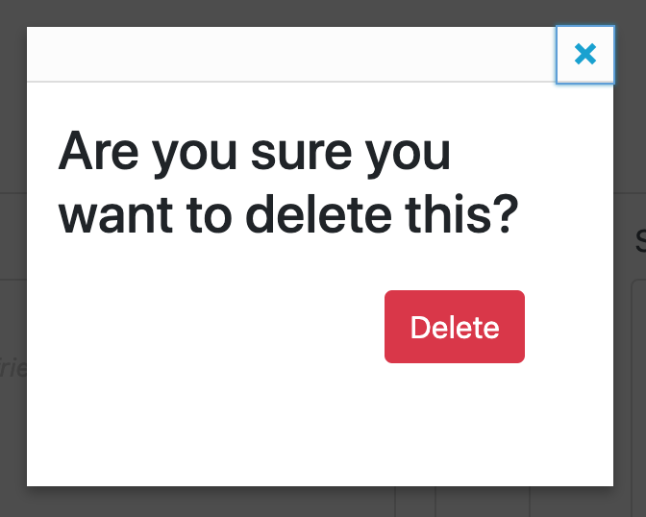

Click ‘Delete’. You will then see that the subitem does not appear in the list:

