## Edit Item

Editing an item is similar to editing a section or menu.

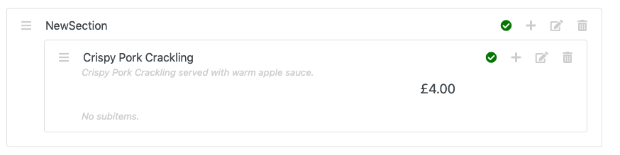

Click the ‘Edit’ icon. You should then see something like this:

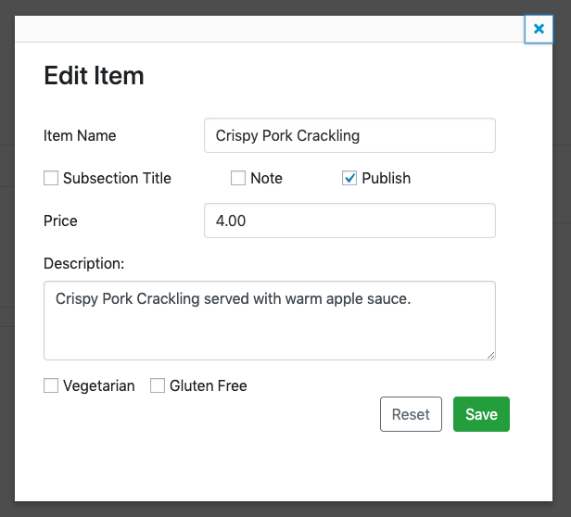

This looks very similar to ‘Add Item’ form. From here you can:

* Change the item name
* Turn the item into a subtitle
* Turn it into a note
* Publish / Unpublish it
* Change its price
* Change its description
* Change it vegetarian / gluten free status.

For example:

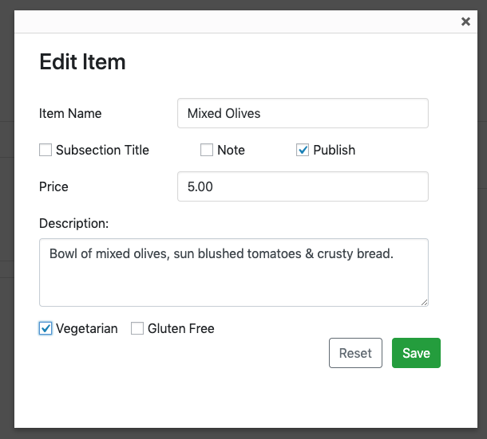

Click ‘Save’. You should the changes reflected in the list:

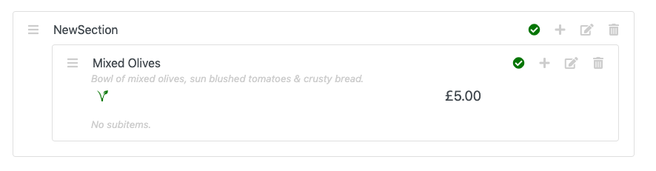

*Notice that as we selected ‘Vegetarian’, we can see the vegetarian icon.*