## Edit Menu

Click ‘Menu’ on the left-side bar to bring up the list of menus:

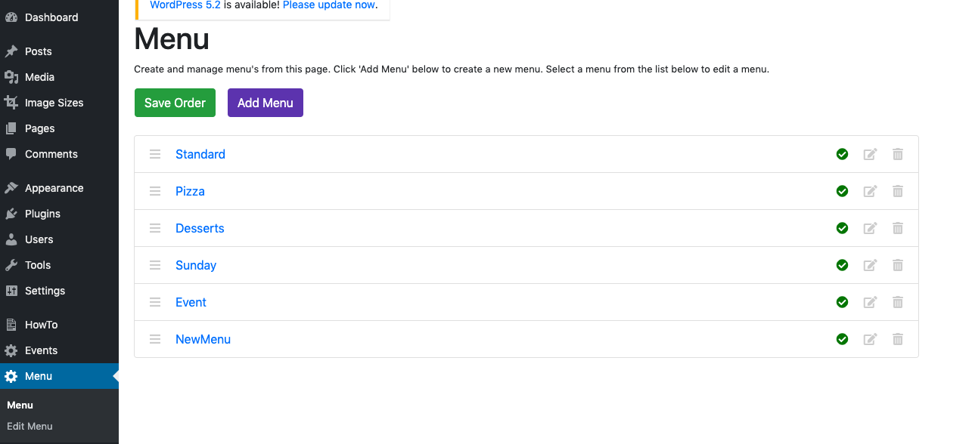

The only ‘menu editing’ that you can do from here, is editing a menu’s name, and whether or not it is published.

If you hover your mouse over *this* icon, you will see ‘Edit’:

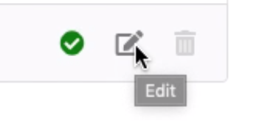

Click this icon, and you should see this screen:

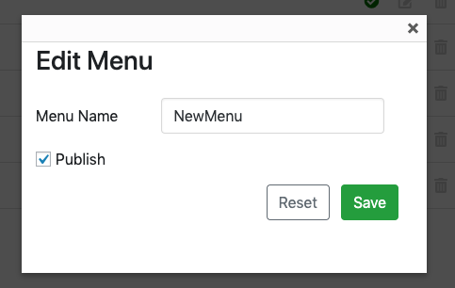

*The Menu Name field will be replaced with the name of whatever menu you have clicked on.*

Change the name to something different:

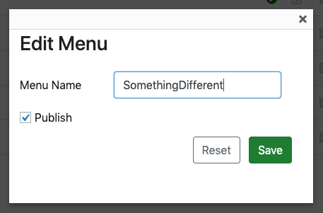

Click ‘Save’. You will now see the name changed in the list of menus:

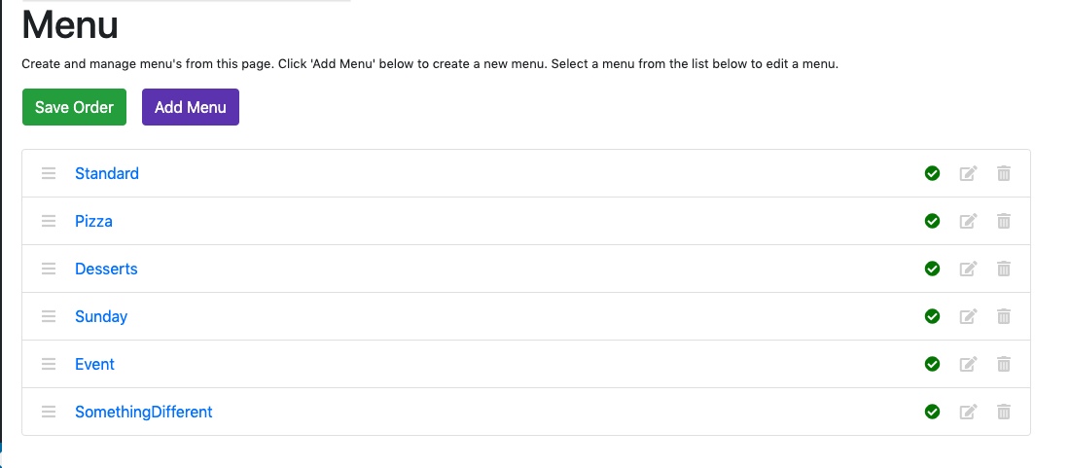

And on the actual website, it will have changed to something like this:

