## Edit Section

Editing a section is very similar.

Click a menu from the list:

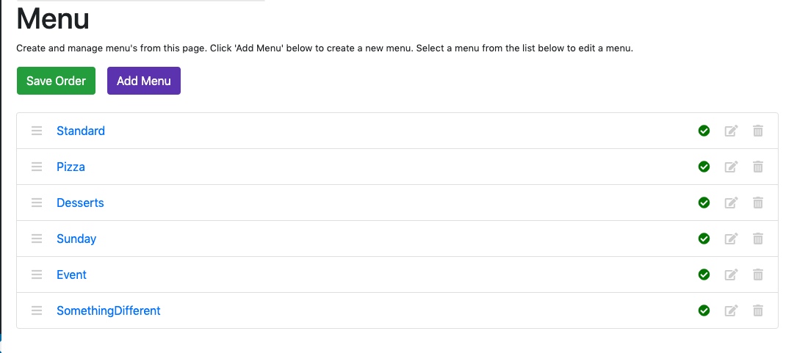

We should now be on the Edit Menu screen:

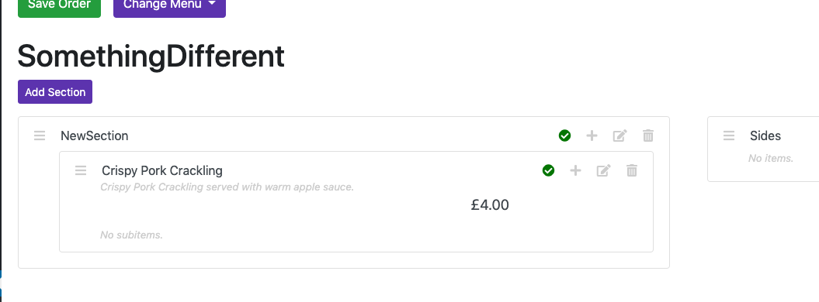

To edit any section on a menu, click the ‘Edit’ icon. You should now see this:

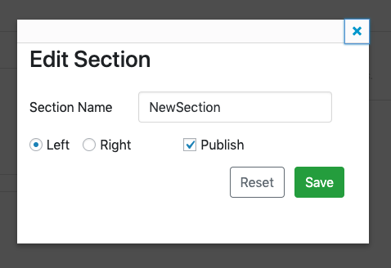

From here you can:

* Change the name
* Change which side it appears on
* Change whether or not it is published

For example, let’s change the name to DifferentSectionName, change it to the right-hand side, and not publish it:

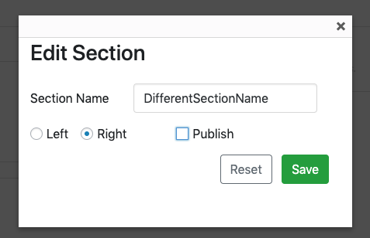

Click ‘Save’ and you should see something like this:

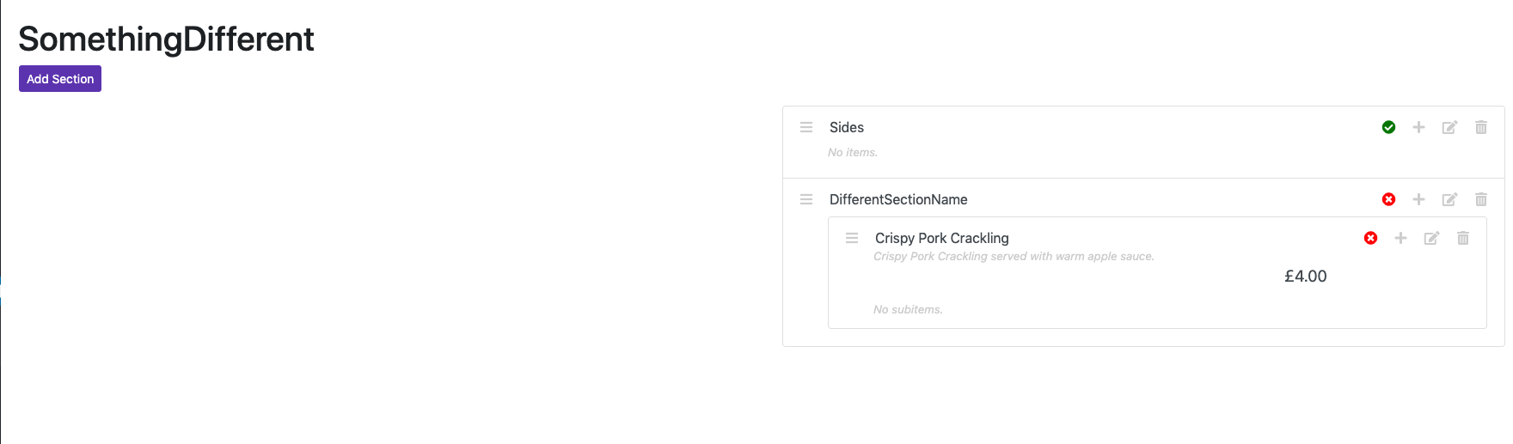

Note the changed section name, the right-hand side and the not published icon now.

*You will notice that Crispy Pork Crackling is also showing the not published icon. If you make a section not published, it’s items will also not be published. Similarly, making a menu not published will make its sections and items not published. The same applies for items and subitems.*