## Edit Subitem

Editing a subitem is also similar to the others.

Say we’ve got a Sides section, with a Chips item, which has the option for a Cheese subitem:

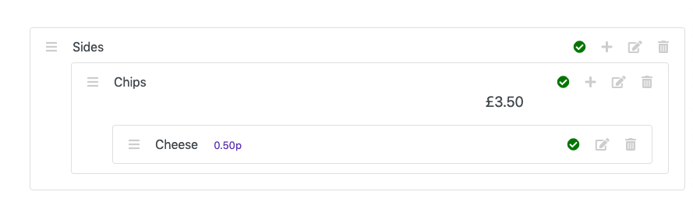

Click the ‘Edit’ icon for the Cheese subitem. You should then see something like this:

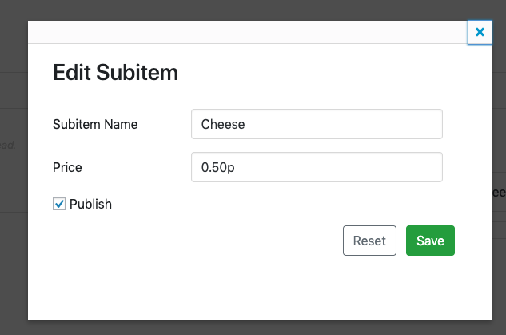

From here you can:

* Change the subitem name
* Change its price
* Change whether or not it is published

For example:

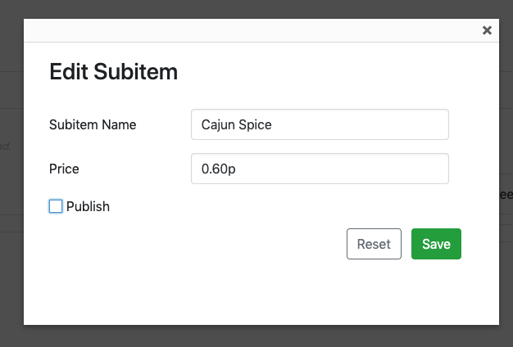

Click ‘Save’. You should then see these changes reflected in the list:

