## How to Access the Menu’s

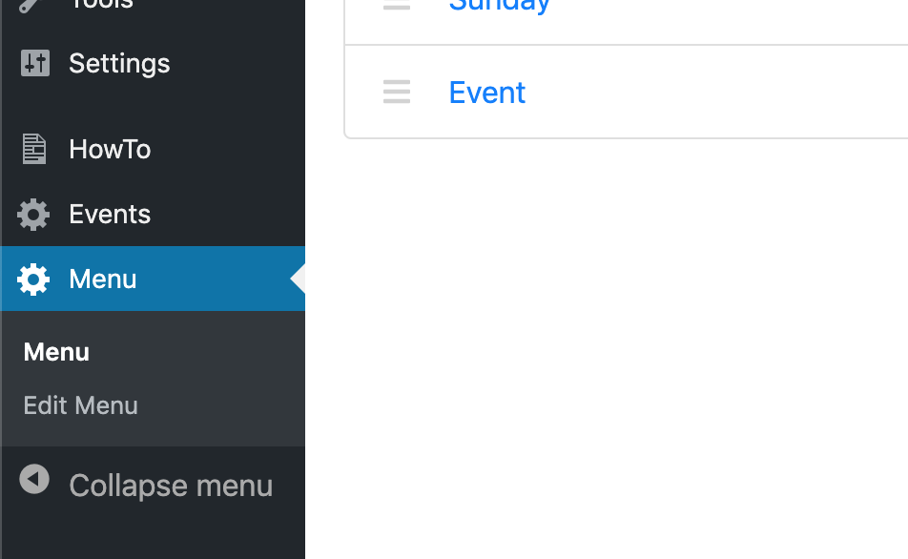

The menus can be accessed by clicking ‘Menu’ in the left-side bar. The two sub-menu items; Menu and Edit Menu, will appear when you click ‘Menu’. It will default to the sub-menu item, also called ‘Menu’.

‘Menu’ shows a list of the menus that have currently been created.

‘Edit Menu’ is used to add, edit and delete sections, items and subitems for a specific menu (more on this in the next section – Menu’s, Sections, Items & Subitems).

Clicking on a menu on the ‘Menu’ page will load the ‘Edit Menu’ page so that you can edit the menu that you clicked on.

For example, clicking ‘Standard’ from the list:

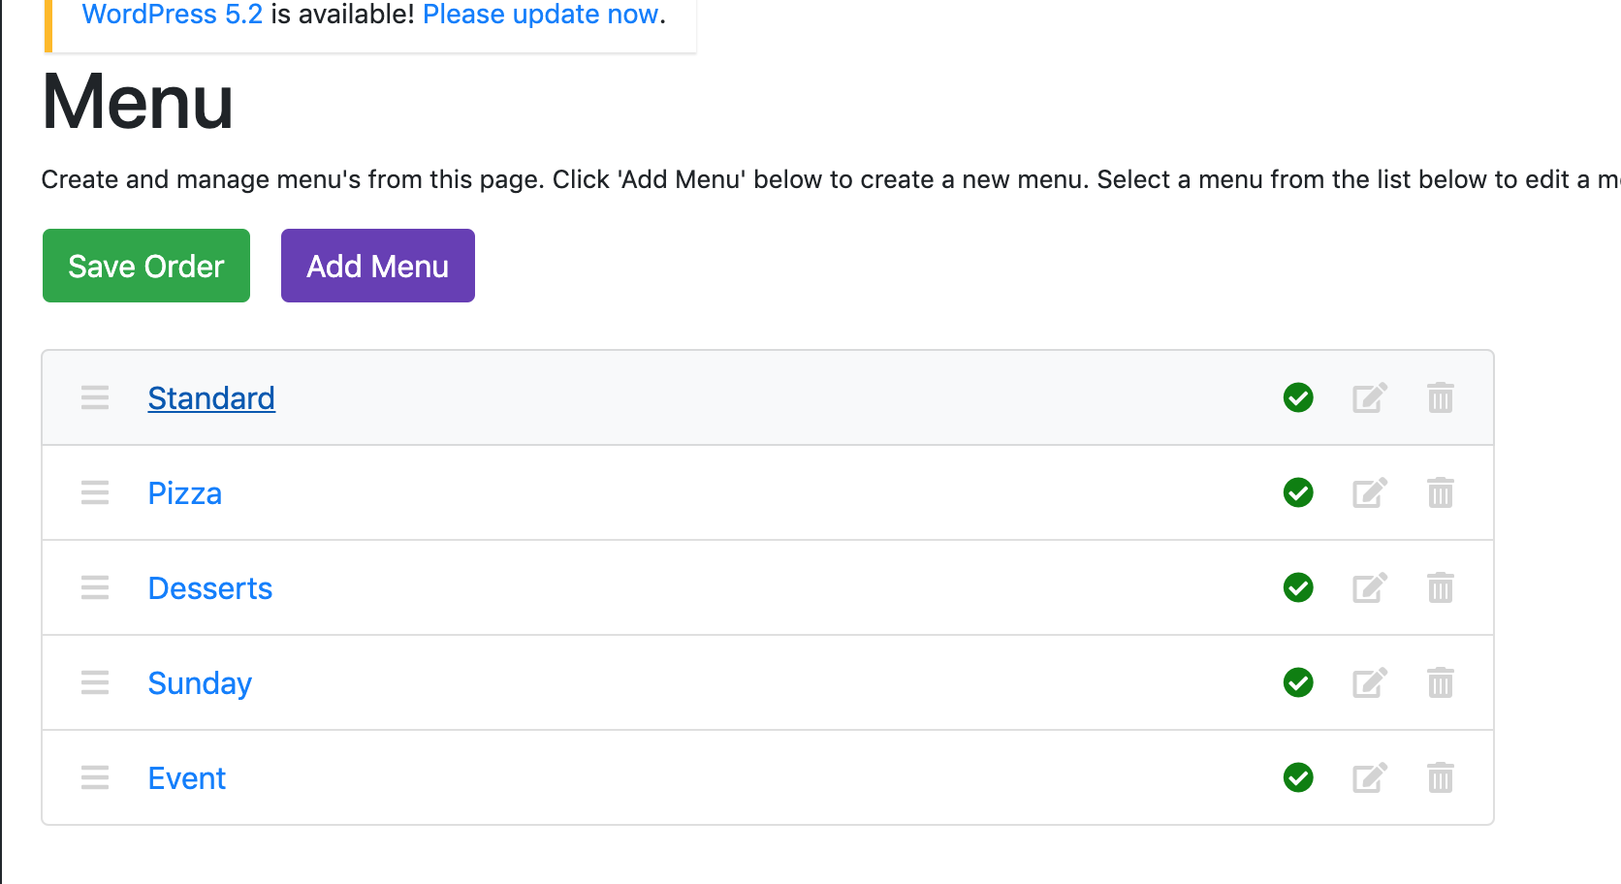

Will load this page:

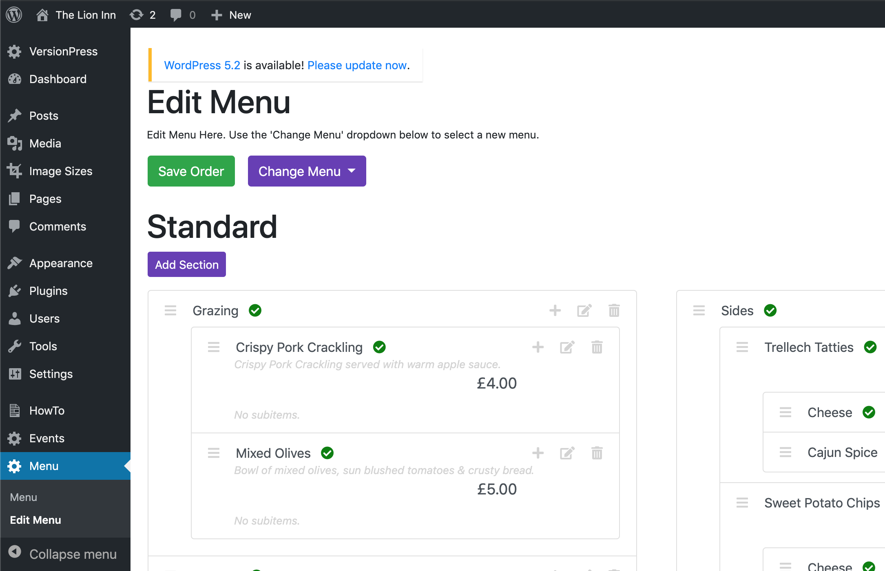

Notice that the menu title (Standard) is shown at the top and that we are on the ‘Edit Menu’ page now.

Clicking ‘Edit Menu’ directly from the left-side bar will bring up this page:

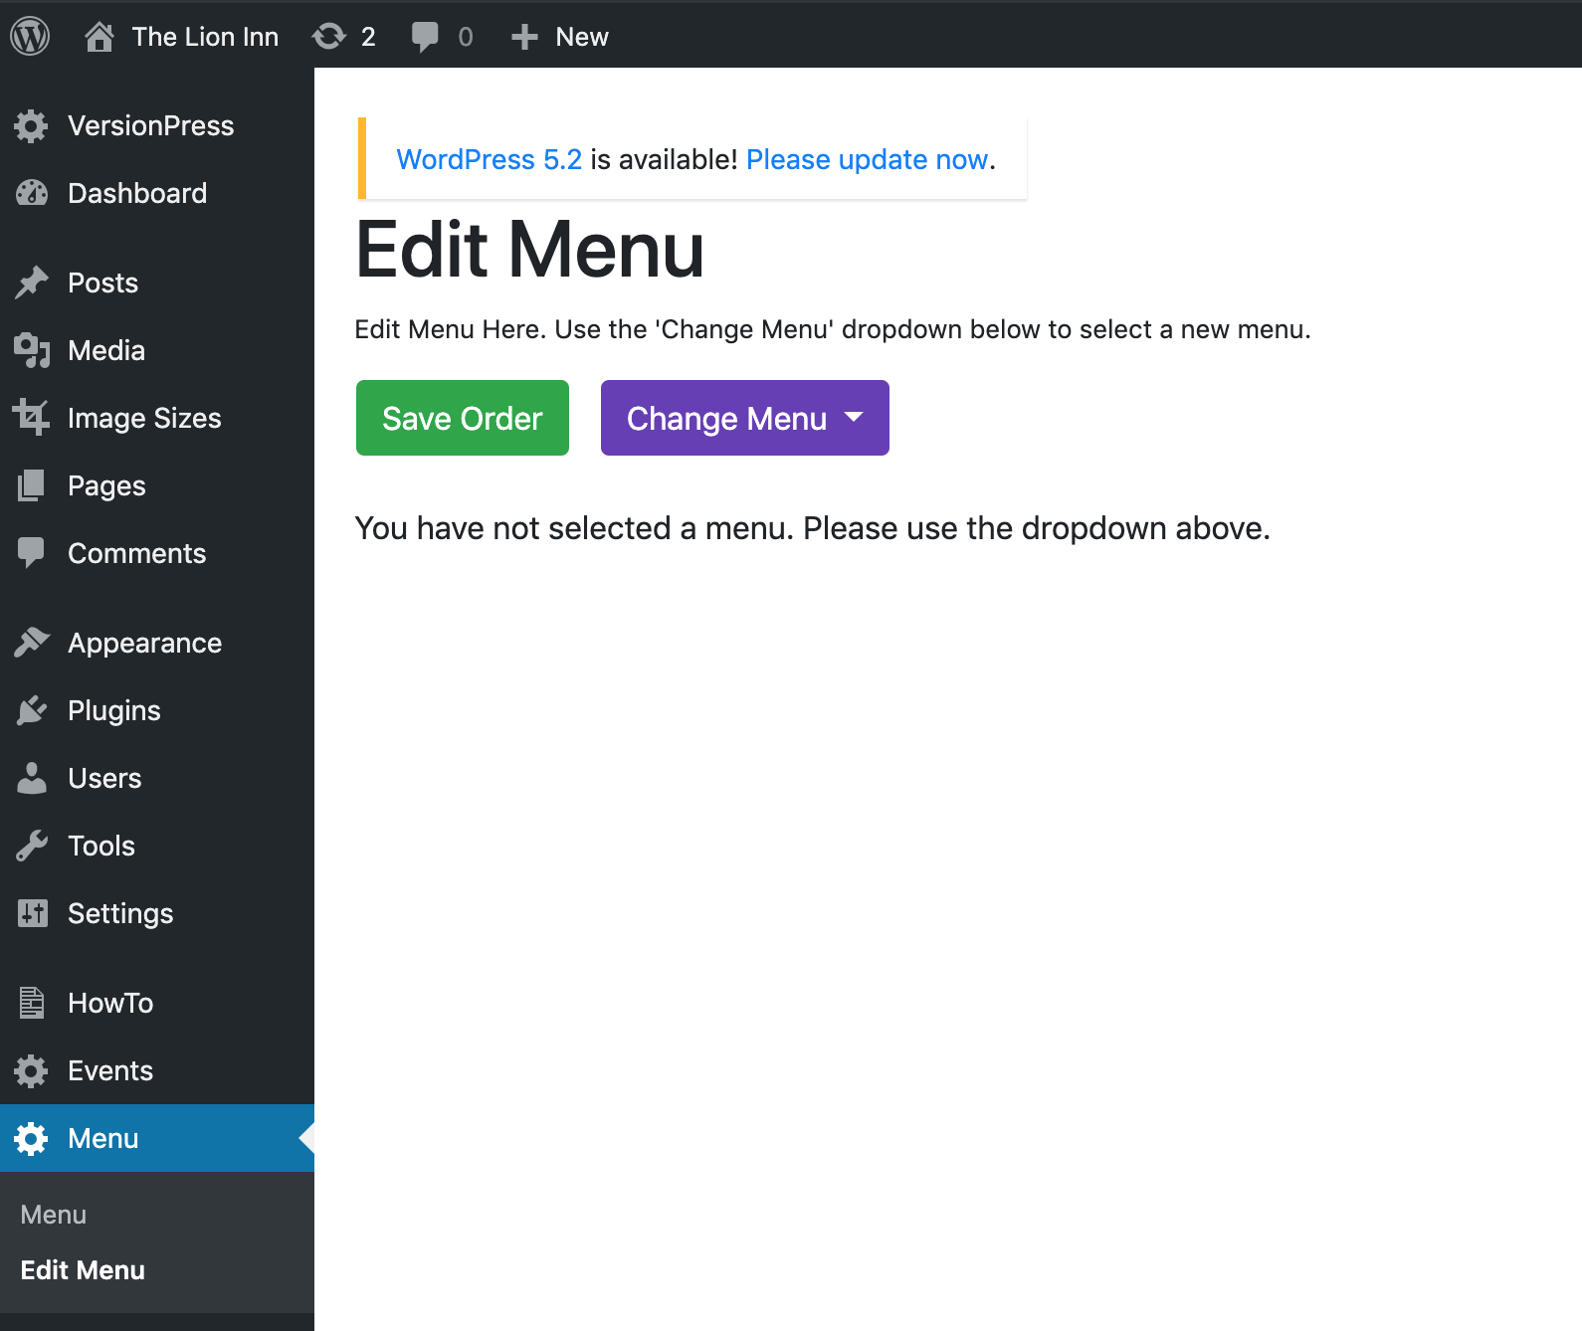

To choose a menu, click the purple ‘Change Menu’ button, and select a menu from the list.