### Basic Usage

Reordering a menu’s content is exactly the same. Select a menu from this list:

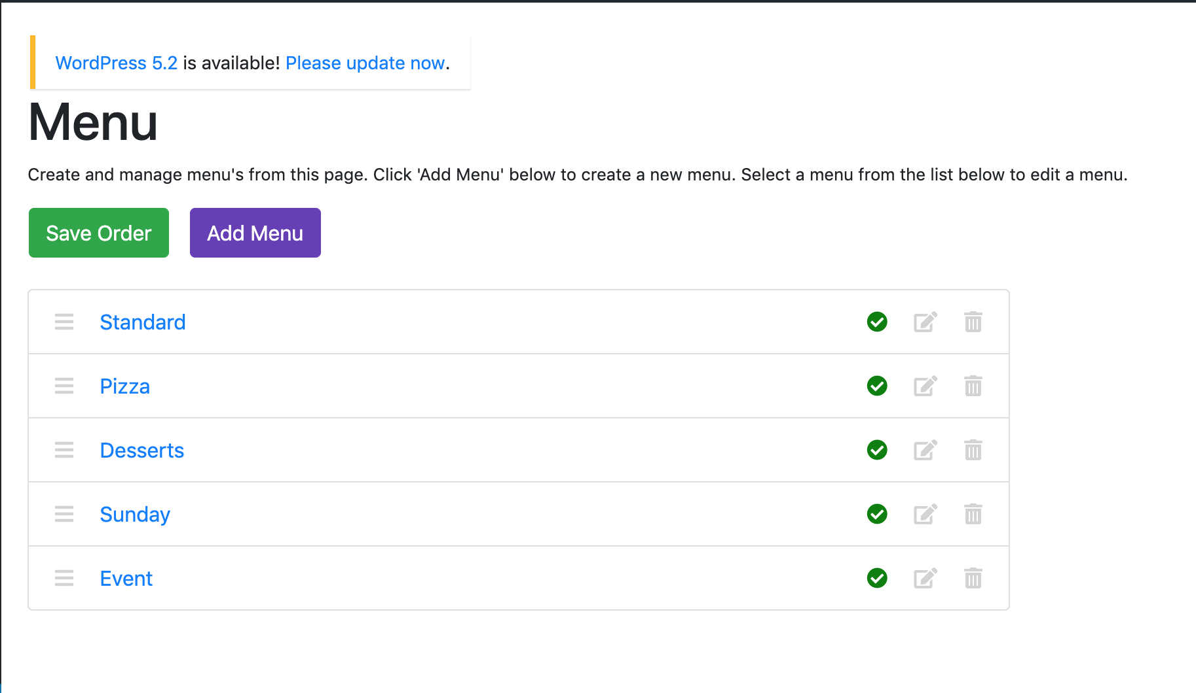

To bring up the edit menu page:

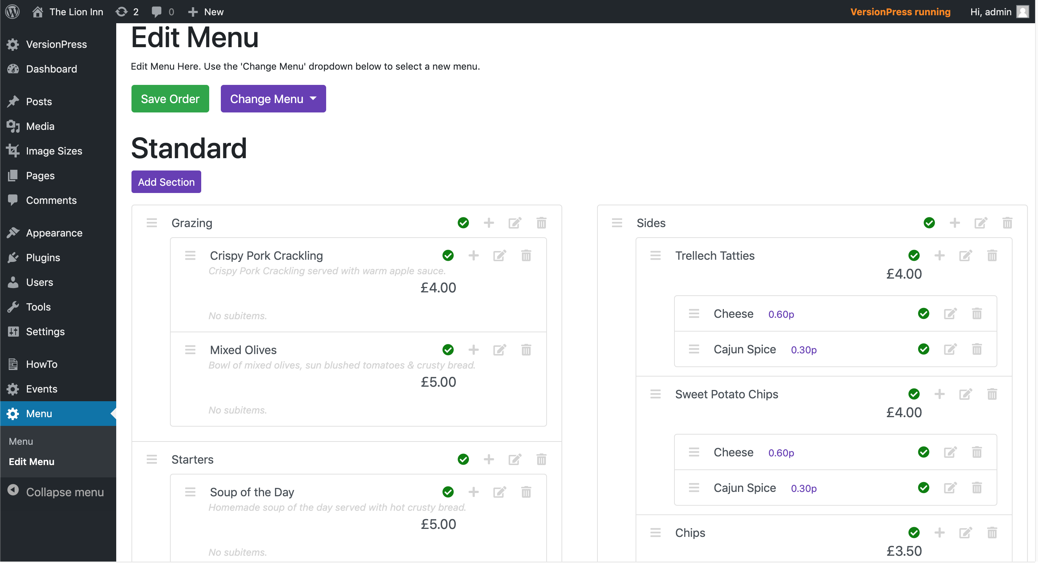

Again, we use *this* icon to move things (notice this icon on everything):



Picking any of these up with give the faded look like so:

The item will go grey as you click it:

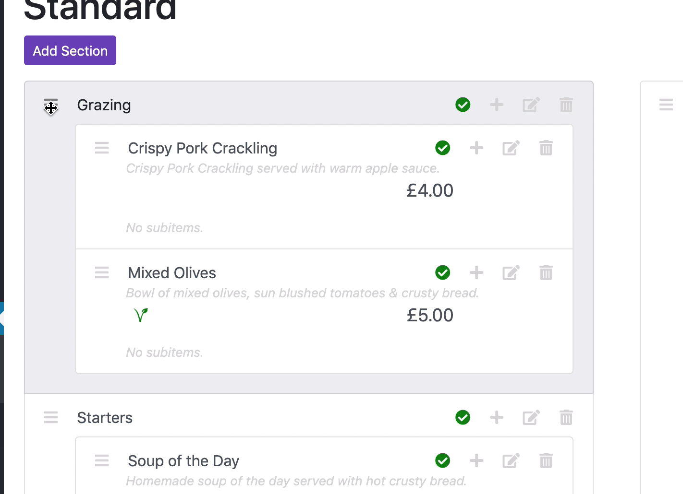

And fade as you move the item:

