### Moving Items

Similarly, items can be moved on their own. This will also move their subitems.

Pick up an item:

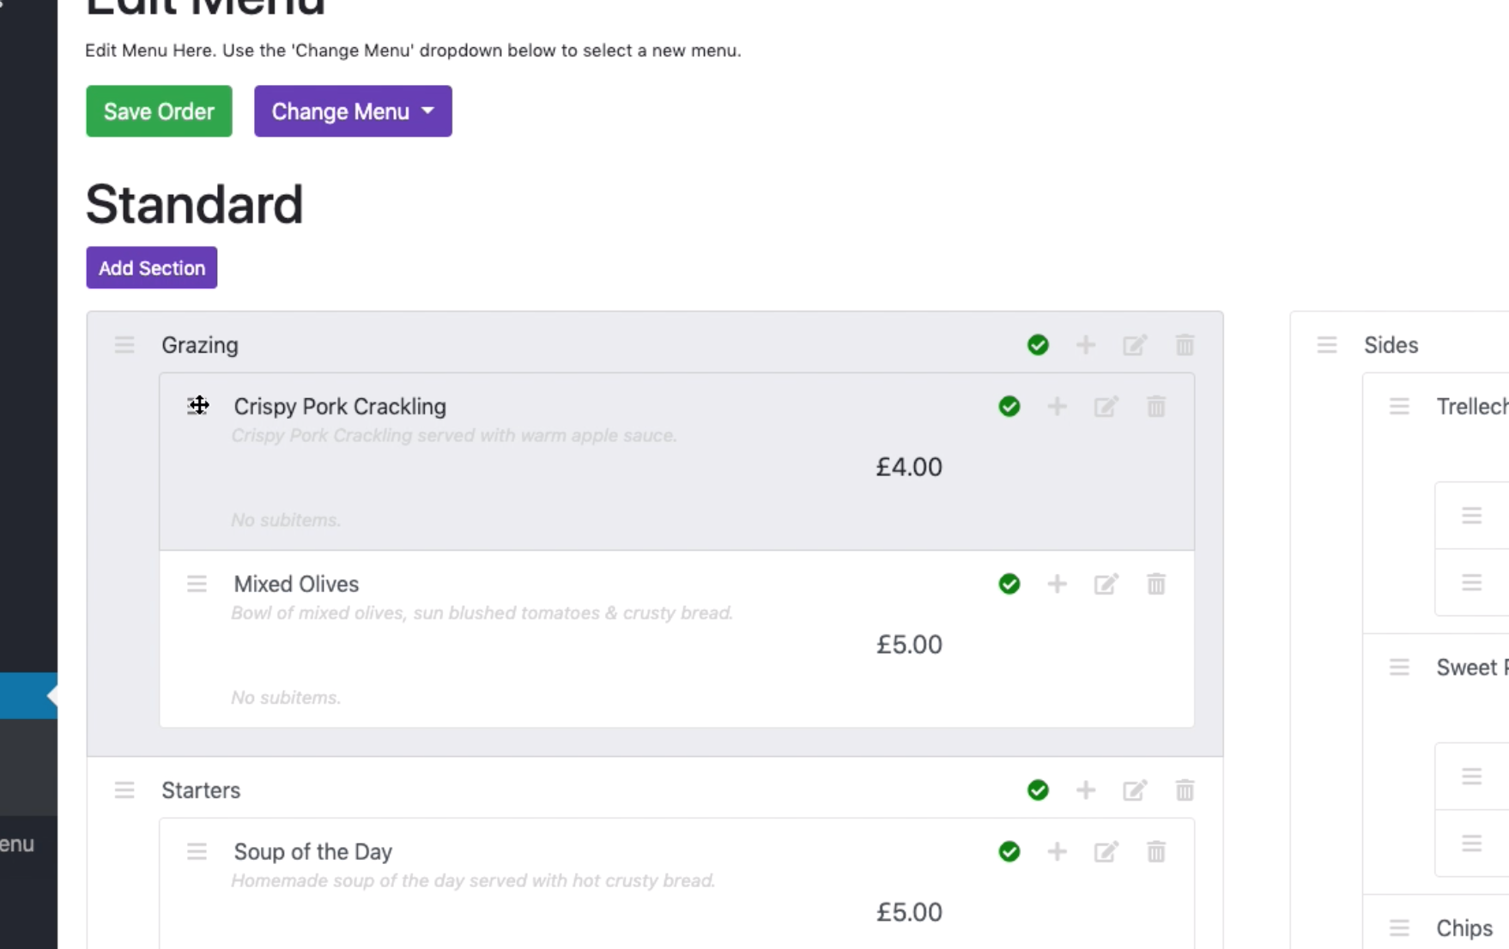

Move the mouse to where you want the item. Use the red arrow as guidance:

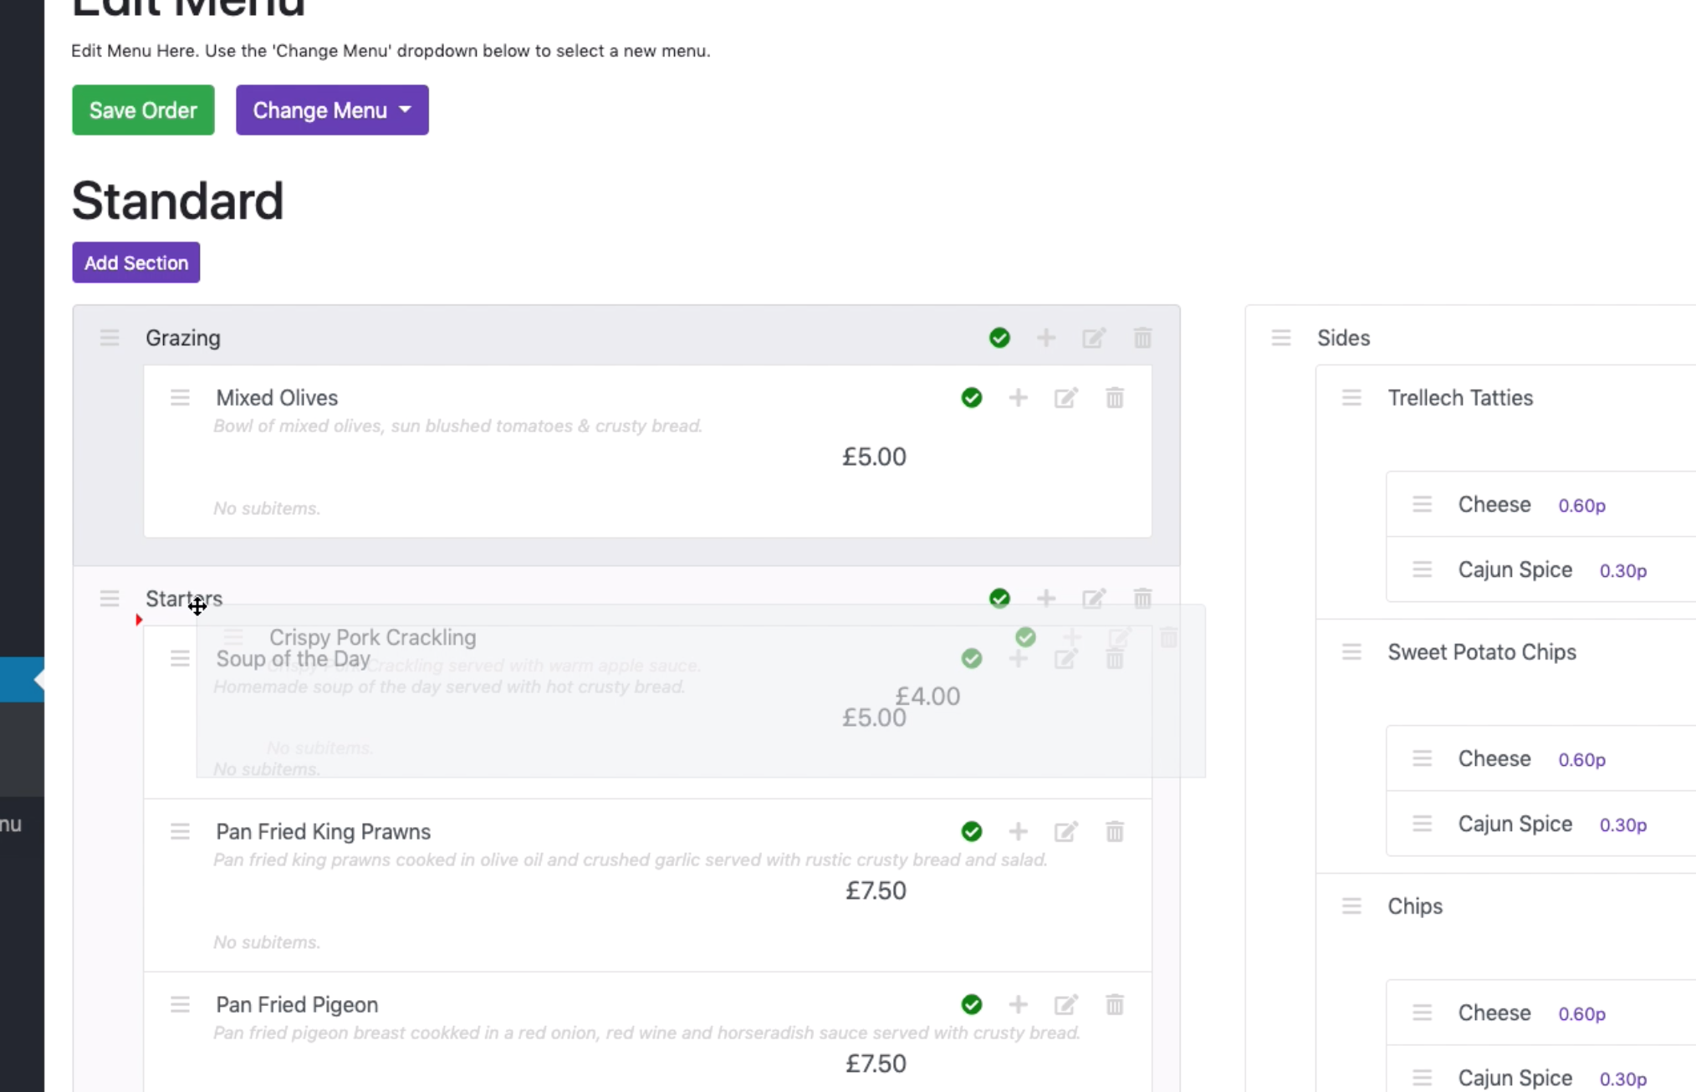

Items can also move sides, to sections on other sides:

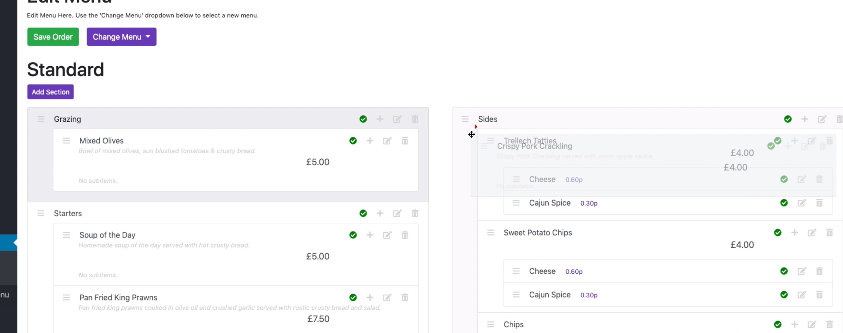

**Make sure you click the ‘Save Order’ button when you’re done re-ordering.**