### Moving Sides (Left & Right)

As mentioned before, sections, items and subitems can be moved across sides as well.

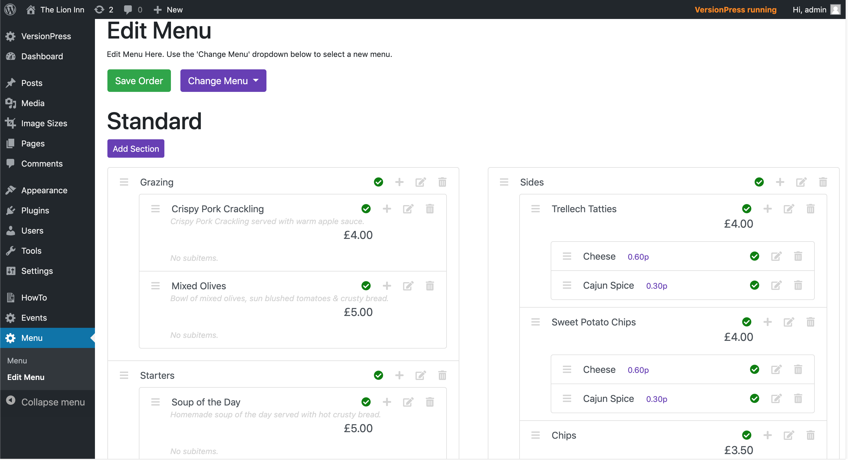

Sections can be moved in two ways:

1. Using the edit modal by clicking the ‘Edit Icon’, selecting the side and clicking ‘Save’:

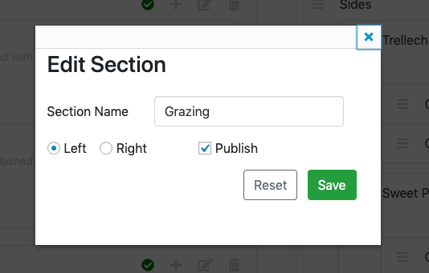

1. By moving the section across using the drag-and-drop reorder:

Pick up the section:

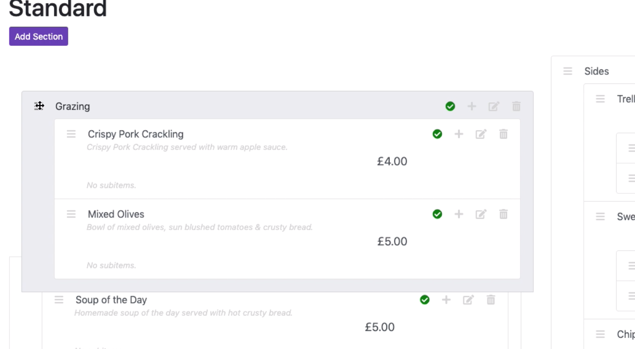

Drag across to the desired side and drop where desired:

