### Moving Sections

Whole sections (‘Grazing’, ‘Starters’, ‘Sides’, etc) can be moved up and down the menu and can also be moved across sides.

Pick up a section:

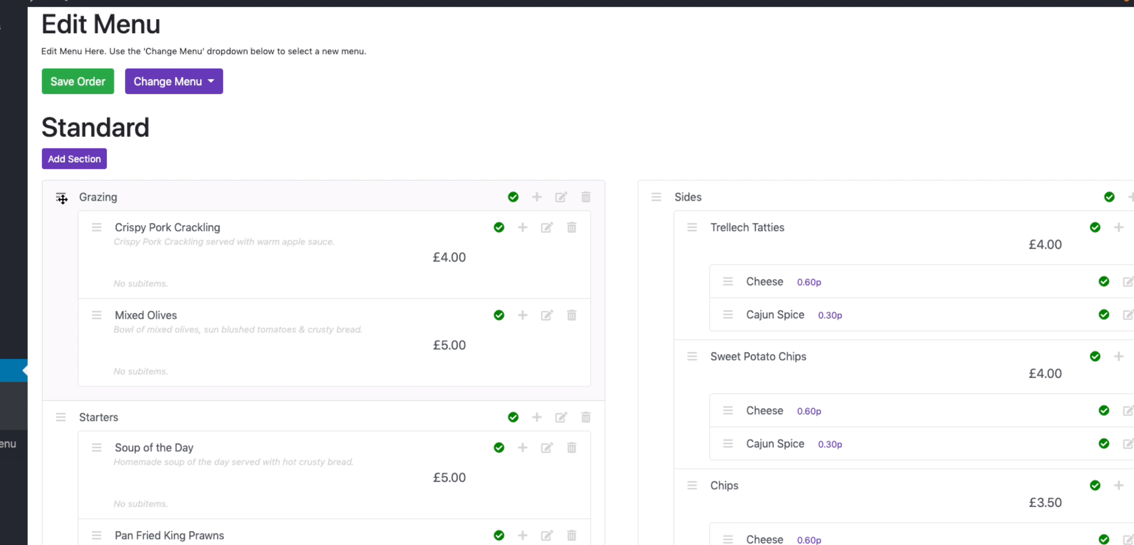

Just like with moving the menu’s, move the item where you want it and let go when the red arrow is in the correct place:

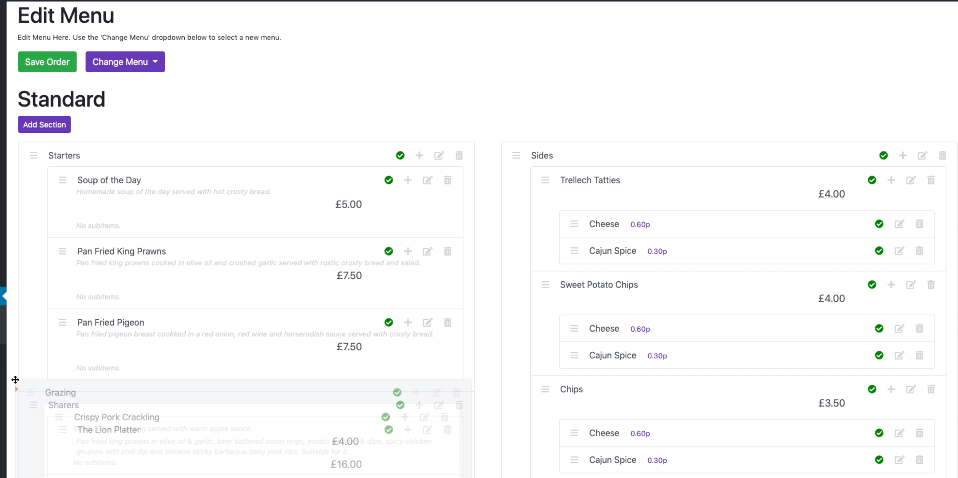

**Make sure you click the ‘Save Order’ button when you’re done re-ordering.**