### Moving Subitems

Similarly, subitems can be moved on their own. Pick up a subitem:

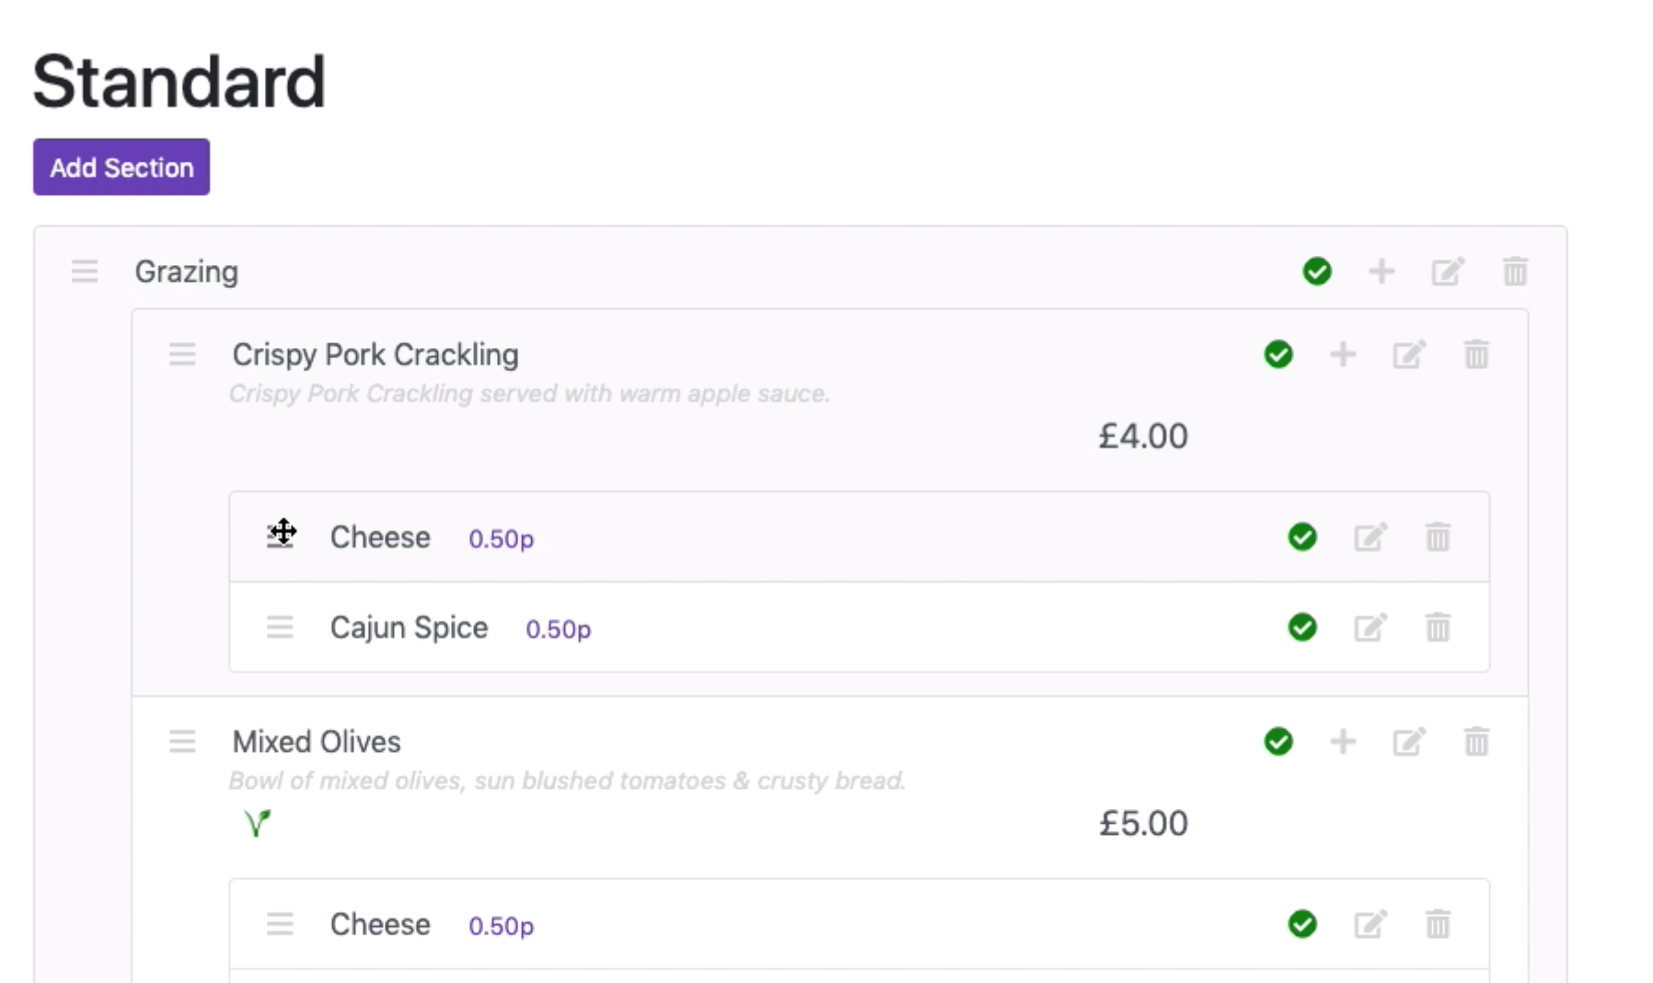

Use the red arrow to guide where to drop it:

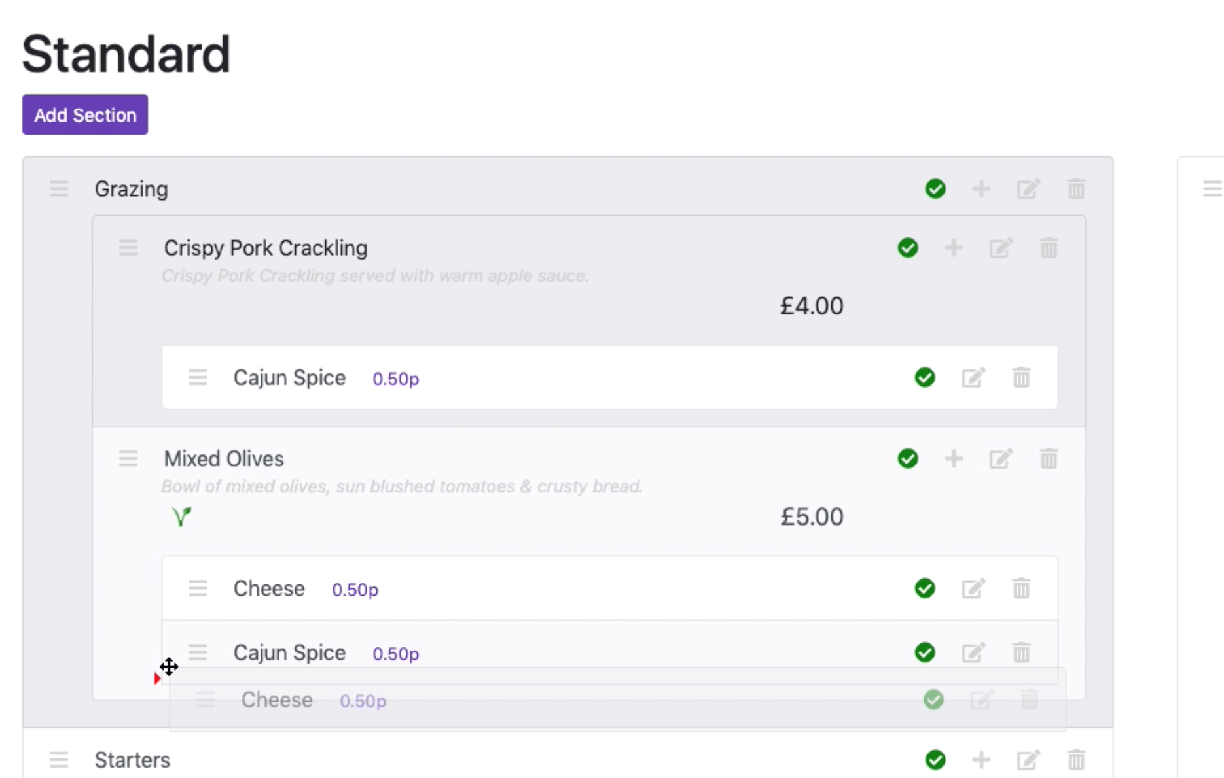

Release the mouse button to drop it into place:

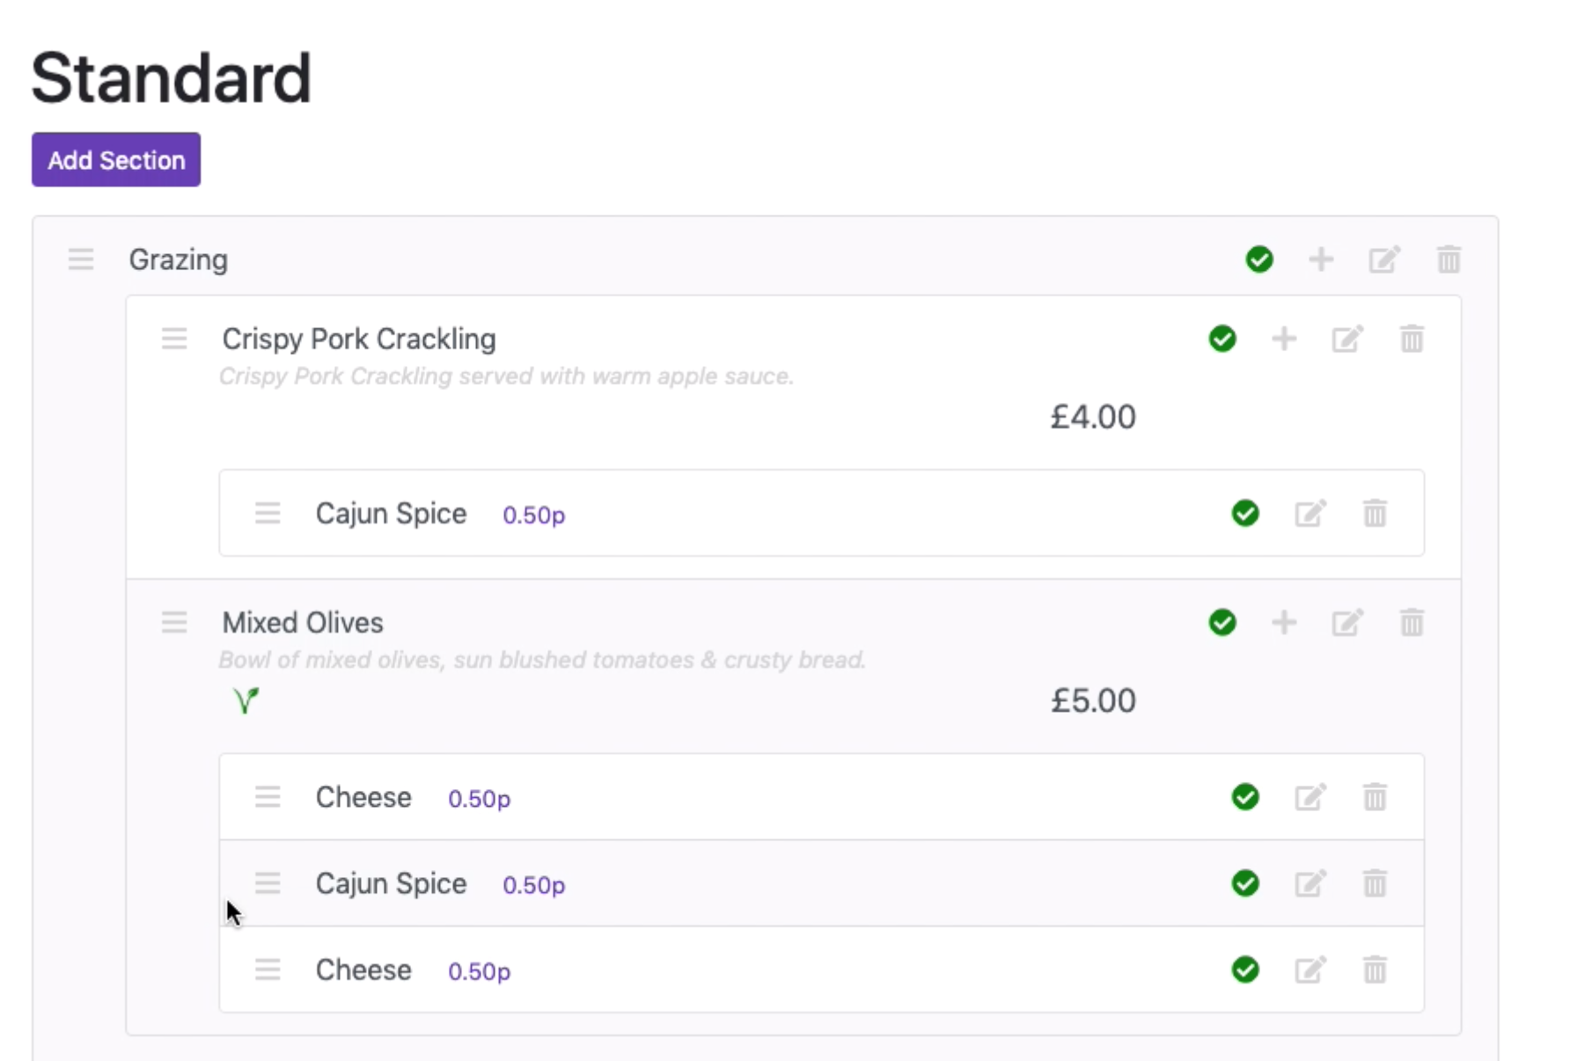

Subitems can also be moved across sides:

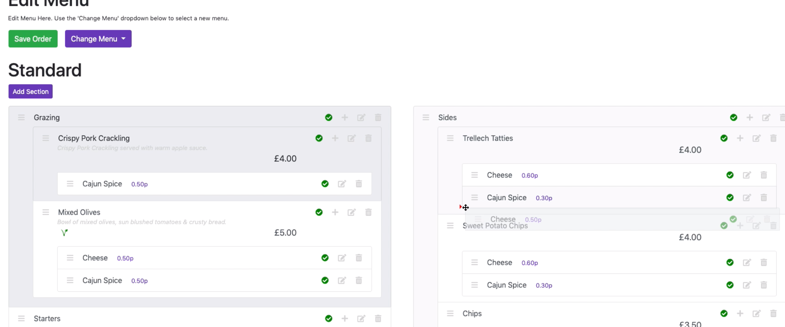

**Make sure you click the ‘Save Order’ button when you’re done re-ordering.**