### Moving Up & Down

Scrolling down the menu when reordering can be done in two ways:

1. If you’re using a normal mouse, you can use the scroll wheel:

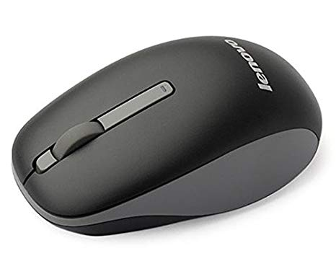

1. If you’re in a laptop, you can ‘pick up’ a menu item, and then move the cursor to the top or bottom of the screen to scroll:

Pick up an item:

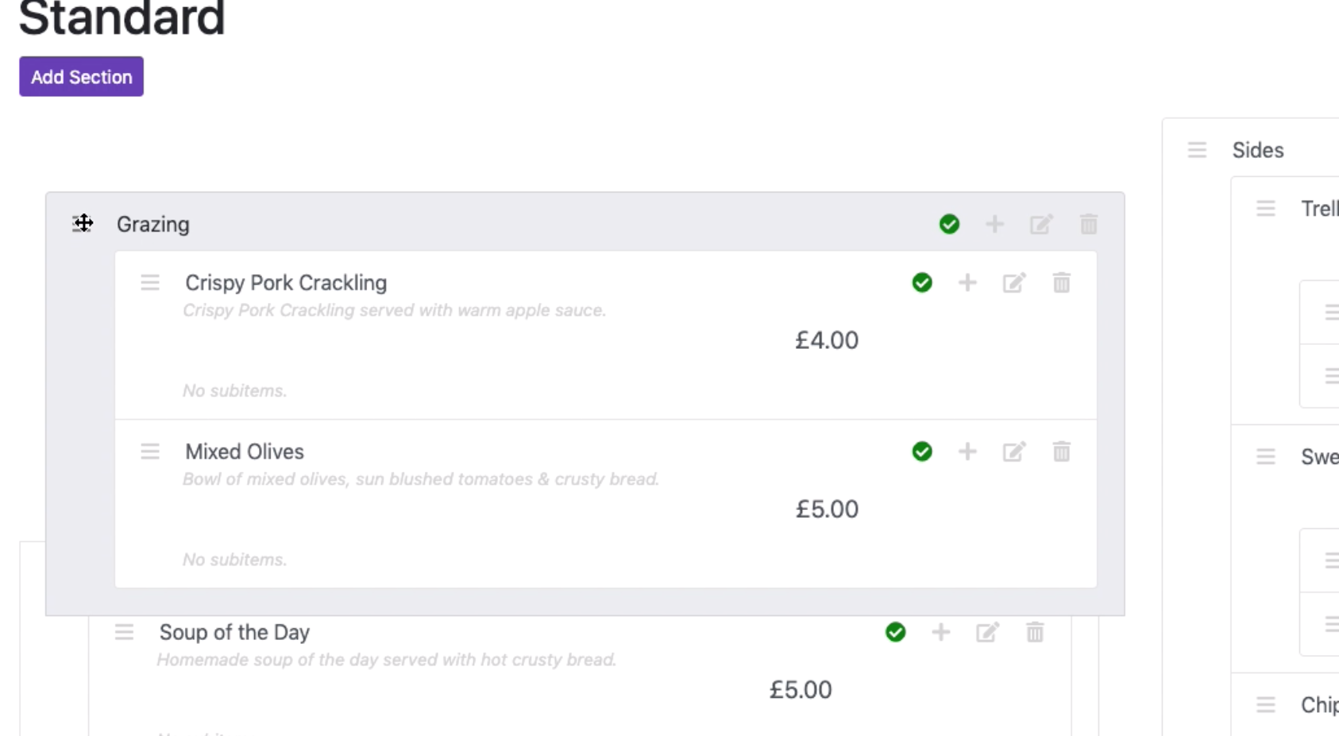

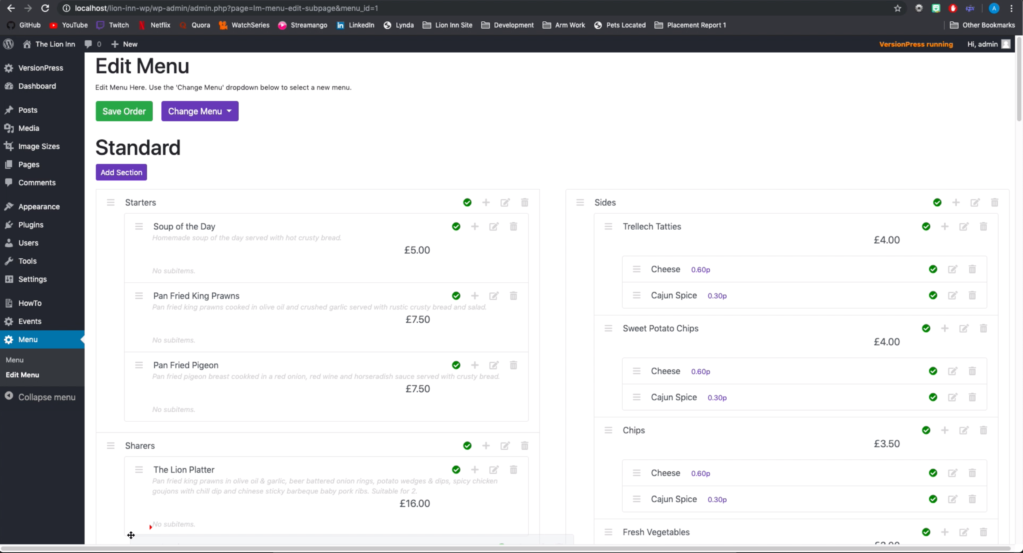

Then move your mouse to the bottom of the screen. The page should slowly start scrolling down. Similarly, moving your mouse to the top of the page will scroll up.