## Reordering Menu’s

To move a menu, click & hold on *this* icon:

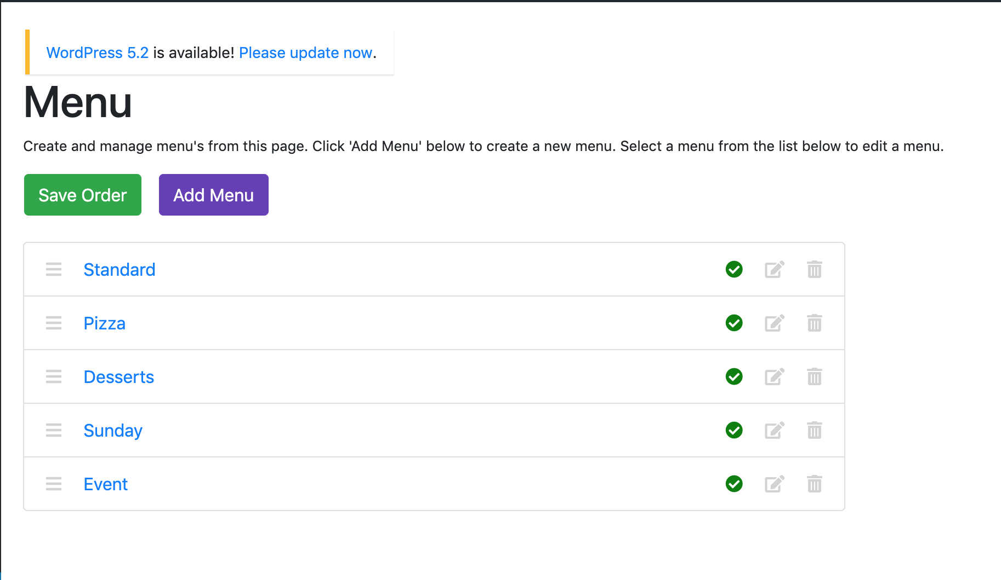

You will see that you almost ‘pick up’ the menu item (it should fade like below):

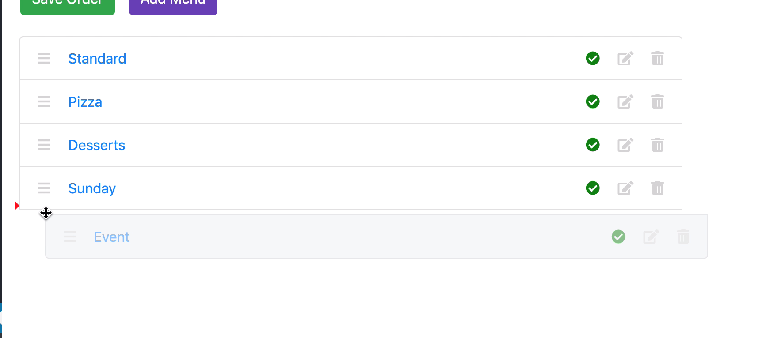

You will also notice the small red arrow. This shows where the menu will be moved to. Let’s move it above ‘Desserts’:

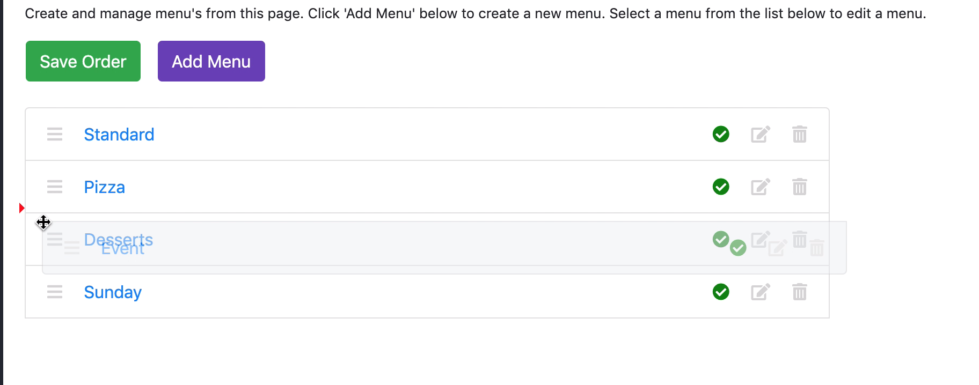

Move the mouse upwards until the red arrow is where you want to put the menu. Let go of the mouse to ‘drop’ the menu in the new place. It will then look like this:

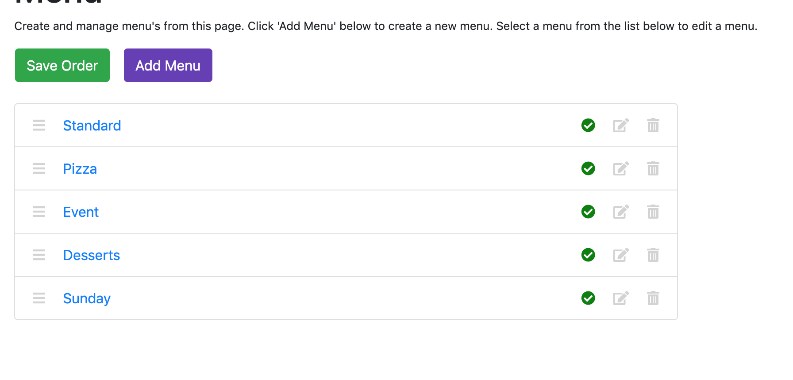

This isn’t finished yet. This won’t save the new order of the menus. If you refresh the page or look at the actual website, you will see that the order has not changed.

Click the green ‘Save Order’ button (**this is very important – remember to click ‘Save Order’**:



The menu has now been reordered:

