Norway Housing Pressure Tracker (1992–present)
  - Portfolio Case Study Report
Author: Babak Balouch
Date: 2025-12-29
GitHub repository: https://github.com/LordBalouch/norway-housing-pressure-pipeline
Tableau Public (interactive dashboards): https://public.tableau.com/app/profile/babak.balouch5382/viz/norway_housing_pressure_part4/D1ExecutiveOverview

1. Executive summary
I built a reproducible analytics pipeline that tracks Norwegian housing pressure from 1992 to the present. The pipeline integrates housing price dynamics (HPI) with inflation context (CPI) and monetary policy context (Norges Bank policy rate) at a quarterly grain. I validated the data with automated checks, then delivered both an analyst workflow (Excel) and stakeholder dashboards (Tableau on Mac).
Business question:
How have housing price growth and volatility evolved since 1992, and how do they relate to monetary policy context over time?
Primary deliverables:
- Reproducible pipeline from API download → tidy transforms → SQL mart → validation → deliverables.
- Excel workbook (checks, descriptive statistics, pivots, charts, and dashboard).
- Tableau dashboard pack (executive overview, growth regimes, volatility regimes, policy context) exported as PNG for review.
- Recruiter-friendly repository packaging (README, reproduce steps, deliverables index, sample data, and GitHub push).

2. Business context and project goal
Housing markets are sensitive to macro conditions such as inflation and interest rates. For analytical decision support, it is often more useful to track growth regimes (YoY and QoQ) and volatility regimes (stability of growth) than to only track index levels. The goal of this project was to build an end-to-end, reviewable analytics project demonstrating reproducibility, validation, and stakeholder-oriented communication.

3. Data sources
I used public APIs so the project can be reproduced without manual downloads.
Sources used:
- Statistics Norway (SSB) PxWeb API: housing price index (HPI) and consumer price index (CPI).
- Norges Bank open data API: policy rate series.
Reference links:
SSB PxWeb API: https://data.ssb.no/api/pxwebapi/
Norges Bank open data: https://data.norges-bank.no/

4. Solution design and workflow
I structured delivery into five parts to keep the project modular, verifiable, and readable for reviewers.

4.1 Part 1 — Ingestion (Python)
I implemented a downloader that fetches raw data from the official APIs and writes timestamped raw outputs plus run metadata. This created a reliable and auditable foundation for downstream transformations.

4.2 Part 2 — Cleaning and reshaping (Python)
I converted API-shaped outputs into tidy, analysis-ready tables, standardized time handling to quarterly grain, and wrote validation metadata and a data dictionary to make assumptions explicit.

4.3 Part 3 — SQL mart (DuckDB) and Excel deliverable
I added a job-realistic SQL layer by building a quarterly mart in DuckDB, computing KPIs with window functions, and validating the mart against upstream outputs. I then delivered an analyst-grade Excel workbook with checks, descriptive statistics, pivots, charts, and a dashboard.

4.4 Part 4 — Tableau dashboards (Mac)
Because Power BI Desktop is not natively available on macOS, I used Tableau on Mac to deliver BI dashboards. I built four dashboards aligned to the business question and exported them as PNG for repository review. A critical implementation detail was percent scaling: the mart’s percent fields are in percentage points, and Tableau required explicit conversion (division by 100) to display correctly as percentages.

4.5 Part 5 — Repository packaging and GitHub push
I packaged the repository to be reviewer-friendly: clear entry points (README and docs), explicit run order, deliverables index, sample data, repo hygiene via .gitignore, Tableau workbook portability fixes, and a clean GitHub push.

5. Data model and KPI definitions
The core dataset is a quarterly mart, one row per quarter (and housing category key where available). In the current extract there is one boligtype_code category, so time-based segmentation (decades) is used for regime analysis.
Key KPIs:
- HPI index level: baseline measure of nominal house price index.
- QoQ % change: quarter-over-quarter growth rate, computed using LAG over quarters.
- YoY % change: year-over-year growth rate, computed using LAG over four quarters.
- Volatility regime: standard deviation of QoQ changes, summarized by decade.
- Policy rate context: end-of-quarter (and average) policy rate measures aligned to quarters.
Caveat: CPI is handled as an annual value repeated quarterly in the current pipeline state; therefore any real-price measures are treated as proxies. CPI is missing for 2025Q1–2025Q3 in the current dataset, so proxy-real measures are null for those quarters.

6. Summary statistics
Table 1 summarizes the dataset profile and validation checks.
Item | Value
Rows (quarters) | 135
Distinct boligtype_code | 1
Start quarter | 1992Q1
End quarter | 2025Q3
Min quarter_start | 1992-01-01
Max quarter_start | 2025-07-01
Duplicate keys (boligtype_code|quarter) | 0
CPI missing quarters | 3

Table 2 provides descriptive statistics for key measures (percent fields are percentage points).
Metric | N | Mean | Std dev | Min | Max
HPI index | 135 | 75.11 | 41.05 | 17.80 | 154.40
HPI YoY (%) | 131 | 6.67 | 5.04 | -6.91 | 21.18
HPI QoQ (%) | 134 | 1.62 | 2.79 | -7.04 | 8.10
Policy rate end (%) | 135 | 4.72 | 2.66 | 1.00 | 11.00
Policy rate average (%) | 135 | 4.75 | 2.69 | 1.00 | 12.72

Table 3 summarizes decade-level growth and volatility regimes.
Decade | Quarters | QoQ mean (%) | QoQ std dev (%) | YoY mean (%) | YoY std dev (%) | Policy end mean (%)
1990s | 32 | 2.22 | 2.75 | 9.25 | 4.94 | 7.44
2000s | 40 | 1.75 | 3.08 | 7.56 | 6.35 | 5.83
2010s | 40 | 1.20 | 2.31 | 5.20 | 2.98 | 2.23
2020s | 23 | 1.29 | 3.08 | 4.55 | 3.79 | 3.36

Table 4 highlights the largest positive and negative HPI YoY changes (top and bottom five).
Rank | quarter | quarter_start | HPI YoY (%)
Bottom | 2009Q2 | 2009-04-01 | -1.53
Bottom | 2008Q3 | 2008-07-01 | -2.11
Bottom | 2009Q1 | 2009-01-01 | -5.20
Bottom | 1993Q1 | 1993-01-01 | -5.32
Bottom | 2008Q4 | 2008-10-01 | -6.91
Top | 2000Q1 | 2000-01-01 | 21.18
Top | 2000Q2 | 2000-04-01 | 19.60
Top | 1999Q4 | 1999-10-01 | 18.77
Top | 2006Q4 | 2006-10-01 | 16.61
Top | 2007Q1 | 2007-01-01 | 16.47

Table 5 highlights the largest positive and negative HPI QoQ changes (top and bottom five).
Rank | quarter | quarter_start | HPI QoQ (%)
Bottom | 2008Q3 | 2008-07-01 | -3.33
Bottom | 2023Q4 | 2023-10-01 | -3.47
Bottom | 1993Q1 | 1993-01-01 | -3.78
Bottom | 2022Q4 | 2022-10-01 | -3.98
Bottom | 2008Q4 | 2008-10-01 | -7.04
Top | 1999Q2 | 1999-04-01 | 8.10
Top | 2004Q1 | 2004-01-01 | 7.33
Top | 1997Q2 | 1997-04-01 | 7.17
Top | 2000Q2 | 2000-04-01 | 6.68
Top | 2006Q1 | 2006-01-01 | 6.32

Table 6 summarizes missingness for key fields.
Field | Missing (count) | Missing (%)
hpi_index | 0 | 0.00
hpi_yoy_pct | 4 | 2.96
hpi_qoq_pct | 1 | 0.74
policy_rate_end | 0 | 0.00
cpi_index | 3 | 2.22
real_hpi_proxy | 3 | 2.22

6.1 Latest-quarter headline (2025Q3)
Latest quarter: 2025Q3. HPI index: 153.2. HPI YoY: 5.00%. HPI QoQ: -0.78%. Policy rate (end): 5.00%.
Interpretation: YoY remains positive while QoQ is negative, which can indicate weakening short-term momentum even if annual growth is still elevated.

7. Dashboards and visualizations
The following figures are exported from Tableau (Part 4) and represent the stakeholder-facing narrative: trend, growth regimes, volatility regimes, and policy context.
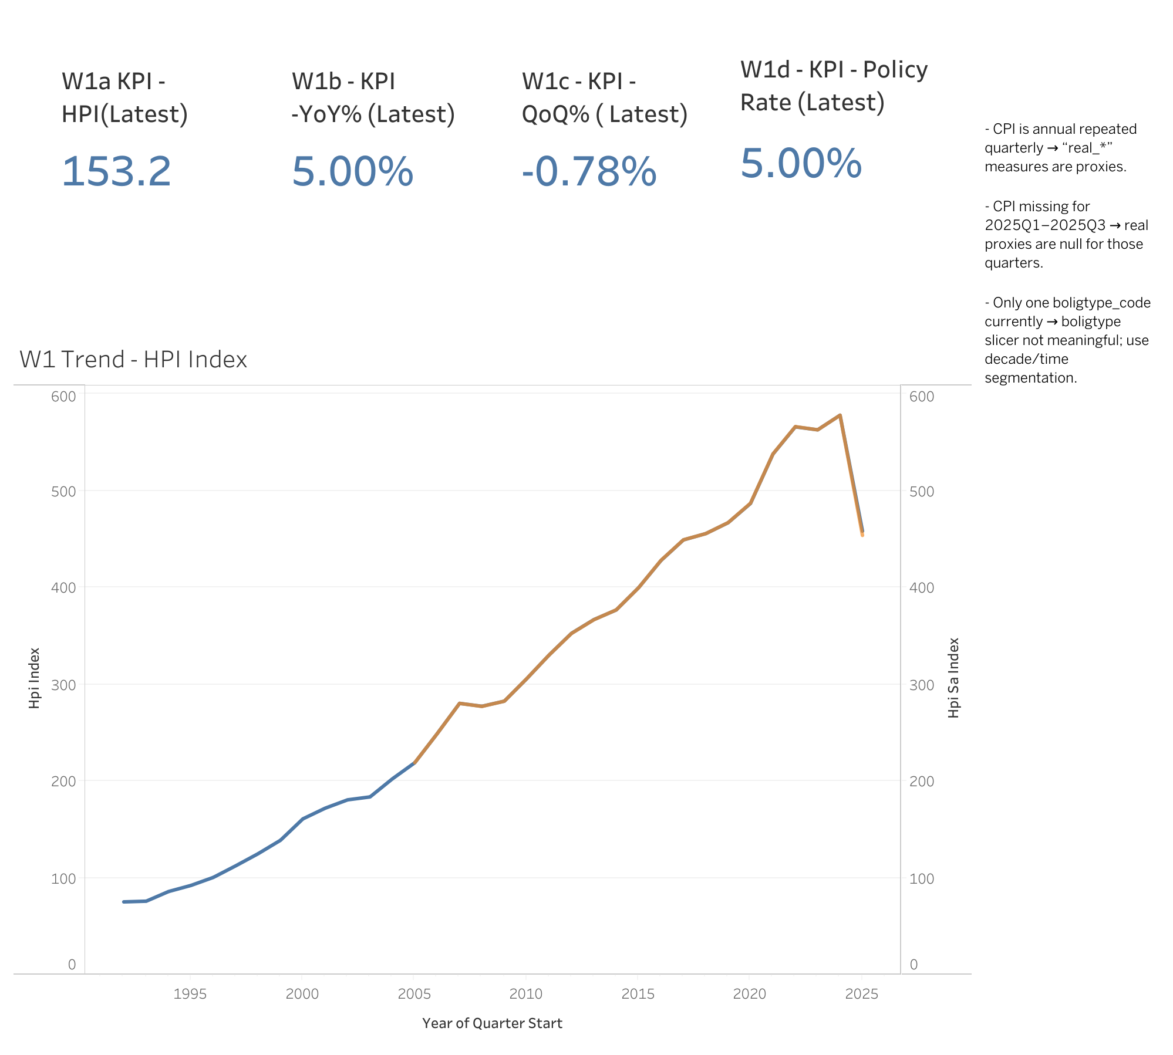
Figure 1. Executive overview (latest-quarter KPIs, HPI trend, and caveats).
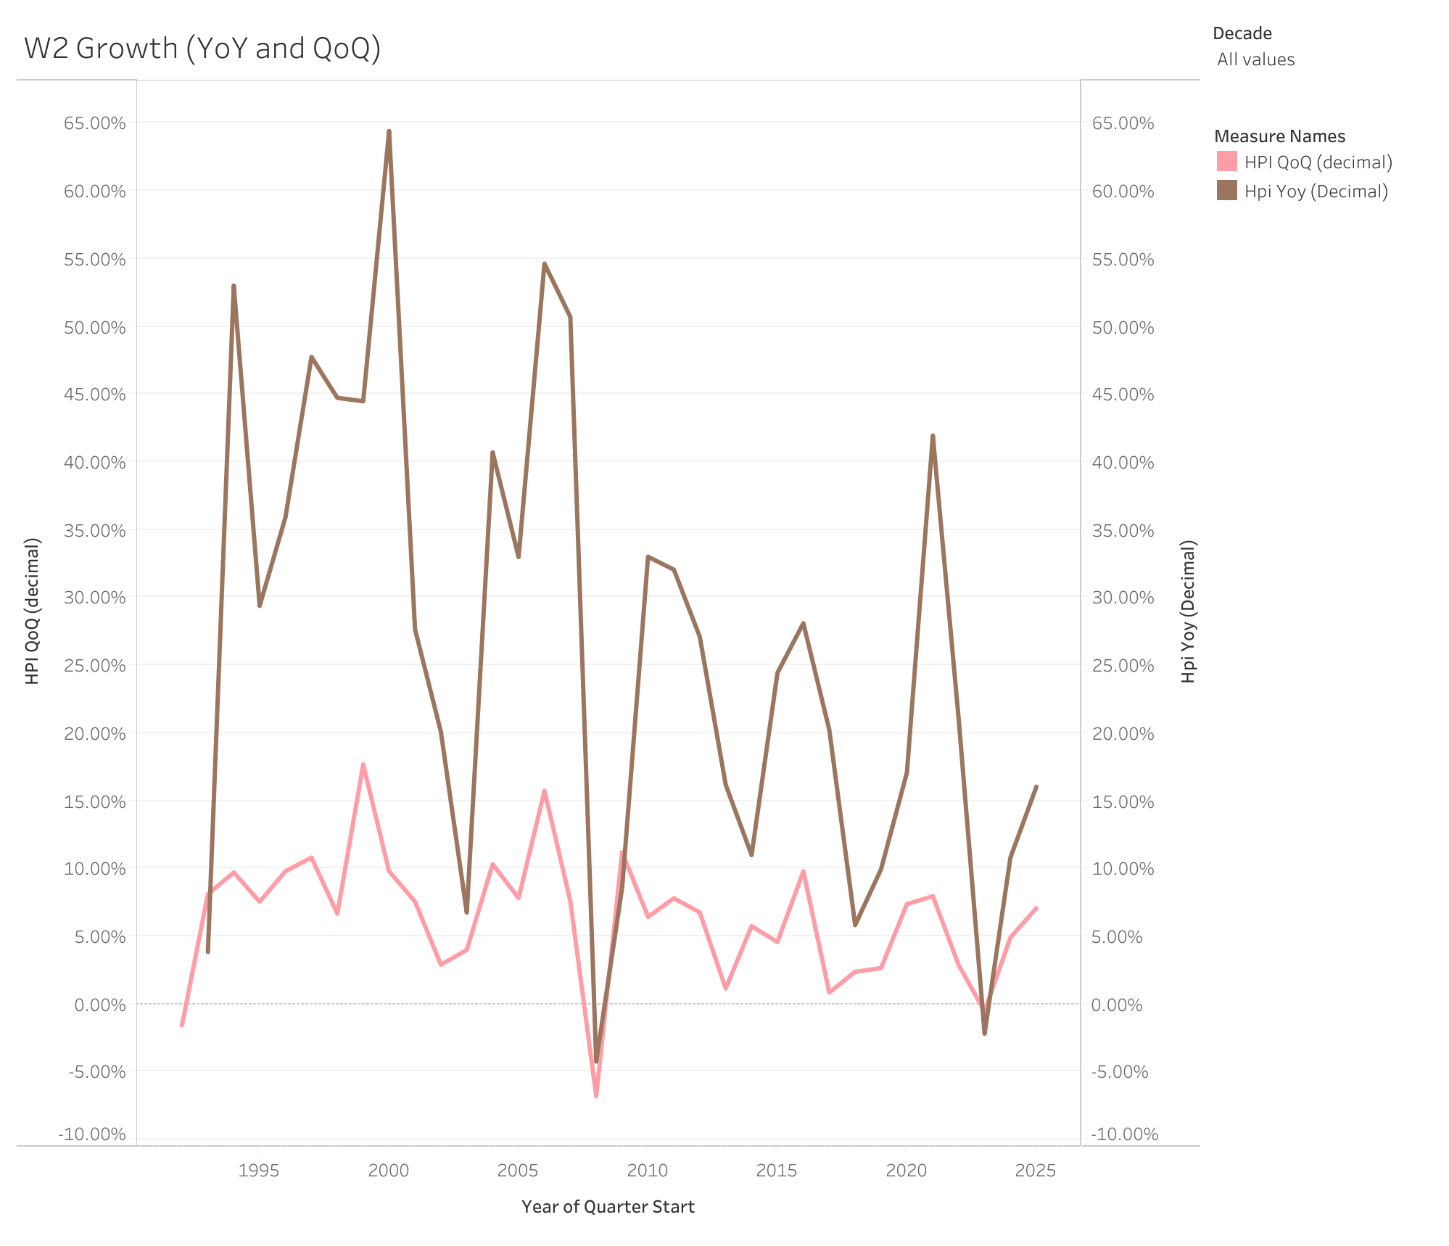
Figure 2. Growth regimes (YoY and QoQ) across the full history, with decade filtering and QoQ baseline.
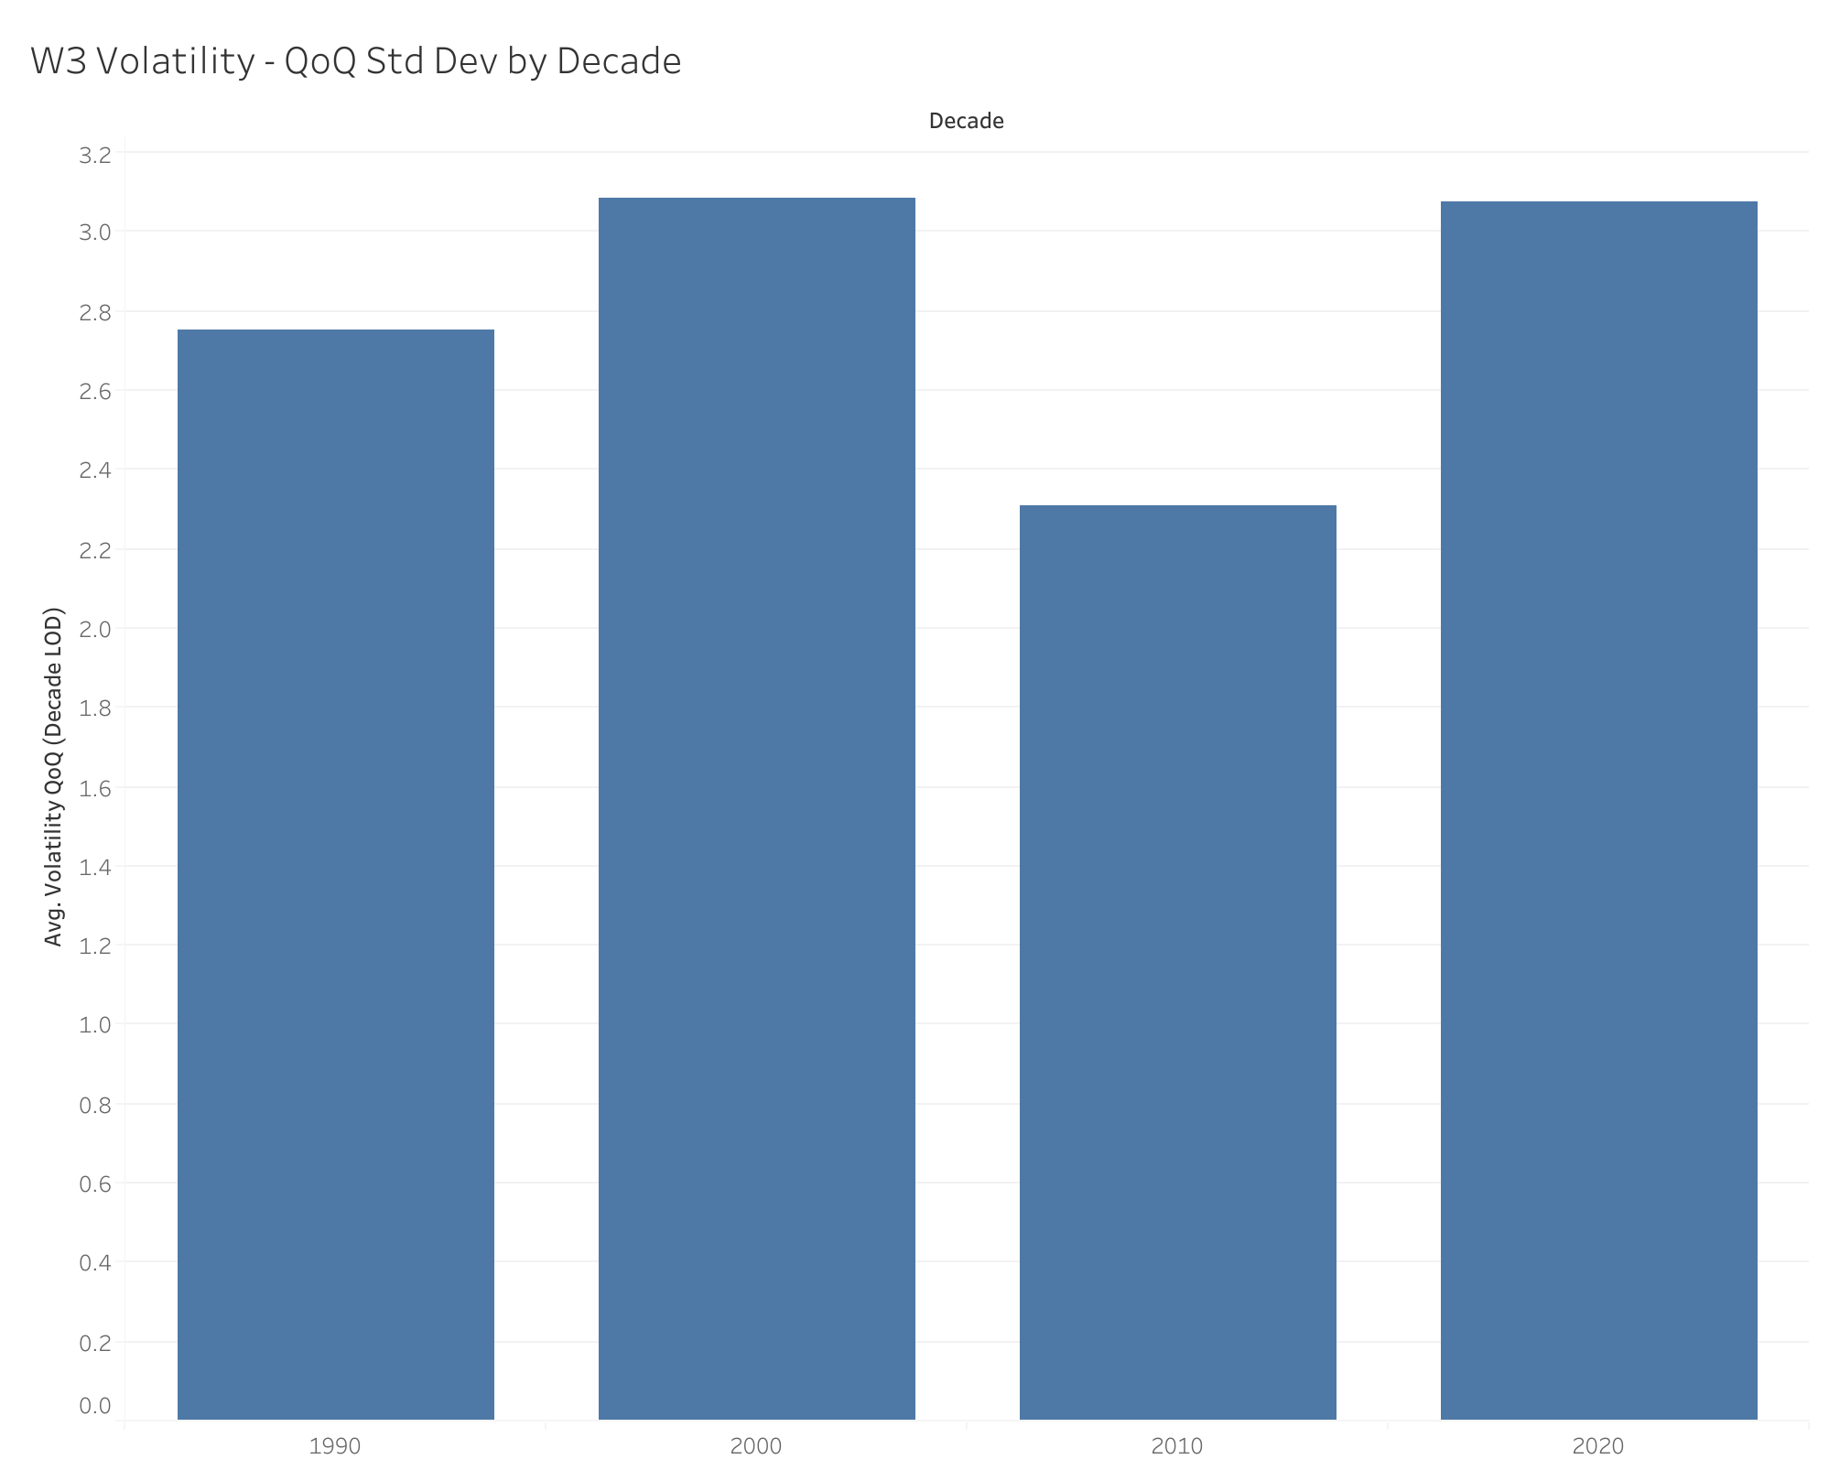
Figure 3. Volatility regimes: QoQ standard deviation summarized by decade.
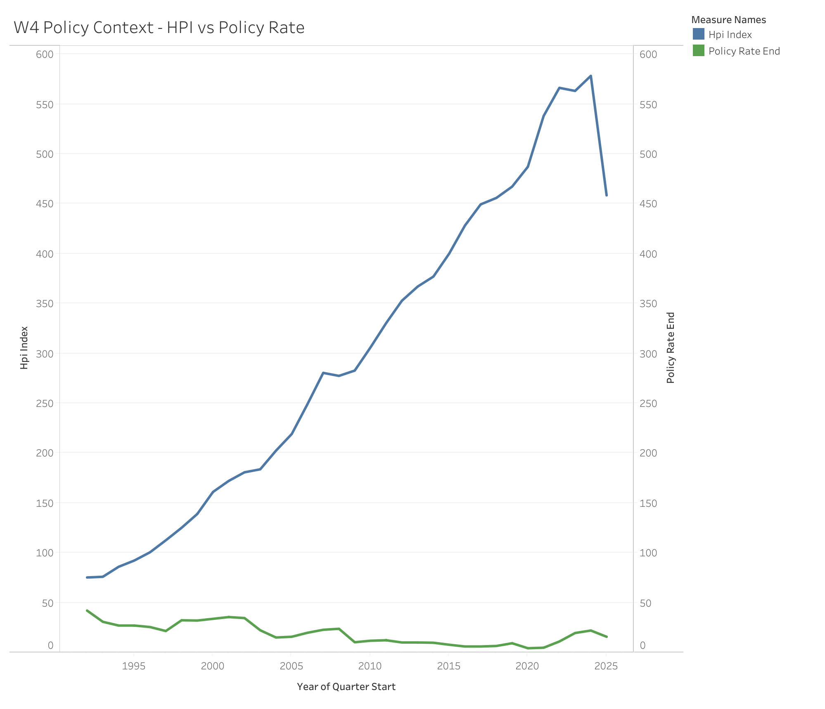
Figure 4. Policy context: HPI index overlaid with the policy rate (end of quarter).
The Excel workbook deliverable includes additional pivot tables, charts, and a dashboard (sheet: 06_Dashboard). It is referenced in the repository as part of the analyst workflow.

8. Challenges encountered and how I solved them
- API outputs were not analysis-ready (wide formats, encoded dimensions).
Resolution: I reshaped outputs into tidy tables, standardized time handling, and made the quarterly grain explicit before computing KPIs.
- Metadata and dimension ordering could lead to incorrect parsing.
Resolution: I used metadata-driven parsing logic and validated outputs with row counts, expected date ranges, and sanity checks.
- Web scraping for policy rate data was unreliable.
Resolution: I switched to official Norges Bank API endpoints to ensure stable, reproducible ingestion.
- Mac constraint: no native Power BI Desktop.
Resolution: I used Tableau on Mac to deliver the BI layer while keeping the same business narrative and reproducibility requirements.
- Percent scaling mismatch in Tableau (percentage points vs decimals).
Resolution: I created calculated fields dividing percent-point KPIs by 100, validated against the mart, and fixed chart reference lines and dimension settings.
- Repo hygiene and reviewer experience.
Resolution: I improved .gitignore rules, removed temporary files, added sample data, created clear docs (run order and deliverables index), and pushed a clean history to GitHub.

9. Use of documentation and AI assistance
I used official documentation and AI assistance to accelerate drafting and debugging. I retained ownership of the analytical design: data grain definitions, KPI definitions, join logic, validation strategy, and the final interpretation and communication of results. Where AI suggestions were used, I validated outputs through automated checks (duplicates, missingness, range checks, KPI reconciliation) and manual spot-checking in Excel and Tableau.

10. Reproducibility and how to run the project
From the repository root (with venv active), the run order is:
- python src/01_download_raw.py
- python src/02_transform_clean.py --run all --tag <TAG>
- python -u src/03_run_duckdb_sql.py --run-validation --run-eda
Raw and processed data directories are gitignored by design. A small sample mart file is included in the repository for schema preview.

11. Skills demonstrated
- API ingestion and reproducibility (Python).
- Data wrangling and transformation to a well-defined grain (quarterly).
- SQL modeling and KPI computation in DuckDB (window functions) with validation checks.
- Excel analytics workflow (checks, descriptive stats, pivots, charts, dashboard).
- Tableau dashboarding and stakeholder communication on macOS.
- Version control and reviewer-first repository packaging.

12. Limitations and next steps
- CPI is handled as an annual value repeated quarterly in the current pipeline state; real-price measures are proxies.
- CPI is missing for 2025Q1–2025Q3 in the current dataset; proxy-real measures are null in those quarters.
- The current extract includes one boligtype_code category, so segmentation is time-based (decades).
- A PowerPoint executive deck is intentionally deferred; it can be added later as presentation practice.

13. References
GitHub repository: https://github.com/LordBalouch/norway-housing-pressure-pipeline
Tableau Public dashboards: https://public.tableau.com/app/profile/babak.balouch5382/viz/norway_housing_pressure_part4/D1ExecutiveOverview
SSB PxWeb API: https://data.ssb.no/api/pxwebapi/
Norges Bank open data: https://data.norges-bank.no/

