Assignment on Wavelet Analysis of Given Image

Abol Basher

ID: 8172615

Department of Telecommunication System

Niek Molenkamp

National Research University of Electronic Technology

**Image processing using Wavelet Function**

I have loaded the image from MATLAB workspace to WaveletAnalyzer.

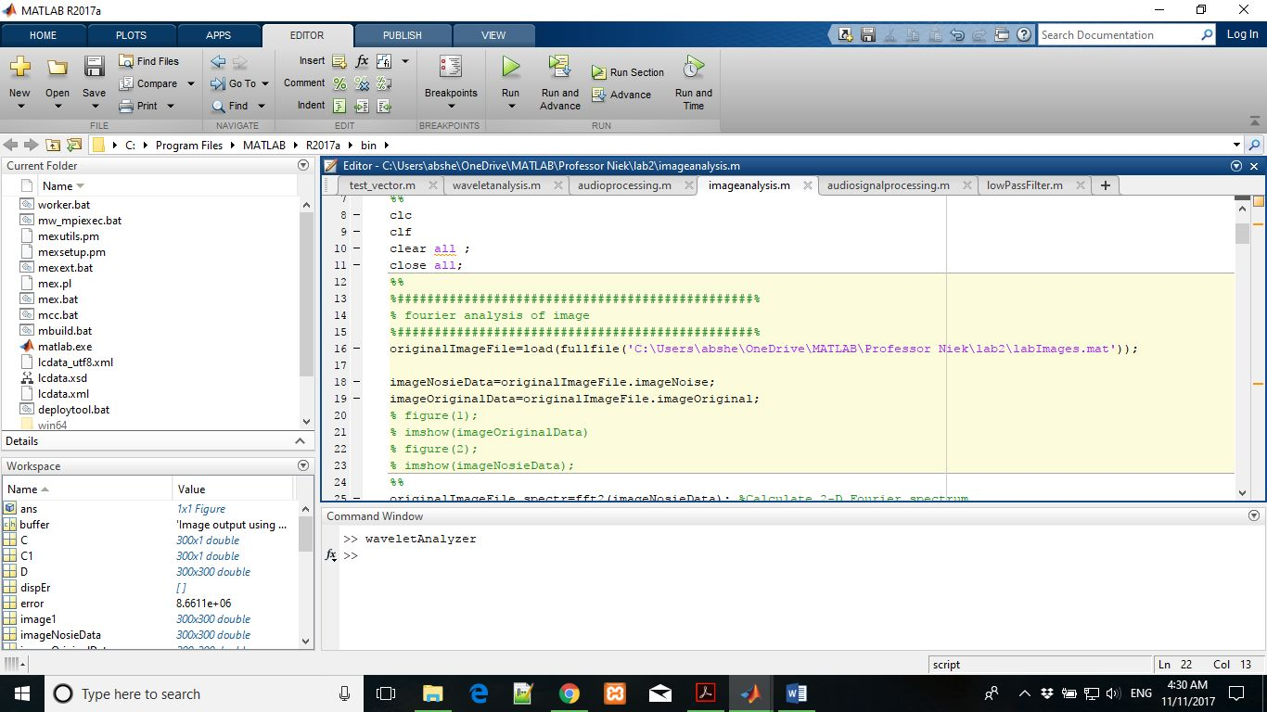

waveletAnalyzer (wavemenu is the old commend that will be removed from next version of MATLAB but in this current version it is still working ('9.2.0.538062 (R2017a)')).

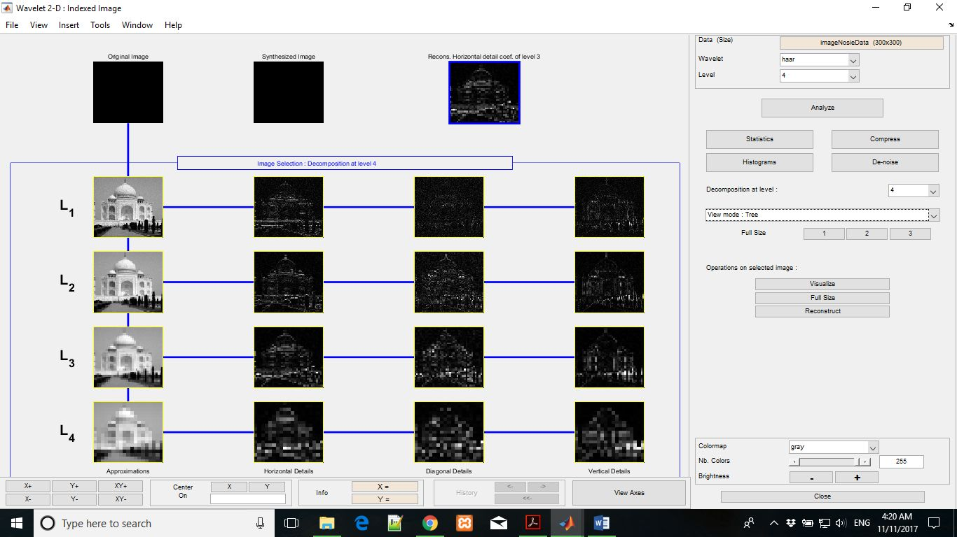

From the waveletAnalyzer window I have loaded the image from the current workspace as I have already loaded the image in MATLAB workspace.

From WaveletAnalyzer window I have selected the Wavelet 2-D from the 2 Dimensional wavelet menu. Then I have used the haar wavelet to synthesis, denoise and reconstruct the image. Image has been decomposed by 4-level Haar Wavelet and got the above effects that are explained in the above image.

After soft de-noising I have got the following effects and the residual

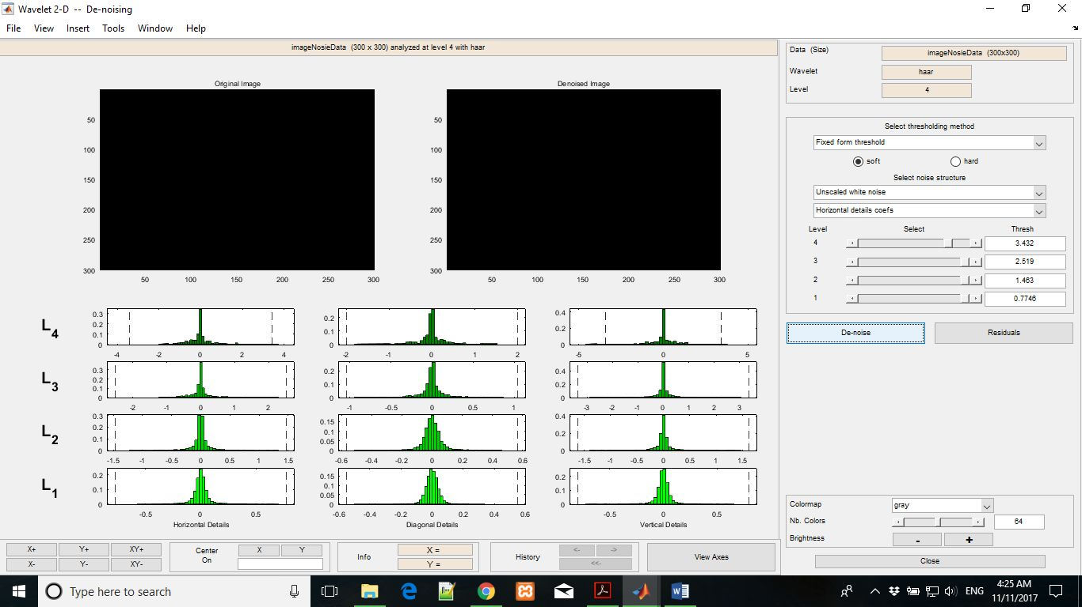

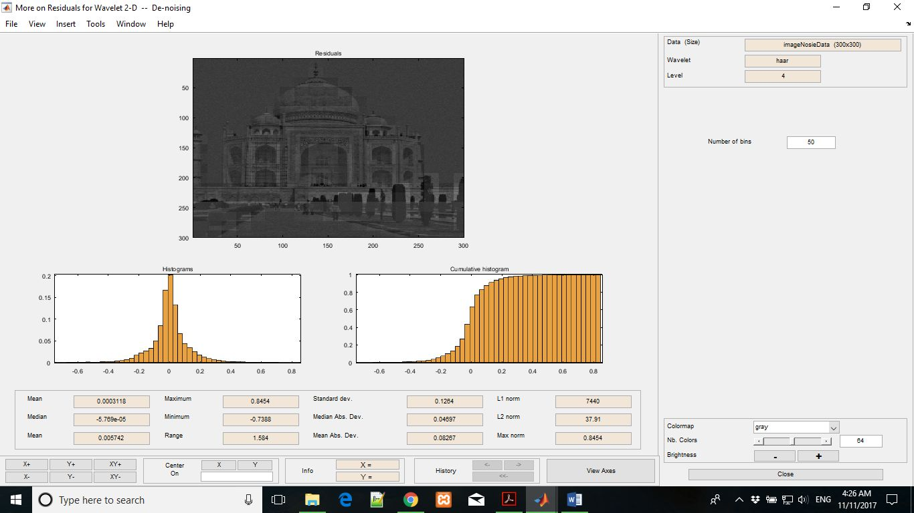

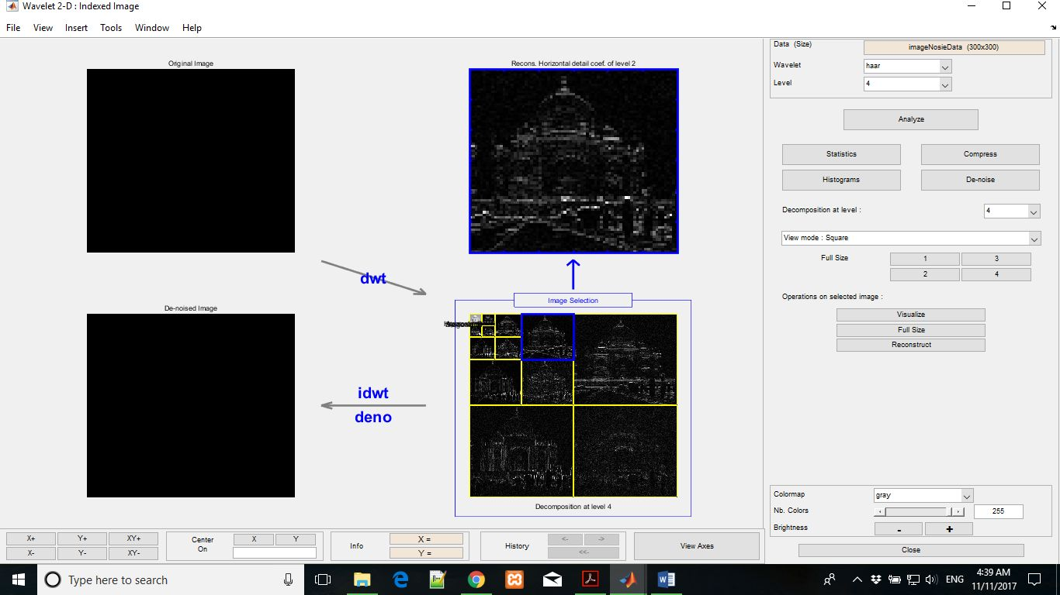

After hard de-noising I have got the following effects and the residual

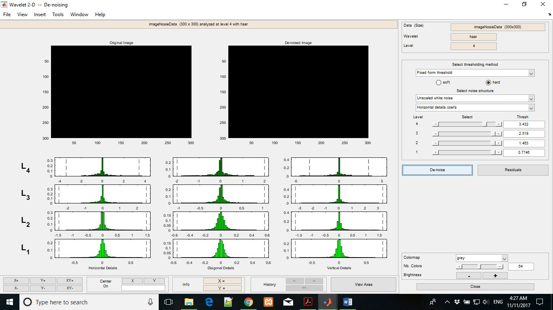

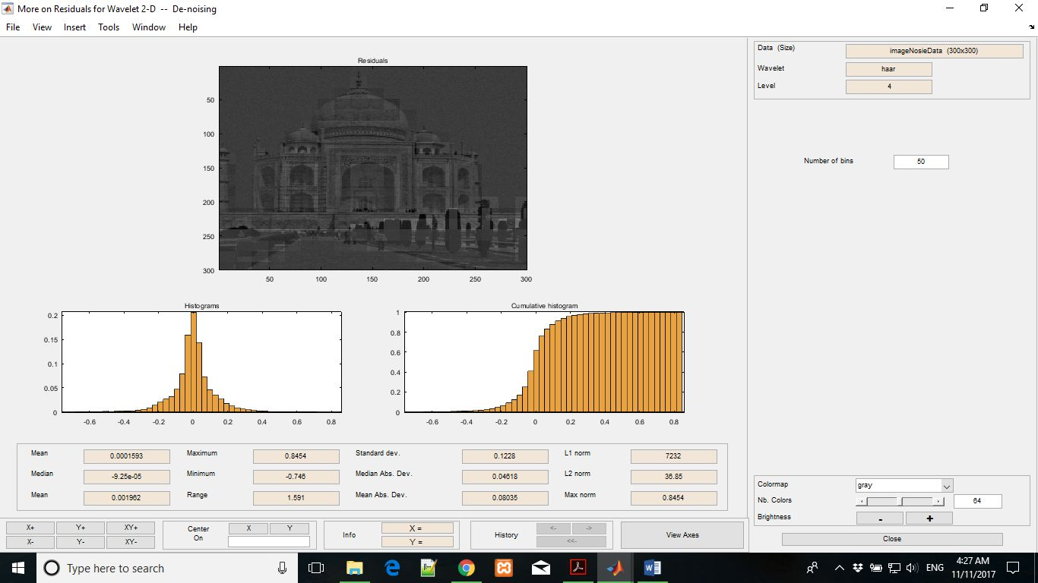

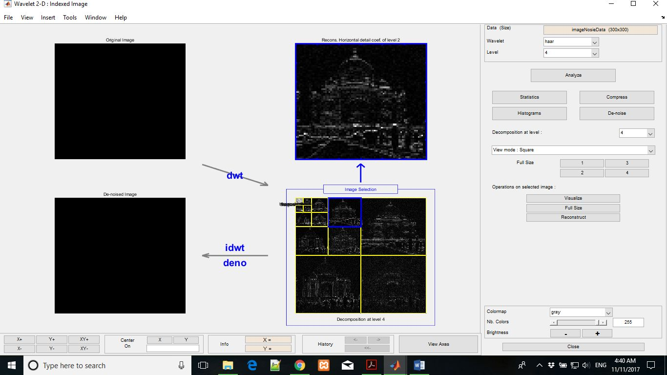

Reconstructed Image

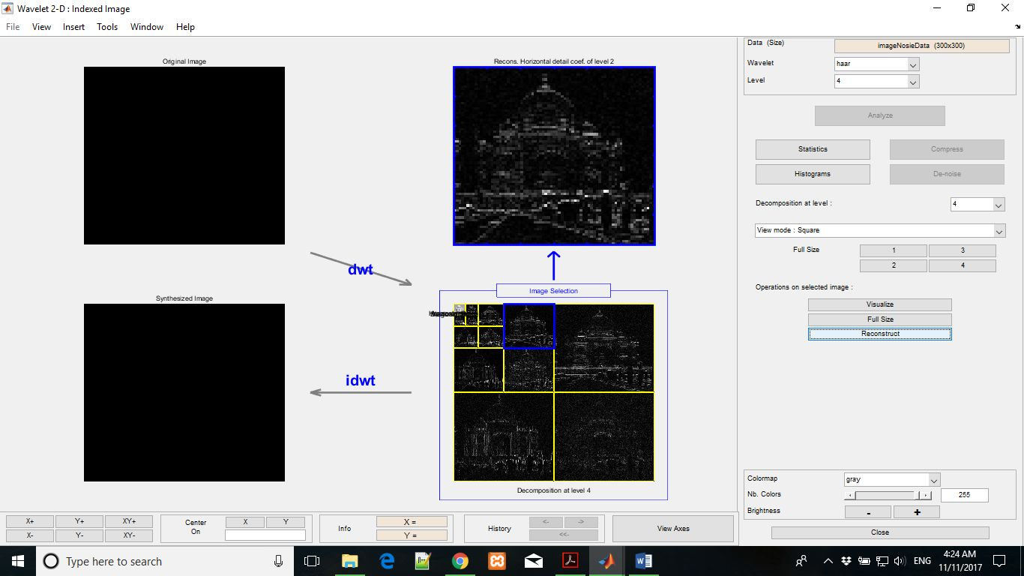

I have chosen Haar wavelet because it is the simplest and basic wavelet family. I have chosen level 4 Haar.