Screenshots

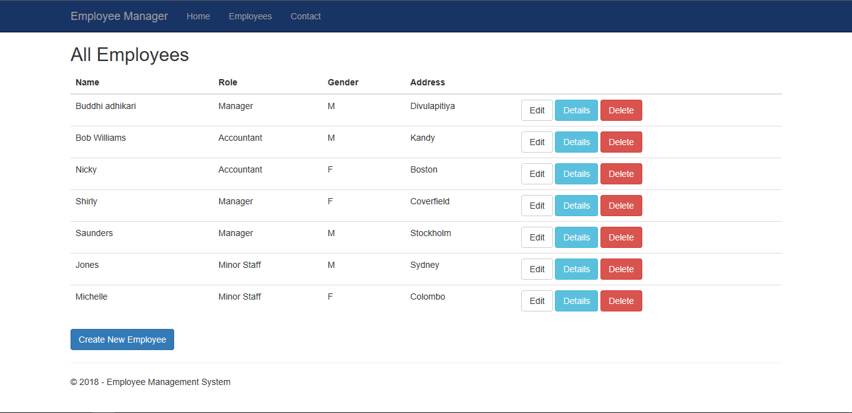

Figure 1: Display All Employees

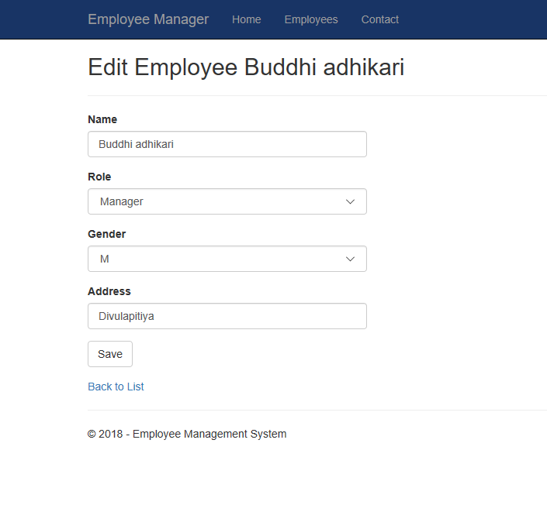

Figure 2: Edit Employee

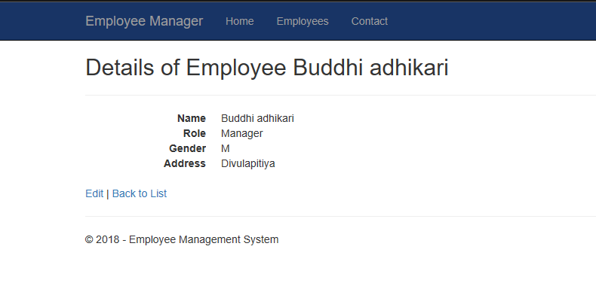

Figure 3: Individual Employee Details

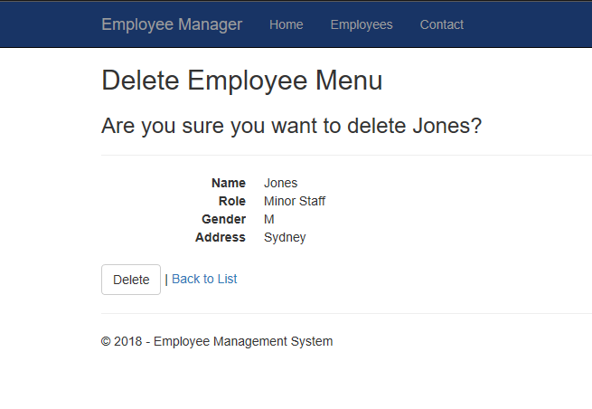

Figure 4: Delete Employee

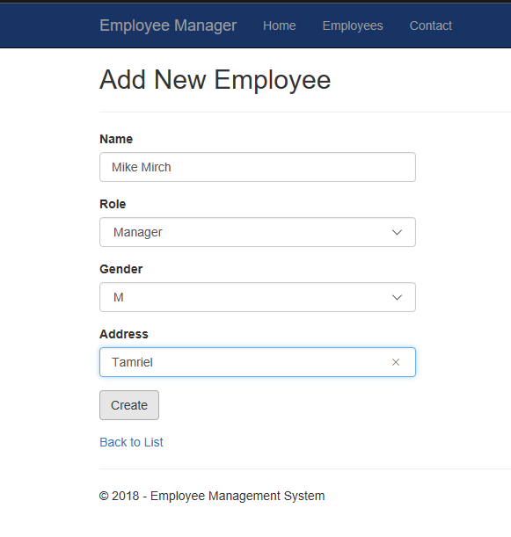

Figure 5: Create New Employee

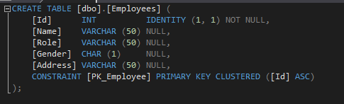

Figure 6: Employees Table Creation

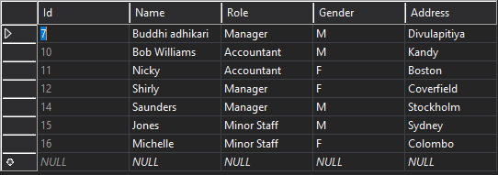

Figure 7: Employees Table Data

References

<https://mva.microsoft.com/en-US/training-courses/asp-net-core-beginner-18153?l=VM5gy36dE_6611787171>

<https://docs.microsoft.com/en-us/aspnet/core/tutorials/first-mvc-app/start-mvc?view=aspnetcore-2.1&tabs=aspnetcore2x>

<https://msdn.microsoft.com/en-us/library/ms239722.aspx>

<https://docs.microsoft.com/en-us/aspnet/core/data/ef-mvc/complex-data-model?view=aspnetcore-2.1>

<https://docs.microsoft.com/en-us/ef/core/get-started/aspnetcore/new-db>

<https://www.c-sharpcorner.com/UploadFile/abhikumarvatsa/various-ways-to-pass-data-from-controller-to-view-in-mvc/>