Processing aaaaaaah:

**Shapes:**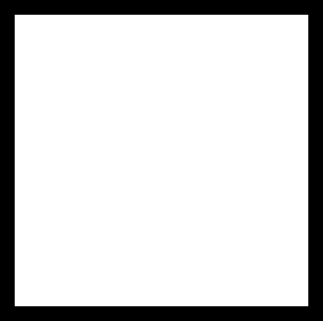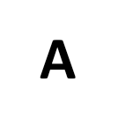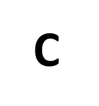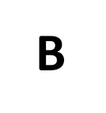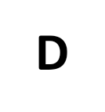

Point(x-as, y-as)

Line(x start, y start, x end, y end)

Circle(x Middle, y Middle, Width of circle)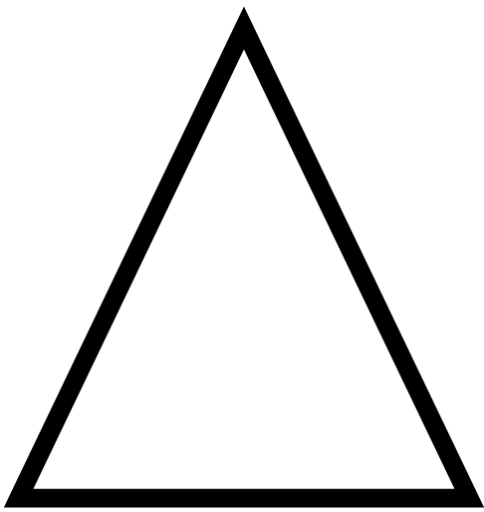

Ellipse(x Middle, y Middle, Width of Ellipse, Height of Ellipse)

Quad(x A, y A, x B, y B, x C, y C, x D, y D)

Rect(x Upper Left, y Upper Left, Width, Height)

Rect(x Upper Left, y Upper Left, Width, Height, Radiuses for all 4 corners)

Rect(x Upper Left, y Upper Left, Width, Height, Radius Top Left, Radius Top Right, Radius Bottom Left, Radius Bottom Right)

Triangle(x A, y A, x B, y B, x C, y C)

Arc(x Middle, y Middle, Width, Height, Angle to start arc, Angle to stop Arc)

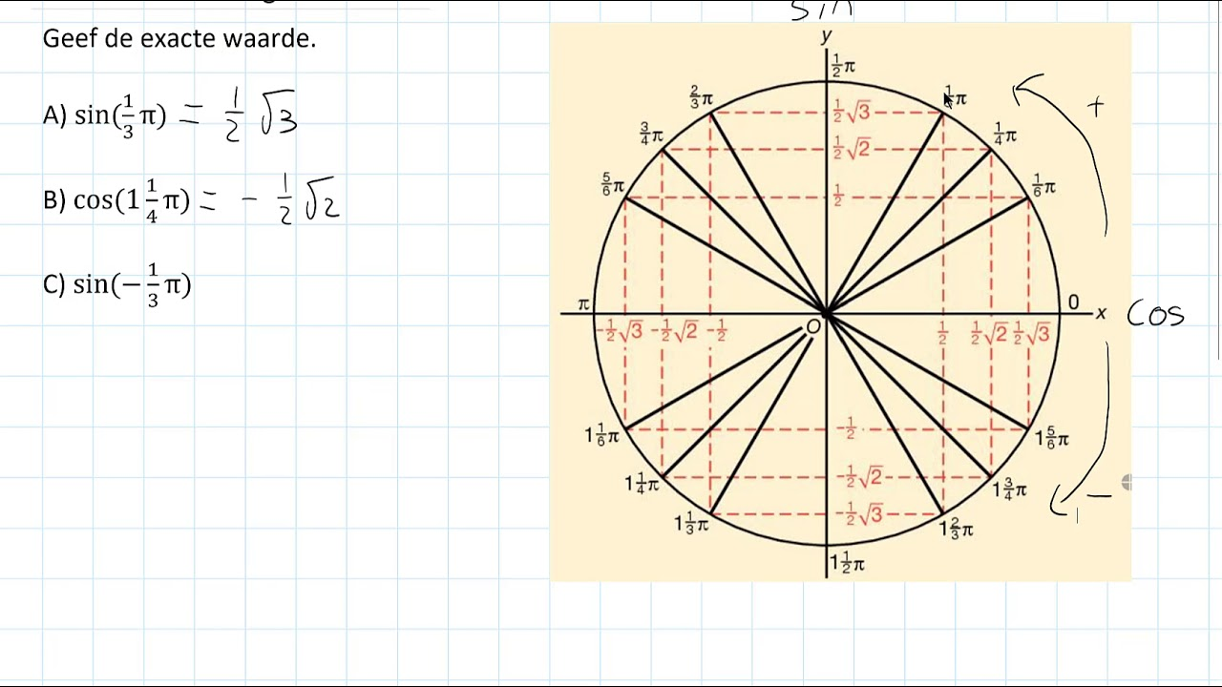

**Colours:**

Background(Greyscale)  
Background(R, G, B)  
Background(R, G, B, Opacity)

Stroke(Grayscale)  
Stroke(R, G, B)

Fill(Greyscale)  
Fill(R, G, B)  
Fill(R, G, B, Opacity)

ColorMode(HSB)

noFill()

noStroke()

Setup:

Size(x screen, y screen)

MouseX and MouseY can be used in place of coordinates

Rotate(Angle in Radians) can be placed before shape to rotate it

random(High end)  
random(Low end, High end)

def setup():

(Indented) global a

(Indented) a = startpoint

a = 0

def draw():

r = random(High end)

(Indented) global a

(Indented) point(a, 10)