School of Computer Science Engineering and Information Systems
BCSE302L – Database Systems | Course Project
EMPLOYEE PAYROLL MANAGEMENT SYSTEM
Review III – Integrated System & Final Demonstration
Submitted by
Krishiv Rajkumar – 24BDE0132
Asher Mathew – 24BDE0128
Sai Praneeth – 24BYB0143
Under the guidance of
Dr Rubimalaya R
October 2026

Contents
Contents 2
1. Project Title and Team Details 4
2. Introduction and Problem Statement 5
2.1 Introduction 5
2.2 Problem Statement 5
2.3 Objectives 5
2.4 Users and Roles 5
3. Functional Requirements 7
4. ER Diagram 8
5. Relational Schema 9
5.1 Relational Schema (text notation) 10
6. Table Creation and Constraints 11
6.1 Constraint Summary 11
6.2 Data Population 11
6.3 DML Demonstration 12
7. SQL Queries and Outputs 13
Q4. Department-wise salary cost for the latest payroll month 13
Q5. Top 5 earners by net salary in the latest month (with rank) 14
Q8. Remaining 2026 leave balance of every active employee 14
Q14. Departments whose average net salary is above the company average (latest month) 15
8. Procedures, Functions, Cursor and Triggers 16
8.1 Overview 16
8.2 Procedure with Cursor – generate_monthly_payroll 16
8.3 Trigger – trg_leave_approved 18
8.4 Calling Procedures from the Application 18
9. Real-World Transaction Demonstrations 20
9.1 Application and Database Connectivity 20
9.2 Integrated Workflow – One Monthly Payroll Cycle 20
9.3 Transactions 21
T1. Employee checks in 21
T2. Employee applies for leave 22
T3. Manager approves leave 22
T4. Payroll officer generates the monthly payroll 23
T5. Viewing an itemised payslip 23
T6. Paying the month’s salaries 24
T7. Attempt to delete a paid payslip 24
T8. Employee resignation 25
T9. Running the report queries from the application 25
9.4 Reports Generated from the Database 26
9.5 Validation – Invalid Operations Rejected by the Database 27
10. Conclusion 28
10.1 Design Decisions and Justification 28
10.2 Conclusion and Future Work 28

(If page numbers are missing, right-click the table and choose “Update Field”.)

1. Project Title and Team Details
Item | Details
Project title | Employee Payroll Management System
Course | BCSE302L – Database Systems (Lab course project)
Team | Krishiv Rajkumar (24BDE0132), Asher Mathew (24BDE0128), Sai Praneeth (24BYB0143)
Guide | Dr Rubimalaya R
Database | PostgreSQL 17 hosted on Supabase (cloud); PL/pgSQL for procedures, functions, cursors and triggers
Application | React + Vite web application connected to the database through the supabase-js client
Source code | github.com/LordFlyaway/DBS_proj
Sample company | All Caps Pvt. Ltd. – a fictional company whose 20 employees are named after musicians and athletes

2. Introduction and Problem Statement

2.1 Introduction
Every organisation has to pay its employees correctly and on time. A salary is not one fixed number: it depends on the designation and basic pay, allowances such as HRA and DA, deductions such as Provident Fund, Professional Tax and TDS, the days actually worked, and approved or unapproved leave. When this is managed in spreadsheets, calculations go wrong, records are duplicated, nothing stops invalid entries and there is no audit trail.
The Employee Payroll Management System stores organisation, employee, attendance, leave and salary-structure data in a relational database and generates monthly payroll and payslips from that data with stored procedures. Business rules are enforced inside the database through constraints, triggers and Row Level Security, and a role-based web application lets HR, payroll staff, managers and employees work with the data.

2.2 Problem Statement
Design and implement a centralised, consistent and secure database that (a) maintains employee and organisational data, (b) records daily attendance and leave, (c) defines salary components (allowances and deductions), and (d) computes each employee’s monthly gross and net salary, including loss-of-pay for unpaid absence, while enforcing business rules with database constraints and triggers instead of manual checks.

2.3 Objectives
- A single source of truth for employees, departments and designations.
- Attendance and leave recording, with loss-of-pay calculated automatically.
- Configurable salary components – fixed amounts or a percentage of basic pay.
- One-step monthly payroll generation with itemised payslips, followed by salary payment.
- Integrity through PK/FK, NOT NULL, UNIQUE, CHECK and DEFAULT constraints, triggers and Row Level Security.
- Interactive access through a web application connected to the database.

2.4 Users and Roles
Role (demo login) | What the role can do
Admin – Daniel Dumile (HR Manager) | Manage employees, departments, designations and attendance; approve any leave; run payroll; run the SQL query catalogue.
Payroll – Jeffery Williams (Payroll Officer) | Maintain salary components; generate, pay and (if unpaid) delete payroll; run the SQL query catalogue.
Manager – Aubrey Graham (Engineering Manager) | See their team; approve or reject the team’s leave; follow team attendance.
Employee – LeBron James (Sr. Software Engineer) | Check in and out; apply for and cancel leave; view own attendance and payslips.
Every role also sees its own dashboard, leave balance and payslips. Logins are e-mail/password accounts in Supabase Auth, linked to EMPLOYEE rows through employee.auth_user_id and authorised through employee.app_role.

3. Functional Requirements
ID | Requirement | Implemented by
FR1 | Add, update and delete departments, including the department head. | DEPARTMENT; Departments page
FR2 | Maintain designations with pay grade, basic salary and annual leave quota. | DESIGNATION; Designations page
FR3 | Register employees with personal, PAN and bank details, department, designation, manager and login role. | EMPLOYEE; CHECK/UNIQUE constraints; trg_validate_manager
FR4 | Record attendance – one row per employee per day; employees check themselves in and out. | ATTENDANCE; UNIQUE (emp_id, att_date); RLS policy
FR5 | Employees apply for leave; managers approve or reject; approved leave appears in attendance. | LEAVE_REQUEST; process_leave; trg_leave_approved
FR6 | Define allowances and deductions as fixed amounts or a percentage of basic. | SALARY_COMPONENT; fn_component_amount
FR7 | Generate the month’s payroll for all active employees with LOP, gross and net salary. | generate_monthly_payroll (cursor); fn_working_days; fn_lop_days
FR8 | Keep an itemised payslip (amount of every component). | PAYROLL_DETAIL (M:N bridge)
FR9 | Pay salaries: mark payroll Paid with date, mode and transaction reference. | pay_monthly_payroll (cursor FOR UPDATE)
FR10 | Prevent invalid operations – duplicate payroll, editing paid payroll, self-approval, exceeding leave balance. | Constraints, procedures and triggers
FR11 | Handle employee exits – reassign their team, clear department headship, reject pending leave. | trg_employee_exit
FR12 | Management reports: department cost, attendance summary, leave balance, top earners and others. | 19 SQL queries saved as views
FR13 | Role-based web application connected to the database. | React app + supabase-js + Row Level Security

4. ER Diagram
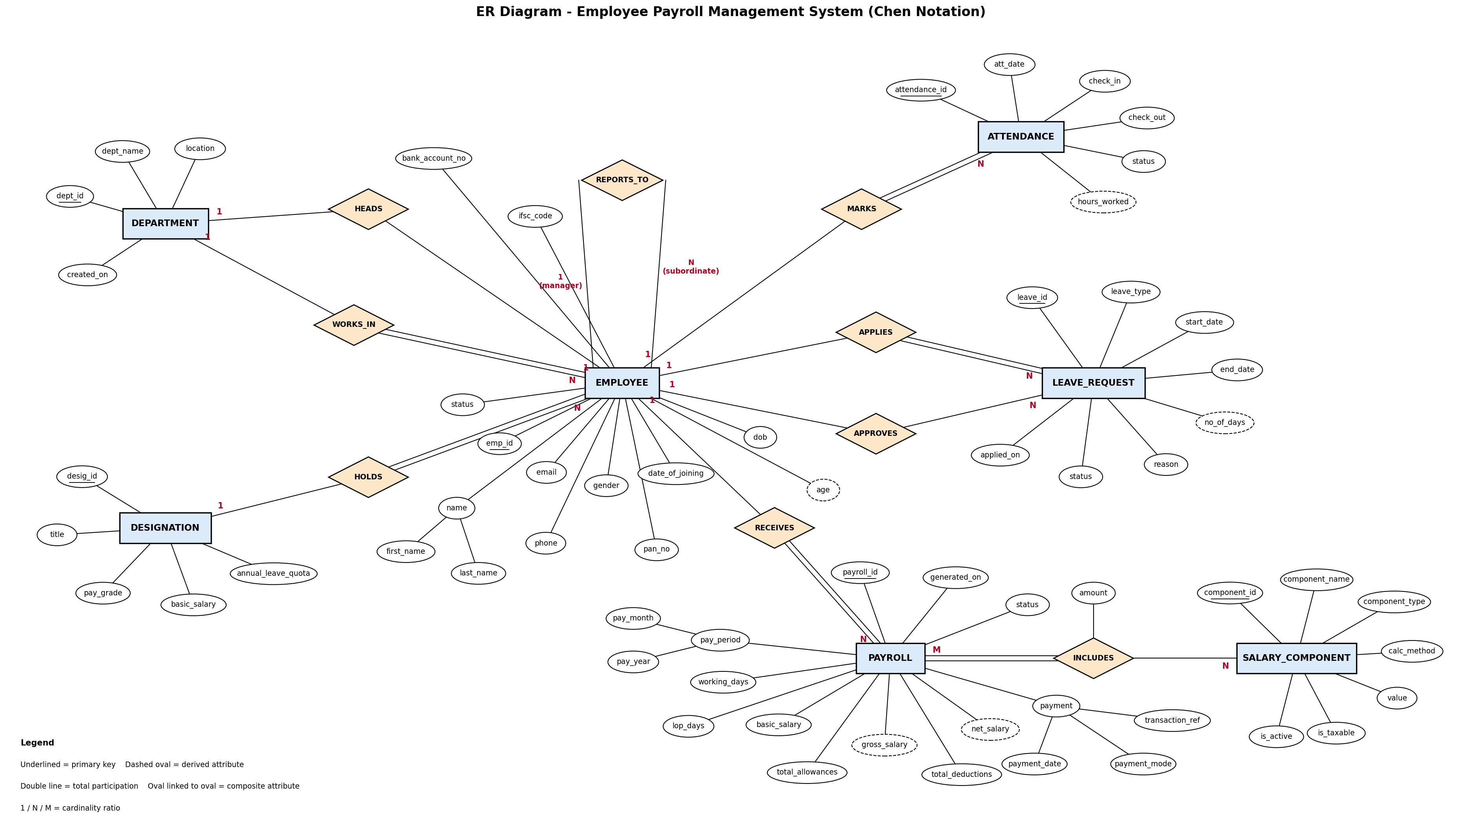
Figure 1 – ER diagram (Chen notation): 7 entities and 9 relationships, including the recursive REPORTS_TO, the 1:1 HEADS and the M:N INCLUDES relationship.

5. Relational Schema
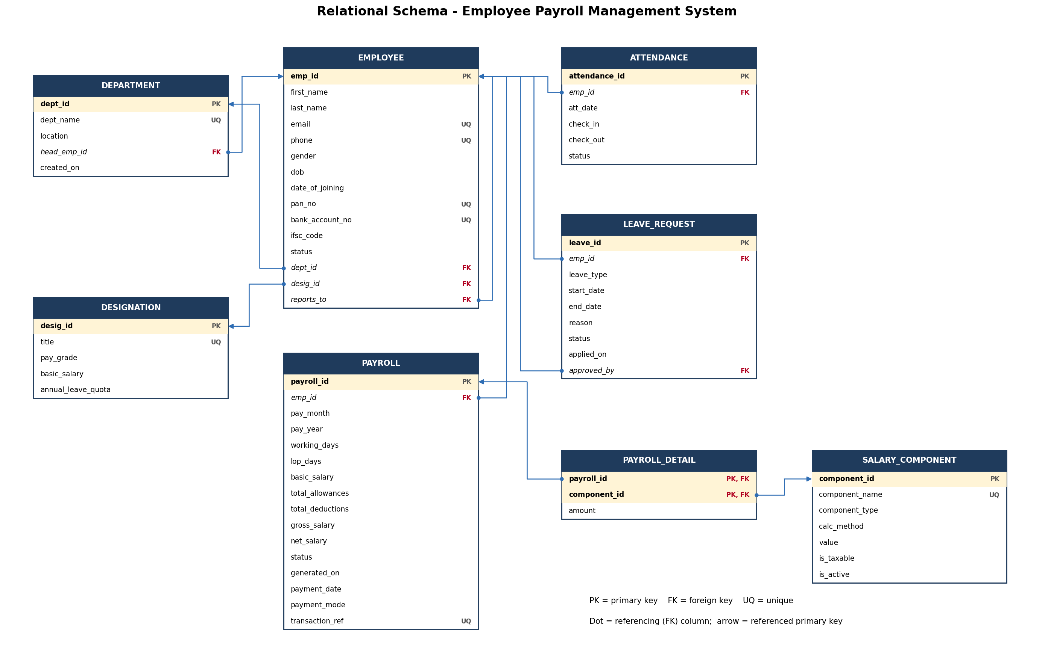
Figure 2 – Relational schema: 8 tables with primary and foreign keys.

5.1 Relational Schema (text notation)
Primary keys are bold and underlined; foreign keys are italic.
DEPARTMENT (dept_id, dept_name, location, head_emp_id, created_on)
DESIGNATION (desig_id, title, pay_grade, basic_salary, annual_leave_quota)
EMPLOYEE (emp_id, first_name, last_name, email, phone, gender, dob, date_of_joining, pan_no, bank_account_no, ifsc_code, status, dept_id, desig_id, reports_to, app_role, auth_user_id)
ATTENDANCE (attendance_id, emp_id, att_date, check_in, check_out, status)
LEAVE_REQUEST (leave_id, emp_id, leave_type, start_date, end_date, reason, status, applied_on, approved_by)
SALARY_COMPONENT (component_id, component_name, component_type, calc_method, value, is_taxable, is_active)
PAYROLL (payroll_id, emp_id, pay_month, pay_year, working_days, lop_days, basic_salary, total_allowances, total_deductions, gross_salary, net_salary, status, generated_on, payment_date, payment_mode, transaction_ref)
PAYROLL_DETAIL (payroll_id, component_id, amount)
Change since Review I: two columns were added to EMPLOYEE for the web application – app_role (Admin, Payroll, Manager or Employee) and auth_user_id (the employee’s Supabase login, UNIQUE). Keeping them in EMPLOYEE keeps the design at 8 tables.
All tables are in Third Normal Form: department and designation details are stored once and referenced by key, salary rules are separate from payslip line items, and the only non-key attribute of the composite-key table PAYROLL_DETAIL (amount) depends on the whole key. Age, hours worked and leave days are derived in queries and are not stored; gross and net salary are stored on purpose as a monthly snapshot so that old payslips do not change when salary rules change.

6. Table Creation and Constraints
The database is created by sql/01_schema.sql. Each table and the business rule behind each constraint is summarised below, followed by the complete DDL.

6.1 Constraint Summary
Table | Keys | NOT NULL / UNIQUE / CHECK / DEFAULT
DEPARTMENT | PK dept_id; FK head_emp_id (UNIQUE) → employee | dept_name UNIQUE NOT NULL; created_on DEFAULT CURRENT_DATE
DESIGNATION | PK desig_id | title UNIQUE; pay_grade IN (G1–G5); basic_salary > 0; annual_leave_quota DEFAULT 24, 0–60
EMPLOYEE | PK emp_id; FK dept_id, desig_id, reports_to (self) | email, phone, pan_no, bank_account_no, auth_user_id UNIQUE; phone ^[6-9][0-9]{9}$; PAN ^[A-Z]{5}[0-9]{4}[A-Z]$; IFSC format; gender IN (M,F,O); status DEFAULT 'Active'; app_role DEFAULT 'Employee'; at least 18 at joining; cannot report to self
ATTENDANCE | PK attendance_id; FK emp_id (CASCADE) | UNIQUE (emp_id, att_date); status IN (Present, Absent, Half-Day, Leave) DEFAULT 'Present'; check_out > check_in
LEAVE_REQUEST | PK leave_id; FK emp_id (CASCADE), approved_by (SET NULL) | leave_type IN (Casual, Sick, Earned, Unpaid); end_date ≥ start_date; status DEFAULT 'Pending'; approver ≠ applicant
SALARY_COMPONENT | PK component_id | component_name UNIQUE; type IN (Allowance, Deduction); calc_method IN (Fixed, Percent); value ≥ 0 and ≤ 100 for Percent; is_taxable, is_active DEFAULT TRUE
PAYROLL | PK payroll_id; FK emp_id (RESTRICT) | UNIQUE (emp_id, pay_month, pay_year); month 1–12; lop_days ≤ working_days; net_salary ≥ 0; status DEFAULT 'Generated'; Paid ⇒ payment_date and mode present; transaction_ref UNIQUE
PAYROLL_DETAIL | PK (payroll_id, component_id); FK both (CASCADE / RESTRICT) | amount ≥ 0
The complete DDL is in sql/01_schema.sql and was presented in full in the Review II report.

6.2 Data Population
Every table holds at least 10 meaningful rows describing All Caps Pvt. Ltd. from August to October 2026; payroll rows are produced by the payroll procedures, not typed in.
Table | Rows
department | 10
designation | 13
employee | 20
attendance | 971
leave_request | 13
salary_component | 12
payroll | 39
payroll_detail | 390

6.3 DML Demonstration
INSERT, UPDATE and DELETE statements executed on the populated database, including statements the constraints reject:
# | Operation | Database result
1 | INSERT a new employee | Success – 1 row(s)
2 | INSERT rejected by CHECK constraint (invalid PAN format) | Rejected – new row for relation "employee" violates check constraint "employee_pan_no_check"
3 | INSERT rejected by UNIQUE constraint (attendance already recorded) | Rejected – duplicate key value violates unique constraint "uq_att_emp_day"
4 | INSERT rejected by FOREIGN KEY (department does not exist) | Rejected – insert or update on table "employee" violates foreign key constraint "employee_dept_id_fkey"
5 | UPDATE: annual salary revision of a designation | Success – 1 row(s)
6 | UPDATE: deactivate a salary component | Success – 1 row(s)
7 | DELETE: employee cancels a pending leave request | Success – 1 row(s)
8 | DELETE: remove the employee added above (no payroll yet) | Success – 1 row(s)
9 | DELETE rejected by FOREIGN KEY (employee has payroll history) | Rejected – update or delete on table "employee" violates foreign key constraint "payroll_emp_id_fkey" on table "payroll"

7. SQL Queries and Outputs
Nineteen queries are saved as views in sql/05_queries.sql and run live from the SQL Queries page. The table lists all of them; four representative queries are shown in full with their actual output.
# | Question answered | SQL concepts | Rows
Q1 | Employee directory with department, designation and manager | INNER JOIN, LEFT SELF-JOIN | 20
Q2 | Head-count and average basic salary of every department (including empty ones) | LEFT JOIN, GROUP BY, COUNT / AVG | 10
Q3 | Employees whose basic salary is above the company average | Scalar subquery, Comparison | 6
Q4 | Department-wise salary cost for the latest payroll month | CTE (WITH), JOIN, SUM, GROUP BY | 10
Q5 | Top 5 earners by net salary in the latest month (with rank) | Window function RANK(), ORDER BY, LIMIT | 5
Q6 | Attendance summary of every employee for September 2026 | Conditional aggregation (FILTER), GROUP BY | 19
Q7 | Employees who lost pay (LOP) in any month, with the amount lost | WHERE filter, Arithmetic expression, JOIN | 32
Q8 | Remaining 2026 leave balance of every active employee | User-defined FUNCTION in SELECT | 19
Q9 | Pending leave requests and the manager who must approve them | Self-join, Date arithmetic | 4
Q10 | Managers with at least 3 direct reports | Self-join, GROUP BY, HAVING | 3
Q11 | Itemised payslip lines of every employee for the latest month | 4-table JOIN, M:N bridge table | 190
Q12 | Active employees who have not taken any approved leave in 2026 | NOT EXISTS (correlated subquery) | 11
Q13 | Month-by-month payroll totals and payment status | GROUP BY multiple columns, SUM, CASE | 2
Q14 | Departments whose average net salary is above the company average (latest month) | HAVING with subquery, AVG | 4
Q15 | Age and tenure of every active employee (derived attributes) | Date functions AGE() / EXTRACT, Derived attributes | 19
Q16 | Total paid out per salary component in the latest month | JOIN, GROUP BY, ROLLUP-style totals with UNION ALL | 12
Q17 | Employees who were both absent and on approved leave in September | INTERSECT (set operation) | 2
Q18 | Everyone with leadership responsibility: department heads or people managers | UNION (set operation), IN subquery | 11
Q19 | Employees who checked in after 09:35 more than 10 times since August | Time comparison, GROUP BY, HAVING | 10

Q4. Department-wise salary cost for the latest payroll month
WITH latest AS (
SELECT pay_month, pay_year
FROM payroll
ORDER BY pay_year DESC, pay_month DESC
LIMIT 1
)
SELECT d.dept_name,
COUNT(*) AS employees_paid,
SUM(p.gross_salary) AS total_gross,
SUM(p.total_deductions) AS total_deductions,
SUM(p.net_salary) AS total_net
FROM payroll p
JOIN latest l ON l.pay_month = p.pay_month AND l.pay_year = p.pay_year
JOIN employee e ON e.emp_id = p.emp_id
JOIN department d ON d.dept_id = e.dept_id
GROUP BY d.dept_name
ORDER BY total_net DESC;
Output – 10 row(s):
dept_name | employees_paid | total_gross | total_deductions | total_net
Engineering | 5 | 473034.11 | 51119.32 | 421914.79
Administration | 1 | 235804.55 | 25040.91 | 210763.64
Sales | 3 | 222518.21 | 24238.64 | 198279.57
Finance | 3 | 218026.37 | 23767.28 | 194259.09
Human Resources | 2 | 193374.11 | 20884.32 | 172489.79
Legal | 1 | 114672.73 | 12329.54 | 102343.19
Quality Assurance | 1 | 75093.18 | 8176.13 | 66917.05
Marketing | 1 | 71890.00 | 7840.00 | 64050.00
Operations | 1 | 49210.00 | 5460.00 | 43750.00
Customer Support | 1 | 43024.55 | 4810.91 | 38213.64

Q5. Top 5 earners by net salary in the latest month (with rank)
WITH latest AS (
SELECT pay_month, pay_year
FROM payroll
ORDER BY pay_year DESC, pay_month DESC
LIMIT 1
)
SELECT RANK() OVER (ORDER BY p.net_salary DESC) AS rank,
e.first_name || ' ' || e.last_name AS employee,
g.title,
p.net_salary
FROM payroll p
JOIN latest l ON l.pay_month = p.pay_month AND l.pay_year = p.pay_year
JOIN employee e ON e.emp_id = p.emp_id
JOIN designation g ON g.desig_id = e.desig_id
ORDER BY p.net_salary DESC
LIMIT 5;
Output – 5 row(s):
rank | employee | title | net_salary
1 | Sachin Tendulkar | Director | 210763.64
2 | Aubrey Graham | Engineering Manager | 134638.64
3 | Daniel Dumile | HR Manager | 117996.60
4 | Michael Jordan | Sales Manager | 113877.28
5 | Mary Kom | Legal Counsel | 102343.19

Q8. Remaining 2026 leave balance of every active employee
SELECT e.emp_id,
e.first_name || ' ' || e.last_name AS employee,
g.annual_leave_quota AS quota,
fn_leave_balance(e.emp_id, 2026) AS balance
FROM employee e
JOIN designation g ON g.desig_id = e.desig_id
WHERE e.status = 'Active'
ORDER BY balance, e.emp_id;
Output – 19 row(s), first 10 shown:
emp_id | employee | quota | balance
12 | PV Sindhu | 18 | 13
10 | Simone Biles | 20 | 17
14 | Naomi Osaka | 20 | 17
7 | Cristiano Ronaldo | 20 | 18
9 | Lionel Messi | 20 | 18
13 | Virat Kohli | 18 | 18
15 | Usain Bolt | 18 | 18
16 | Sania Mirza | 18 | 18
6 | LeBron James | 22 | 20
8 | Serena Williams | 20 | 20

Q14. Departments whose average net salary is above the company average (latest month)
WITH latest AS (
SELECT pay_month, pay_year
FROM payroll
ORDER BY pay_year DESC, pay_month DESC
LIMIT 1
)
SELECT d.dept_name,
ROUND(AVG(p.net_salary), 2) AS avg_net_salary
FROM payroll p
JOIN latest l ON l.pay_month = p.pay_month AND l.pay_year = p.pay_year
JOIN employee e ON e.emp_id = p.emp_id
JOIN department d ON d.dept_id = e.dept_id
GROUP BY d.dept_name
HAVING AVG(p.net_salary) > (SELECT AVG(p2.net_salary)
FROM payroll p2
JOIN latest l2 ON l2.pay_month = p2.pay_month AND l2.pay_year = p2.pay_year)
ORDER BY avg_net_salary DESC;
Output – 4 row(s):
dept_name | avg_net_salary
Administration | 210763.64
Legal | 102343.19
Human Resources | 86244.90
Engineering | 84382.96

8. Procedures, Functions, Cursor and Triggers
All server-side logic is written in PL/pgSQL, PostgreSQL’s procedural language (the equivalent of Oracle PL/SQL). It lives in sql/02_functions_procedures.sql and sql/03_triggers.sql.

8.1 Overview
Type | Name | Business purpose | Used by
Function | fn_working_days(month, year) | Working days (Mon–Fri) in a month | generate_monthly_payroll
Function | fn_component_amount(component, basic) | Amount of a fixed or % salary component | generate_monthly_payroll
Function | fn_lop_days(emp, month, year) | Loss-of-pay days: absent + ½ half-day + unpaid leave | generate_monthly_payroll, Q7
Function | fn_leave_balance(emp, year) | Remaining paid leave for the year | process_leave, Q8, Leave page
Procedure + cursor | generate_monthly_payroll(month, year) | Creates every active employee’s payroll and payslip lines | Payroll Run page
Procedure | process_leave(leave, approver, decision) | Validates and approves/rejects a leave request | Leave approvals page
Procedure + cursor | pay_monthly_payroll(month, year, mode) | Marks the month’s payroll Paid with a transaction reference | Payroll Run page
Trigger | trg_leave_approved | Approved leave → ‘Leave’ rows in ATTENDANCE | leave_request UPDATE
Trigger | trg_lock_paid_payroll | Paid payroll cannot be changed or deleted | payroll UPDATE/DELETE
Trigger | trg_validate_manager | Manager must be active; no reporting cycles | employee INSERT/UPDATE
Trigger | trg_employee_exit | On resignation: reassign team, clear headship, reject pending leave | employee UPDATE
The complete code of every function, procedure and trigger is in sql/02_functions_procedures.sql and sql/03_triggers.sql; the two components at the heart of the monthly cycle are shown below.

8.2 Procedure with Cursor – generate_monthly_payroll
-- ---------------------------------------------------------------------
-- PROCEDURE 1: generate_monthly_payroll(month, year, INOUT generated)
-- Uses an explicit CURSOR over all active employees. For each one:
-- LOP days -> earned basic -> every active salary component
-- -> PAYROLL row + PAYROLL_DETAIL line items.
-- Employees who already have a payroll for that month are skipped,
-- so the procedure can safely be run again.
-- ---------------------------------------------------------------------
CREATE OR REPLACE PROCEDURE generate_monthly_payroll(
p_month INT,
p_year INT,
INOUT p_generated INT DEFAULT 0)
LANGUAGE plpgsql
AS $$
DECLARE
v_month_end DATE := (make_date(p_year, p_month, 1) + INTERVAL '1 month' - INTERVAL '1 day')::DATE;
v_work_days INT := fn_working_days(p_month, p_year);

cur_emp CURSOR FOR
SELECT e.emp_id, d.basic_salary
FROM employee e
JOIN designation d ON d.desig_id = e.desig_id
WHERE e.status IN ('Active', 'On Leave')
AND e.date_of_joining <= v_month_end
ORDER BY e.emp_id;

rec RECORD;
comp RECORD;
v_lop NUMERIC;
v_earned NUMERIC;
v_amount NUMERIC;
v_allow NUMERIC;
v_deduct NUMERIC;
v_payroll_id INT;
BEGIN
p_generated := 0;
OPEN cur_emp;
LOOP
FETCH cur_emp INTO rec;
EXIT WHEN NOT FOUND;

CONTINUE WHEN EXISTS (SELECT 1 FROM payroll
WHERE emp_id = rec.emp_id
AND pay_month = p_month AND pay_year = p_year);

v_lop := LEAST(fn_lop_days(rec.emp_id, p_month, p_year), v_work_days);
v_earned := ROUND(rec.basic_salary - rec.basic_salary / v_work_days * v_lop, 2);
v_allow := 0;
v_deduct := 0;

INSERT INTO payroll (emp_id, pay_month, pay_year, working_days, lop_days, basic_salary)
VALUES (rec.emp_id, p_month, p_year, v_work_days, v_lop, rec.basic_salary)
RETURNING payroll_id INTO v_payroll_id;

FOR comp IN SELECT component_id, component_type
FROM salary_component
WHERE is_active
ORDER BY component_id
LOOP
v_amount := fn_component_amount(comp.component_id, v_earned);
INSERT INTO payroll_detail (payroll_id, component_id, amount)
VALUES (v_payroll_id, comp.component_id, v_amount);

IF comp.component_type = 'Allowance' THEN
v_allow := v_allow + v_amount;
ELSE
v_deduct := v_deduct + v_amount;
END IF;
END LOOP;

UPDATE payroll
SET total_allowances = v_allow,
total_deductions = v_deduct,
gross_salary = v_earned + v_allow,
net_salary = GREATEST(v_earned + v_allow - v_deduct, 0)
WHERE payroll_id = v_payroll_id;

p_generated := p_generated + 1;
END LOOP;
CLOSE cur_emp;

RAISE NOTICE 'Payroll % / %: % employee(s) processed', p_month, p_year, p_generated;
END;
$$;
How the cursor is used: cur_emp is declared over the active employees. Each FETCH returns one employee; the loop computes LOP days, earned basic and every active component with the three functions, writes one PAYROLL row and its PAYROLL_DETAIL lines, and skips employees already processed, so a second run creates nothing.
p_generated
19
emp_id | employee | working_days | lop_days | basic_salary | gross_salary | total_deductions | net_salary | status
1 | Sachin Tendulkar | 22 | 0.5 | 150000.00 | 240327.27 | 25620.46 | 214706.81 | Generated
6 | LeBron James | 22 | 0.0 | 65000.00 | 108150.00 | 11750.00 | 96400.00 | Generated
7 | Cristiano Ronaldo | 22 | 2.5 | 49500.00 | 73927.50 | 8158.75 | 65768.75 | Generated
13 | Virat Kohli | 22 | 0.5 | 30000.00 | 50345.45 | 5684.09 | 44661.36 | Generated
20 | Coco Gauff | 22 | 0.0 | 49500.00 | 83040.00 | 9115.00 | 73925.00 | Generated

8.3 Trigger – trg_leave_approved
-- ---------------------------------------------------------------------
-- TRIGGER 1: trg_leave_approved (AFTER UPDATE ON leave_request)
-- When a leave request becomes 'Approved', every weekday in the leave
-- range is written to ATTENDANCE with status 'Leave'. Existing rows for
-- those days are overwritten (UPSERT on the (emp_id, att_date) key).
-- ---------------------------------------------------------------------
CREATE OR REPLACE FUNCTION trgfn_leave_approved()
RETURNS TRIGGER
LANGUAGE plpgsql
AS $$
BEGIN
IF NEW.status = 'Approved' AND OLD.status IS DISTINCT FROM 'Approved' THEN
INSERT INTO attendance (emp_id, att_date, check_in, check_out, status)
SELECT NEW.emp_id, d::DATE, NULL, NULL, 'Leave'
FROM generate_series(NEW.start_date, NEW.end_date, INTERVAL '1 day') AS d
WHERE EXTRACT(ISODOW FROM d) < 6
ON CONFLICT (emp_id, att_date)
DO UPDATE SET status = 'Leave', check_in = NULL, check_out = NULL;
END IF;
RETURN NEW;
END;
$$;

DROP TRIGGER IF EXISTS trg_leave_approved ON leave_request;
CREATE TRIGGER trg_leave_approved
AFTER UPDATE OF status ON leave_request
FOR EACH ROW
EXECUTE FUNCTION trgfn_leave_approved();
Approving Coco Gauff’s sick leave for 15–16 October writes the leave days into ATTENDANCE automatically:
att_date | status
2026-10-15 | Leave
2026-10-16 | Leave

8.4 Calling Procedures from the Application
The web application talks to the database through Supabase’s REST interface (PostgREST), which can call SQL functions over HTTP but not procedures. Thin SECURITY DEFINER wrapper functions therefore check the caller’s role and then CALL the procedure. Row Level Security policies decide which rows each role may read or change; they are defined in sql/06_supabase_auth_rls.sql.
CREATE OR REPLACE FUNCTION public.api_generate_payroll(p_month INT, p_year INT)
RETURNS INT
LANGUAGE plpgsql SECURITY DEFINER SET search_path = public
AS $$
DECLARE v_count INT := 0;
BEGIN
IF NOT app_is_staff() THEN
RAISE EXCEPTION 'Only Admin or Payroll staff can generate payroll';
END IF;
CALL generate_monthly_payroll(p_month, p_year, v_count);
RETURN v_count;
END;
$$;

-- Row Level Security example: employees see only their own payslips
CREATE POLICY pay_read ON payroll FOR SELECT TO authenticated
USING (app_is_staff() OR emp_id = app_emp_id());

9. Real-World Transaction Demonstrations

9.1 Application and Database Connectivity
The application is a React single-page app. It connects to the PostgreSQL database with the supabase-js client: SELECT/INSERT/UPDATE/DELETE requests are sent to PostgREST, procedures are reached through the api_* functions (RPC), and every request carries the signed-in user’s token so Row Level Security applies. Every screen has a “DB activity” panel that lists, for each user action, the SQL or PL/pgSQL component executed, the tables involved and the result – the flow the guidelines ask for:
User operation → SQL / PL/pgSQL → Database processing → Database update / retrieval → Result
Row Level Security was verified by signing in as each role and counting the rows the database returned for the same queries:
Signed in as | employee | payroll | leave_request | attendance | Generate payroll?
Not signed in | denied | denied | denied | denied | denied
Admin (Daniel Dumile) | 20 | 39 | 13 | 971 | allowed
Payroll (Jeffery Williams) | 20 | 39 | 13 | 971 | allowed
Manager (Aubrey Graham) | 8 (self, manager, team) | 2 (own) | 6 (own + team) | 321 | blocked
Employee (LeBron James) | 2 (self + manager) | 2 (own) | 2 (own) | 50 (own) | blocked

9.2 Integrated Workflow – One Monthly Payroll Cycle
The database components are not independent programs: the output of one operation is the input of the next. Attendance and leave recorded during the month feed fn_lop_days, which feeds the payroll procedure; approving leave writes attendance through a trigger; paying salaries locks the payroll through another trigger; and the reports read what the procedures produced. The table follows one month from start to finish.
Step | Actor | User operation | SQL / PL/pgSQL executed | Tables written
1 | Admin | Onboards a new employee | INSERT employee – CHECK, UNIQUE and FK constraints; trg_validate_manager | employee
2 | Employee | Checks in and out every day | INSERT / UPDATE attendance (RLS: own row, today) | attendance
3 | Employee | Applies for leave | fn_leave_balance; INSERT leave_request (status Pending) | leave_request
4 | Manager | Approves the leave | process_leave → fn_leave_balance → trg_leave_approved | leave_request, attendance
5 | Payroll | Generates the month’s payroll | generate_monthly_payroll – cursor cur_emp; fn_working_days, fn_lop_days, fn_component_amount | payroll, payroll_detail
6 | Payroll | Pays salaries | pay_monthly_payroll – cursor cur_pay FOR UPDATE … WHERE CURRENT OF | payroll
7 | Payroll | Tries to change a paid payslip | UPDATE / DELETE payroll → trg_lock_paid_payroll rejects it | – (rolled back)
8 | Employee | Opens their payslip | SELECT payroll ⋈ payroll_detail ⋈ salary_component (RLS: own rows) | – (read)
9 | Admin / Payroll | Reviews reports | Views q04, q06, q08, q13 and the other query views | – (read)
10 | Admin | Records a resignation | UPDATE employee status → trg_employee_exit → trg_validate_manager | employee, department, leave_request
Data flow: attendance (step 2) and approved unpaid leave (step 4) → fn_lop_days → loss of pay in the payroll (step 5) → payslip and reports (steps 8–9). Approved leave reaches attendance only through trg_leave_approved, so the payroll always sees the approved leave without the application having to update two tables.

Which database component runs in which transaction
Component | T1 | T2 | T3 | T4 | T5 | T6 | T7 | T8 | T9
fn_working_days |  |  |  | ✓
fn_component_amount |  |  |  | ✓
fn_lop_days |  |  |  | ✓
fn_leave_balance |  | ✓ | ✓ |  |  |  |  |  | ✓
generate_monthly_payroll + cursor cur_emp |  |  |  | ✓
process_leave |  |  | ✓
pay_monthly_payroll + cursor cur_pay |  |  |  |  |  | ✓
trg_leave_approved |  |  | ✓
trg_lock_paid_payroll |  |  |  |  |  | ✓ | ✓
trg_validate_manager |  |  |  |  |  |  |  | ✓
trg_employee_exit |  |  |  |  |  |  |  | ✓
Constraints (PK/FK/UNIQUE/CHECK) | ✓ | ✓ | ✓ | ✓ |  | ✓ |  | ✓
Row Level Security | ✓ | ✓ | ✓ | ✓ | ✓ | ✓ | ✓ | ✓ | ✓
Query views (Q1–Q19) |  |  |  |  |  |  |  |  | ✓
T1 check-in · T2 apply leave · T3 approve leave · T4 generate payroll · T5 payslip · T6 pay salaries · T7 delete paid payroll · T8 resignation · T9 report queries. In T6 the lock trigger runs while the rows are updated from Generated to Paid and lets the change through.

9.3 Transactions

T1. Employee checks in
Question | Answer
Operation | LeBron James clicks “Check in” on his dashboard.
Tables involved | ATTENDANCE
SQL component | INSERT INTO attendance (emp_id, att_date, check_in, status) VALUES (6, CURRENT_DATE, <time>, 'Present'); – allowed by an RLS policy only for the employee’s own row and only for today.
Effect on database | One attendance row is inserted. UNIQUE (emp_id, att_date) rejects a second check-in on the same day.
Result | The dashboard shows “Present · In 16:02” and a Check out button (which performs an UPDATE of check_out).

T2. Employee applies for leave
Question | Answer
Operation | LeBron applies for 2 days of Casual leave (27–28 October).
Tables involved | LEAVE_REQUEST (read: LEAVE_REQUEST, DESIGNATION for the balance)
SQL component | SELECT fn_leave_balance(6, 2026) to show the balance; INSERT INTO leave_request … with status DEFAULT 'Pending'.
Effect on database | A Pending request is inserted. CHECK (end_date ≥ start_date) and the RLS policy (own row, status Pending, no approver) are enforced.
Result | The request appears under “My requests” with status Pending.

T3. Manager approves leave
Question | Answer
Operation | Aubrey Graham approves Coco Gauff’s sick leave (request #10).
Tables involved | LEAVE_REQUEST, EMPLOYEE, DESIGNATION, ATTENDANCE
SQL / PL/pgSQL component | SELECT api_process_leave(10, 'Approved') → CALL process_leave(10, 4, 'Approved') → fn_leave_balance → TRIGGER trg_leave_approved.
Effect on database | leave_request #10 becomes Approved with approved_by = 4; the trigger inserts ‘Leave’ attendance rows for 15 and 16 October.
Result | The request leaves the approval queue; Coco’s attendance shows the two leave days (section 8.4).
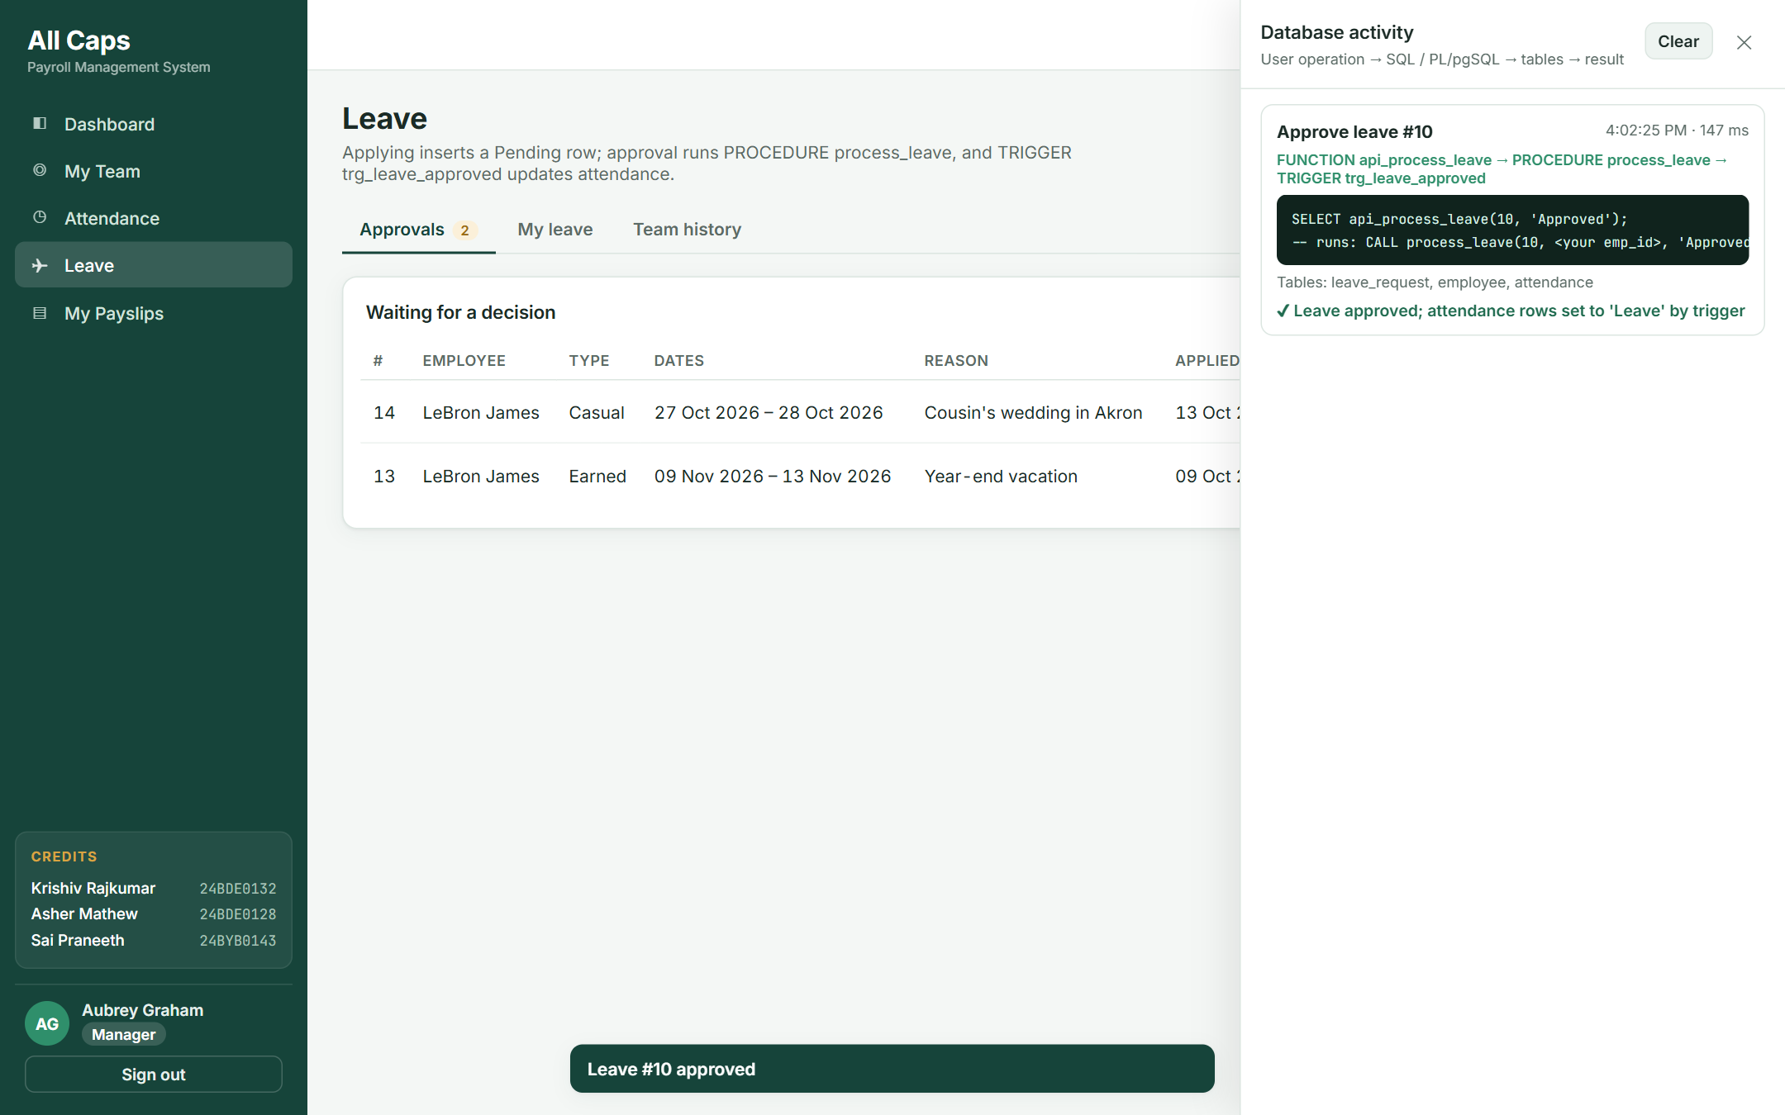
Figure 3 – After approval: the procedure and trigger chain shown in the activity panel.

T4. Payroll officer generates the monthly payroll
Question | Answer
Operation | Jeffery Williams selects October 2026 and clicks “Generate payroll”.
Tables involved | EMPLOYEE, DESIGNATION, ATTENDANCE, LEAVE_REQUEST, SALARY_COMPONENT (read); PAYROLL, PAYROLL_DETAIL (write)
SQL / PL/pgSQL component | SELECT api_generate_payroll(10, 2026) → CALL generate_monthly_payroll(10, 2026) – cursor over active employees using fn_working_days, fn_lop_days and fn_component_amount.
Effect on database | 19 PAYROLL rows (status Generated) and one PAYROLL_DETAIL row per active salary component for each are inserted. Running it again inserts nothing.
Result | The payroll table lists all 19 active employees with LOP days, gross, deductions and net pay; totals are shown above it.
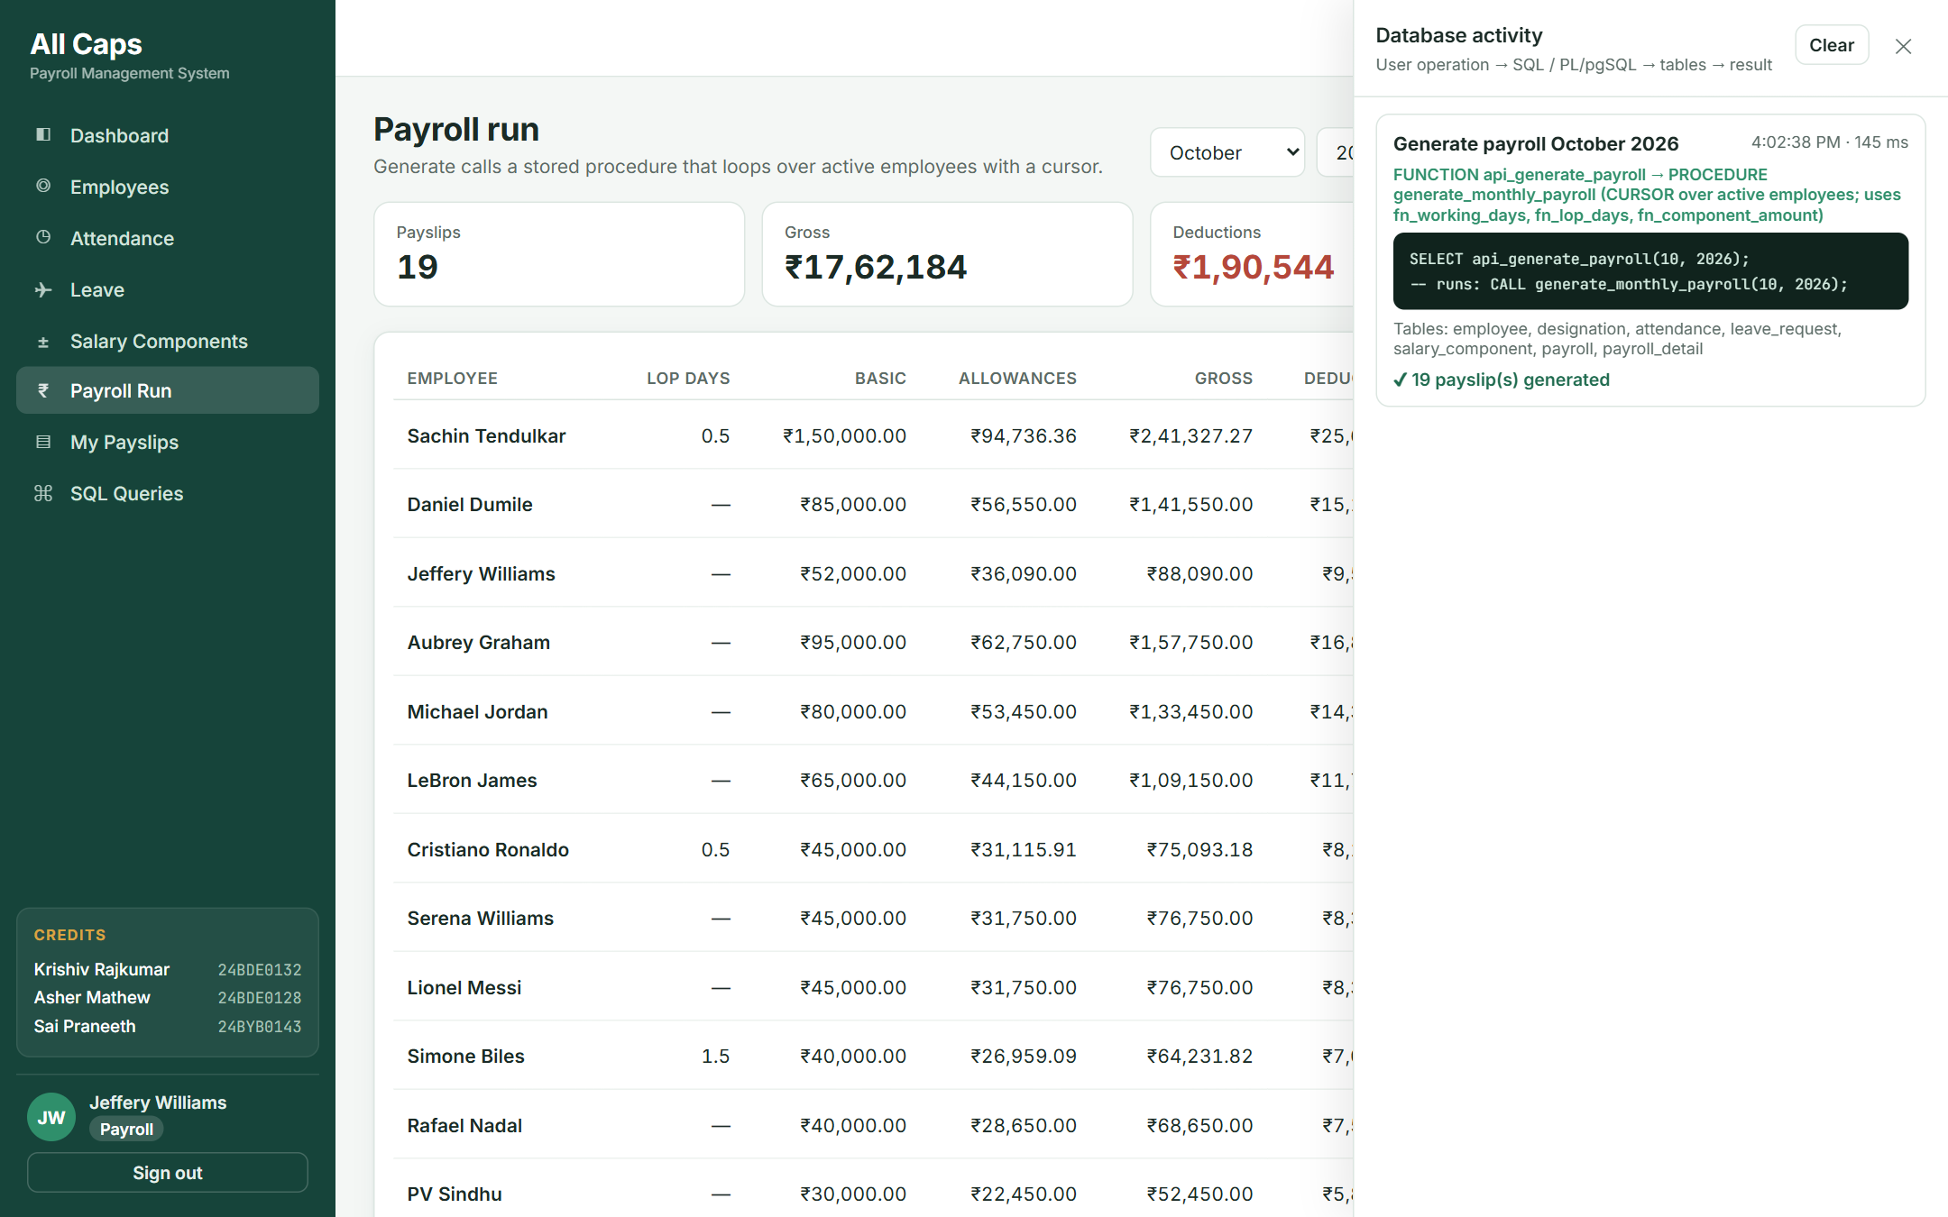
Figure 4 – Generating October payroll: one click runs the cursor-based procedure for 19 employees.

T5. Viewing an itemised payslip
Question | Answer
Operation | The payroll officer (or the employee, from My Payslips) opens a payslip.
Tables involved | PAYROLL, PAYROLL_DETAIL, SALARY_COMPONENT, EMPLOYEE, DEPARTMENT, DESIGNATION
SQL component | SELECT … FROM payroll_detail JOIN salary_component … WHERE payroll_id = ? (the M:N bridge table) plus the employee details.
Effect on database | Read only. RLS lets an employee read only their own payslips.
Result | Earnings (basic, loss of pay, allowances), deductions and net pay, ready to print.
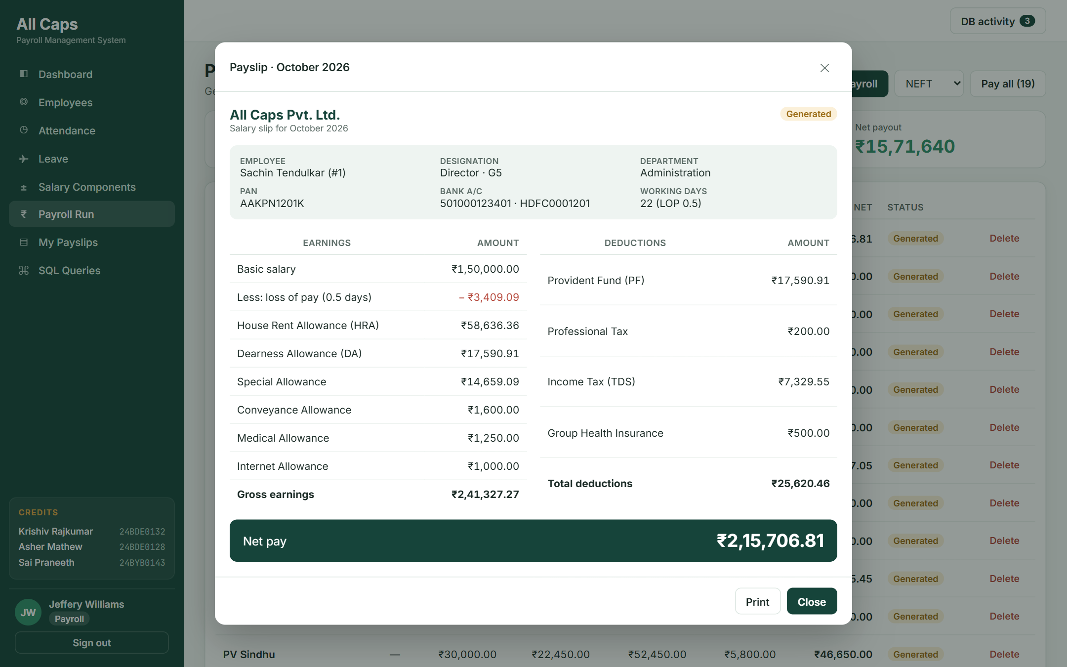
Figure 5 – Itemised payslip built from PAYROLL_DETAIL.

T6. Paying the month’s salaries
Question | Answer
Operation | The payroll officer chooses NEFT and clicks “Pay all”.
Tables involved | PAYROLL
SQL / PL/pgSQL component | SELECT api_pay_payroll(10, 2026, 'NEFT') → CALL pay_monthly_payroll(…) – cursor FOR UPDATE with UPDATE … WHERE CURRENT OF.
Effect on database | Every Generated row of the month becomes Paid with payment_date, payment_mode and a unique transaction_ref (CHECK: Paid ⇒ date and mode present).
Result | “19 payroll row(s) marked Paid”; the rows are now locked by trg_lock_paid_payroll.

T7. Attempt to delete a paid payslip
Question | Answer
Operation | The payroll officer clicks Delete on Sachin Tendulkar’s paid October payroll.
Tables involved | PAYROLL (PAYROLL_DETAIL would cascade)
SQL / PL/pgSQL component | DELETE FROM payroll WHERE payroll_id = 40; → BEFORE DELETE trigger trg_lock_paid_payroll.
Effect on database | The trigger raises an exception, so the DELETE is rolled back and nothing changes.
Result | The error message from the database is shown to the user.
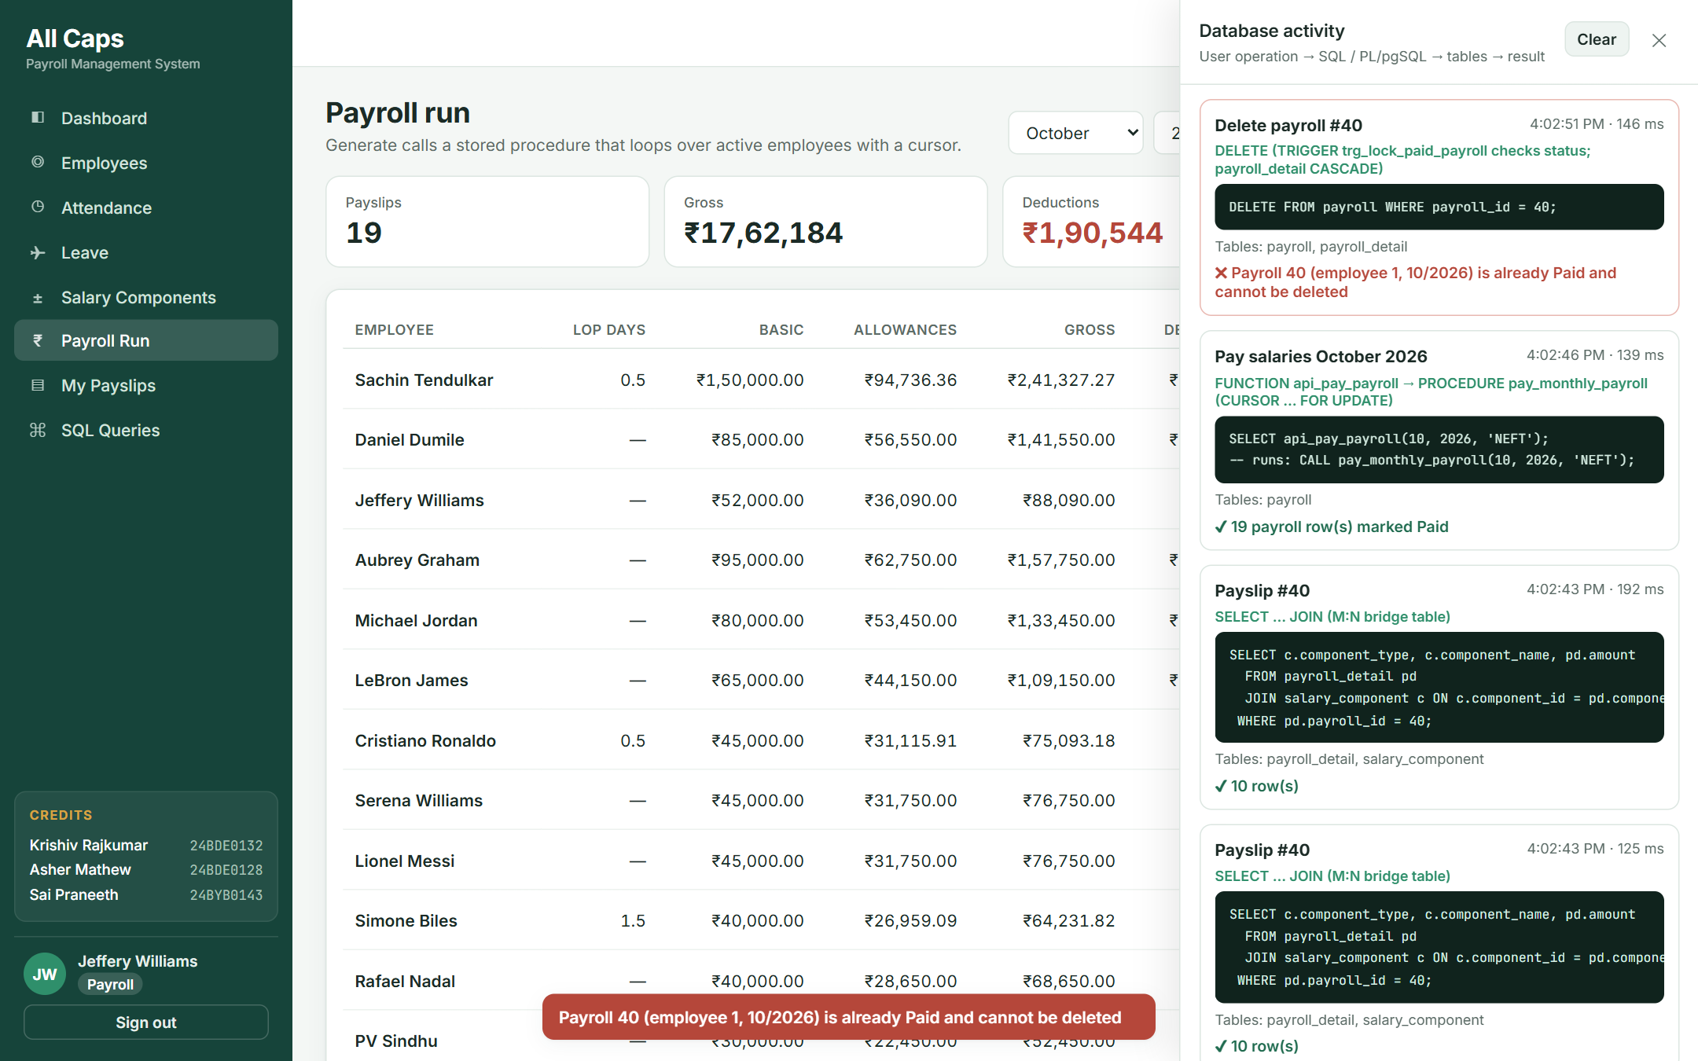
Figure 6 – The trigger blocks deleting a paid payroll; the error comes from the database.

T8. Employee resignation
Question | Answer
Operation | The Admin edits Michael Jordan’s record and sets status to Resigned.
Tables involved | EMPLOYEE, DEPARTMENT, LEAVE_REQUEST
SQL / PL/pgSQL component | UPDATE employee SET status = 'Resigned' WHERE emp_id = 5; → AFTER UPDATE trigger trg_employee_exit (which in turn fires trg_validate_manager for the moved employees).
Effect on database | His three reports now report to Sachin Tendulkar, the Sales department has no head, and any pending leave of his is rejected. He is excluded from later payroll runs.
Result | Shown with before/after outputs in section 8.4 (Trigger 4).

T9. Running the report queries from the application
Question | Answer
Operation | The Admin opens SQL Queries and runs Q4 (department-wise salary cost).
Tables involved | PAYROLL, EMPLOYEE, DEPARTMENT (through view q04_department_salary_cost)
SQL component | SELECT * FROM q04_department_salary_cost; – a view created WITH (security_invoker = true) so RLS still applies.
Effect on database | Read only.
Result | The SQL text, the concepts used and the live result table are shown on one page.
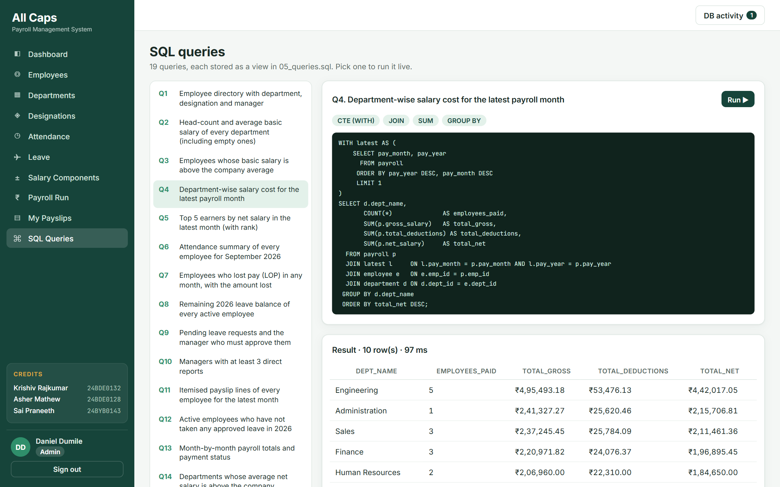
Figure 7 – The SQL Queries page running Q4 live against the database.

9.4 Reports Generated from the Database
The application turns the stored data into the reports a payroll team needs. Each report below is produced by the database (a view or a procedure) and shown in the application; the figures are actual outputs on the sample data.
Report | Produced by | Where it appears
Itemised payslip | PAYROLL + PAYROLL_DETAIL + SALARY_COMPONENT (written by generate_monthly_payroll) | Payroll Run and My Payslips pages
Monthly payroll totals and payment status | View q13_monthly_payroll_totals | Admin / Payroll dashboard
Department-wise salary cost | View q04_department_salary_cost | Dashboard bar chart and SQL Queries page
Attendance summary | View q06_attendance_summary | SQL Queries page
Leave balance of every employee | View q08_leave_balance → fn_leave_balance | SQL Queries page; each employee’s Leave page
Loss-of-pay report | View q07_loss_of_pay | SQL Queries page

Monthly payroll totals (q13)
pay_year | pay_month | payslips | total_gross | total_net | payment_status
2026 | 8 | 20 | 1825944.25 | 1628413.03 | All paid
2026 | 9 | 19 | 1696647.81 | 1512980.76 | 19 unpaid

Department-wise salary cost, September 2026 (q04)
dept_name | employees_paid | total_gross | total_deductions | total_net
Engineering | 5 | 473034.11 | 51119.32 | 421914.79
Administration | 1 | 235804.55 | 25040.91 | 210763.64
Sales | 3 | 222518.21 | 24238.64 | 198279.57
Finance | 3 | 218026.37 | 23767.28 | 194259.09
Human Resources | 2 | 193374.11 | 20884.32 | 172489.79
Legal | 1 | 114672.73 | 12329.54 | 102343.19
Quality Assurance | 1 | 75093.18 | 8176.13 | 66917.05
Marketing | 1 | 71890.00 | 7840.00 | 64050.00
Operations | 1 | 49210.00 | 5460.00 | 43750.00
Customer Support | 1 | 43024.55 | 4810.91 | 38213.64

9.5 Validation – Invalid Operations Rejected by the Database
Every business rule was tested by deliberately attempting an invalid operation. In each case the database itself refused the change, so the rule holds no matter which client sends the request.
# | Attempted operation | Rule / component | Database response | Result
1 | Insert employee with PAN 'BADPAN' | CHECK constraint | new row for relation "employee" violates check constraint "employee_pan_no_check" | Pass
2 | Second attendance row for the same day | UNIQUE (emp_id, att_date) | duplicate key value violates unique constraint "uq_att_emp_day" | Pass
3 | Employee in a non-existent department | FOREIGN KEY | insert or update on table "employee" violates foreign key constraint "employee_dept_id_fkey" | Pass
4 | Delete an employee who has payroll history | FK ON DELETE RESTRICT | update or delete on table "employee" violates foreign key constraint "payroll_emp_id_fkey" on table "payroll" | Pass
5 | Manager approves leave of someone outside their team | process_leave | Employee 5 is not the manager of employee 7 | Pass
6 | Employee approves their own leave | process_leave | An employee cannot approve their own leave | Pass
7 | Approve the same request twice | process_leave | Leave request 10 is already Approved | Pass
8 | Approve 20 days of paid leave with 13 left | process_leave + fn_leave_balance | Insufficient leave balance: requested 20, available 13 | Pass
9 | Generate October payroll a second time | generate_monthly_payroll (skip logic) | 0 new payslips created | Pass
10 | Change net salary of a paid payslip | trg_lock_paid_payroll | Payroll 45 (employee 6, 10/2026) is already Paid and cannot be modified | Pass
11 | Delete a paid payslip | trg_lock_paid_payroll | Payroll 45 (employee 6, 10/2026) is already Paid and cannot be deleted | Pass
12 | Assign a resigned employee as manager | trg_validate_manager | Manager 19 is not an active employee | Pass
13 | Create a two-person reporting cycle | trg_validate_manager | Circular reporting: employee 6 already reports to 4 | Pass
14 | Employee calls the payroll generation API | api_generate_payroll role check | Only Admin or Payroll staff can generate payroll | Pass
15 | Read employee data without signing in | Privileges + Row Level Security | permission denied for table employee | Pass

10. Conclusion

10.1 Design Decisions and Justification
Decision | Justification
PostgreSQL (Supabase) with PL/pgSQL | A hosted database the web application can reach from anywhere; PL/pgSQL offers the same procedures, functions, cursors and triggers as Oracle PL/SQL.
Surrogate SERIAL keys, natural keys kept UNIQUE | Short, stable keys for joins and foreign keys, while e-mail, phone, PAN and bank account still cannot be duplicated.
Gross and net salary stored in PAYROLL | A deliberate snapshot: a payslip must not change when salary rules change later. Derived values that never become history (age, hours worked, leave days) are computed instead.
PAYROLL_DETAIL bridge table | Resolves the M:N relationship between payroll and salary components and keeps an auditable, itemised payslip.
Business rules inside the database | Constraints and triggers apply to every client – the web app, the SQL editor or the API – so a rule cannot be skipped by a missing UI check.
Explicit cursor in generate_monthly_payroll | Each employee needs several dependent steps (LOP, earned basic, every component, one header and many detail rows), with already-processed employees skipped; a cursor processes them one at a time in a defined order.
Cursor FOR UPDATE in pay_monthly_payroll | Locks the month’s unpaid rows so two payroll officers cannot pay the same salary twice; WHERE CURRENT OF updates exactly the fetched row.
FK actions: RESTRICT / CASCADE / SET NULL | Payroll history can never be deleted with an employee (RESTRICT); attendance and leave have no meaning without the employee (CASCADE); a departing manager or approver leaves the records intact (SET NULL).
Triggers for side effects | Writing leave into attendance and cleaning up after a resignation happen in the same transaction as the change that causes them, so they cannot be forgotten or half-done.
Row Level Security + api_* wrapper functions | Each role sees only permitted rows; PostgREST cannot call procedures, so SECURITY DEFINER functions check the caller’s role and then CALL the procedure.
Views with security_invoker | Report queries are written once, reused by the dashboard and the SQL Queries page, and still respect each user’s row permissions.

10.2 Conclusion and Future Work
The Employee Payroll Management System has been implemented as a PostgreSQL database on Supabase with a role-based web application. The database has 8 normalised tables with complete primary key, foreign key, NOT NULL, UNIQUE, CHECK and DEFAULT constraints, populated with realistic data for a 20-employee company over three months.
Nineteen SQL queries cover joins, self-joins, aggregation, grouping with HAVING, correlated and scalar subqueries, set operations, window functions and date functions. Four functions, three procedures (two using explicit cursors) and four triggers implement the real business operations – loss-of-pay calculation, leave approval, payroll generation, salary payment and employee exit – and the database itself rejects invalid operations such as editing a paid payslip, approving one’s own leave or exceeding the leave balance.
Every component has a clear purpose in the application: each user action in the web app maps to a specific SQL statement, procedure or trigger, and the DB activity panel shows that flow live during the demonstration. Possible extensions are tax-regime based TDS calculation, salary revisions with effective dates, and an audit log table populated by triggers.

