School of Computer Science Engineering and Information Systems
BCSE302L – Database Systems | Course Project
EMPLOYEE PAYROLL MANAGEMENT SYSTEM
Review II – Database Implementation
Submitted by
Krishiv Rajkumar – 24BDE0132
Asher Mathew – 24BDE0128
Sai Praneeth – 24BYB0143
Under the guidance of
Dr Rubimalaya R
October 2026

Contents
Contents 2
1. Project Title and Team Details 4
2. Introduction and Problem Statement 5
2.1 Introduction 5
2.2 Problem Statement 5
2.3 Objectives 5
2.4 Users and Roles 5
3. Functional Requirements 7
4. ER Diagram 8
5. Relational Schema 9
5.1 Relational Schema (text notation) 10
6. Table Creation and Constraints 11
6.1 Constraint Summary 11
6.2 DDL – sql/01_schema.sql 11
6.3 Data Population 13
6.4 DML Demonstration – INSERT, UPDATE and DELETE 17
7. SQL Queries and Outputs 19
Q1. Employee directory with department, designation and manager 19
Q2. Head-count and average basic salary of every department (including empty ones) 20
Q3. Employees whose basic salary is above the company average 20
Q4. Department-wise salary cost for the latest payroll month 21
Q5. Top 5 earners by net salary in the latest month (with rank) 21
Q6. Attendance summary of every employee for September 2026 22
Q7. Employees who lost pay (LOP) in any month, with the amount lost 22
Q8. Remaining 2026 leave balance of every active employee 23
Q9. Pending leave requests and the manager who must approve them 23
Q10. Managers with at least 3 direct reports 24
Q11. Itemised payslip lines of every employee for the latest month 24
Q12. Active employees who have not taken any approved leave in 2026 25
Q13. Month-by-month payroll totals and payment status 25
Q14. Departments whose average net salary is above the company average (latest month) 26
Q15. Age and tenure of every active employee (derived attributes) 26
Q16. Total paid out per salary component in the latest month 27
Q17. Employees who were both absent and on approved leave in September 27
Q18. Everyone with leadership responsibility: department heads or people managers 28
Q19. Employees who checked in after 09:35 more than 10 times since August 28
8. Procedures, Functions, Cursor and Triggers 30
8.1 Overview 30
8.2 Functions 30
8.3 Procedures and Cursors 33
8.4 Triggers 36
8.5 Calling Procedures from the Application 39
9. Real-World Transaction Demonstrations 41
9.1 Application and Database Connectivity 41
T1. Employee checks in 42
T2. Employee applies for leave 42
T3. Manager approves leave 43
T4. Payroll officer generates the monthly payroll 44
T5. Viewing an itemised payslip 45
T6. Paying the month’s salaries 46
T7. Attempt to delete a paid payslip 47
T8. Employee resignation 48
T9. Running the report queries from the application 48
10. Conclusion 50

(If page numbers are missing, right-click the table and choose “Update Field”.)

1. Project Title and Team Details
Item | Details
Project title | Employee Payroll Management System
Course | BCSE302L – Database Systems (Lab course project)
Team | Krishiv Rajkumar (24BDE0132), Asher Mathew (24BDE0128), Sai Praneeth (24BYB0143)
Guide | Dr Rubimalaya R
Database | PostgreSQL 17 hosted on Supabase (cloud); PL/pgSQL for procedures, functions, cursors and triggers
Application | React + Vite web application connected to the database through the supabase-js client
Source code | github.com/LordFlyaway/DBS_proj
Sample company | All Caps Pvt. Ltd. – a fictional company whose 20 employees are named after musicians and athletes

2. Introduction and Problem Statement

2.1 Introduction
Every organisation has to pay its employees correctly and on time. A salary is not one fixed number: it depends on the designation and basic pay, allowances such as HRA and DA, deductions such as Provident Fund, Professional Tax and TDS, the days actually worked, and approved or unapproved leave. When this is managed in spreadsheets, calculations go wrong, records are duplicated, nothing stops invalid entries and there is no audit trail.
The Employee Payroll Management System stores organisation, employee, attendance, leave and salary-structure data in a relational database and generates monthly payroll and payslips from that data with stored procedures. Business rules are enforced inside the database through constraints, triggers and Row Level Security, and a role-based web application lets HR, payroll staff, managers and employees work with the data.

2.2 Problem Statement
Design and implement a centralised, consistent and secure database that (a) maintains employee and organisational data, (b) records daily attendance and leave, (c) defines salary components (allowances and deductions), and (d) computes each employee’s monthly gross and net salary, including loss-of-pay for unpaid absence, while enforcing business rules with database constraints and triggers instead of manual checks.

2.3 Objectives
- A single source of truth for employees, departments and designations.
- Attendance and leave recording, with loss-of-pay calculated automatically.
- Configurable salary components – fixed amounts or a percentage of basic pay.
- One-step monthly payroll generation with itemised payslips, followed by salary payment.
- Integrity through PK/FK, NOT NULL, UNIQUE, CHECK and DEFAULT constraints, triggers and Row Level Security.
- Interactive access through a web application connected to the database.

2.4 Users and Roles
Role (demo login) | What the role can do
Admin – Daniel Dumile (HR Manager) | Manage employees, departments, designations and attendance; approve any leave; run payroll; run the SQL query catalogue.
Payroll – Jeffery Williams (Payroll Officer) | Maintain salary components; generate, pay and (if unpaid) delete payroll; run the SQL query catalogue.
Manager – Aubrey Graham (Engineering Manager) | See their team; approve or reject the team’s leave; follow team attendance.
Employee – LeBron James (Sr. Software Engineer) | Check in and out; apply for and cancel leave; view own attendance and payslips.
Every role also sees its own dashboard, leave balance and payslips. Logins are e-mail/password accounts in Supabase Auth, linked to EMPLOYEE rows through employee.auth_user_id and authorised through employee.app_role.

3. Functional Requirements
ID | Requirement | Implemented by
FR1 | Add, update and delete departments, including the department head. | DEPARTMENT; Departments page
FR2 | Maintain designations with pay grade, basic salary and annual leave quota. | DESIGNATION; Designations page
FR3 | Register employees with personal, PAN and bank details, department, designation, manager and login role. | EMPLOYEE; CHECK/UNIQUE constraints; trg_validate_manager
FR4 | Record attendance – one row per employee per day; employees check themselves in and out. | ATTENDANCE; UNIQUE (emp_id, att_date); RLS policy
FR5 | Employees apply for leave; managers approve or reject; approved leave appears in attendance. | LEAVE_REQUEST; process_leave; trg_leave_approved
FR6 | Define allowances and deductions as fixed amounts or a percentage of basic. | SALARY_COMPONENT; fn_component_amount
FR7 | Generate the month’s payroll for all active employees with LOP, gross and net salary. | generate_monthly_payroll (cursor); fn_working_days; fn_lop_days
FR8 | Keep an itemised payslip (amount of every component). | PAYROLL_DETAIL (M:N bridge)
FR9 | Pay salaries: mark payroll Paid with date, mode and transaction reference. | pay_monthly_payroll (cursor FOR UPDATE)
FR10 | Prevent invalid operations – duplicate payroll, editing paid payroll, self-approval, exceeding leave balance. | Constraints, procedures and triggers
FR11 | Handle employee exits – reassign their team, clear department headship, reject pending leave. | trg_employee_exit
FR12 | Management reports: department cost, attendance summary, leave balance, top earners and others. | 19 SQL queries saved as views
FR13 | Role-based web application connected to the database. | React app + supabase-js + Row Level Security

4. ER Diagram
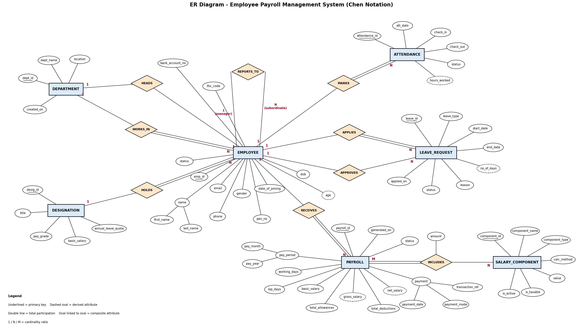
Figure 1 – ER diagram (Chen notation): 7 entities and 9 relationships, including the recursive REPORTS_TO, the 1:1 HEADS and the M:N INCLUDES relationship.

5. Relational Schema
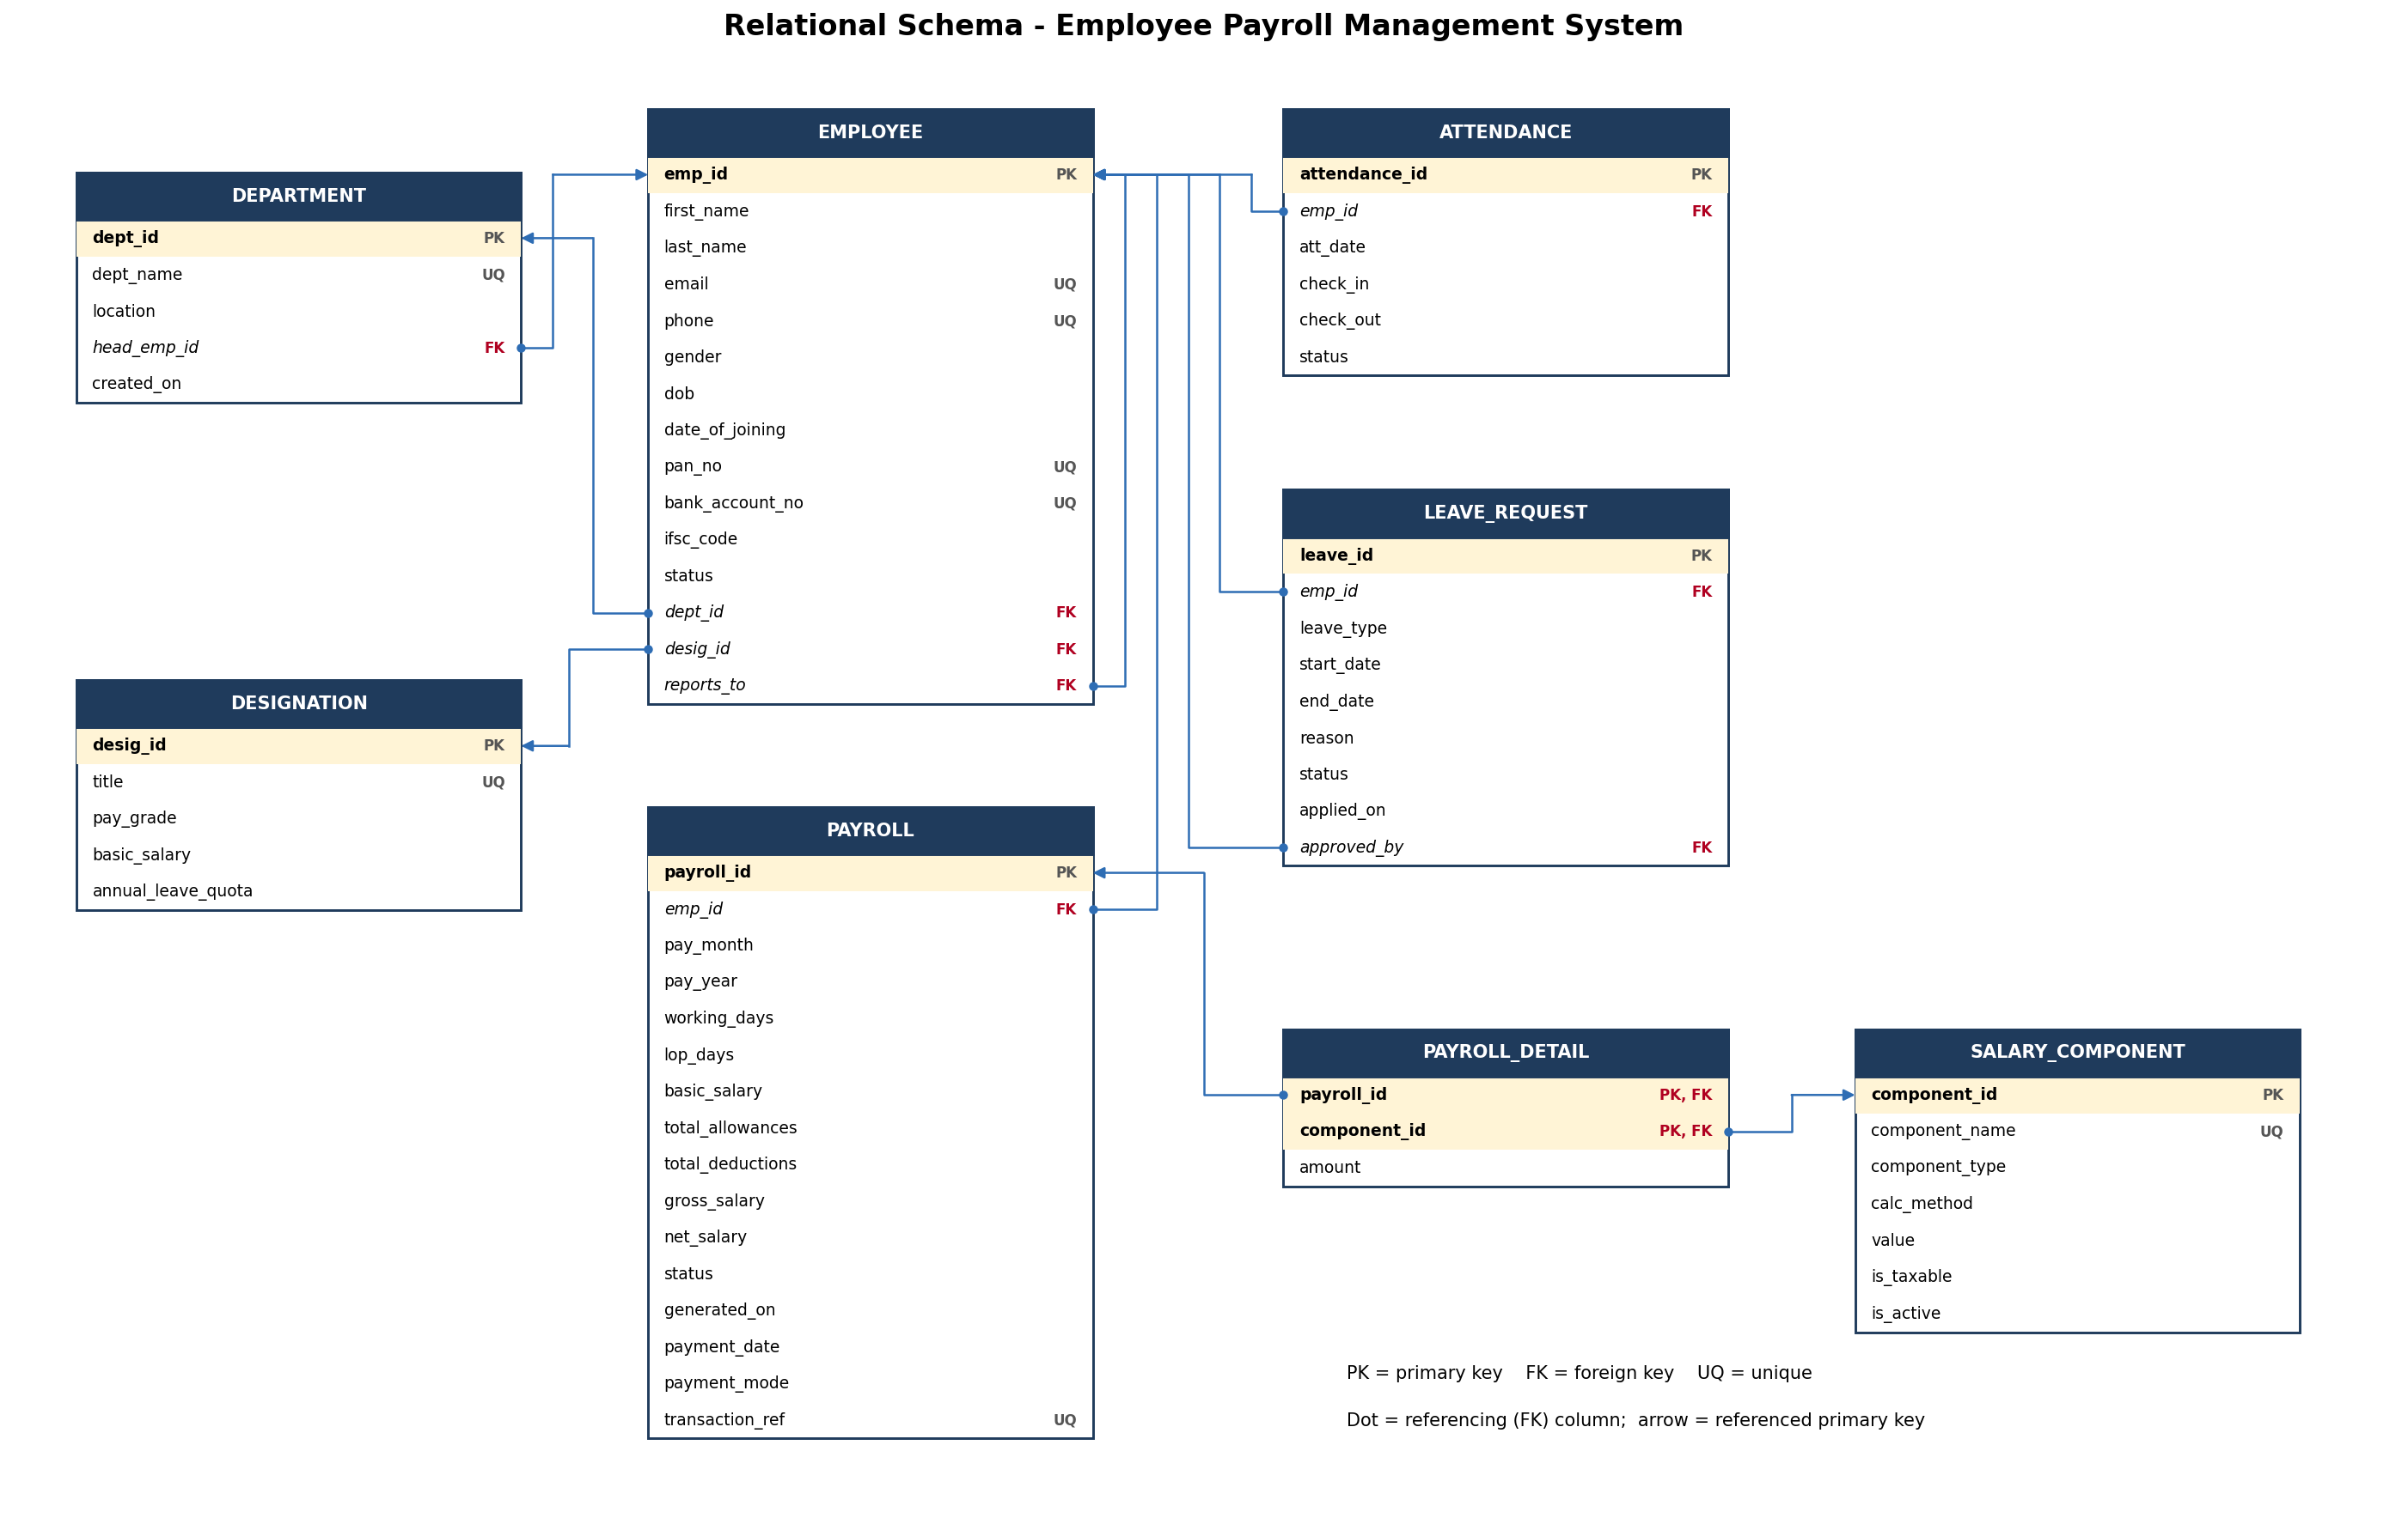
Figure 2 – Relational schema: 8 tables with primary and foreign keys.

5.1 Relational Schema (text notation)
Primary keys are bold and underlined; foreign keys are italic.
DEPARTMENT (dept_id, dept_name, location, head_emp_id, created_on)
DESIGNATION (desig_id, title, pay_grade, basic_salary, annual_leave_quota)
EMPLOYEE (emp_id, first_name, last_name, email, phone, gender, dob, date_of_joining, pan_no, bank_account_no, ifsc_code, status, dept_id, desig_id, reports_to, app_role, auth_user_id)
ATTENDANCE (attendance_id, emp_id, att_date, check_in, check_out, status)
LEAVE_REQUEST (leave_id, emp_id, leave_type, start_date, end_date, reason, status, applied_on, approved_by)
SALARY_COMPONENT (component_id, component_name, component_type, calc_method, value, is_taxable, is_active)
PAYROLL (payroll_id, emp_id, pay_month, pay_year, working_days, lop_days, basic_salary, total_allowances, total_deductions, gross_salary, net_salary, status, generated_on, payment_date, payment_mode, transaction_ref)
PAYROLL_DETAIL (payroll_id, component_id, amount)
Change since Review I: two columns were added to EMPLOYEE for the web application – app_role (Admin, Payroll, Manager or Employee) and auth_user_id (the employee’s Supabase login, UNIQUE). Keeping them in EMPLOYEE keeps the design at 8 tables.
All tables are in Third Normal Form: department and designation details are stored once and referenced by key, salary rules are separate from payslip line items, and the only non-key attribute of the composite-key table PAYROLL_DETAIL (amount) depends on the whole key. Age, hours worked and leave days are derived in queries and are not stored; gross and net salary are stored on purpose as a monthly snapshot so that old payslips do not change when salary rules change.

6. Table Creation and Constraints
The database is created by sql/01_schema.sql. Each table and the business rule behind each constraint is summarised below, followed by the complete DDL.

6.1 Constraint Summary
Table | Keys | NOT NULL / UNIQUE / CHECK / DEFAULT
DEPARTMENT | PK dept_id; FK head_emp_id (UNIQUE) → employee | dept_name UNIQUE NOT NULL; created_on DEFAULT CURRENT_DATE
DESIGNATION | PK desig_id | title UNIQUE; pay_grade IN (G1–G5); basic_salary > 0; annual_leave_quota DEFAULT 24, 0–60
EMPLOYEE | PK emp_id; FK dept_id, desig_id, reports_to (self) | email, phone, pan_no, bank_account_no, auth_user_id UNIQUE; phone ^[6-9][0-9]{9}$; PAN ^[A-Z]{5}[0-9]{4}[A-Z]$; IFSC format; gender IN (M,F,O); status DEFAULT 'Active'; app_role DEFAULT 'Employee'; at least 18 at joining; cannot report to self
ATTENDANCE | PK attendance_id; FK emp_id (CASCADE) | UNIQUE (emp_id, att_date); status IN (Present, Absent, Half-Day, Leave) DEFAULT 'Present'; check_out > check_in
LEAVE_REQUEST | PK leave_id; FK emp_id (CASCADE), approved_by (SET NULL) | leave_type IN (Casual, Sick, Earned, Unpaid); end_date ≥ start_date; status DEFAULT 'Pending'; approver ≠ applicant
SALARY_COMPONENT | PK component_id | component_name UNIQUE; type IN (Allowance, Deduction); calc_method IN (Fixed, Percent); value ≥ 0 and ≤ 100 for Percent; is_taxable, is_active DEFAULT TRUE
PAYROLL | PK payroll_id; FK emp_id (RESTRICT) | UNIQUE (emp_id, pay_month, pay_year); month 1–12; lop_days ≤ working_days; net_salary ≥ 0; status DEFAULT 'Generated'; Paid ⇒ payment_date and mode present; transaction_ref UNIQUE
PAYROLL_DETAIL | PK (payroll_id, component_id); FK both (CASCADE / RESTRICT) | amount ≥ 0

6.2 DDL – sql/01_schema.sql
-- =====================================================================
-- Employee Payroll Management System
-- BCSE302L Database Systems - Course Project
-- Target DBMS : PostgreSQL 15+ (hosted on Supabase)
-- File : 01_schema.sql (table creation + constraints)
-- =====================================================================

-- Drop in reverse dependency order so the script can be re-run
DROP TABLE IF EXISTS payroll_detail CASCADE;
DROP TABLE IF EXISTS payroll CASCADE;
DROP TABLE IF EXISTS salary_component CASCADE;
DROP TABLE IF EXISTS leave_request CASCADE;
DROP TABLE IF EXISTS attendance CASCADE;
DROP TABLE IF EXISTS employee CASCADE;
DROP TABLE IF EXISTS designation CASCADE;
DROP TABLE IF EXISTS department CASCADE;

-- ---------------------------------------------------------------------
-- 1. DEPARTMENT : organisational units of the company
-- ---------------------------------------------------------------------
CREATE TABLE department (
dept_id SERIAL PRIMARY KEY,
dept_name VARCHAR(50) NOT NULL UNIQUE,
location VARCHAR(50) NOT NULL,
head_emp_id INT, -- FK added after EMPLOYEE exists
created_on DATE NOT NULL DEFAULT CURRENT_DATE
);

-- ---------------------------------------------------------------------
-- 2. DESIGNATION : job titles and their basic pay
-- ---------------------------------------------------------------------
CREATE TABLE designation (
desig_id SERIAL PRIMARY KEY,
title VARCHAR(50) NOT NULL UNIQUE,
pay_grade CHAR(2) NOT NULL CHECK (pay_grade IN ('G1','G2','G3','G4','G5')),
basic_salary NUMERIC(10,2) NOT NULL CHECK (basic_salary > 0),
annual_leave_quota INT NOT NULL DEFAULT 24 CHECK (annual_leave_quota BETWEEN 0 AND 60)
);

-- ---------------------------------------------------------------------
-- 3. EMPLOYEE : core entity; reports_to is a recursive (self) FK
-- ---------------------------------------------------------------------
CREATE TABLE employee (
emp_id SERIAL PRIMARY KEY,
first_name VARCHAR(30) NOT NULL,
last_name VARCHAR(30) NOT NULL,
email VARCHAR(100) NOT NULL UNIQUE CHECK (email LIKE '%_@_%._%'),
phone CHAR(10) NOT NULL UNIQUE CHECK (phone ~ '^[6-9][0-9]{9}$'),
gender CHAR(1) NOT NULL CHECK (gender IN ('M','F','O')),
dob DATE NOT NULL,
date_of_joining DATE NOT NULL DEFAULT CURRENT_DATE,
pan_no CHAR(10) NOT NULL UNIQUE CHECK (pan_no ~ '^[A-Z]{5}[0-9]{4}[A-Z]$'),
bank_account_no VARCHAR(18) NOT NULL UNIQUE,
ifsc_code CHAR(11) NOT NULL CHECK (ifsc_code ~ '^[A-Z]{4}0[A-Z0-9]{6}$'),
status VARCHAR(10) NOT NULL DEFAULT 'Active'
CHECK (status IN ('Active','On Leave','Resigned','Terminated')),
dept_id INT NOT NULL REFERENCES department(dept_id),
desig_id INT NOT NULL REFERENCES designation(desig_id),
reports_to INT REFERENCES employee(emp_id) ON DELETE SET NULL,
app_role VARCHAR(10) NOT NULL DEFAULT 'Employee'
CHECK (app_role IN ('Admin','Payroll','Manager','Employee')),
auth_user_id UUID UNIQUE, -- login account (Supabase auth.users.id)
CONSTRAINT chk_emp_age CHECK (date_of_joining >= dob + INTERVAL '18 years'),
CONSTRAINT chk_not_own_mgr CHECK (reports_to IS NULL OR reports_to <> emp_id)
);

-- Department head is an employee (1:1 "heads" relationship)
ALTER TABLE department
ADD CONSTRAINT fk_dept_head
FOREIGN KEY (head_emp_id) REFERENCES employee(emp_id) ON DELETE SET NULL;
ALTER TABLE department
ADD CONSTRAINT uq_dept_head UNIQUE (head_emp_id);

-- ---------------------------------------------------------------------
-- 4. ATTENDANCE : one row per employee per working day
-- ---------------------------------------------------------------------
CREATE TABLE attendance (
attendance_id SERIAL PRIMARY KEY,
emp_id INT NOT NULL REFERENCES employee(emp_id) ON DELETE CASCADE,
att_date DATE NOT NULL,
check_in TIME,
check_out TIME,
status VARCHAR(8) NOT NULL DEFAULT 'Present'
CHECK (status IN ('Present','Absent','Half-Day','Leave')),
CONSTRAINT uq_att_emp_day UNIQUE (emp_id, att_date),
CONSTRAINT chk_att_times CHECK (check_out IS NULL OR check_in IS NULL OR check_out > check_in)
);

-- ---------------------------------------------------------------------
-- 5. LEAVE_REQUEST : applied by an employee, approved by a manager
-- ---------------------------------------------------------------------
CREATE TABLE leave_request (
leave_id SERIAL PRIMARY KEY,
emp_id INT NOT NULL REFERENCES employee(emp_id) ON DELETE CASCADE,
leave_type VARCHAR(10) NOT NULL CHECK (leave_type IN ('Casual','Sick','Earned','Unpaid')),
start_date DATE NOT NULL,
end_date DATE NOT NULL,
reason VARCHAR(200),
status VARCHAR(10) NOT NULL DEFAULT 'Pending'
CHECK (status IN ('Pending','Approved','Rejected')),
applied_on DATE NOT NULL DEFAULT CURRENT_DATE,
approved_by INT REFERENCES employee(emp_id) ON DELETE SET NULL,
CONSTRAINT chk_leave_dates CHECK (end_date >= start_date),
CONSTRAINT chk_not_self_appr CHECK (approved_by IS NULL OR approved_by <> emp_id)
);

-- ---------------------------------------------------------------------
-- 6. SALARY_COMPONENT : master list of allowances and deductions
-- ---------------------------------------------------------------------
CREATE TABLE salary_component (
component_id SERIAL PRIMARY KEY,
component_name VARCHAR(40) NOT NULL UNIQUE,
component_type VARCHAR(10) NOT NULL CHECK (component_type IN ('Allowance','Deduction')),
calc_method VARCHAR(10) NOT NULL CHECK (calc_method IN ('Fixed','Percent')),
value NUMERIC(10,2) NOT NULL CHECK (value >= 0),
is_taxable BOOLEAN NOT NULL DEFAULT TRUE,
is_active BOOLEAN NOT NULL DEFAULT TRUE,
CONSTRAINT chk_percent_range CHECK (calc_method <> 'Percent' OR value <= 100)
);

-- ---------------------------------------------------------------------
-- 7. PAYROLL : one salary record per employee per month (+ payment info)
-- ---------------------------------------------------------------------
CREATE TABLE payroll (
payroll_id SERIAL PRIMARY KEY,
emp_id INT NOT NULL REFERENCES employee(emp_id),
pay_month SMALLINT NOT NULL CHECK (pay_month BETWEEN 1 AND 12),
pay_year SMALLINT NOT NULL CHECK (pay_year BETWEEN 2000 AND 2100),
working_days SMALLINT NOT NULL CHECK (working_days BETWEEN 0 AND 31),
lop_days NUMERIC(4,1) NOT NULL DEFAULT 0 CHECK (lop_days >= 0),
basic_salary NUMERIC(10,2) NOT NULL CHECK (basic_salary >= 0),
total_allowances NUMERIC(10,2) NOT NULL DEFAULT 0 CHECK (total_allowances >= 0),
total_deductions NUMERIC(10,2) NOT NULL DEFAULT 0 CHECK (total_deductions >= 0),
gross_salary NUMERIC(10,2) NOT NULL DEFAULT 0,
net_salary NUMERIC(10,2) NOT NULL DEFAULT 0 CHECK (net_salary >= 0),
status VARCHAR(10) NOT NULL DEFAULT 'Generated'
CHECK (status IN ('Generated','Paid','On Hold')),
generated_on TIMESTAMP NOT NULL DEFAULT CURRENT_TIMESTAMP,
payment_date DATE,
payment_mode VARCHAR(10) CHECK (payment_mode IN ('NEFT','IMPS','Cheque')),
transaction_ref VARCHAR(30) UNIQUE,
CONSTRAINT uq_payroll_emp_month UNIQUE (emp_id, pay_month, pay_year),
CONSTRAINT chk_lop_le_days CHECK (lop_days <= working_days),
CONSTRAINT chk_paid_has_date CHECK (status <> 'Paid' OR (payment_date IS NOT NULL AND payment_mode IS NOT NULL))
);

-- ---------------------------------------------------------------------
-- 8. PAYROLL_DETAIL : M:N between PAYROLL and SALARY_COMPONENT
-- (line items of a payslip)
-- ---------------------------------------------------------------------
CREATE TABLE payroll_detail (
payroll_id INT NOT NULL REFERENCES payroll(payroll_id) ON DELETE CASCADE,
component_id INT NOT NULL REFERENCES salary_component(component_id),
amount NUMERIC(10,2) NOT NULL CHECK (amount >= 0),
PRIMARY KEY (payroll_id, component_id)
);

-- Helpful indexes on foreign keys used in joins
CREATE INDEX idx_emp_dept ON employee(dept_id);
CREATE INDEX idx_emp_desig ON employee(desig_id);
CREATE INDEX idx_att_emp_date ON attendance(emp_id, att_date);
CREATE INDEX idx_leave_emp ON leave_request(emp_id);
CREATE INDEX idx_payroll_month ON payroll(pay_year, pay_month);

6.3 Data Population
The sample data (sql/04_seed_data.sql) describes All Caps Pvt. Ltd. from August to October 2026. Every table has at least 10 meaningful rows. Attendance is generated for every working day; payroll rows are not typed in by hand but produced by calling the payroll procedures, exactly as the application does.
Table | Rows | Contents
department | 10 | Departments in seven cities, six with a department head
designation | 13 | Job titles from Operations Associate (G1) to Director (G5)
employee | 20 | 20 employees in a 3-level reporting hierarchy; one resigned in August
attendance | 971 | Every weekday from 1 Aug to 9 Oct 2026, with absences, half days and leave
leave_request | 13 | Approved, rejected and pending requests, including unpaid leave
salary_component | 12 | 6 active allowances, 4 active deductions, 2 inactive components
payroll | 39 | August (20 employees, Paid) and September (19 employees, Generated)
payroll_detail | 390 | 10 line items per payslip

DEPARTMENT
dept_id | dept_name | location | head_emp_id | created_on
1 | Human Resources | Chennai | 2 | 2012-06-01
2 | Engineering | Bengaluru | 4 | 2012-06-01
3 | Finance | Chennai | 3 | 2012-06-01
4 | Sales | Mumbai | 5 | 2013-04-15
5 | Marketing | Mumbai | 14 | 2014-02-10
6 | Operations | Pune | NULL | 2015-09-01
7 | Customer Support | Hyderabad | NULL | 2016-01-04
8 | Quality Assurance | Bengaluru | NULL | 2017-07-17
9 | Legal | New Delhi | NULL | 2018-03-12
10 | Administration | Vellore | 1 | 2012-06-01

DESIGNATION
desig_id | title | pay_grade | basic_salary | annual_leave_quota
1 | HR Manager | G4 | 85000.00 | 24
2 | Software Engineer | G2 | 45000.00 | 20
3 | Senior Software Engineer | G3 | 65000.00 | 22
4 | Engineering Manager | G4 | 95000.00 | 24
5 | Accountant | G2 | 40000.00 | 20
6 | Payroll Officer | G3 | 52000.00 | 22
7 | Sales Executive | G1 | 30000.00 | 18
8 | Sales Manager | G4 | 80000.00 | 24
9 | Marketing Analyst | G2 | 42000.00 | 20
10 | Operations Associate | G1 | 28000.00 | 18
11 | Director | G5 | 150000.00 | 30
12 | HR Executive | G2 | 38000.00 | 20
13 | Legal Counsel | G3 | 70000.00 | 22

EMPLOYEE
emp_id | first_name | last_name | gender | date_of_joining | dept_id | desig_id | reports_to | app_role | status
1 | Sachin | Tendulkar | M | 2012-06-01 | 10 | 11 | NULL | Admin | Active
2 | Daniel | Dumile | M | 2015-03-16 | 1 | 1 | 1 | Admin | Active
3 | Jeffery | Williams | M | 2016-07-11 | 3 | 6 | 1 | Payroll | Active
4 | Aubrey | Graham | M | 2014-01-20 | 2 | 4 | 1 | Manager | Active
5 | Michael | Jordan | M | 2013-08-05 | 4 | 8 | 1 | Manager | Active
6 | LeBron | James | M | 2019-07-01 | 2 | 3 | 4 | Employee | Active
7 | Cristiano | Ronaldo | M | 2021-08-02 | 2 | 2 | 4 | Employee | Active
8 | Serena | Williams | F | 2022-01-10 | 2 | 2 | 4 | Employee | Active
9 | Lionel | Messi | M | 2020-11-16 | 8 | 2 | 4 | Employee | Active
10 | Simone | Biles | F | 2019-04-08 | 3 | 5 | 3 | Employee | Active
11 | Rafael | Nadal | M | 2018-09-03 | 3 | 5 | 3 | Employee | Active
12 | PV | Sindhu | F | 2023-02-01 | 4 | 7 | 5 | Employee | Active
13 | Virat | Kohli | M | 2022-06-15 | 4 | 7 | 5 | Employee | Active
14 | Naomi | Osaka | F | 2017-10-23 | 5 | 9 | 5 | Employee | Active
15 | Usain | Bolt | M | 2024-01-08 | 6 | 10 | 1 | Employee | Active
16 | Sania | Mirza | F | 2021-03-22 | 7 | 10 | 1 | Employee | Active
17 | Novak | Djokovic | M | 2017-05-29 | 1 | 12 | 2 | Employee | Active
18 | Mary | Kom | F | 2020-02-17 | 9 | 13 | 1 | Employee | Active
19 | Zlatan | Ibrahimovic | M | 2016-12-05 | 2 | 3 | 4 | Employee | Resigned
20 | Coco | Gauff | F | 2025-07-14 | 2 | 2 | 4 | Employee | Active

SALARY_COMPONENT
component_id | component_name | component_type | calc_method | value | is_taxable | is_active
1 | House Rent Allowance (HRA) | Allowance | Percent | 40.00 | true | true
2 | Dearness Allowance (DA) | Allowance | Percent | 12.00 | true | true
3 | Special Allowance | Allowance | Percent | 10.00 | true | true
4 | Conveyance Allowance | Allowance | Fixed | 1600.00 | false | true
5 | Medical Allowance | Allowance | Fixed | 1250.00 | false | true
6 | Internet Allowance | Allowance | Fixed | 1000.00 | false | true
7 | Night Shift Allowance | Allowance | Fixed | 2000.00 | true | false
8 | Provident Fund (PF) | Deduction | Percent | 12.00 | false | true
9 | Professional Tax | Deduction | Fixed | 200.00 | false | true
10 | Income Tax (TDS) | Deduction | Percent | 5.00 | false | true
11 | Group Health Insurance | Deduction | Fixed | 500.00 | false | true
12 | Labour Welfare Fund | Deduction | Fixed | 25.00 | false | false

LEAVE_REQUEST
leave_id | emp_id | leave_type | start_date | end_date | status | applied_on | approved_by
1 | 6 | Casual | 2026-08-10 | 2026-08-11 | Approved | 2026-08-03 | 4
2 | 7 | Sick | 2026-08-19 | 2026-08-20 | Approved | 2026-08-19 | 4
3 | 12 | Earned | 2026-08-24 | 2026-08-28 | Approved | 2026-08-05 | 5
4 | 13 | Unpaid | 2026-09-07 | 2026-09-09 | Approved | 2026-08-31 | 5
5 | 8 | Casual | 2026-09-14 | 2026-09-14 | Rejected | 2026-09-10 | 4
6 | 10 | Sick | 2026-09-21 | 2026-09-23 | Approved | 2026-09-18 | 3
7 | 14 | Earned | 2026-09-28 | 2026-09-30 | Approved | 2026-09-12 | 5
8 | 16 | Unpaid | 2026-09-16 | 2026-09-17 | Approved | 2026-09-08 | 1
9 | 9 | Casual | 2026-10-05 | 2026-10-06 | Approved | 2026-09-29 | 4
10 | 20 | Sick | 2026-10-15 | 2026-10-16 | Pending | 2026-10-09 | NULL
11 | 11 | Earned | 2026-10-26 | 2026-10-30 | Pending | 2026-10-07 | NULL
12 | 17 | Casual | 2026-10-19 | 2026-10-19 | Pending | 2026-10-08 | NULL
13 | 6 | Earned | 2026-11-09 | 2026-11-13 | Pending | 2026-10-09 | NULL

ATTENDANCE (Virat Kohli, 1–14 September 2026)
attendance_id | emp_id | att_date | check_in | check_out | status
433 | 13 | 2026-09-01 | 09:20:00 | 18:37:00 | Present
452 | 13 | 2026-09-02 | 09:21:00 | 18:38:00 | Present
471 | 13 | 2026-09-03 | 09:22:00 | 18:39:00 | Present
490 | 13 | 2026-09-04 | 09:23:00 | 18:40:00 | Present
509 | 13 | 2026-09-07 | NULL | NULL | Leave
528 | 13 | 2026-09-08 | NULL | NULL | Leave
547 | 13 | 2026-09-09 | NULL | NULL | Leave
566 | 13 | 2026-09-10 | 09:29:00 | 18:46:00 | Present
585 | 13 | 2026-09-11 | 09:30:00 | 18:47:00 | Present
604 | 13 | 2026-09-14 | 09:33:00 | 18:00:00 | Present
Virat Kohli’s approved unpaid leave on 7–9 September appears as status Leave – it was written by trigger trg_leave_approved.

PAYROLL (September 2026, first 12 employees)
payroll_id | emp_id | pay_month | pay_year | working_days | lop_days | basic_salary | gross_salary | total_deductions | net_salary | status
21 | 1 | 9 | 2026 | 22 | 1.0 | 150000.00 | 235804.55 | 25040.91 | 210763.64 | Generated
22 | 2 | 9 | 2026 | 22 | 1.5 | 85000.00 | 132161.38 | 14164.78 | 117996.60 | Generated
23 | 3 | 9 | 2026 | 22 | 0.0 | 52000.00 | 88090.00 | 9540.00 | 78550.00 | Generated
24 | 4 | 9 | 2026 | 22 | 1.0 | 95000.00 | 150754.55 | 16115.91 | 134638.64 | Generated
25 | 5 | 9 | 2026 | 22 | 1.0 | 80000.00 | 127559.10 | 13681.82 | 113877.28 | Generated
26 | 6 | 9 | 2026 | 22 | 1.5 | 65000.00 | 101970.45 | 10996.59 | 90973.86 | Generated
27 | 7 | 9 | 2026 | 22 | 1.0 | 45000.00 | 73436.38 | 8002.28 | 65434.10 | Generated
28 | 8 | 9 | 2026 | 22 | 0.5 | 45000.00 | 75093.18 | 8176.13 | 66917.05 | Generated
29 | 9 | 9 | 2026 | 22 | 0.5 | 45000.00 | 75093.18 | 8176.13 | 66917.05 | Generated
30 | 10 | 9 | 2026 | 22 | 1.0 | 40000.00 | 65704.55 | 7190.91 | 58513.64 | Generated
31 | 11 | 9 | 2026 | 22 | 1.5 | 40000.00 | 64231.82 | 7036.37 | 57195.45 | Generated
32 | 12 | 9 | 2026 | 22 | 1.5 | 30000.00 | 49136.38 | 5452.28 | 43684.10 | Generated

PAYROLL_DETAIL (LeBron James, September 2026)
payroll_id | component_id | component_name | amount
26 | 1 | House Rent Allowance (HRA) | 24227.27
26 | 2 | Dearness Allowance (DA) | 7268.18
26 | 3 | Special Allowance | 6056.82
26 | 4 | Conveyance Allowance | 1600.00
26 | 5 | Medical Allowance | 1250.00
26 | 6 | Internet Allowance | 1000.00
26 | 8 | Provident Fund (PF) | 7268.18
26 | 9 | Professional Tax | 200.00
26 | 10 | Income Tax (TDS) | 3028.41
26 | 11 | Group Health Insurance | 500.00

6.4 DML Demonstration – INSERT, UPDATE and DELETE
Each statement below was executed on the populated database. Successful statements show the returned rows; rejected statements show the error PostgreSQL raised, which proves the constraint is enforced by the database itself.

1. INSERT a new employee
INSERT INTO employee (first_name, last_name, email, phone, gender, dob, date_of_joining,
pan_no, bank_account_no, ifsc_code, dept_id, desig_id, reports_to)
VALUES ('Kylian', 'Mbappe', 'kylian.mbappe@allcaps.example', '9840012321', 'M', '1998-12-20',
'2026-10-01', 'AUKPM1221F', '501000123421', 'HDFC0001201', 2, 2, 4)
RETURNING emp_id, first_name, last_name, status, app_role;
emp_id | first_name | last_name | status | app_role
21 | Kylian | Mbappe | Active | Employee
status and app_role take their DEFAULT values ('Active', 'Employee').

2. INSERT rejected by CHECK constraint (invalid PAN format)
INSERT INTO employee (first_name, last_name, email, phone, gender, dob, date_of_joining,
pan_no, bank_account_no, ifsc_code, dept_id, desig_id)
VALUES ('Test', 'User', 'test.user@allcaps.example', '9840012399', 'M', '1999-01-01',
'2026-10-01', 'BADPAN', '501000999999', 'HDFC0001201', 2, 2);
ERROR: new row for relation "employee" violates check constraint "employee_pan_no_check"
The PAN must match ^[A-Z]{5}[0-9]{4}[A-Z]$.

3. INSERT rejected by UNIQUE constraint (attendance already recorded)
INSERT INTO attendance (emp_id, att_date, status)
VALUES (6, '2026-09-01', 'Present');
ERROR: duplicate key value violates unique constraint "uq_att_emp_day"
UNIQUE (emp_id, att_date) allows one row per employee per day.

4. INSERT rejected by FOREIGN KEY (department does not exist)
INSERT INTO employee (first_name, last_name, email, phone, gender, dob, date_of_joining,
pan_no, bank_account_no, ifsc_code, dept_id, desig_id)
VALUES ('Test', 'User', 'test.user@allcaps.example', '9840012399', 'M', '1999-01-01',
'2026-10-01', 'AVTPU1299G', '501000999999', 'HDFC0001201', 99, 2);
ERROR: insert or update on table "employee" violates foreign key constraint "employee_dept_id_fkey"
dept_id 99 is not in DEPARTMENT.

5. UPDATE: annual salary revision of a designation
UPDATE designation
SET basic_salary = basic_salary * 1.10
WHERE title = 'Software Engineer'
RETURNING desig_id, title, basic_salary;
desig_id | title | basic_salary
2 | Software Engineer | 49500.00
Future payroll runs use the new basic; paid payslips keep their stored snapshot.

6. UPDATE: deactivate a salary component
UPDATE salary_component
SET is_active = FALSE
WHERE component_name = 'Internet Allowance'
RETURNING component_id, component_name, is_active;
component_id | component_name | is_active
6 | Internet Allowance | false
Inactive components are skipped by generate_monthly_payroll.

7. DELETE: employee cancels a pending leave request
DELETE FROM leave_request
WHERE leave_id = 13 AND status = 'Pending'
RETURNING leave_id, emp_id, leave_type, status;
leave_id | emp_id | leave_type | status
13 | 6 | Earned | Pending

8. DELETE: remove the employee added above (no payroll yet)
DELETE FROM employee
WHERE email = 'kylian.mbappe@allcaps.example'
RETURNING emp_id, first_name, last_name;
emp_id | first_name | last_name
21 | Kylian | Mbappe

9. DELETE rejected by FOREIGN KEY (employee has payroll history)
DELETE FROM employee WHERE emp_id = 7;
ERROR: update or delete on table "employee" violates foreign key constraint "payroll_emp_id_fkey" on table "payroll"
payroll.emp_id references employee with ON DELETE RESTRICT (default NO ACTION), so salary history cannot be lost.

7. SQL Queries and Outputs
Nineteen queries answer real questions an HR or payroll team asks. Each is saved as a view in sql/05_queries.sql and can be run live from the SQL Queries page of the application. Outputs below are the actual results on the sample data (at most 10 rows shown).
# | Question answered | SQL concepts
Q1 | Employee directory with department, designation and manager | INNER JOIN, LEFT SELF-JOIN
Q2 | Head-count and average basic salary of every department (including empty ones) | LEFT JOIN, GROUP BY, COUNT / AVG
Q3 | Employees whose basic salary is above the company average | Scalar subquery, Comparison
Q4 | Department-wise salary cost for the latest payroll month | CTE (WITH), JOIN, SUM, GROUP BY
Q5 | Top 5 earners by net salary in the latest month (with rank) | Window function RANK(), ORDER BY, LIMIT
Q6 | Attendance summary of every employee for September 2026 | Conditional aggregation (FILTER), GROUP BY
Q7 | Employees who lost pay (LOP) in any month, with the amount lost | WHERE filter, Arithmetic expression, JOIN
Q8 | Remaining 2026 leave balance of every active employee | User-defined FUNCTION in SELECT
Q9 | Pending leave requests and the manager who must approve them | Self-join, Date arithmetic
Q10 | Managers with at least 3 direct reports | Self-join, GROUP BY, HAVING
Q11 | Itemised payslip lines of every employee for the latest month | 4-table JOIN, M:N bridge table
Q12 | Active employees who have not taken any approved leave in 2026 | NOT EXISTS (correlated subquery)
Q13 | Month-by-month payroll totals and payment status | GROUP BY multiple columns, SUM, CASE
Q14 | Departments whose average net salary is above the company average (latest month) | HAVING with subquery, AVG
Q15 | Age and tenure of every active employee (derived attributes) | Date functions AGE() / EXTRACT, Derived attributes
Q16 | Total paid out per salary component in the latest month | JOIN, GROUP BY, ROLLUP-style totals with UNION ALL
Q17 | Employees who were both absent and on approved leave in September | INTERSECT (set operation)
Q18 | Everyone with leadership responsibility: department heads or people managers | UNION (set operation), IN subquery
Q19 | Employees who checked in after 09:35 more than 10 times since August | Time comparison, GROUP BY, HAVING

Q1. Employee directory with department, designation and manager
Concepts: INNER JOIN, LEFT SELF-JOIN
SELECT e.emp_id,
e.first_name || ' ' || e.last_name AS employee,
d.dept_name,
g.title AS designation,
m.first_name || ' ' || m.last_name AS manager,
e.status
FROM employee e
JOIN department d ON d.dept_id = e.dept_id
JOIN designation g ON g.desig_id = e.desig_id
LEFT JOIN employee m ON m.emp_id = e.reports_to
ORDER BY e.emp_id;
Output – 20 row(s), first 10 shown:
emp_id | employee | dept_name | designation | manager | status
1 | Sachin Tendulkar | Administration | Director | NULL | Active
2 | Daniel Dumile | Human Resources | HR Manager | Sachin Tendulkar | Active
3 | Jeffery Williams | Finance | Payroll Officer | Sachin Tendulkar | Active
4 | Aubrey Graham | Engineering | Engineering Manager | Sachin Tendulkar | Active
5 | Michael Jordan | Sales | Sales Manager | Sachin Tendulkar | Active
6 | LeBron James | Engineering | Senior Software Engineer | Aubrey Graham | Active
7 | Cristiano Ronaldo | Engineering | Software Engineer | Aubrey Graham | Active
8 | Serena Williams | Engineering | Software Engineer | Aubrey Graham | Active
9 | Lionel Messi | Quality Assurance | Software Engineer | Aubrey Graham | Active
10 | Simone Biles | Finance | Accountant | Jeffery Williams | Active

Q2. Head-count and average basic salary of every department (including empty ones)
Concepts: LEFT JOIN, GROUP BY, COUNT / AVG
SELECT d.dept_name,
d.location,
COUNT(e.emp_id) AS active_employees,
ROUND(AVG(g.basic_salary), 2) AS avg_basic_salary
FROM department d
LEFT JOIN employee e ON e.dept_id = d.dept_id AND e.status = 'Active'
LEFT JOIN designation g ON g.desig_id = e.desig_id
GROUP BY d.dept_id, d.dept_name, d.location
ORDER BY active_employees DESC, d.dept_name;
Output – 10 row(s):
dept_name | location | active_employees | avg_basic_salary
Engineering | Bengaluru | 5 | 59000.00
Finance | Chennai | 3 | 44000.00
Sales | Mumbai | 3 | 46666.67
Human Resources | Chennai | 2 | 61500.00
Administration | Vellore | 1 | 150000.00
Customer Support | Hyderabad | 1 | 28000.00
Legal | New Delhi | 1 | 70000.00
Marketing | Mumbai | 1 | 42000.00
Operations | Pune | 1 | 28000.00
Quality Assurance | Bengaluru | 1 | 45000.00

Q3. Employees whose basic salary is above the company average
Concepts: Scalar subquery, Comparison
SELECT e.emp_id,
e.first_name || ' ' || e.last_name AS employee,
g.title,
g.basic_salary
FROM employee e
JOIN designation g ON g.desig_id = e.desig_id
WHERE e.status = 'Active'
AND g.basic_salary > (SELECT AVG(g2.basic_salary)
FROM employee e2
JOIN designation g2 ON g2.desig_id = e2.desig_id
WHERE e2.status = 'Active')
ORDER BY g.basic_salary DESC;
Output – 6 row(s):
emp_id | employee | title | basic_salary
1 | Sachin Tendulkar | Director | 150000.00
4 | Aubrey Graham | Engineering Manager | 95000.00
2 | Daniel Dumile | HR Manager | 85000.00
5 | Michael Jordan | Sales Manager | 80000.00
18 | Mary Kom | Legal Counsel | 70000.00
6 | LeBron James | Senior Software Engineer | 65000.00

Q4. Department-wise salary cost for the latest payroll month
Concepts: CTE (WITH), JOIN, SUM, GROUP BY
WITH latest AS (
SELECT pay_month, pay_year
FROM payroll
ORDER BY pay_year DESC, pay_month DESC
LIMIT 1
)
SELECT d.dept_name,
COUNT(*) AS employees_paid,
SUM(p.gross_salary) AS total_gross,
SUM(p.total_deductions) AS total_deductions,
SUM(p.net_salary) AS total_net
FROM payroll p
JOIN latest l ON l.pay_month = p.pay_month AND l.pay_year = p.pay_year
JOIN employee e ON e.emp_id = p.emp_id
JOIN department d ON d.dept_id = e.dept_id
GROUP BY d.dept_name
ORDER BY total_net DESC;
Output – 10 row(s):
dept_name | employees_paid | total_gross | total_deductions | total_net
Engineering | 5 | 473034.11 | 51119.32 | 421914.79
Administration | 1 | 235804.55 | 25040.91 | 210763.64
Sales | 3 | 222518.21 | 24238.64 | 198279.57
Finance | 3 | 218026.37 | 23767.28 | 194259.09
Human Resources | 2 | 193374.11 | 20884.32 | 172489.79
Legal | 1 | 114672.73 | 12329.54 | 102343.19
Quality Assurance | 1 | 75093.18 | 8176.13 | 66917.05
Marketing | 1 | 71890.00 | 7840.00 | 64050.00
Operations | 1 | 49210.00 | 5460.00 | 43750.00
Customer Support | 1 | 43024.55 | 4810.91 | 38213.64

Q5. Top 5 earners by net salary in the latest month (with rank)
Concepts: Window function RANK(), ORDER BY, LIMIT
WITH latest AS (
SELECT pay_month, pay_year
FROM payroll
ORDER BY pay_year DESC, pay_month DESC
LIMIT 1
)
SELECT RANK() OVER (ORDER BY p.net_salary DESC) AS rank,
e.first_name || ' ' || e.last_name AS employee,
g.title,
p.net_salary
FROM payroll p
JOIN latest l ON l.pay_month = p.pay_month AND l.pay_year = p.pay_year
JOIN employee e ON e.emp_id = p.emp_id
JOIN designation g ON g.desig_id = e.desig_id
ORDER BY p.net_salary DESC
LIMIT 5;
Output – 5 row(s):
rank | employee | title | net_salary
1 | Sachin Tendulkar | Director | 210763.64
2 | Aubrey Graham | Engineering Manager | 134638.64
3 | Daniel Dumile | HR Manager | 117996.60
4 | Michael Jordan | Sales Manager | 113877.28
5 | Mary Kom | Legal Counsel | 102343.19

Q6. Attendance summary of every employee for September 2026
Concepts: Conditional aggregation (FILTER), GROUP BY
SELECT e.emp_id,
e.first_name || ' ' || e.last_name AS employee,
COUNT(*) FILTER (WHERE a.status = 'Present') AS present,
COUNT(*) FILTER (WHERE a.status = 'Half-Day') AS half_days,
COUNT(*) FILTER (WHERE a.status = 'Absent') AS absent,
COUNT(*) FILTER (WHERE a.status = 'Leave') AS on_leave
FROM employee e
JOIN attendance a ON a.emp_id = e.emp_id
WHERE a.att_date BETWEEN DATE '2026-09-01' AND DATE '2026-09-30'
GROUP BY e.emp_id, e.first_name, e.last_name
ORDER BY absent DESC, half_days DESC, e.emp_id;
Output – 19 row(s), first 10 shown:
emp_id | employee | present | half_days | absent | on_leave
2 | Daniel Dumile | 20 | 1 | 1 | 0
6 | LeBron James | 20 | 1 | 1 | 0
11 | Rafael Nadal | 20 | 1 | 1 | 0
12 | PV Sindhu | 20 | 1 | 1 | 0
17 | Novak Djokovic | 20 | 1 | 1 | 0
20 | Coco Gauff | 20 | 1 | 1 | 0
1 | Sachin Tendulkar | 21 | 0 | 1 | 0
4 | Aubrey Graham | 21 | 0 | 1 | 0
5 | Michael Jordan | 21 | 0 | 1 | 0
7 | Cristiano Ronaldo | 21 | 0 | 1 | 0

Q7. Employees who lost pay (LOP) in any month, with the amount lost
Concepts: WHERE filter, Arithmetic expression, JOIN
SELECT p.pay_month,
p.pay_year,
e.first_name || ' ' || e.last_name AS employee,
p.lop_days,
ROUND(p.basic_salary / p.working_days * p.lop_days, 2) AS basic_lost
FROM payroll p
JOIN employee e ON e.emp_id = p.emp_id
WHERE p.lop_days > 0
ORDER BY p.pay_year, p.pay_month, basic_lost DESC;
Output – 32 row(s), first 10 shown:
pay_month | pay_year | employee | lop_days | basic_lost
8 | 2026 | Michael Jordan | 1.5 | 5714.29
8 | 2026 | Mary Kom | 1.5 | 5000.00
8 | 2026 | Sachin Tendulkar | 0.5 | 3571.43
8 | 2026 | Coco Gauff | 1.5 | 3214.29
8 | 2026 | Serena Williams | 1.5 | 3214.29
8 | 2026 | Zlatan Ibrahimovic | 1.0 | 3095.24
8 | 2026 | Jeffery Williams | 1.0 | 2476.19
8 | 2026 | Lionel Messi | 1.0 | 2142.86
8 | 2026 | Naomi Osaka | 1.0 | 2000.00
8 | 2026 | Usain Bolt | 1.5 | 2000.00

Q8. Remaining 2026 leave balance of every active employee
Concepts: User-defined FUNCTION in SELECT
SELECT e.emp_id,
e.first_name || ' ' || e.last_name AS employee,
g.annual_leave_quota AS quota,
fn_leave_balance(e.emp_id, 2026) AS balance
FROM employee e
JOIN designation g ON g.desig_id = e.desig_id
WHERE e.status = 'Active'
ORDER BY balance, e.emp_id;
Output – 19 row(s), first 10 shown:
emp_id | employee | quota | balance
12 | PV Sindhu | 18 | 13
10 | Simone Biles | 20 | 17
14 | Naomi Osaka | 20 | 17
7 | Cristiano Ronaldo | 20 | 18
9 | Lionel Messi | 20 | 18
13 | Virat Kohli | 18 | 18
15 | Usain Bolt | 18 | 18
16 | Sania Mirza | 18 | 18
6 | LeBron James | 22 | 20
8 | Serena Williams | 20 | 20

Q9. Pending leave requests and the manager who must approve them
Concepts: Self-join, Date arithmetic
SELECT lr.leave_id,
e.first_name || ' ' || e.last_name AS employee,
lr.leave_type,
lr.start_date,
lr.end_date,
(lr.end_date - lr.start_date + 1) AS calendar_days,
COALESCE(m.first_name || ' ' || m.last_name, '(Admin)') AS approver
FROM leave_request lr
JOIN employee e ON e.emp_id = lr.emp_id
LEFT JOIN employee m ON m.emp_id = e.reports_to
WHERE lr.status = 'Pending'
ORDER BY lr.start_date;
Output – 4 row(s):
leave_id | employee | leave_type | start_date | end_date | calendar_days | approver
10 | Coco Gauff | Sick | 2026-10-15 | 2026-10-16 | 2 | Aubrey Graham
12 | Novak Djokovic | Casual | 2026-10-19 | 2026-10-19 | 1 | Daniel Dumile
11 | Rafael Nadal | Earned | 2026-10-26 | 2026-10-30 | 5 | Jeffery Williams
13 | LeBron James | Earned | 2026-11-09 | 2026-11-13 | 5 | Aubrey Graham

Q10. Managers with at least 3 direct reports
Concepts: Self-join, GROUP BY, HAVING
SELECT m.emp_id,
m.first_name || ' ' || m.last_name AS manager,
COUNT(e.emp_id) AS direct_reports
FROM employee m
JOIN employee e ON e.reports_to = m.emp_id AND e.status = 'Active'
GROUP BY m.emp_id, m.first_name, m.last_name
HAVING COUNT(e.emp_id) >= 3
ORDER BY direct_reports DESC;
Output – 3 row(s):
emp_id | manager | direct_reports
1 | Sachin Tendulkar | 7
4 | Aubrey Graham | 5
5 | Michael Jordan | 3

Q11. Itemised payslip lines of every employee for the latest month
Concepts: 4-table JOIN, M:N bridge table
WITH latest AS (
SELECT pay_month, pay_year
FROM payroll
ORDER BY pay_year DESC, pay_month DESC
LIMIT 1
)
SELECT e.emp_id,
e.first_name || ' ' || e.last_name AS employee,
c.component_type,
c.component_name,
pd.amount
FROM payroll p
JOIN latest l ON l.pay_month = p.pay_month AND l.pay_year = p.pay_year
JOIN employee e ON e.emp_id = p.emp_id
JOIN payroll_detail pd ON pd.payroll_id = p.payroll_id
JOIN salary_component c ON c.component_id = pd.component_id
ORDER BY e.emp_id, c.component_type, pd.amount DESC;
Output – 190 row(s), first 10 shown:
emp_id | employee | component_type | component_name | amount
1 | Sachin Tendulkar | Allowance | House Rent Allowance (HRA) | 57272.73
1 | Sachin Tendulkar | Allowance | Dearness Allowance (DA) | 17181.82
1 | Sachin Tendulkar | Allowance | Special Allowance | 14318.18
1 | Sachin Tendulkar | Allowance | Conveyance Allowance | 1600.00
1 | Sachin Tendulkar | Allowance | Medical Allowance | 1250.00
1 | Sachin Tendulkar | Allowance | Internet Allowance | 1000.00
1 | Sachin Tendulkar | Deduction | Provident Fund (PF) | 17181.82
1 | Sachin Tendulkar | Deduction | Income Tax (TDS) | 7159.09
1 | Sachin Tendulkar | Deduction | Group Health Insurance | 500.00
1 | Sachin Tendulkar | Deduction | Professional Tax | 200.00

Q12. Active employees who have not taken any approved leave in 2026
Concepts: NOT EXISTS (correlated subquery)
SELECT e.emp_id,
e.first_name || ' ' || e.last_name AS employee,
d.dept_name
FROM employee e
JOIN department d ON d.dept_id = e.dept_id
WHERE e.status = 'Active'
AND NOT EXISTS (SELECT 1
FROM leave_request lr
WHERE lr.emp_id = e.emp_id
AND lr.status = 'Approved'
AND EXTRACT(YEAR FROM lr.start_date) = 2026)
ORDER BY e.emp_id;
Output – 11 row(s), first 10 shown:
emp_id | employee | dept_name
1 | Sachin Tendulkar | Administration
2 | Daniel Dumile | Human Resources
3 | Jeffery Williams | Finance
4 | Aubrey Graham | Engineering
5 | Michael Jordan | Sales
8 | Serena Williams | Engineering
11 | Rafael Nadal | Finance
15 | Usain Bolt | Operations
17 | Novak Djokovic | Human Resources
18 | Mary Kom | Legal

Q13. Month-by-month payroll totals and payment status
Concepts: GROUP BY multiple columns, SUM, CASE
SELECT pay_year,
pay_month,
COUNT(*) AS payslips,
SUM(gross_salary) AS total_gross,
SUM(net_salary) AS total_net,
CASE WHEN BOOL_AND(status = 'Paid') THEN 'All paid'
ELSE COUNT(*) FILTER (WHERE status <> 'Paid') || ' unpaid' END AS payment_status
FROM payroll
GROUP BY pay_year, pay_month
ORDER BY pay_year, pay_month;
Output – 2 row(s):
pay_year | pay_month | payslips | total_gross | total_net | payment_status
2026 | 8 | 20 | 1825944.25 | 1628413.03 | All paid
2026 | 9 | 19 | 1696647.81 | 1512980.76 | 19 unpaid

Q14. Departments whose average net salary is above the company average (latest month)
Concepts: HAVING with subquery, AVG
WITH latest AS (
SELECT pay_month, pay_year
FROM payroll
ORDER BY pay_year DESC, pay_month DESC
LIMIT 1
)
SELECT d.dept_name,
ROUND(AVG(p.net_salary), 2) AS avg_net_salary
FROM payroll p
JOIN latest l ON l.pay_month = p.pay_month AND l.pay_year = p.pay_year
JOIN employee e ON e.emp_id = p.emp_id
JOIN department d ON d.dept_id = e.dept_id
GROUP BY d.dept_name
HAVING AVG(p.net_salary) > (SELECT AVG(p2.net_salary)
FROM payroll p2
JOIN latest l2 ON l2.pay_month = p2.pay_month AND l2.pay_year = p2.pay_year)
ORDER BY avg_net_salary DESC;
Output – 4 row(s):
dept_name | avg_net_salary
Administration | 210763.64
Legal | 102343.19
Human Resources | 86244.90
Engineering | 84382.96

Q15. Age and tenure of every active employee (derived attributes)
Concepts: Date functions AGE() / EXTRACT, Derived attributes
SELECT e.emp_id,
e.first_name || ' ' || e.last_name AS employee,
EXTRACT(YEAR FROM AGE(CURRENT_DATE, e.dob))::INT AS age,
e.date_of_joining,
EXTRACT(YEAR FROM AGE(CURRENT_DATE, e.date_of_joining))::INT AS years_of_service
FROM employee e
WHERE e.status = 'Active'
ORDER BY years_of_service DESC, e.emp_id;
Output – 19 row(s), first 10 shown:
emp_id | employee | age | date_of_joining | years_of_service
1 | Sachin Tendulkar | 51 | 2012-06-01 | 14
5 | Michael Jordan | 43 | 2013-08-05 | 13
4 | Aubrey Graham | 41 | 2014-01-20 | 12
2 | Daniel Dumile | 41 | 2015-03-16 | 11
3 | Jeffery Williams | 38 | 2016-07-11 | 10
17 | Novak Djokovic | 34 | 2017-05-29 | 9
11 | Rafael Nadal | 32 | 2018-09-03 | 8
14 | Naomi Osaka | 33 | 2017-10-23 | 8
6 | LeBron James | 30 | 2019-07-01 | 7
10 | Simone Biles | 30 | 2019-04-08 | 7

Q16. Total paid out per salary component in the latest month
Concepts: JOIN, GROUP BY, ROLLUP-style totals with UNION ALL
WITH latest AS (
SELECT pay_month, pay_year
FROM payroll
ORDER BY pay_year DESC, pay_month DESC
LIMIT 1
),
lines AS (
SELECT c.component_type, c.component_name, pd.amount
FROM payroll p
JOIN latest l ON l.pay_month = p.pay_month AND l.pay_year = p.pay_year
JOIN payroll_detail pd ON pd.payroll_id = p.payroll_id
JOIN salary_component c ON c.component_id = pd.component_id
)
SELECT component_type, component_name, SUM(amount) AS total
FROM lines
GROUP BY component_type, component_name
UNION ALL
SELECT component_type, '— TOTAL ' || UPPER(component_type) || 'S', SUM(amount)
FROM lines
GROUP BY component_type
ORDER BY component_type, total;
Output – 12 row(s), first 10 shown:
component_type | component_name | total
Allowance | Internet Allowance | 19000.00
Allowance | Medical Allowance | 23750.00
Allowance | Conveyance Allowance | 30400.00
Allowance | Special Allowance | 100215.92
Allowance | Dearness Allowance (DA) | 120259.11
Allowance | House Rent Allowance (HRA) | 400863.67
Allowance | — TOTAL ALLOWANCES | 694488.70
Deduction | Professional Tax | 3800.00
Deduction | Group Health Insurance | 9500.00
Deduction | Income Tax (TDS) | 50107.94

Q17. Employees who were both absent and on approved leave in September
Concepts: INTERSECT (set operation)
SELECT e.emp_id, e.first_name || ' ' || e.last_name AS employee
FROM employee e
JOIN attendance a ON a.emp_id = e.emp_id
WHERE a.status IN ('Absent', 'Half-Day')
AND a.att_date BETWEEN DATE '2026-09-01' AND DATE '2026-09-30'
INTERSECT
SELECT e.emp_id, e.first_name || ' ' || e.last_name
FROM employee e
JOIN leave_request lr ON lr.emp_id = e.emp_id
WHERE lr.status = 'Approved'
AND lr.start_date <= DATE '2026-09-30' AND lr.end_date >= DATE '2026-09-01'
ORDER BY emp_id;
Output – 2 row(s):
emp_id | employee
10 | Simone Biles
16 | Sania Mirza

Q18. Everyone with leadership responsibility: department heads or people managers
Concepts: UNION (set operation), IN subquery
SELECT e.emp_id, e.first_name || ' ' || e.last_name AS employee, 'Department head' AS responsibility
FROM employee e
WHERE e.emp_id IN (SELECT head_emp_id FROM department WHERE head_emp_id IS NOT NULL)
UNION
SELECT m.emp_id, m.first_name || ' ' || m.last_name, 'People manager'
FROM employee m
WHERE EXISTS (SELECT 1 FROM employee e WHERE e.reports_to = m.emp_id AND e.status = 'Active')
ORDER BY emp_id, responsibility;
Output – 11 row(s), first 10 shown:
emp_id | employee | responsibility
1 | Sachin Tendulkar | Department head
1 | Sachin Tendulkar | People manager
2 | Daniel Dumile | Department head
2 | Daniel Dumile | People manager
3 | Jeffery Williams | Department head
3 | Jeffery Williams | People manager
4 | Aubrey Graham | Department head
4 | Aubrey Graham | People manager
5 | Michael Jordan | Department head
5 | Michael Jordan | People manager

Q19. Employees who checked in after 09:35 more than 10 times since August
Concepts: Time comparison, GROUP BY, HAVING
SELECT e.emp_id,
e.first_name || ' ' || e.last_name AS employee,
COUNT(*) AS late_days,
MAX(a.check_in) AS latest_check_in
FROM attendance a
JOIN employee e ON e.emp_id = a.emp_id
WHERE a.check_in > TIME '09:35'
GROUP BY e.emp_id, e.first_name, e.last_name
HAVING COUNT(*) > 10
ORDER BY late_days DESC;
Output – 10 row(s):
emp_id | employee | late_days | latest_check_in
11 | Rafael Nadal | 14 | 09:44:00
12 | PV Sindhu | 14 | 09:44:00
13 | Virat Kohli | 14 | 09:44:00
18 | Mary Kom | 13 | 09:44:00
5 | Michael Jordan | 13 | 09:44:00
17 | Novak Djokovic | 12 | 09:44:00
6 | LeBron James | 11 | 09:44:00
20 | Coco Gauff | 11 | 09:44:00
4 | Aubrey Graham | 11 | 09:43:00
7 | Cristiano Ronaldo | 11 | 09:44:00

8. Procedures, Functions, Cursor and Triggers
All server-side logic is written in PL/pgSQL, PostgreSQL’s procedural language (the equivalent of Oracle PL/SQL). It lives in sql/02_functions_procedures.sql and sql/03_triggers.sql.

8.1 Overview
Type | Name | Business purpose | Used by
Function | fn_working_days(month, year) | Working days (Mon–Fri) in a month | generate_monthly_payroll
Function | fn_component_amount(component, basic) | Amount of a fixed or % salary component | generate_monthly_payroll
Function | fn_lop_days(emp, month, year) | Loss-of-pay days: absent + ½ half-day + unpaid leave | generate_monthly_payroll, Q7
Function | fn_leave_balance(emp, year) | Remaining paid leave for the year | process_leave, Q8, Leave page
Procedure + cursor | generate_monthly_payroll(month, year) | Creates every active employee’s payroll and payslip lines | Payroll Run page
Procedure | process_leave(leave, approver, decision) | Validates and approves/rejects a leave request | Leave approvals page
Procedure + cursor | pay_monthly_payroll(month, year, mode) | Marks the month’s payroll Paid with a transaction reference | Payroll Run page
Trigger | trg_leave_approved | Approved leave → ‘Leave’ rows in ATTENDANCE | leave_request UPDATE
Trigger | trg_lock_paid_payroll | Paid payroll cannot be changed or deleted | payroll UPDATE/DELETE
Trigger | trg_validate_manager | Manager must be active; no reporting cycles | employee INSERT/UPDATE
Trigger | trg_employee_exit | On resignation: reassign team, clear headship, reject pending leave | employee UPDATE

8.2 Functions

Function 1 – fn_working_days
-- ---------------------------------------------------------------------
-- FUNCTION 1: fn_working_days(month, year)
-- Number of working days (Monday-Friday) in a month.
-- Used by: generate_monthly_payroll
-- ---------------------------------------------------------------------
CREATE OR REPLACE FUNCTION fn_working_days(p_month INT, p_year INT)
RETURNS INT
LANGUAGE plpgsql IMMUTABLE
AS $$
DECLARE
v_first DATE := make_date(p_year, p_month, 1);
v_last DATE := (make_date(p_year, p_month, 1) + INTERVAL '1 month' - INTERVAL '1 day')::DATE;
BEGIN
RETURN (SELECT COUNT(*)
FROM generate_series(v_first, v_last, INTERVAL '1 day') AS d
WHERE EXTRACT(ISODOW FROM d) < 6);
END;
$$;
Example:
aug_2026 | sep_2026 | oct_2026
21 | 22 | 22

Function 2 – fn_component_amount
-- ---------------------------------------------------------------------
-- FUNCTION 2: fn_component_amount(component_id, basic)
-- Amount of one salary component for a given (earned) basic salary.
-- Fixed components return their value; Percent components return
-- value% of basic.
-- ---------------------------------------------------------------------
CREATE OR REPLACE FUNCTION fn_component_amount(p_component_id INT, p_basic NUMERIC)
RETURNS NUMERIC
LANGUAGE plpgsql STABLE
AS $$
DECLARE
v_method salary_component.calc_method%TYPE;
v_value salary_component.value%TYPE;
BEGIN
SELECT calc_method, value INTO v_method, v_value
FROM salary_component
WHERE component_id = p_component_id;

IF NOT FOUND THEN
RAISE EXCEPTION 'Salary component % does not exist', p_component_id;
END IF;

IF v_method = 'Fixed' THEN
RETURN v_value;
END IF;
RETURN ROUND(p_basic * v_value / 100, 2);
END;
$$;
Example – every active component for a basic salary of ₹45,000:
component_name | calc_method | value | amount_for_basic_45000
House Rent Allowance (HRA) | Percent | 40.00 | 18000.00
Dearness Allowance (DA) | Percent | 12.00 | 5400.00
Special Allowance | Percent | 10.00 | 4500.00
Conveyance Allowance | Fixed | 1600.00 | 1600.00
Medical Allowance | Fixed | 1250.00 | 1250.00
Internet Allowance | Fixed | 1000.00 | 1000.00
Provident Fund (PF) | Percent | 12.00 | 5400.00
Professional Tax | Fixed | 200.00 | 200.00
Income Tax (TDS) | Percent | 5.00 | 2250.00
Group Health Insurance | Fixed | 500.00 | 500.00

Function 3 – fn_lop_days
-- ---------------------------------------------------------------------
-- FUNCTION 3: fn_lop_days(emp_id, month, year)
-- Loss-of-pay days = Absent days + 0.5 x Half-Day days
-- + weekdays covered by APPROVED UNPAID leave.
-- ---------------------------------------------------------------------
CREATE OR REPLACE FUNCTION fn_lop_days(p_emp_id INT, p_month INT, p_year INT)
RETURNS NUMERIC
LANGUAGE plpgsql STABLE
AS $$
DECLARE
v_first DATE := make_date(p_year, p_month, 1);
v_last DATE := (make_date(p_year, p_month, 1) + INTERVAL '1 month' - INTERVAL '1 day')::DATE;
v_absent NUMERIC;
v_unpaid NUMERIC;
BEGIN
SELECT COALESCE(SUM(CASE status WHEN 'Absent' THEN 1
WHEN 'Half-Day' THEN 0.5
ELSE 0 END), 0)
INTO v_absent
FROM attendance
WHERE emp_id = p_emp_id
AND att_date BETWEEN v_first AND v_last;

SELECT COUNT(*)
INTO v_unpaid
FROM leave_request lr
CROSS JOIN LATERAL generate_series(GREATEST(lr.start_date, v_first),
LEAST(lr.end_date, v_last),
INTERVAL '1 day') AS d
WHERE lr.emp_id = p_emp_id
AND lr.leave_type = 'Unpaid'
AND lr.status = 'Approved'
AND EXTRACT(ISODOW FROM d) < 6;

RETURN v_absent + v_unpaid;
END;
$$;
Example – September 2026:
emp_id | employee | lop_sep_2026
2 | Daniel Dumile | 1.5
10 | Simone Biles | 1
13 | Virat Kohli | 3
16 | Sania Mirza | 3
Virat Kohli and Sania Mirza each had 2–3 days of approved unpaid leave in September; Daniel Dumile’s 1.5 days come from one absence and one half day.

Function 4 – fn_leave_balance
-- ---------------------------------------------------------------------
-- FUNCTION 4: fn_leave_balance(emp_id, year)
-- Remaining paid leave = designation quota - approved paid leave
-- (Casual/Sick/Earned) weekdays taken in that year.
-- ---------------------------------------------------------------------
CREATE OR REPLACE FUNCTION fn_leave_balance(p_emp_id INT, p_year INT)
RETURNS INT
LANGUAGE plpgsql STABLE
AS $$
DECLARE
v_quota INT;
v_taken INT;
BEGIN
SELECT d.annual_leave_quota INTO v_quota
FROM employee e JOIN designation d ON d.desig_id = e.desig_id
WHERE e.emp_id = p_emp_id;

IF NOT FOUND THEN
RAISE EXCEPTION 'Employee % does not exist', p_emp_id;
END IF;

SELECT COUNT(*) INTO v_taken
FROM leave_request lr
CROSS JOIN LATERAL generate_series(lr.start_date, lr.end_date, INTERVAL '1 day') AS d
WHERE lr.emp_id = p_emp_id
AND lr.status = 'Approved'
AND lr.leave_type <> 'Unpaid'
AND EXTRACT(YEAR FROM d) = p_year
AND EXTRACT(ISODOW FROM d) < 6;

RETURN v_quota - v_taken;
END;
$$;
Example:
emp_id | employee | quota | balance
6 | LeBron James | 22 | 20
7 | Cristiano Ronaldo | 20 | 18
12 | PV Sindhu | 18 | 13
14 | Naomi Osaka | 20 | 17

8.3 Procedures and Cursors

Procedure 1 – generate_monthly_payroll (explicit cursor)
-- ---------------------------------------------------------------------
-- PROCEDURE 1: generate_monthly_payroll(month, year, INOUT generated)
-- Uses an explicit CURSOR over all active employees. For each one:
-- LOP days -> earned basic -> every active salary component
-- -> PAYROLL row + PAYROLL_DETAIL line items.
-- Employees who already have a payroll for that month are skipped,
-- so the procedure can safely be run again.
-- ---------------------------------------------------------------------
CREATE OR REPLACE PROCEDURE generate_monthly_payroll(
p_month INT,
p_year INT,
INOUT p_generated INT DEFAULT 0)
LANGUAGE plpgsql
AS $$
DECLARE
v_month_end DATE := (make_date(p_year, p_month, 1) + INTERVAL '1 month' - INTERVAL '1 day')::DATE;
v_work_days INT := fn_working_days(p_month, p_year);

cur_emp CURSOR FOR
SELECT e.emp_id, d.basic_salary
FROM employee e
JOIN designation d ON d.desig_id = e.desig_id
WHERE e.status IN ('Active', 'On Leave')
AND e.date_of_joining <= v_month_end
ORDER BY e.emp_id;

rec RECORD;
comp RECORD;
v_lop NUMERIC;
v_earned NUMERIC;
v_amount NUMERIC;
v_allow NUMERIC;
v_deduct NUMERIC;
v_payroll_id INT;
BEGIN
p_generated := 0;
OPEN cur_emp;
LOOP
FETCH cur_emp INTO rec;
EXIT WHEN NOT FOUND;

CONTINUE WHEN EXISTS (SELECT 1 FROM payroll
WHERE emp_id = rec.emp_id
AND pay_month = p_month AND pay_year = p_year);

v_lop := LEAST(fn_lop_days(rec.emp_id, p_month, p_year), v_work_days);
v_earned := ROUND(rec.basic_salary - rec.basic_salary / v_work_days * v_lop, 2);
v_allow := 0;
v_deduct := 0;

INSERT INTO payroll (emp_id, pay_month, pay_year, working_days, lop_days, basic_salary)
VALUES (rec.emp_id, p_month, p_year, v_work_days, v_lop, rec.basic_salary)
RETURNING payroll_id INTO v_payroll_id;

FOR comp IN SELECT component_id, component_type
FROM salary_component
WHERE is_active
ORDER BY component_id
LOOP
v_amount := fn_component_amount(comp.component_id, v_earned);
INSERT INTO payroll_detail (payroll_id, component_id, amount)
VALUES (v_payroll_id, comp.component_id, v_amount);

IF comp.component_type = 'Allowance' THEN
v_allow := v_allow + v_amount;
ELSE
v_deduct := v_deduct + v_amount;
END IF;
END LOOP;

UPDATE payroll
SET total_allowances = v_allow,
total_deductions = v_deduct,
gross_salary = v_earned + v_allow,
net_salary = GREATEST(v_earned + v_allow - v_deduct, 0)
WHERE payroll_id = v_payroll_id;

p_generated := p_generated + 1;
END LOOP;
CLOSE cur_emp;

RAISE NOTICE 'Payroll % / %: % employee(s) processed', p_month, p_year, p_generated;
END;
$$;
How the cursor is used: cur_emp is declared over all Active / On Leave employees who had joined by the end of the month. The procedure OPENs it, FETCHes one employee per loop iteration (EXIT WHEN NOT FOUND), computes LOP days, earned basic and every active component through the functions above, inserts one PAYROLL row and its PAYROLL_DETAIL lines, then CLOSEs the cursor. Employees who already have a payroll for that month are skipped with CONTINUE, so running it twice never creates duplicates.
Execution – October 2026, then the same call again:
p_generated
19
p_generated
0
emp_id | employee | working_days | lop_days | basic_salary | gross_salary | total_deductions | net_salary | status
1 | Sachin Tendulkar | 22 | 0.5 | 150000.00 | 240327.27 | 25620.46 | 214706.81 | Generated
6 | LeBron James | 22 | 0.0 | 65000.00 | 108150.00 | 11750.00 | 96400.00 | Generated
7 | Cristiano Ronaldo | 22 | 2.5 | 49500.00 | 73927.50 | 8158.75 | 65768.75 | Generated
13 | Virat Kohli | 22 | 0.5 | 30000.00 | 50345.45 | 5684.09 | 44661.36 | Generated
20 | Coco Gauff | 22 | 0.0 | 49500.00 | 83040.00 | 9115.00 | 73925.00 | Generated
Cristiano Ronaldo has 2.5 LOP days: 0.5 from a half day plus 2 days of approved unpaid leave on 21–22 October (see 8.4). October was generated after the 10 % Software Engineer revision and the Internet Allowance deactivation from section 6.4, so Cristiano and Coco Gauff are paid the new basic of ₹49,500 and nobody receives the Internet Allowance.

Procedure 2 – process_leave
-- ---------------------------------------------------------------------
-- PROCEDURE 2: process_leave(leave_id, approver_id, decision)
-- Approves or rejects a pending leave request.
-- Rules: request must be Pending; approver must be the applicant's
-- manager or an Admin; paid leave cannot exceed the leave balance.
-- On approval, trigger trg_leave_approved updates ATTENDANCE.
-- ---------------------------------------------------------------------
CREATE OR REPLACE PROCEDURE process_leave(
p_leave_id INT,
p_approver_id INT,
p_decision VARCHAR)
LANGUAGE plpgsql
AS $$
DECLARE
v_req leave_request%ROWTYPE;
v_manager INT;
v_role employee.app_role%TYPE;
v_days INT;
v_balance INT;
BEGIN
IF p_decision NOT IN ('Approved', 'Rejected') THEN
RAISE EXCEPTION 'Decision must be Approved or Rejected, got %', p_decision;
END IF;

SELECT * INTO v_req FROM leave_request WHERE leave_id = p_leave_id FOR UPDATE;
IF NOT FOUND THEN
RAISE EXCEPTION 'Leave request % not found', p_leave_id;
END IF;
IF v_req.status <> 'Pending' THEN
RAISE EXCEPTION 'Leave request % is already %', p_leave_id, v_req.status;
END IF;

SELECT reports_to INTO v_manager FROM employee WHERE emp_id = v_req.emp_id;
SELECT app_role INTO v_role FROM employee WHERE emp_id = p_approver_id;
IF p_approver_id = v_req.emp_id THEN
RAISE EXCEPTION 'An employee cannot approve their own leave';
END IF;
IF v_role IS DISTINCT FROM 'Admin' AND p_approver_id IS DISTINCT FROM v_manager THEN
RAISE EXCEPTION 'Employee % is not the manager of employee %', p_approver_id, v_req.emp_id;
END IF;

IF p_decision = 'Approved' AND v_req.leave_type <> 'Unpaid' THEN
SELECT COUNT(*) INTO v_days
FROM generate_series(v_req.start_date, v_req.end_date, INTERVAL '1 day') AS d
WHERE EXTRACT(ISODOW FROM d) < 6;
v_balance := fn_leave_balance(v_req.emp_id, EXTRACT(YEAR FROM v_req.start_date)::INT);
IF v_days > v_balance THEN
RAISE EXCEPTION 'Insufficient leave balance: requested %, available %', v_days, v_balance;
END IF;
END IF;

UPDATE leave_request
SET status = p_decision,
approved_by = p_approver_id
WHERE leave_id = p_leave_id;
END;
$$;

Procedure 3 – pay_monthly_payroll (cursor FOR UPDATE … WHERE CURRENT OF)
-- ---------------------------------------------------------------------
-- PROCEDURE 3: pay_monthly_payroll(month, year, mode, INOUT paid)
-- Uses a CURSOR ... FOR UPDATE over all 'Generated' payroll rows of
-- the month, marks each one Paid and assigns a transaction reference.
-- ---------------------------------------------------------------------
CREATE OR REPLACE PROCEDURE pay_monthly_payroll(
p_month INT,
p_year INT,
p_mode VARCHAR DEFAULT 'NEFT',
INOUT p_paid INT DEFAULT 0)
LANGUAGE plpgsql
AS $$
DECLARE
cur_pay CURSOR FOR
SELECT payroll_id, emp_id
FROM payroll
WHERE pay_month = p_month AND pay_year = p_year AND status = 'Generated'
ORDER BY emp_id
FOR UPDATE;
rec RECORD;
BEGIN
p_paid := 0;
OPEN cur_pay;
LOOP
FETCH cur_pay INTO rec;
EXIT WHEN NOT FOUND;

UPDATE payroll
SET status = 'Paid',
payment_date = (make_date(p_year, p_month, 1) + INTERVAL '1 month' - INTERVAL '1 day')::DATE,
payment_mode = p_mode,
transaction_ref = 'TXN' || p_year || LPAD(p_month::TEXT, 2, '0') || LPAD(rec.emp_id::TEXT, 4, '0')
WHERE CURRENT OF cur_pay;

p_paid := p_paid + 1;
END LOOP;
CLOSE cur_pay;
END;
$$;
How the cursor is used: cur_pay selects the month’s unpaid payroll rows FOR UPDATE, which locks them so two payroll officers cannot pay the same salaries at the same time. Each fetched row is updated through WHERE CURRENT OF cur_pay, the positioned update that changes exactly the row the cursor is on.
p_paid
19
emp_id | status | payment_date | payment_mode | transaction_ref
1 | Paid | 2026-10-31 | NEFT | TXN2026100001
6 | Paid | 2026-10-31 | NEFT | TXN2026100006
7 | Paid | 2026-10-31 | NEFT | TXN2026100007

8.4 Triggers

Trigger 1 – trg_leave_approved
-- ---------------------------------------------------------------------
-- TRIGGER 1: trg_leave_approved (AFTER UPDATE ON leave_request)
-- When a leave request becomes 'Approved', every weekday in the leave
-- range is written to ATTENDANCE with status 'Leave'. Existing rows for
-- those days are overwritten (UPSERT on the (emp_id, att_date) key).
-- ---------------------------------------------------------------------
CREATE OR REPLACE FUNCTION trgfn_leave_approved()
RETURNS TRIGGER
LANGUAGE plpgsql
AS $$
BEGIN
IF NEW.status = 'Approved' AND OLD.status IS DISTINCT FROM 'Approved' THEN
INSERT INTO attendance (emp_id, att_date, check_in, check_out, status)
SELECT NEW.emp_id, d::DATE, NULL, NULL, 'Leave'
FROM generate_series(NEW.start_date, NEW.end_date, INTERVAL '1 day') AS d
WHERE EXTRACT(ISODOW FROM d) < 6
ON CONFLICT (emp_id, att_date)
DO UPDATE SET status = 'Leave', check_in = NULL, check_out = NULL;
END IF;
RETURN NEW;
END;
$$;

DROP TRIGGER IF EXISTS trg_leave_approved ON leave_request;
CREATE TRIGGER trg_leave_approved
AFTER UPDATE OF status ON leave_request
FOR EACH ROW
EXECUTE FUNCTION trgfn_leave_approved();
Coco Gauff’s pending sick leave (15–16 October) is approved by her manager Aubrey Graham (employee 4). Attendance before and after:
Before: no attendance rows for 14–17 October (future dates).
RESULT: Statement completed successfully (no rows returned).
After:
att_date |  |  |  | status
2026-10-15 |  |  |  | Leave
2026-10-16 |  |  |  | Leave
leave_id | emp_id | leave_type | status |  | approved_by
10 | 20 | Sick | Approved |  | 4
The procedure process_leave also rejects invalid approvals:
Attempt | Database response
Michael Jordan (not his manager) approves Cristiano’s leave | Employee 5 is not the manager of employee 7
Cristiano approves his own leave | An employee cannot approve their own leave
The same request is approved twice | Leave request 10 is already Approved
PV Sindhu requests 20 days of Earned leave | Insufficient leave balance: requested 20, available 13

Trigger 2 – trg_lock_paid_payroll
-- ---------------------------------------------------------------------
-- TRIGGER 2: trg_lock_paid_payroll (BEFORE UPDATE OR DELETE ON payroll)
-- A payroll that has been Paid is a financial record: it can no longer
-- be changed or deleted.
-- ---------------------------------------------------------------------
CREATE OR REPLACE FUNCTION trgfn_lock_paid_payroll()
RETURNS TRIGGER
LANGUAGE plpgsql
AS $$
BEGIN
IF OLD.status = 'Paid' THEN
RAISE EXCEPTION 'Payroll % (employee %, %/%) is already Paid and cannot be %',
OLD.payroll_id, OLD.emp_id, OLD.pay_month, OLD.pay_year,
CASE TG_OP WHEN 'DELETE' THEN 'deleted' ELSE 'modified' END;
END IF;
IF TG_OP = 'DELETE' THEN
RETURN OLD;
END IF;
RETURN NEW;
END;
$$;

DROP TRIGGER IF EXISTS trg_lock_paid_payroll ON payroll;
CREATE TRIGGER trg_lock_paid_payroll
BEFORE UPDATE OR DELETE ON payroll
FOR EACH ROW
EXECUTE FUNCTION trgfn_lock_paid_payroll();
After October is paid, attempts to change or delete a payslip:
ERROR: Payroll 45 (employee 6, 10/2026) is already Paid and cannot be modified
ERROR: Payroll 45 (employee 6, 10/2026) is already Paid and cannot be deleted

Trigger 3 – trg_validate_manager
-- ---------------------------------------------------------------------
-- TRIGGER 3: trg_validate_manager (BEFORE INSERT OR UPDATE ON employee)
-- The reporting manager must exist, be Active, and must not report to
-- this employee (no two-person cycles).
-- ---------------------------------------------------------------------
CREATE OR REPLACE FUNCTION trgfn_validate_manager()
RETURNS TRIGGER
LANGUAGE plpgsql
AS $$
DECLARE
v_status employee.status%TYPE;
v_mgr_mgr employee.reports_to%TYPE;
BEGIN
IF NEW.reports_to IS NULL THEN
RETURN NEW;
END IF;

SELECT status, reports_to INTO v_status, v_mgr_mgr
FROM employee WHERE emp_id = NEW.reports_to;

IF v_status IS DISTINCT FROM 'Active' THEN
RAISE EXCEPTION 'Manager % is not an active employee', NEW.reports_to;
END IF;
IF v_mgr_mgr = NEW.emp_id THEN
RAISE EXCEPTION 'Circular reporting: employee % already reports to %', NEW.reports_to, NEW.emp_id;
END IF;
RETURN NEW;
END;
$$;

DROP TRIGGER IF EXISTS trg_validate_manager ON employee;
CREATE TRIGGER trg_validate_manager
BEFORE INSERT OR UPDATE OF reports_to ON employee
FOR EACH ROW
EXECUTE FUNCTION trgfn_validate_manager();
Assigning a resigned employee as manager, and creating a reporting cycle (Aubrey Graham to report to his own report LeBron James):
ERROR: Manager 19 is not an active employee
ERROR: Circular reporting: employee 6 already reports to 4

Trigger 4 – trg_employee_exit
-- ---------------------------------------------------------------------
-- TRIGGER 4: trg_employee_exit (AFTER UPDATE OF status ON employee)
-- When an employee Resigns or is Terminated:
-- * their direct reports are moved to the leaving employee's manager
-- * they are removed as head of any department
-- * their pending leave requests are rejected
-- ---------------------------------------------------------------------
CREATE OR REPLACE FUNCTION trgfn_employee_exit()
RETURNS TRIGGER
LANGUAGE plpgsql
AS $$
BEGIN
IF NEW.status IN ('Resigned', 'Terminated')
AND OLD.status NOT IN ('Resigned', 'Terminated') THEN

UPDATE employee
SET reports_to = NEW.reports_to
WHERE reports_to = NEW.emp_id;

UPDATE department
SET head_emp_id = NULL
WHERE head_emp_id = NEW.emp_id;

UPDATE leave_request
SET status = 'Rejected'
WHERE emp_id = NEW.emp_id AND status = 'Pending';
END IF;
RETURN NEW;
END;
$$;

DROP TRIGGER IF EXISTS trg_employee_exit ON employee;
CREATE TRIGGER trg_employee_exit
AFTER UPDATE OF status ON employee
FOR EACH ROW
EXECUTE FUNCTION trgfn_employee_exit();
Michael Jordan (employee 5, Sales Manager and head of Sales) resigns:
UPDATE employee SET status = 'Resigned' WHERE emp_id = 5;
Before – his direct reports and the Sales department head:
emp_id | employee |  | reports_to
12 | PV Sindhu |  | 5
13 | Virat Kohli |  | 5
14 | Naomi Osaka |  | 5
dept_name |  | head_emp_id
Sales |  | 5
After – the trigger moved his team to his own manager (Sachin Tendulkar, employee 1) and cleared the department head:
emp_id | employee |  | reports_to
12 | PV Sindhu |  | 1
13 | Virat Kohli |  | 1
14 | Naomi Osaka |  | 1
dept_name |  | head_emp_id
Sales |  | NULL

8.5 Calling Procedures from the Application
The web application talks to the database through Supabase’s REST interface (PostgREST), which can call SQL functions over HTTP but not procedures. Thin SECURITY DEFINER wrapper functions therefore check the caller’s role and then CALL the procedure. Row Level Security policies decide which rows each role may read or change; they are defined in sql/06_supabase_auth_rls.sql.
CREATE OR REPLACE FUNCTION public.api_generate_payroll(p_month INT, p_year INT)
RETURNS INT
LANGUAGE plpgsql SECURITY DEFINER SET search_path = public
AS $$
DECLARE v_count INT := 0;
BEGIN
IF NOT app_is_staff() THEN
RAISE EXCEPTION 'Only Admin or Payroll staff can generate payroll';
END IF;
CALL generate_monthly_payroll(p_month, p_year, v_count);
RETURN v_count;
END;
$$;

-- Row Level Security example: employees see only their own payslips
CREATE POLICY pay_read ON payroll FOR SELECT TO authenticated
USING (app_is_staff() OR emp_id = app_emp_id());

9. Real-World Transaction Demonstrations

9.1 Application and Database Connectivity
The application is a React single-page app. It connects to the PostgreSQL database with the supabase-js client: SELECT/INSERT/UPDATE/DELETE requests are sent to PostgREST, procedures are reached through the api_* functions (RPC), and every request carries the signed-in user’s token so Row Level Security applies. Every screen has a “DB activity” panel that lists, for each user action, the SQL or PL/pgSQL component executed, the tables involved and the result – the flow the guidelines ask for:
User operation → SQL / PL/pgSQL → Database processing → Database update / retrieval → Result
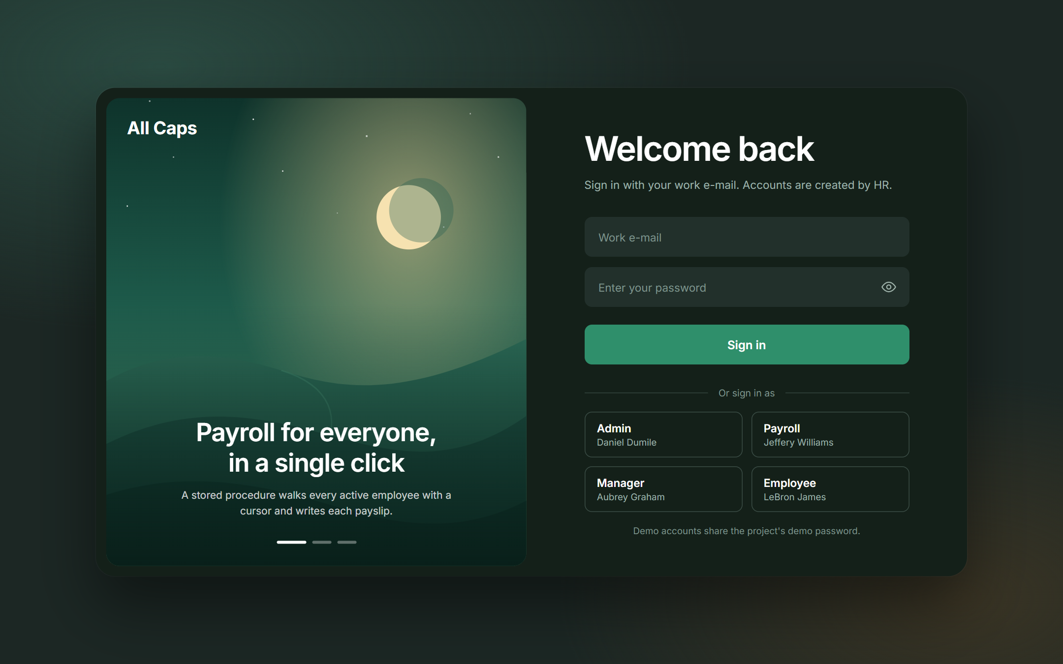
Figure 3 – Sign-in page. Each demo account opens a different role.
Row Level Security was verified by signing in as each role and counting the rows the database returned for the same queries:
Signed in as | employee | payroll | leave_request | attendance | Generate payroll?
Not signed in | denied | denied | denied | denied | denied
Admin (Daniel Dumile) | 20 | 39 | 13 | 971 | allowed
Payroll (Jeffery Williams) | 20 | 39 | 13 | 971 | allowed
Manager (Aubrey Graham) | 8 (self, manager, team) | 2 (own) | 6 (own + team) | 321 | blocked
Employee (LeBron James) | 2 (self + manager) | 2 (own) | 2 (own) | 50 (own) | blocked

T1. Employee checks in
Question | Answer
Operation | LeBron James clicks “Check in” on his dashboard.
Tables involved | ATTENDANCE
SQL component | INSERT INTO attendance (emp_id, att_date, check_in, status) VALUES (6, CURRENT_DATE, <time>, 'Present'); – allowed by an RLS policy only for the employee’s own row and only for today.
Effect on database | One attendance row is inserted. UNIQUE (emp_id, att_date) rejects a second check-in on the same day.
Result | The dashboard shows “Present · In 16:02” and a Check out button (which performs an UPDATE of check_out).
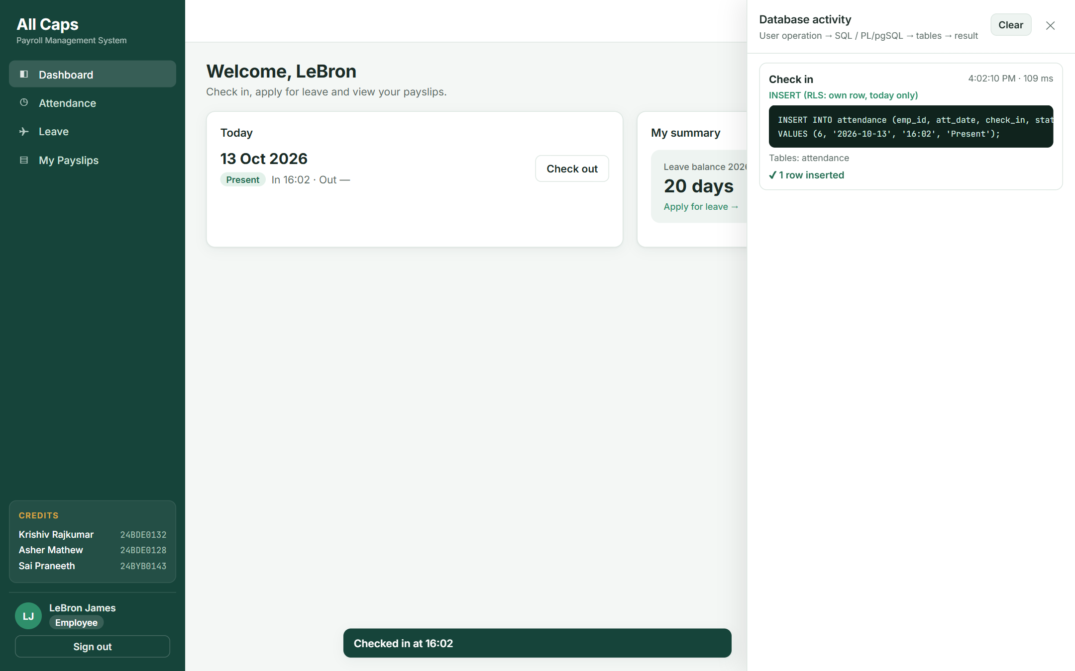
Figure 4 – Employee check-in with the INSERT shown in the DB activity panel.

T2. Employee applies for leave
Question | Answer
Operation | LeBron applies for 2 days of Casual leave (27–28 October).
Tables involved | LEAVE_REQUEST (read: LEAVE_REQUEST, DESIGNATION for the balance)
SQL component | SELECT fn_leave_balance(6, 2026) to show the balance; INSERT INTO leave_request … with status DEFAULT 'Pending'.
Effect on database | A Pending request is inserted. CHECK (end_date ≥ start_date) and the RLS policy (own row, status Pending, no approver) are enforced.
Result | The request appears under “My requests” with status Pending.
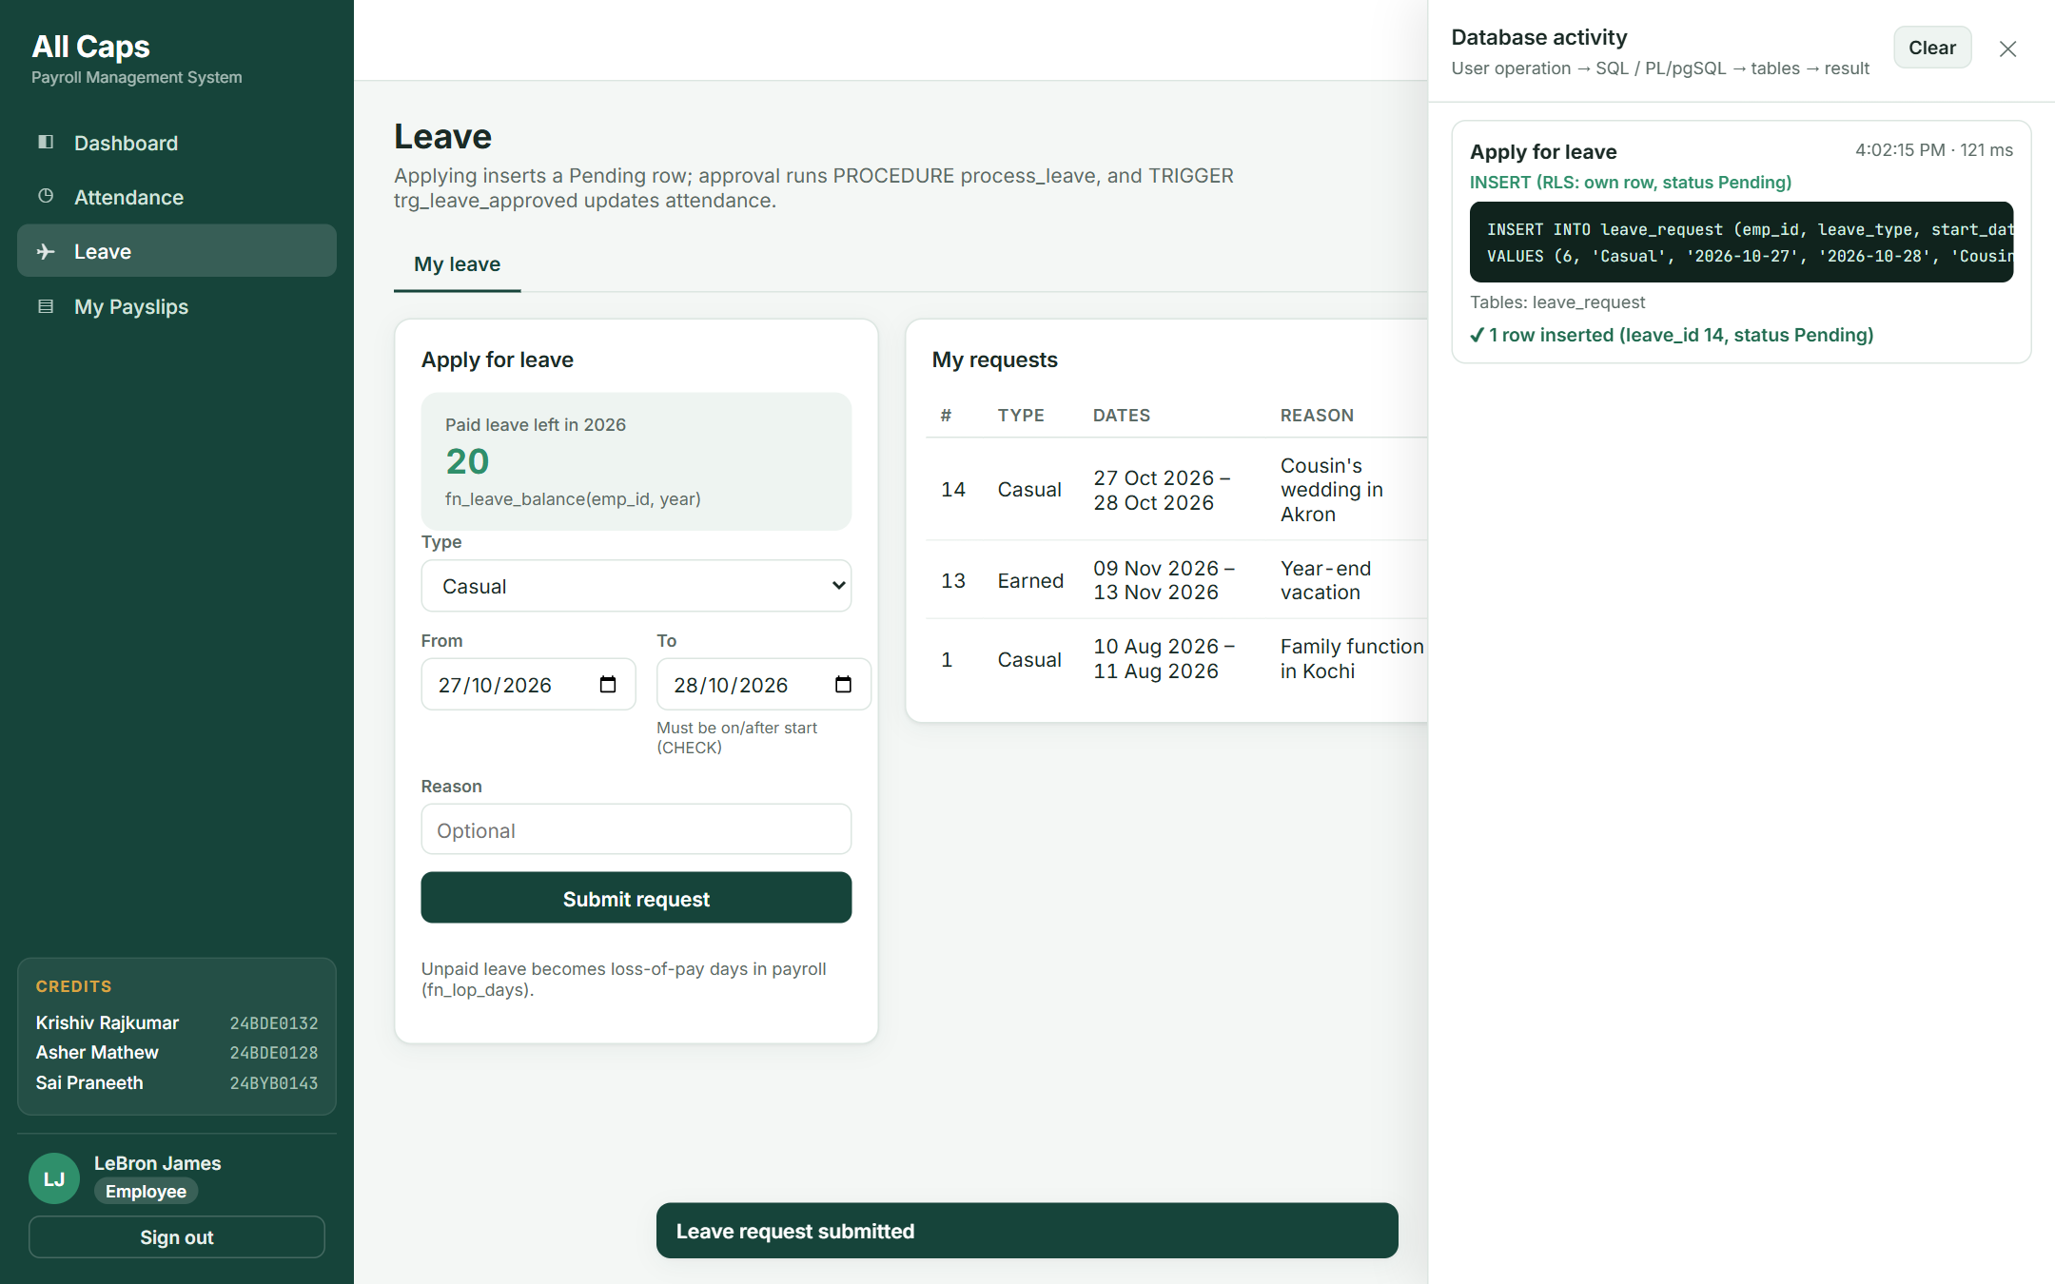
Figure 5 – Applying for leave: fn_leave_balance shown on the left, the INSERT in the activity panel.

T3. Manager approves leave
Question | Answer
Operation | Aubrey Graham approves Coco Gauff’s sick leave (request #10).
Tables involved | LEAVE_REQUEST, EMPLOYEE, DESIGNATION, ATTENDANCE
SQL / PL/pgSQL component | SELECT api_process_leave(10, 'Approved') → CALL process_leave(10, 4, 'Approved') → fn_leave_balance → TRIGGER trg_leave_approved.
Effect on database | leave_request #10 becomes Approved with approved_by = 4; the trigger inserts ‘Leave’ attendance rows for 15 and 16 October.
Result | The request leaves the approval queue; Coco’s attendance shows the two leave days (section 8.4).
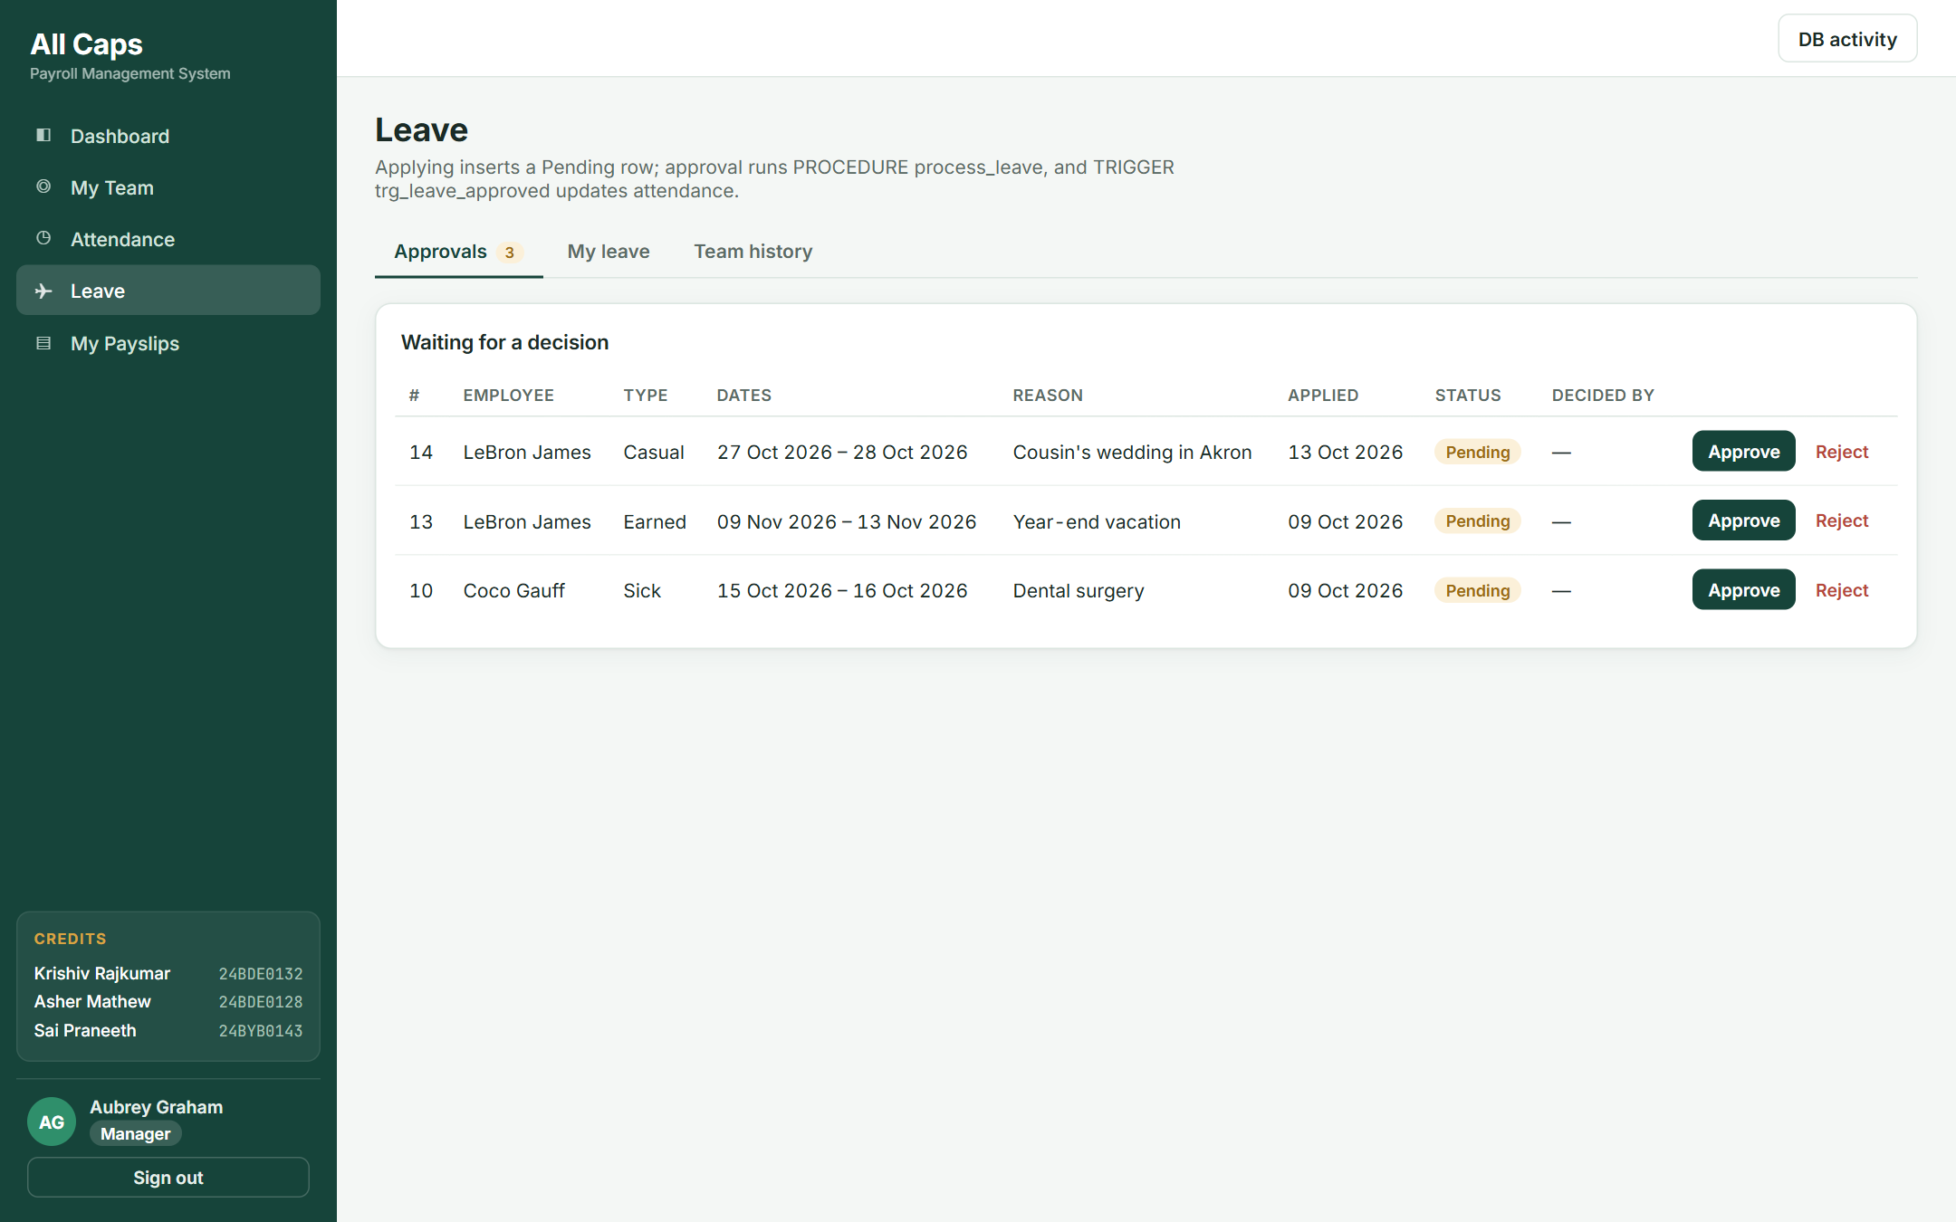
Figure 6 – The manager’s approval queue (RLS returns only the manager’s team).
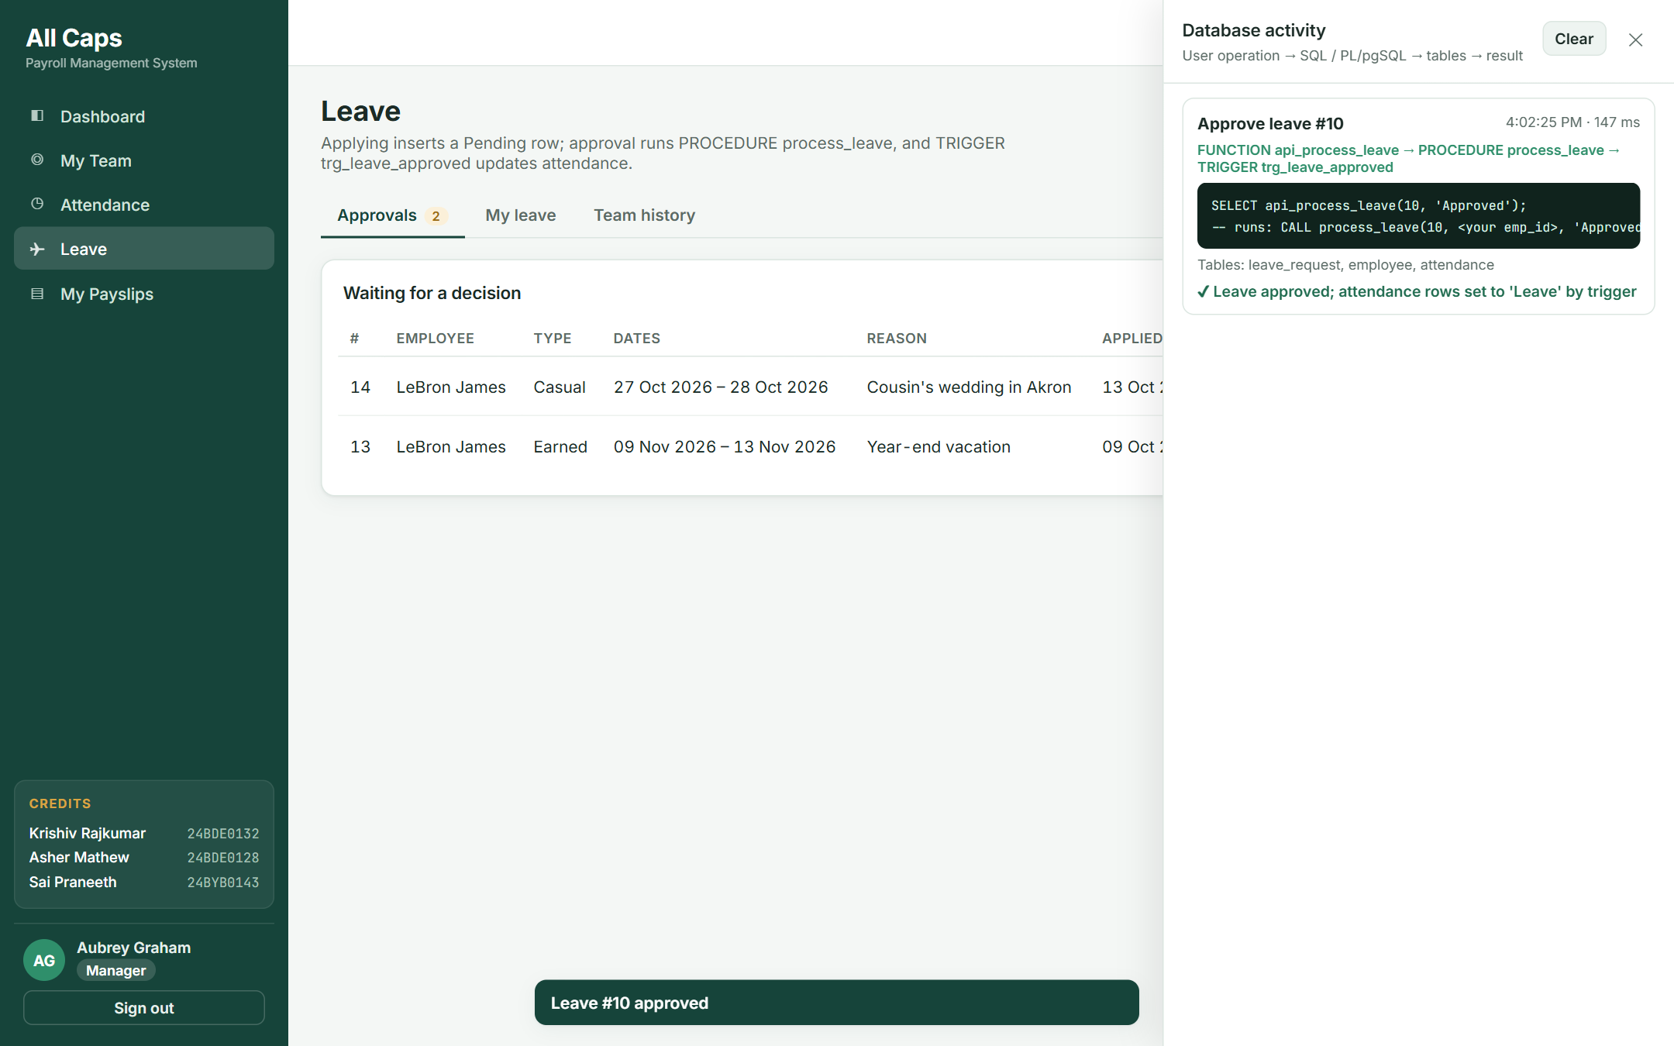
Figure 7 – After approval: the procedure and trigger chain shown in the activity panel.

T4. Payroll officer generates the monthly payroll
Question | Answer
Operation | Jeffery Williams selects October 2026 and clicks “Generate payroll”.
Tables involved | EMPLOYEE, DESIGNATION, ATTENDANCE, LEAVE_REQUEST, SALARY_COMPONENT (read); PAYROLL, PAYROLL_DETAIL (write)
SQL / PL/pgSQL component | SELECT api_generate_payroll(10, 2026) → CALL generate_monthly_payroll(10, 2026) – cursor over active employees using fn_working_days, fn_lop_days and fn_component_amount.
Effect on database | 19 PAYROLL rows (status Generated) and one PAYROLL_DETAIL row per active salary component for each are inserted. Running it again inserts nothing.
Result | The payroll table lists all 19 active employees with LOP days, gross, deductions and net pay; totals are shown above it.
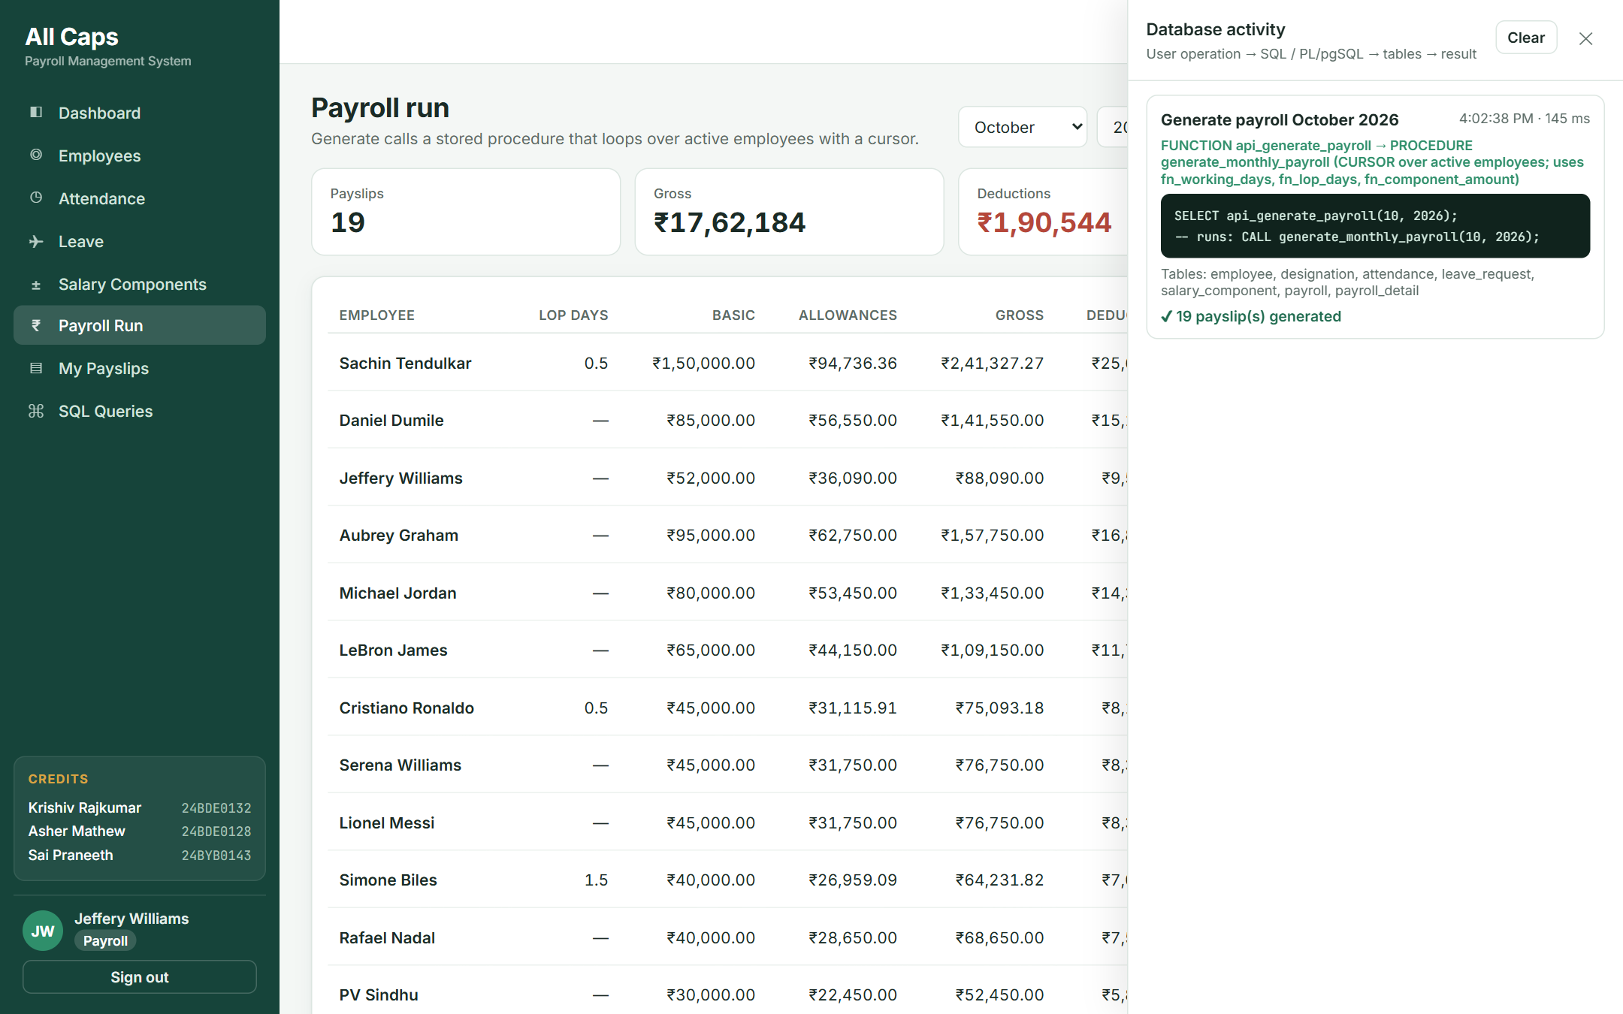
Figure 8 – Generating October payroll: one click runs the cursor-based procedure for 19 employees.

T5. Viewing an itemised payslip
Question | Answer
Operation | The payroll officer (or the employee, from My Payslips) opens a payslip.
Tables involved | PAYROLL, PAYROLL_DETAIL, SALARY_COMPONENT, EMPLOYEE, DEPARTMENT, DESIGNATION
SQL component | SELECT … FROM payroll_detail JOIN salary_component … WHERE payroll_id = ? (the M:N bridge table) plus the employee details.
Effect on database | Read only. RLS lets an employee read only their own payslips.
Result | Earnings (basic, loss of pay, allowances), deductions and net pay, ready to print.
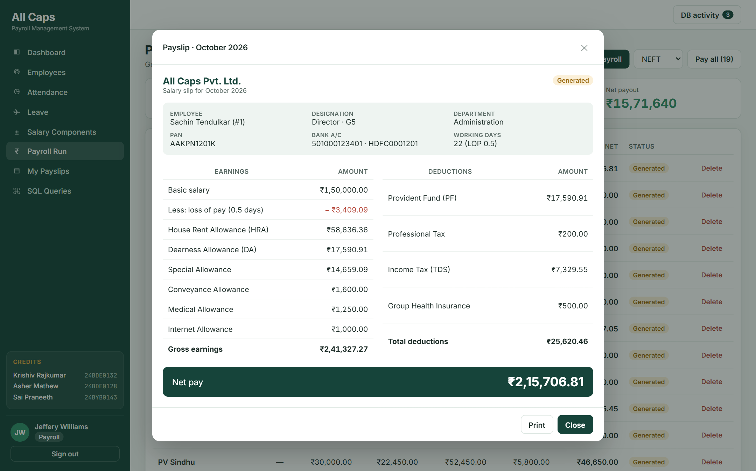
Figure 9 – Itemised payslip built from PAYROLL_DETAIL.

T6. Paying the month’s salaries
Question | Answer
Operation | The payroll officer chooses NEFT and clicks “Pay all”.
Tables involved | PAYROLL
SQL / PL/pgSQL component | SELECT api_pay_payroll(10, 2026, 'NEFT') → CALL pay_monthly_payroll(…) – cursor FOR UPDATE with UPDATE … WHERE CURRENT OF.
Effect on database | Every Generated row of the month becomes Paid with payment_date, payment_mode and a unique transaction_ref (CHECK: Paid ⇒ date and mode present).
Result | “19 payroll row(s) marked Paid”; the rows are now locked by trg_lock_paid_payroll.
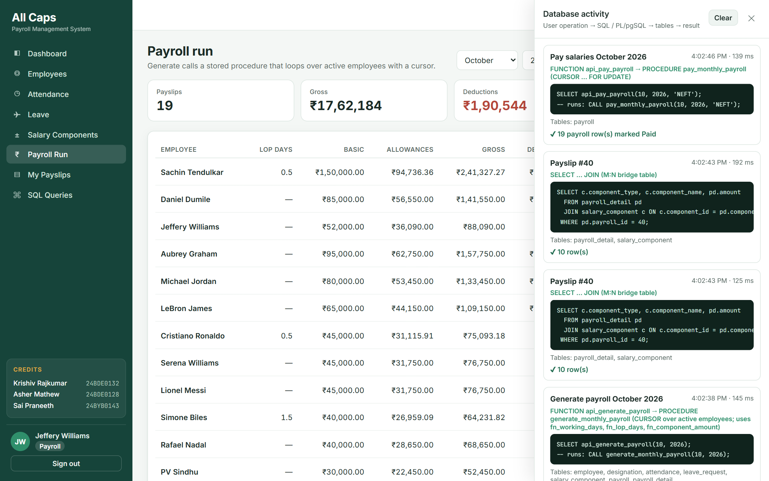
Figure 10 – Paying salaries through the second cursor-based procedure.

T7. Attempt to delete a paid payslip
Question | Answer
Operation | The payroll officer clicks Delete on Sachin Tendulkar’s paid October payroll.
Tables involved | PAYROLL (PAYROLL_DETAIL would cascade)
SQL / PL/pgSQL component | DELETE FROM payroll WHERE payroll_id = 40; → BEFORE DELETE trigger trg_lock_paid_payroll.
Effect on database | The trigger raises an exception, so the DELETE is rolled back and nothing changes.
Result | The error message from the database is shown to the user.
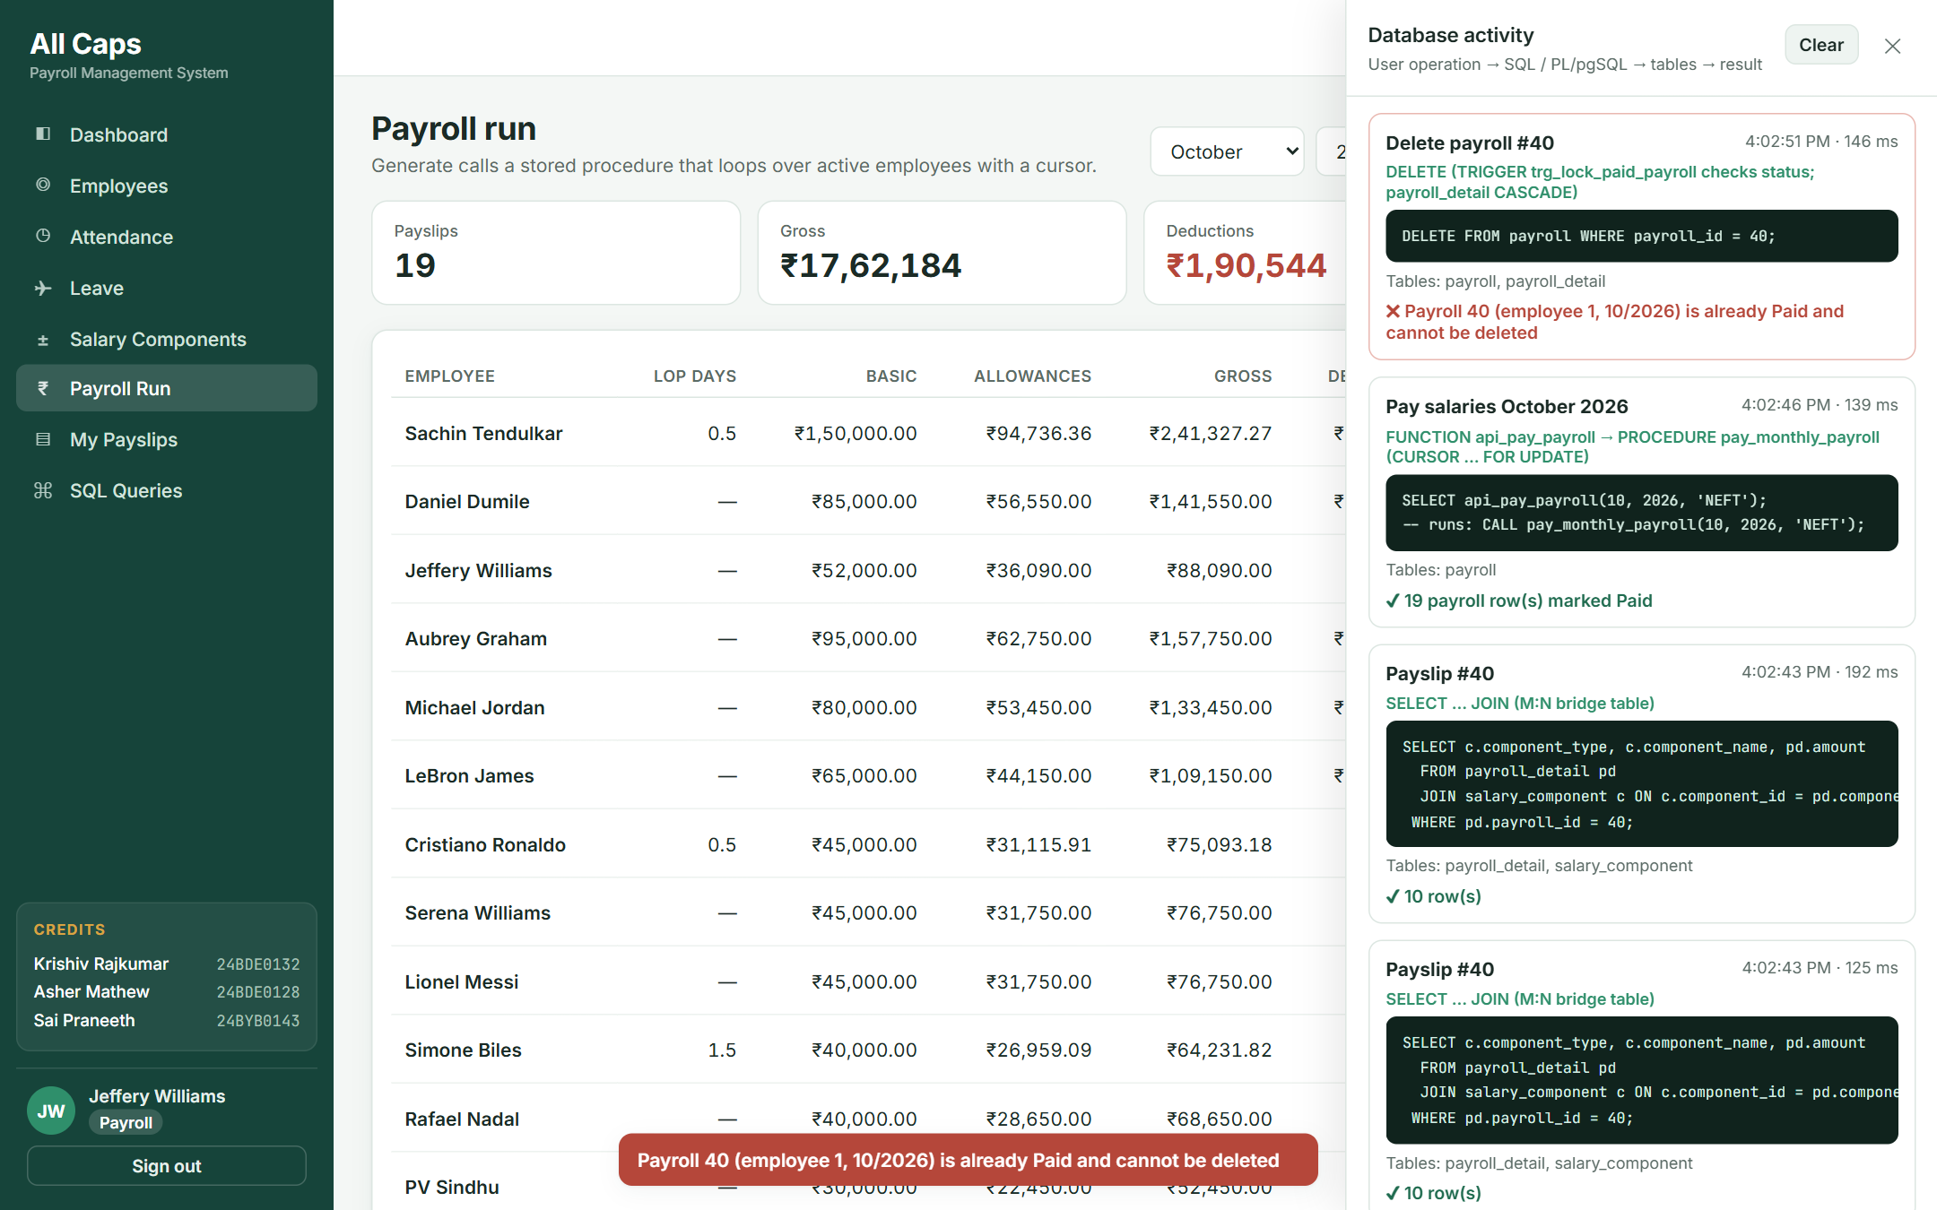
Figure 11 – The trigger blocks deleting a paid payroll; the error comes from the database.

T8. Employee resignation
Question | Answer
Operation | The Admin edits Michael Jordan’s record and sets status to Resigned.
Tables involved | EMPLOYEE, DEPARTMENT, LEAVE_REQUEST
SQL / PL/pgSQL component | UPDATE employee SET status = 'Resigned' WHERE emp_id = 5; → AFTER UPDATE trigger trg_employee_exit (which in turn fires trg_validate_manager for the moved employees).
Effect on database | His three reports now report to Sachin Tendulkar, the Sales department has no head, and any pending leave of his is rejected. He is excluded from later payroll runs.
Result | Shown with before/after outputs in section 8.4 (Trigger 4).

T9. Running the report queries from the application
Question | Answer
Operation | The Admin opens SQL Queries and runs Q4 (department-wise salary cost).
Tables involved | PAYROLL, EMPLOYEE, DEPARTMENT (through view q04_department_salary_cost)
SQL component | SELECT * FROM q04_department_salary_cost; – a view created WITH (security_invoker = true) so RLS still applies.
Effect on database | Read only.
Result | The SQL text, the concepts used and the live result table are shown on one page.
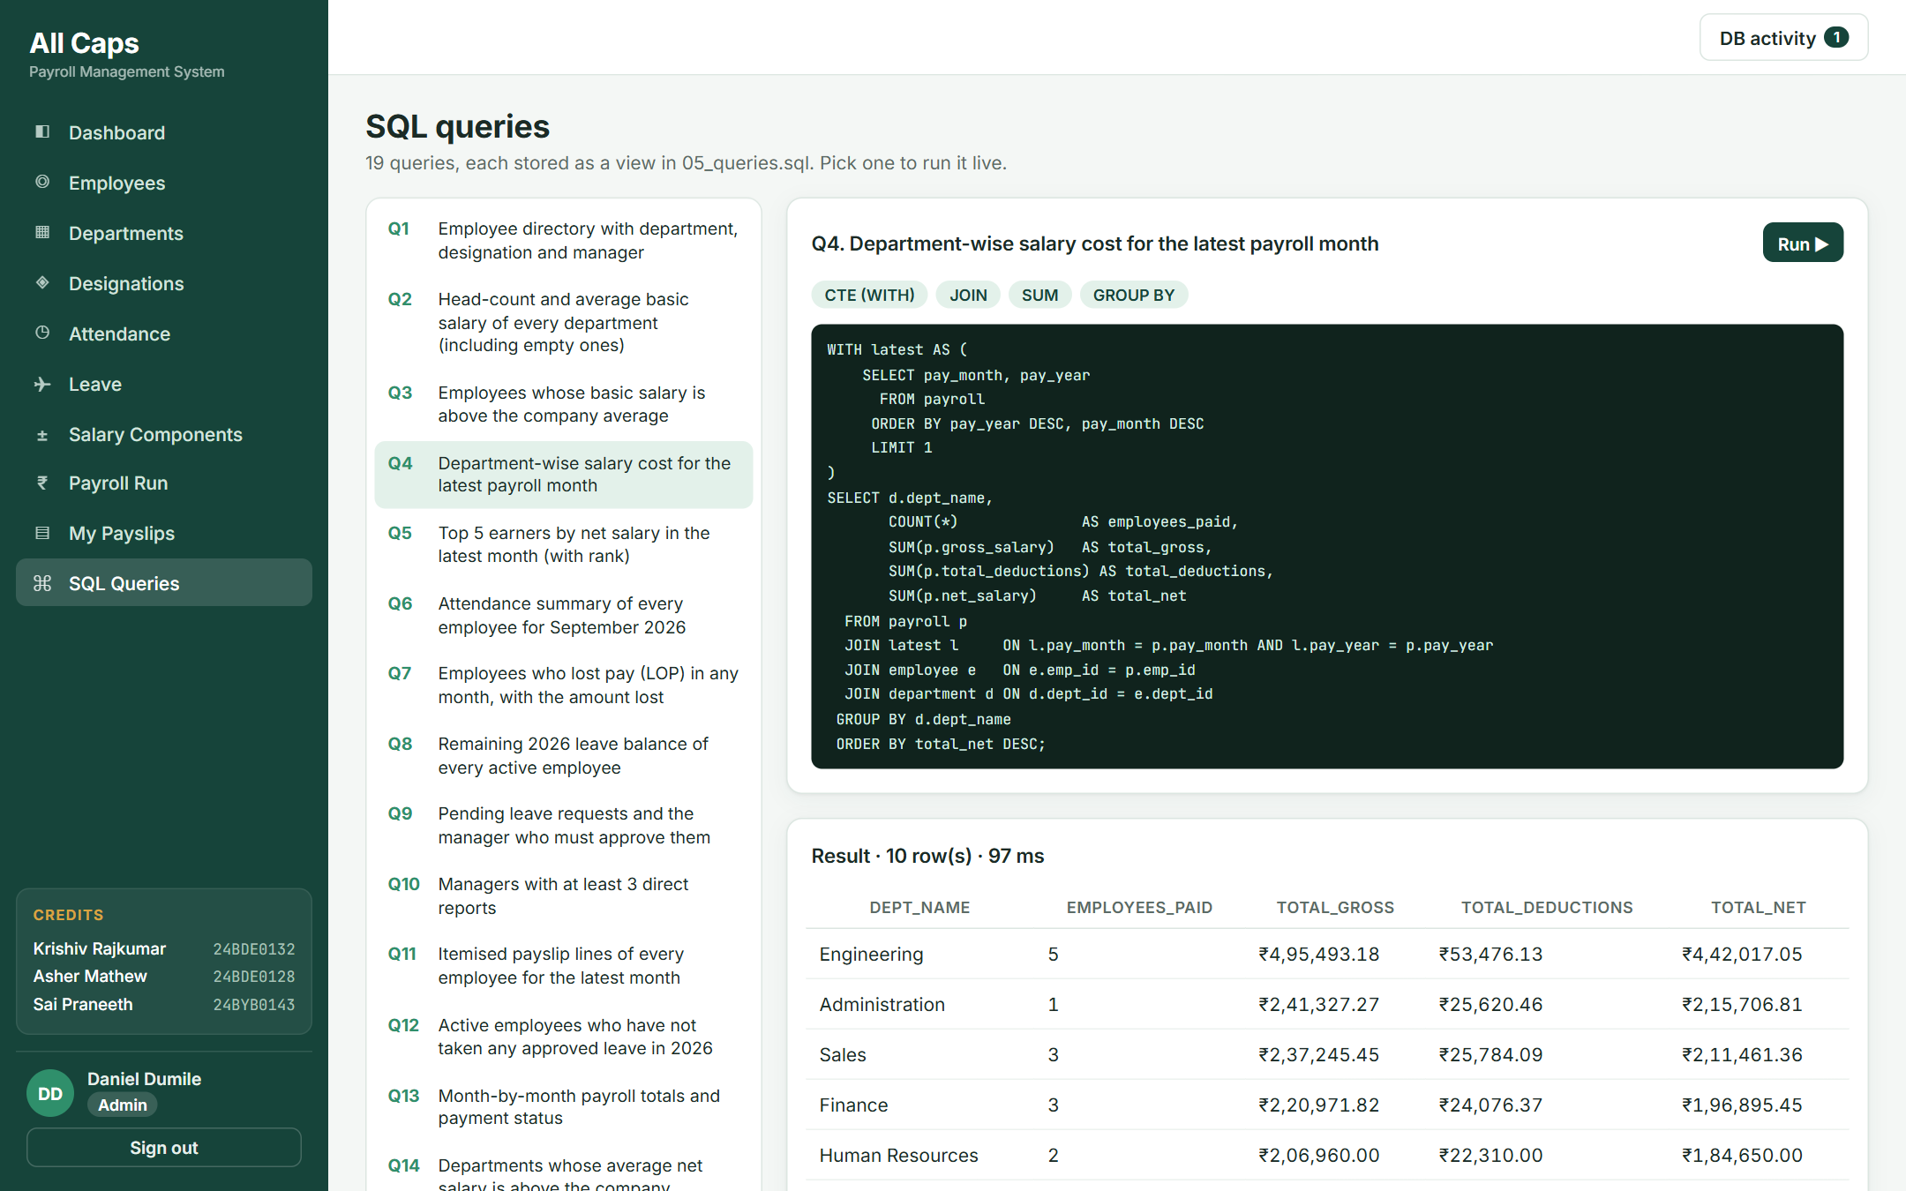
Figure 12 – The SQL Queries page running Q4 live against the database.
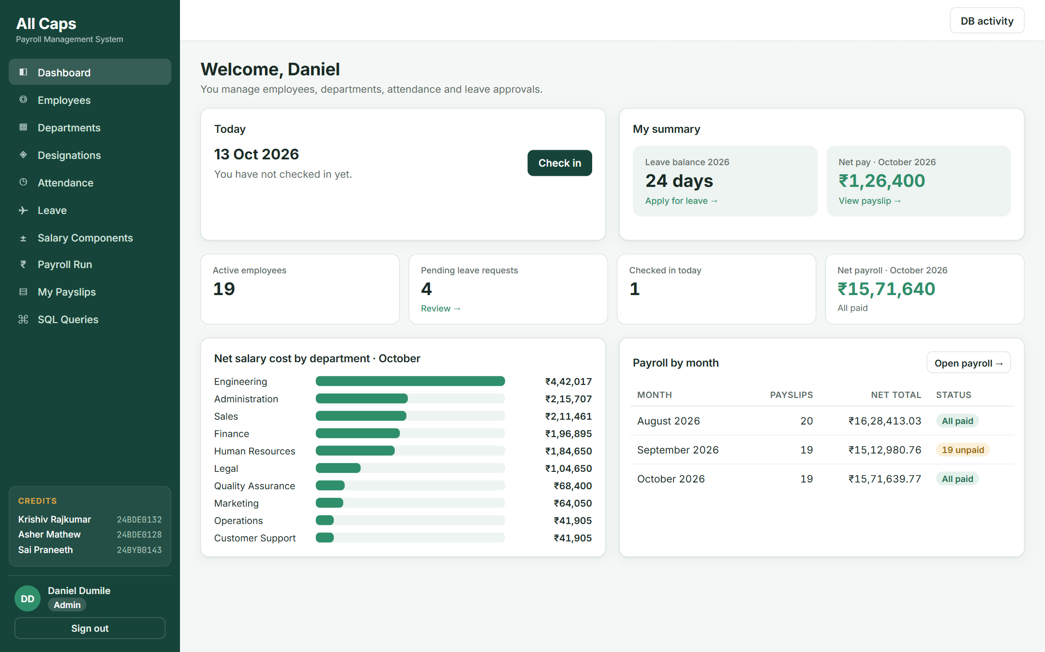
Figure 13 – Admin dashboard built from views q13 and q04 and live counts.

10. Conclusion
The Employee Payroll Management System has been implemented as a PostgreSQL database on Supabase with a role-based web application. The database has 8 normalised tables with complete primary key, foreign key, NOT NULL, UNIQUE, CHECK and DEFAULT constraints, populated with realistic data for a 20-employee company over three months.
Nineteen SQL queries cover joins, self-joins, aggregation, grouping with HAVING, correlated and scalar subqueries, set operations, window functions and date functions. Four functions, three procedures (two using explicit cursors) and four triggers implement the real business operations – loss-of-pay calculation, leave approval, payroll generation, salary payment and employee exit – and the database itself rejects invalid operations such as editing a paid payslip, approving one’s own leave or exceeding the leave balance.
Every component has a clear purpose in the application: each user action in the web app maps to a specific SQL statement, procedure or trigger, and the DB activity panel shows that flow live during the demonstration. Possible extensions are tax-regime based TDS calculation, salary revisions with effective dates, and an audit log table populated by triggers.

