School of Computer Science Engineering and Information Systems
BCSE302L – Database Systems | Course Project
EMPLOYEE PAYROLL MANAGEMENT SYSTEM
Review I – Problem Analysis & Database Design
Submitted by
<Student Name> – <Register Number>
Under the guidance of
<Faculty Name>
October 2026

Contents
Contents 2
1. Introduction and Problem Statement 3
1.1 Introduction 3
1.2 Problem Statement 3
1.3 Objectives 3
1.4 Users of the System 3
1.5 Scope 4
2. Requirement Analysis 5
2.1 Functional Requirements 5
2.2 Non-Functional Requirements 5
2.3 Entities and Attributes 5
2.4 Relationships and Cardinality 6
3. ER Diagram 8
4. Relational Schema 9
4.1 Relational Schema (text notation) 10
4.2 Foreign Keys 10
4.3 ER to Relational Mapping Steps 11
5. Table Creation and Constraints 12
5.1 Normalisation 12
6. System Architecture and Planned Implementation 13
6.1 Technology Stack 13
6.2 Interactive Flow 13
6.3 Planned Database Programs (Review II) 13
7. Conclusion 13

(Right-click the table above and choose “Update Field” in Word to refresh page numbers.)

1. Introduction and Problem Statement

1.1 Introduction
Every organisation must pay its employees accurately and on time every month. Salary is not a single fixed number: it depends on the employee’s designation and basic pay, statutory allowances (HRA, DA), deductions (Provident Fund, Professional Tax, Income Tax/TDS), the number of days actually worked, and approved or unapproved leave. In many small and medium organisations this is still handled in spreadsheets, which leads to calculation errors, duplicate records, no audit trail and no easy way to answer questions such as “What is the total salary cost of the Sales department this month?”.
The Employee Payroll Management System is a relational database application, hosted on a cloud PostgreSQL database (Supabase), with a web-based admin panel. It stores employee, department, attendance, leave and salary-structure data, and generates monthly payroll and payslips from that data automatically using SQL and PL/pgSQL (procedures, functions, cursors and triggers).

1.2 Problem Statement
Design and implement a centralised, consistent and secure database that (a) maintains employee and organisational data, (b) records daily attendance and leave, (c) defines salary components such as allowances and deductions, and (d) computes each employee’s monthly gross and net salary, including loss-of-pay (LOP) for unpaid absences, while enforcing business rules through database constraints and triggers instead of manual checks.

1.3 Objectives
- Maintain a single source of truth for employees, departments and designations, with no duplicate or inconsistent data.
- Record attendance and leave, and automatically compute loss-of-pay days for each month.
- Define configurable salary components (fixed or percentage-based allowances and deductions).
- Generate the monthly payroll for all active employees in one operation, with an itemised payslip.
- Enforce data integrity with PK/FK, NOT NULL, UNIQUE, CHECK and DEFAULT constraints and triggers.
- Provide an admin web interface connected to the database for interactive INSERT, UPDATE, DELETE and reporting.

1.4 Users of the System
User / Role | Responsibilities in the system
HR Administrator | Adds and updates departments, designations and employees; records attendance; manages employee status (resigned, terminated).
Payroll Officer (Accounts) | Maintains salary components, runs the monthly payroll, marks salaries as paid and records payment details.
Reporting Manager | Approves or rejects leave requests of employees who report to them.
Employee (read-only view) | Views own attendance, leave status and payslips; applies for leave.

1.5 Scope
In scope: employee master data, department and designation hierarchy, reporting structure, daily attendance, leave requests and approval, salary components, monthly payroll generation, payslip line items, payment records and management reports.
Out of scope: actual bank fund transfers, full income-tax computation under the different tax regimes, recruitment, performance appraisal, and biometric hardware integration. TDS is modelled as a simple percentage deduction.

2. Requirement Analysis

2.1 Functional Requirements
ID | Requirement | Tables involved
FR1 | Add, update, deactivate and view departments, including the department head. | DEPARTMENT, EMPLOYEE
FR2 | Maintain designations with pay grade, basic salary and annual leave quota. | DESIGNATION
FR3 | Register a new employee with personal, statutory (PAN) and bank details, and assign department, designation and reporting manager. | EMPLOYEE
FR4 | Record daily attendance (check-in, check-out, status); only one record per employee per day. | ATTENDANCE
FR5 | Employee applies for leave; manager approves or rejects. Approved leave is reflected in attendance automatically. | LEAVE_REQUEST, ATTENDANCE
FR6 | Define allowances and deductions as a fixed amount or a percentage of basic salary. | SALARY_COMPONENT
FR7 | Generate payroll for a given month and year for every active employee, calculating LOP days, gross and net salary. | PAYROLL, PAYROLL_DETAIL, ATTENDANCE, LEAVE_REQUEST
FR8 | Store an itemised payslip (amount of each component) for every payroll record. | PAYROLL_DETAIL
FR9 | Mark payroll as paid with payment date, mode and transaction reference. | PAYROLL
FR10 | Prevent invalid operations: duplicate payroll for the same month, editing a paid payroll, self-approval of leave. | All (constraints + triggers)
FR11 | Reports: department-wise salary cost, attendance summary, leave balance, top earners, employees under a manager. | All
FR12 | Web admin panel connected to the database for all of the above operations. | All

2.2 Non-Functional Requirements
- Integrity: all business rules that can be expressed declaratively are enforced as constraints in the database, not only in the UI.
- Security: the database is accessed through Supabase with Row Level Security; only authenticated admins can modify data.
- Availability: cloud-hosted PostgreSQL, so the admin panel works from any browser.
- Auditability: payroll figures are stored as a monthly snapshot, so past payslips do not change if salary rules change later.

2.3 Entities and Attributes
Seven entity types were identified. Primary keys are shown in bold. Derived attributes are calculated and marked (D); composite attributes are marked (C).
Entity | Description | Attributes
DEPARTMENT | An organisational unit of the company. | dept_id, dept_name, location, created_on
DESIGNATION | A job title with its pay grade and basic pay. | desig_id, title, pay_grade, basic_salary, annual_leave_quota
EMPLOYEE | A person employed by the company. | emp_id, name (C: first_name, last_name), email, phone, gender, dob, age (D), date_of_joining, pan_no, bank_account_no, ifsc_code, status
ATTENDANCE | Attendance of one employee on one day. | attendance_id, att_date, check_in, check_out, status, hours_worked (D)
LEAVE_REQUEST | A leave application and its approval status. | leave_id, leave_type, start_date, end_date, no_of_days (D), reason, status, applied_on
SALARY_COMPONENT | An allowance or deduction rule. | component_id, component_name, component_type, calc_method, value, is_taxable, is_active
PAYROLL | The salary record of one employee for one month. | payroll_id, pay_period (C: pay_month, pay_year), working_days, lop_days, basic_salary, total_allowances, total_deductions, gross_salary (D), net_salary (D), status, generated_on, payment (C: payment_date, payment_mode, transaction_ref)

2.4 Relationships and Cardinality
Relationship | Entities | Cardinality | Participation | Meaning
WORKS_IN | DEPARTMENT – EMPLOYEE | 1 : N | Employee total | Every employee belongs to exactly one department.
HEADS | EMPLOYEE – DEPARTMENT | 1 : 1 | Partial both | A department may have one head; an employee heads at most one department.
HOLDS | DESIGNATION – EMPLOYEE | 1 : N | Employee total | Every employee has exactly one designation.
REPORTS_TO | EMPLOYEE – EMPLOYEE (recursive) | 1 : N | Partial | A manager supervises many employees; each employee has at most one manager.
MARKS | EMPLOYEE – ATTENDANCE | 1 : N | Attendance total | Each attendance row belongs to one employee.
APPLIES | EMPLOYEE – LEAVE_REQUEST | 1 : N | Leave total | An employee can apply for many leaves.
APPROVES | EMPLOYEE – LEAVE_REQUEST | 1 : N | Partial | A manager approves many leave requests; a pending request has no approver yet.
RECEIVES | EMPLOYEE – PAYROLL | 1 : N | Payroll total | An employee receives one payroll record per month.
INCLUDES | PAYROLL – SALARY_COMPONENT | M : N | Payroll total | A payroll has many components; a component appears in many payrolls. Attribute: amount.

3. ER Diagram
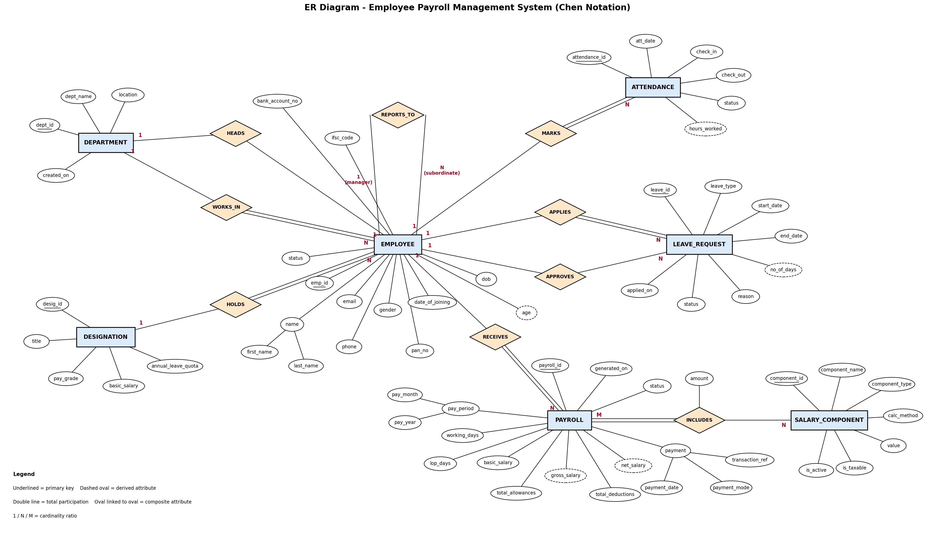
Figure 1 – ER diagram (Chen notation). Underlined: primary key; dashed oval: derived; double line: total participation.

4. Relational Schema
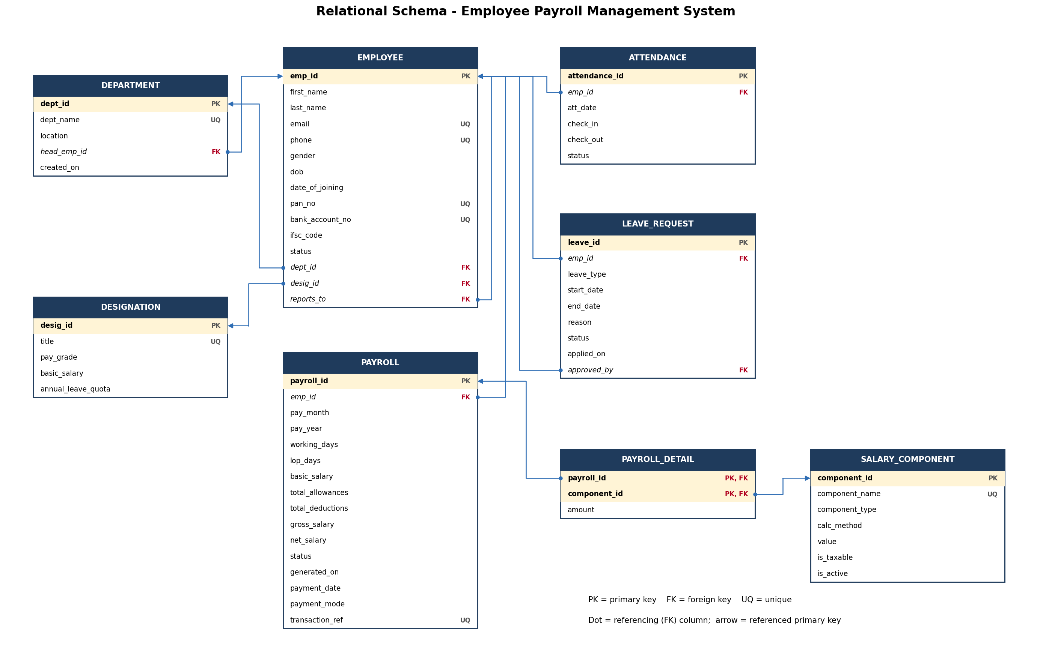
Figure 2 – Relational schema with primary keys and foreign-key references

4.1 Relational Schema (text notation)
Primary keys are bold and underlined; foreign keys are italic.
DEPARTMENT (dept_id, dept_name, location, head_emp_id, created_on)
DESIGNATION (desig_id, title, pay_grade, basic_salary, annual_leave_quota)
EMPLOYEE (emp_id, first_name, last_name, email, phone, gender, dob, date_of_joining, pan_no, bank_account_no, ifsc_code, status, dept_id, desig_id, reports_to)
ATTENDANCE (attendance_id, emp_id, att_date, check_in, check_out, status)
LEAVE_REQUEST (leave_id, emp_id, leave_type, start_date, end_date, reason, status, applied_on, approved_by)
SALARY_COMPONENT (component_id, component_name, component_type, calc_method, value, is_taxable, is_active)
PAYROLL (payroll_id, emp_id, pay_month, pay_year, working_days, lop_days, basic_salary, total_allowances, total_deductions, gross_salary, net_salary, status, generated_on, payment_date, payment_mode, transaction_ref)
PAYROLL_DETAIL (payroll_id, component_id, amount)

4.2 Foreign Keys
Foreign key | References | On delete | Reason
employee.dept_id | department.dept_id | Restrict | Cannot delete a department that still has employees.
employee.desig_id | designation.desig_id | Restrict | Cannot delete a designation in use.
employee.reports_to | employee.emp_id | Set null | If a manager leaves, subordinates remain without a manager.
department.head_emp_id | employee.emp_id | Set null | Department survives if its head is removed.
attendance.emp_id | employee.emp_id | Cascade | Attendance has no meaning without the employee.
leave_request.emp_id | employee.emp_id | Cascade | Leave belongs to the employee.
leave_request.approved_by | employee.emp_id | Set null | Keep the leave record even if the approver leaves.
payroll.emp_id | employee.emp_id | Restrict | Salary history must never be lost (employees are marked Resigned, not deleted).
payroll_detail.payroll_id | payroll.payroll_id | Cascade | Line items are deleted with their payroll.
payroll_detail.component_id | salary_component.component_id | Restrict | A component used in a payslip cannot be deleted (it is deactivated instead).

4.3 ER to Relational Mapping Steps
- Strong entities → tables. Each of the 7 entities became a table with a surrogate primary key (SERIAL).
- Composite attributes → simple columns. name → first_name, last_name; pay_period → pay_month, pay_year; payment → payment_date, payment_mode, transaction_ref.
- Derived attributes. age, hours_worked and no_of_days are not stored; they are calculated in queries or functions. gross_salary and net_salary are stored on purpose as a monthly snapshot, so that old payslips stay correct after salary rules change.
- 1:N relationships → FK on the N side. WORKS_IN → employee.dept_id; HOLDS → employee.desig_id; MARKS, APPLIES, RECEIVES → emp_id in attendance, leave_request and payroll; APPROVES → leave_request.approved_by.
- Recursive 1:N (REPORTS_TO) → self-referencing FK employee.reports_to → employee.emp_id.
- 1:1 relationship (HEADS) → FK with UNIQUE department.head_emp_id, placed on the DEPARTMENT side because each department has at most one head, so this column has the fewest NULLs.
- M:N relationship (INCLUDES) → new table payroll_detail(payroll_id, component_id, amount) with a composite primary key made of both foreign keys. The relationship attribute amount becomes a column of this table.

5. Table Creation and Constraints
The full DDL is in sql/01_schema.sql (PostgreSQL / Supabase). The table below summarises the constraints and the business rule each one enforces.
Table | Key constraints | NOT NULL / UNIQUE / CHECK / DEFAULT
DEPARTMENT | PK dept_id; FK head_emp_id (UNIQUE) | dept_name UNIQUE NOT NULL; created_on DEFAULT CURRENT_DATE
DESIGNATION | PK desig_id | title UNIQUE; pay_grade IN (G1–G5); basic_salary > 0; annual_leave_quota DEFAULT 24, CHECK 0–60
EMPLOYEE | PK emp_id; FK dept_id, desig_id, reports_to | email, phone, pan_no, bank_account_no UNIQUE; phone matches ^[6-9][0-9]{9}$; PAN format ^[A-Z]{5}[0-9]{4}[A-Z]$; IFSC format; gender IN (M,F,O); status DEFAULT 'Active'; joining age ≥ 18; employee cannot report to self
ATTENDANCE | PK attendance_id; FK emp_id | UNIQUE (emp_id, att_date); status IN (Present, Absent, Half-Day, Leave) DEFAULT 'Present'; check_out > check_in
LEAVE_REQUEST | PK leave_id; FK emp_id, approved_by | leave_type IN (Casual, Sick, Earned, Unpaid); end_date ≥ start_date; status DEFAULT 'Pending'; approver ≠ applicant
SALARY_COMPONENT | PK component_id | component_name UNIQUE; type IN (Allowance, Deduction); calc_method IN (Fixed, Percent); value ≥ 0 and ≤ 100 when Percent; is_taxable, is_active DEFAULT TRUE
PAYROLL | PK payroll_id; FK emp_id | UNIQUE (emp_id, pay_month, pay_year); month 1–12; lop_days ≤ working_days; net_salary ≥ 0; status DEFAULT 'Generated'; a ‘Paid’ row must have payment_date and payment_mode; transaction_ref UNIQUE
PAYROLL_DETAIL | PK (payroll_id, component_id); both FK | amount ≥ 0

5.1 Normalisation
All tables are in Third Normal Form (3NF). Every non-key attribute depends on the whole key and nothing but the key:
- Department and designation details are stored once and referenced by FK, not repeated in every employee row (removes update anomalies).
- Salary component rules are separate from payslip line items, so a change in HRA percentage does not require editing old payslips.
- payroll_detail has a composite key, and its only non-key attribute (amount) depends on the full key (payroll and component), so there is no partial dependency.
- Age is not stored because it depends on dob and the current date (it would become a transitive or stale value).

6. System Architecture and Planned Implementation

6.1 Technology Stack
Layer | Technology | Purpose
Database | PostgreSQL 15 on Supabase (cloud) | Tables, constraints, SQL queries, PL/pgSQL procedures, functions, cursor and triggers
Connectivity | supabase-js client (JavaScript) / PostgREST API | Application ↔ database communication; procedures and functions are called through RPC
Front end | Web admin panel (HTML/CSS/JavaScript) | Forms and tables for HR and payroll operations, reports and payslips
Security | Supabase Auth + Row Level Security | Only signed-in administrators can modify data

6.2 Interactive Flow
User operation (web form) → SQL / PL/pgSQL call (supabase-js) → database processing (constraints, triggers, procedures) → database update or retrieval → result shown on the admin panel.

6.3 Planned Database Programs (Review II)
Component | Name | Business purpose
Procedure | generate_monthly_payroll(month, year) | Uses a cursor over all active employees to compute LOP, allowances, deductions, gross and net salary; inserts PAYROLL and PAYROLL_DETAIL rows.
Procedure | process_leave(leave_id, approver_id, decision) | Approves or rejects a leave request after checking the leave balance.
Function | fn_lop_days(emp_id, month, year) | Returns the number of unpaid (loss-of-pay) days in a month.
Function | fn_component_amount(component_id, basic) | Returns the amount of a fixed or percentage component for a given basic salary.
Function | fn_leave_balance(emp_id, year) | Returns the remaining annual leave of an employee.
Cursor | inside generate_monthly_payroll | Processes employees one record at a time.
Trigger | trg_leave_approved | When a leave is approved, inserts ‘Leave’ rows into ATTENDANCE for each day in the range.
Trigger | trg_lock_paid_payroll | Blocks UPDATE or DELETE of a payroll that is already Paid.
Trigger | trg_validate_manager | Ensures reports_to refers to an active employee in the same department.

7. Conclusion
This review defined the problem, users and scope of the Employee Payroll Management System, identified 7 entities and 9 relationships (including a recursive, a 1:1 and an M:N relationship), and converted the ER model into 8 relational tables in Third Normal Form, with complete primary key, foreign key and integrity constraints. The schema has been written as PostgreSQL DDL for Supabase. The next phase will add sample data (at least 10 rows per table), the 15+ SQL queries, the PL/pgSQL procedures, functions, cursor and triggers listed above, and the web admin panel that connects to the database.

