Justin Austin

Structures of Programming Languages

Dr. Li

January 27, 2017

System Specifications

Github URL: <https://github.com/LordJustinxAustin/StructuresProgram1>

Screen Shots:

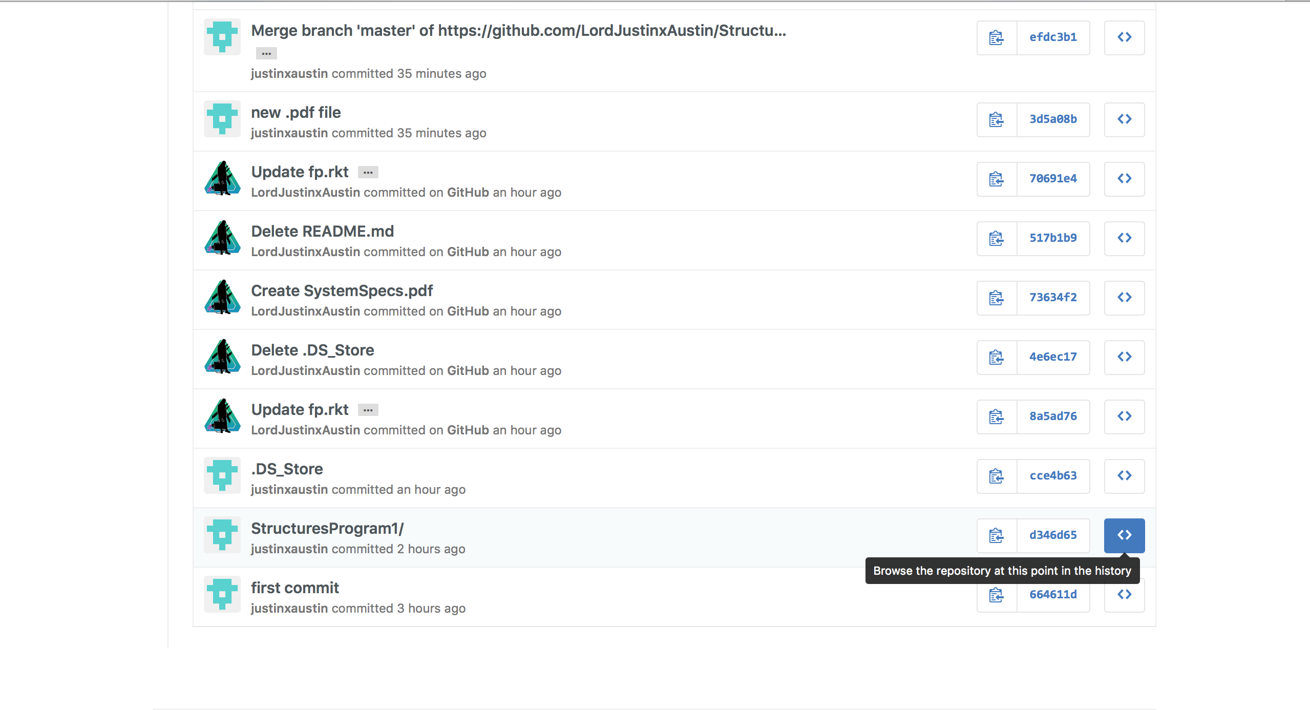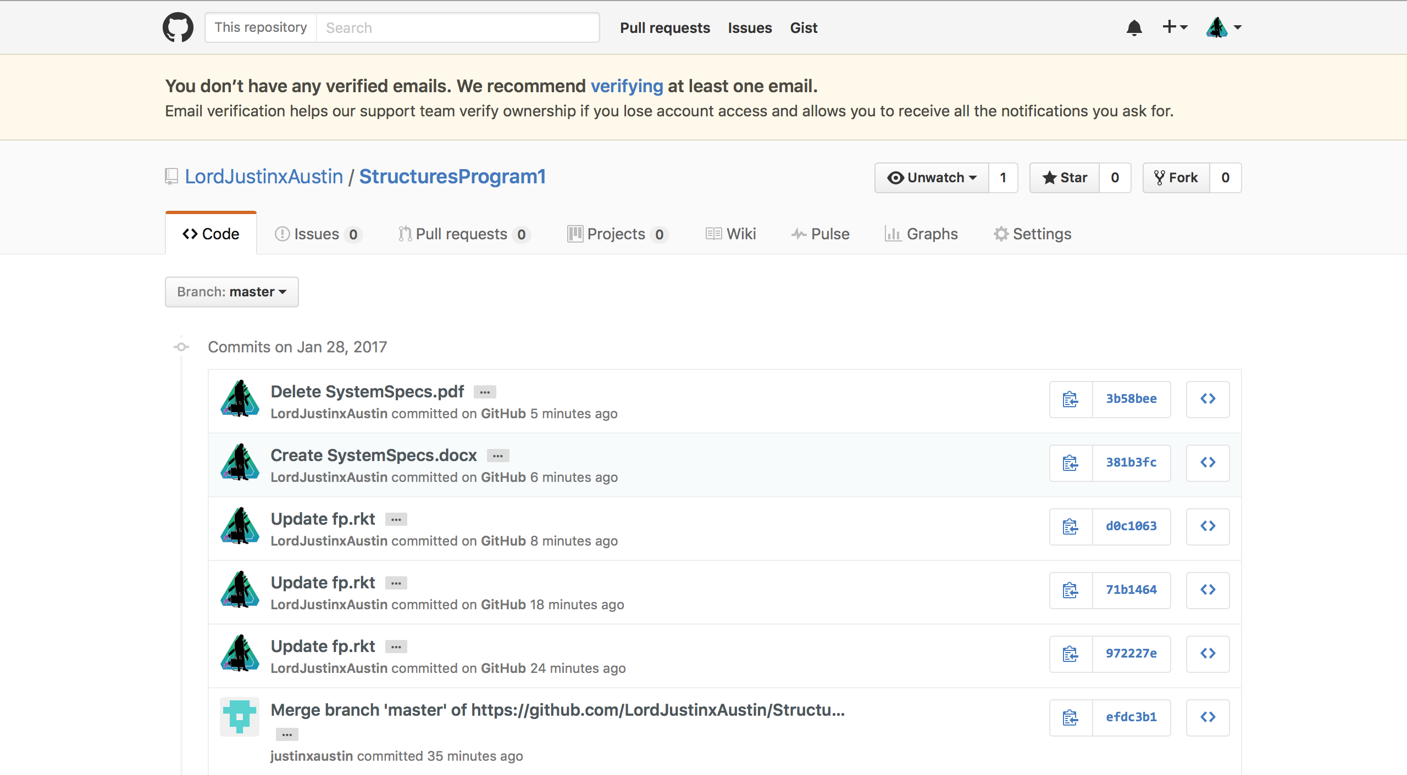

Commit History:

1. First commit I wasn’t that knowledgeable of github, therefore I didn’t know how to commit or set up any of my files. The timestamp doesn’t correctly show when I completed each because of this error.
2. I created and finally realized how to correctly format the files
3. .DS_Store was pushed and committed by accident I was playing around with the files
4. I updated the entire repository because at first I was coding in c++, so I deleted those recors. Created an fp.rkt directory and commented the entire assignment with each question
5. Deleted .DS_Store because I realized I didn’t need it after rereading the assignment
6. Tried to create a pdf but it wouldn’t let me edit so I played around with it and eventually created a .docx file that I could edit
7. I merged the work I was doing remote to the work on the web
8. Updated the repo with code from DrRacket
9. Came back through and supplied comments to the code
10. Deleted whatever excess documentation I had