Task 1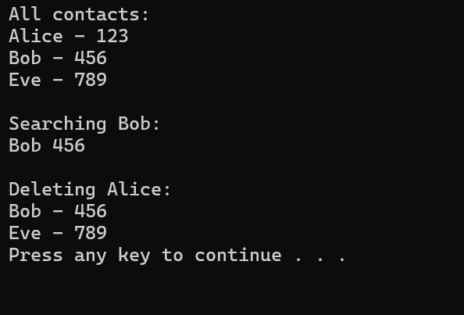

Task 2- Benchmark
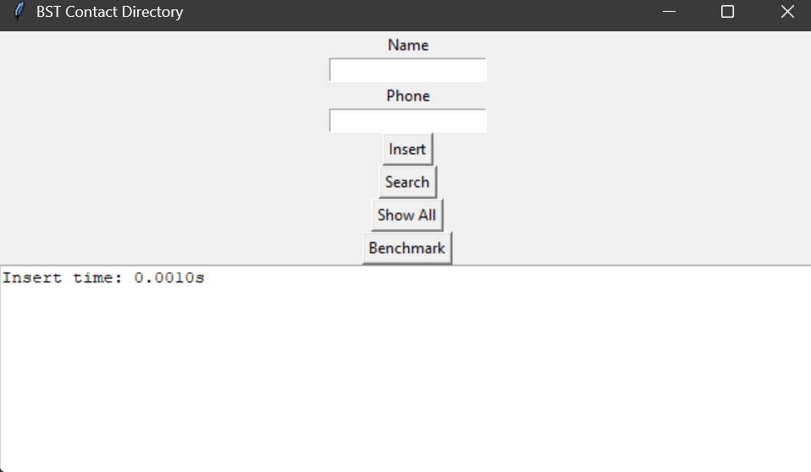

Show all
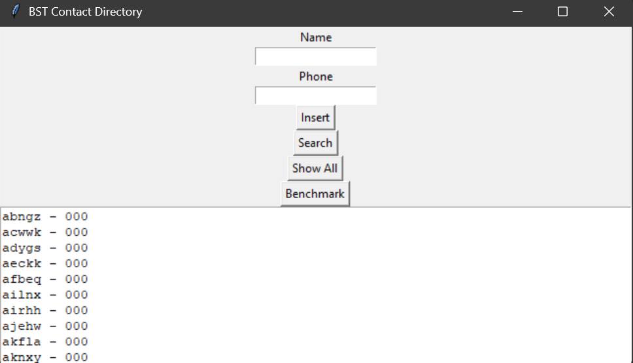
Insert – Aaron, 123456789
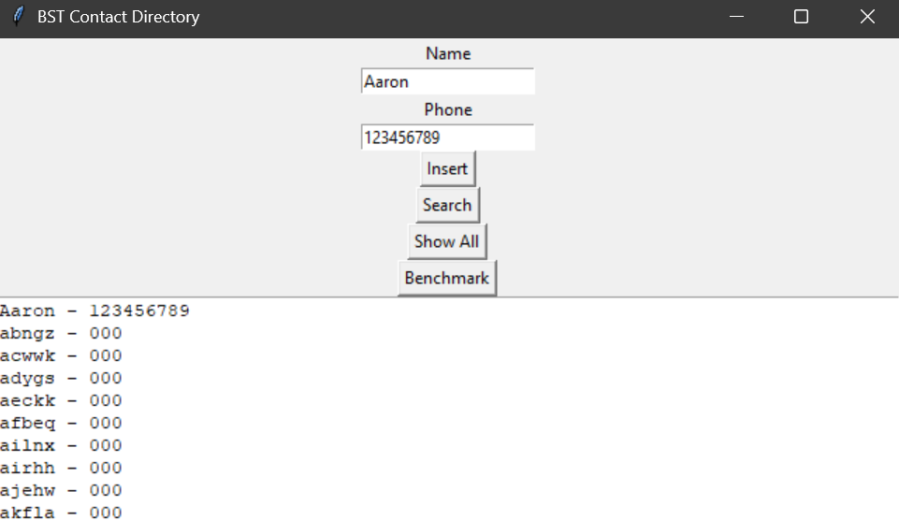

Search- Aaron, 123456789
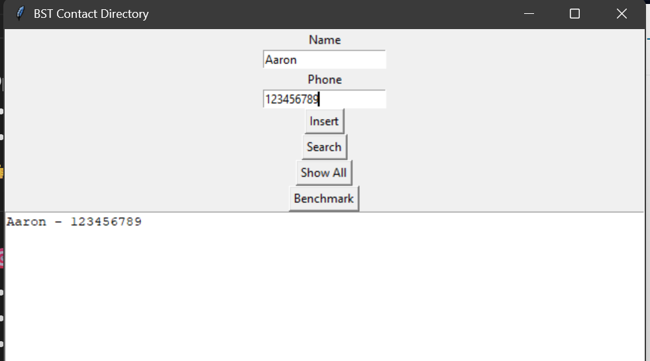
Delete – Aaron
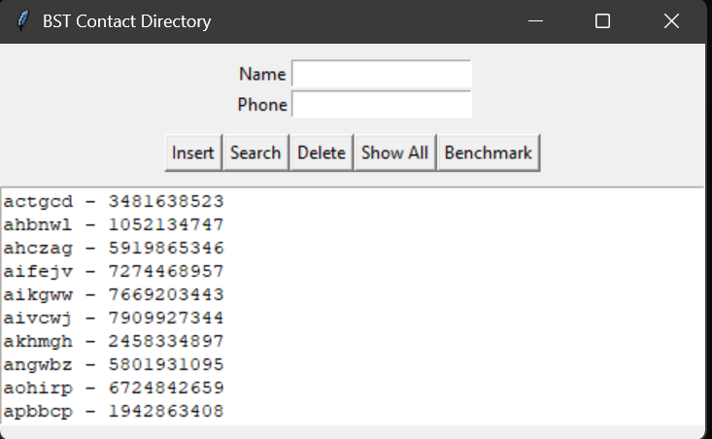

Task 3 – output
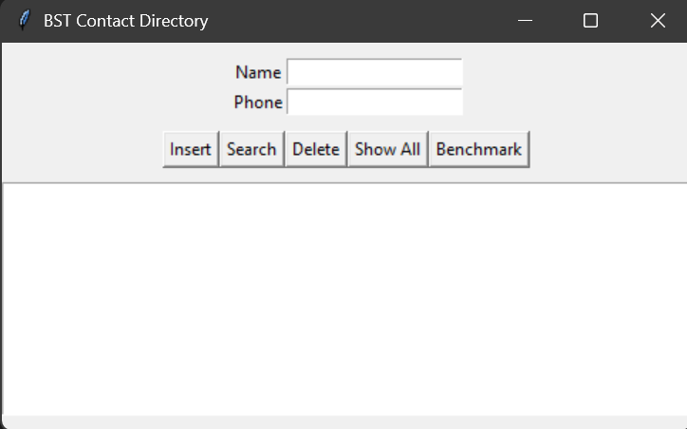

Task 4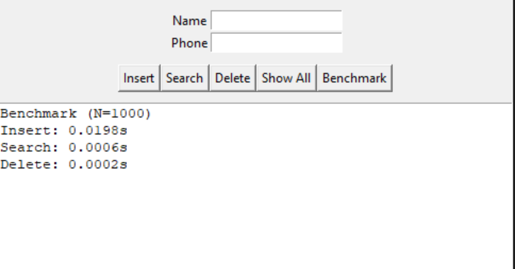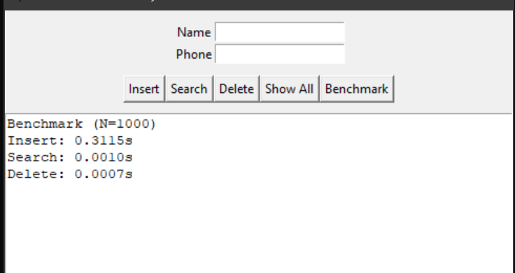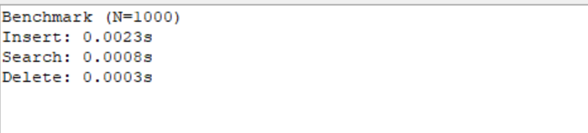
Operation | BST | AVL
Insert | fast | slightly slower
Search | can be slow | always fast
Delete | can be slow | always fast

Key Take Aways BST worse case O(n) is bad and AVL Always o(log n) is good, BST is faster to but abut risky AVL is slightly slower but always efficient.

