5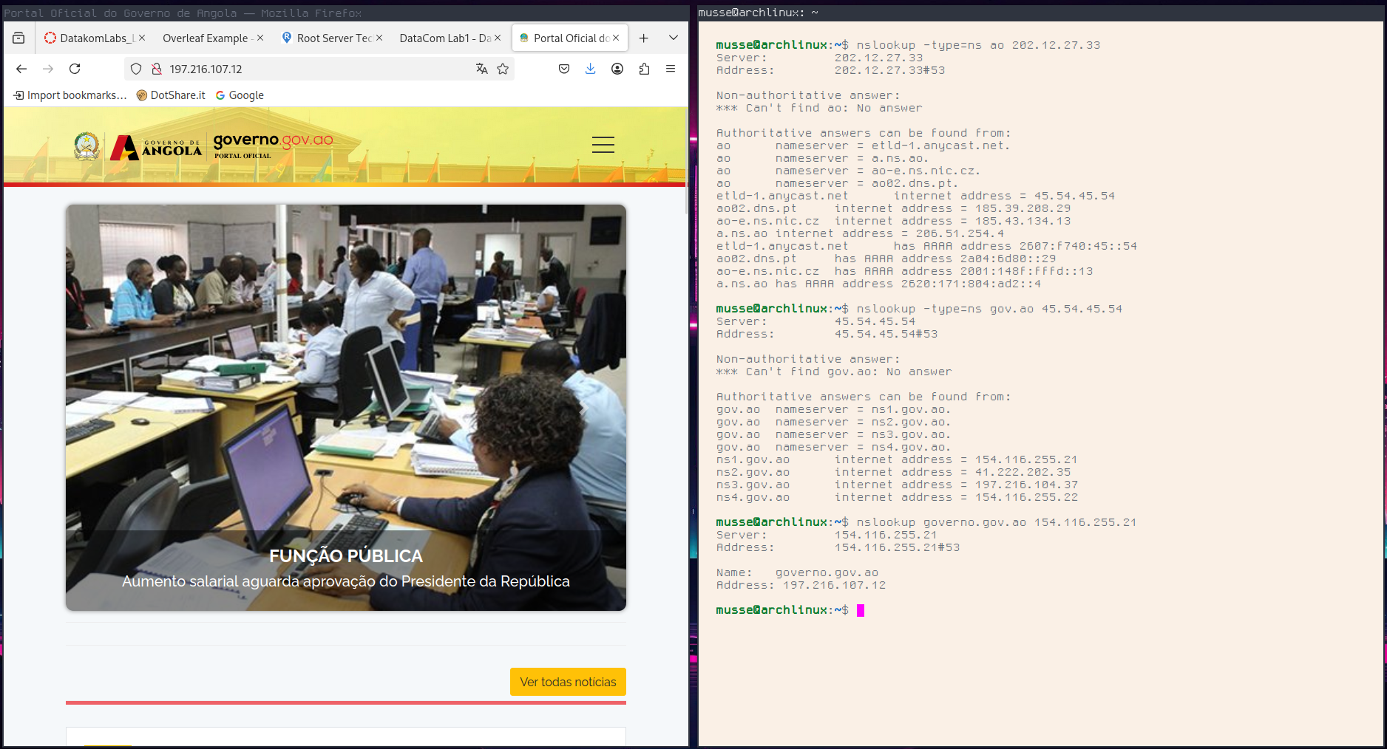



6.

a)



b)

1. UDP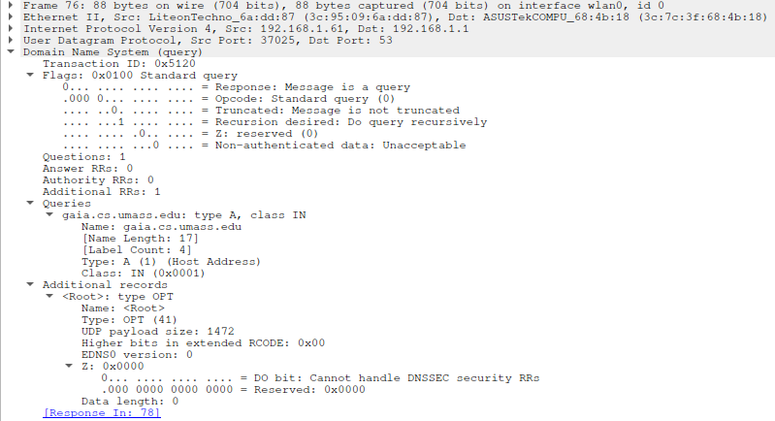
2. They are the same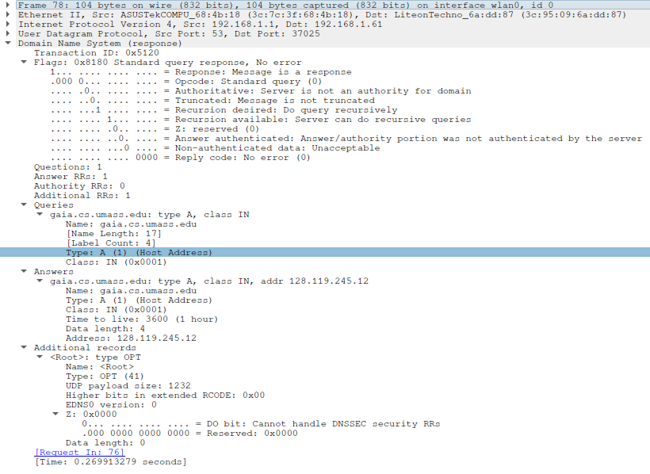
3. It is sent to my router

Query:



c) Response:



It’s a standard query

d)

No new queries since all info about the paths are in the html which the web server provides for

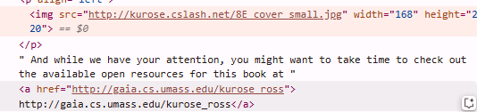

e) no the browser cached the ip-adress connected to the domain in it’s DNS cache

7.

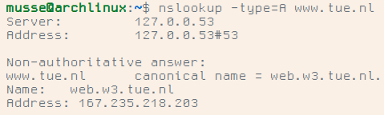

nslookup gave CNAME web.w3.tue.nl and Ipv4 adress 167.235.218.203.

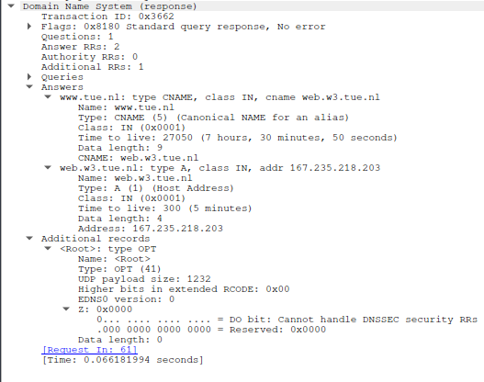

It’s a standard query response

It contains the query for the IPv4 address (A) of [www.tue.nl](http://www.tue.nl)

It contains the answer for the canonical name (CNAME) web.w3.tue.nl

It contains the DNS resolve for its CNAME the address 167.235.218.203

It contains additional records you didnt ask for but received anyways like how large the UDP payload was

b)

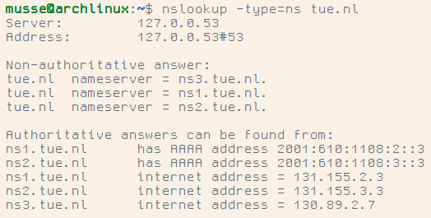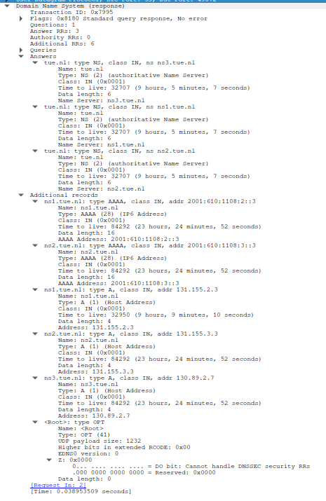

We asked for name servers and got 3 answers. We didn’t specifically ask for their IPv4 and IPv6 addresses but got them anyways through the glue record. We didnt receive an IPv6 address for nameserver 3.

c)

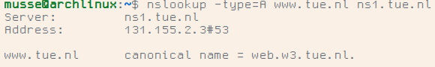

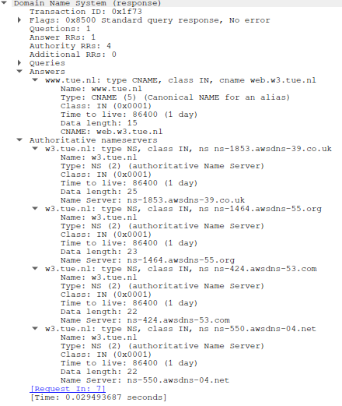

d)

4 name servers in 4 different TLDs

e)

