# Task 1

a)

The browser has sent one GET request excluding the favicon request.

b)

The second packet contains the response. The status code and phrase can be found in the top of the HTTP header.

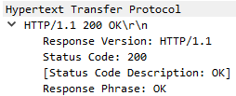

c)

4500 bytes



d)

4 segments. HTTP_Header_Length = 4861-4500 = 361 bytes

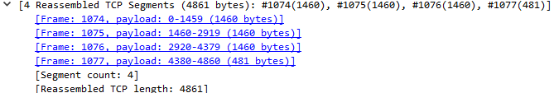

## Task 2

a)

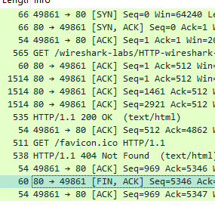

The same connection was used since the finish flag terminating the connection was used once and that was after the favicon request putting it inside the persistent connection.

b)

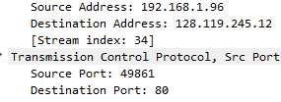

Source IP is 192.168.1.96

Source Port is 49861

c)

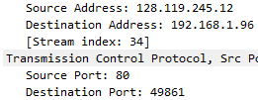

Source IP is 128.119.145.12

Source Port is 80

d)

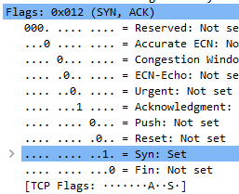

3 segments. Header flags for initiating connection SYN : SYN,ACK : ACK.

e)



The ACK to the server for receiveing the webpage and the ACK for recieving the response for the nonexistence of favicon.

## Task 3

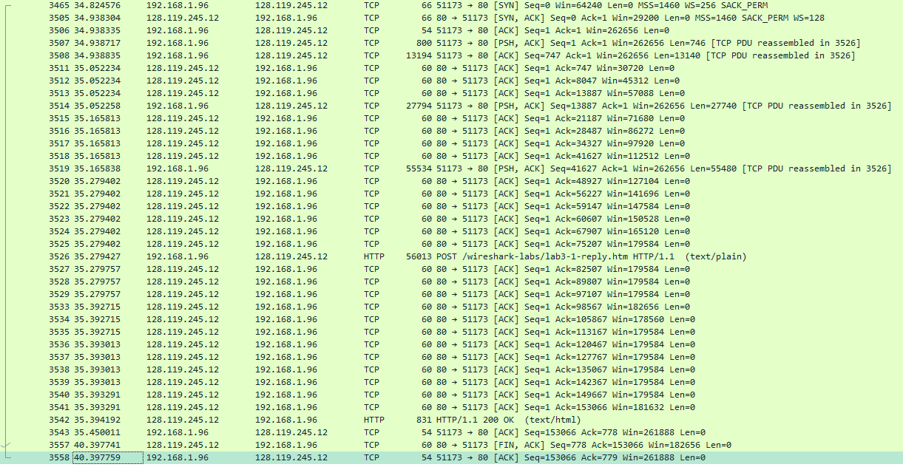

a)

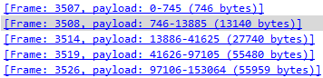

It increases with each packet. But the last two packets indicated the link handled packets with a payload of little over 55 000 bytes.

b)

The value of the Acknowledgement number of a packet is the sequence number + the length of the tcp packet it’s acknowleding.

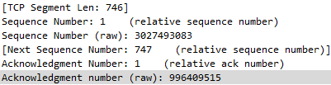

Sent PDU.

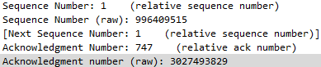

ACK. It uses the previous packets acknowledgement as sequence number (996409515). Sequence number of the PSH is 3 027 493 083. ACK number of the ack packet is 3 027 493 829. The difference between the Ack number and the previous sequence number is 746 just like the length of the tcp PSH packet.

Last ack number 3027646148. Last Ack – First sequence number = 153 065 bytes.

c)

First packet 746

Second 5800

All in the middle 7300.

Last 3399.

d)

There is only 2 closing packets captured in this instance 1 initiation from the server and one ACK from my computer. This was sent 5 seconds after the last HTTP. ( There was expected to be 4 packets to close but repeated capturing confirmed that we only captured 2).

### Task 4

a)

|  |  |  |  |  |  |  |
| --- | --- | --- | --- | --- | --- | --- |
| No | Seq. Number | Payload Length | Time sent | Time ACKed | RTT | Estimated RTT |
| 4 | 1 | 565 | 0,03 | 0,05 | 0,03 | 0,03 |
| 5 | 566 | 1460 | 0,04 | 0,08 | 0,04 | 0,03 |
| 7 | 2026 | 1460 | 0,05 | 0,12 | 0,07 | 0,03367048 |
| 8 | 3486 | 1460 | 0,05 | 0,17 | 0,11 | 0,04376517 |
| 10 | 4946 | 1460 | 0,08 | 0,22 | 0,14 | 0,05578128 |
| 11 | 6406 | 1460 | 0,08 | 0,27 | 0,19 | 0,07251424 |