Q1
A Software Defined Network, SDN, is a network whose Control Plane is separated from it’s Data Plane through software making a network configurable through Application Programmable Interfaces, APIs rather than having to physically connect to possibly hundreds of switches and routers to configure them.

Q2
Continuing this configuration is done by an SDN controller which manages the entire networks forwarding decisions/schemes. The SDN controller is the software that the network administrator uses.

Q3
An SDN switch is a a switch that runs a SDN protocol like OpenFlow and is configurable by an SDN controller. These can be pure SDN switches that is fully reliant on SDN, Hybrid that runs both SDN and traditional swicthing configuration and Virtual Switches (vSwitch) that are fully software-based switches that resides strictly in cloud and virtualized environments.

Q4
Match-plus-action is an SDN principle whilst desitination-based routing is a traditional principle. Destination-based routing means that packets that are forwarded in a router or switch are based only on it’s destination IP adress that is matched with the switch MAC table or routers routing table. Match-plus-action examines packets incoming and can match them against rules that now can have multiple attributes and after rules are applied performs an action like forward, drop or modify. It can apply priority, ports firewall rules filtering etc all since the Data Plane, control plane and management plane now is abstracted.

Q5

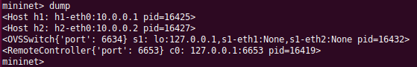
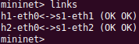
Q6

Q7

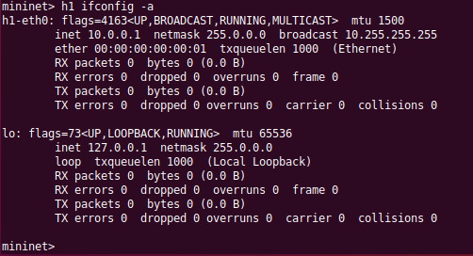
Q8
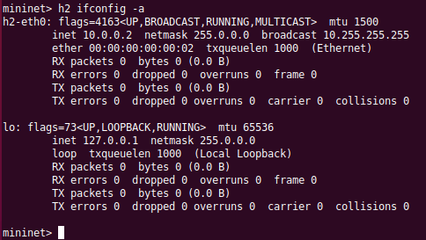

Q9
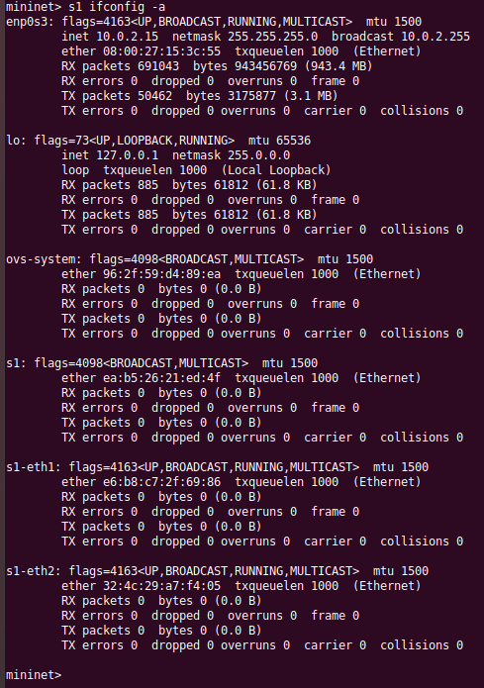

Q10

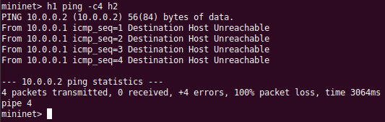
Q11
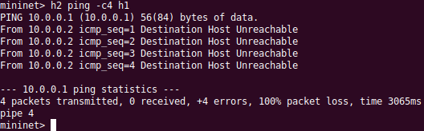

Q12
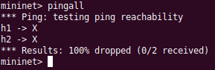
The reason is that as of yet we have no flow rules to determine routes inside the network so packets are by default dropped due to the lack of rules.

Q13

Q14

Q15
Cookie =0x0 means no cookie was attached meaning the flow rule it’s not set up to be modified elsewhere.
Duration is how long the flow rule has been active
Table=0 means these flow rules are the first entry in the table of flow rules.
n_packets is a value of how many packets have been matched with the specific rule
n_bytes is how many bytes have been matched with the specific rule
priority, which we set to 1 in the config line, is applied when there are multiple rules that apply to a packet. Priority 1 is low the rule with the highest priority is the one that is going to apply.
in_port is the port on the switch where the rule applies for in coming packets. We specified this with alias names 1 and 2 in the command line and here their full name is viewed.
Actions is where the rule applies it’s action(drop,forward etc.) on. In this case it’s to forward(output) to the other rules in-port.

Q16
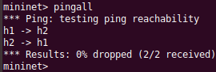
It works now since the flow rules have port forwarded outputs to corresponding inputs of the hosts.

Q17
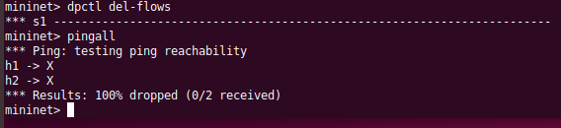
No, ping packets dropped and as you can see the output of the dpctl del-flows is a dump of the flows which shows there are none. Del-flows also suspiciosly looks like an abbreviation of delete flows.

Q18
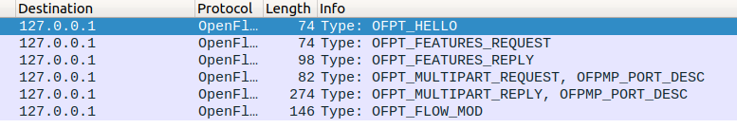
OpenFlow Protocol Type, OFPT: Hello, Features Request and Reply, Multipart Message Port Descriptions Request and Reply as well as a Flow Modifyer (add, modify or delete flow entries).

Q19
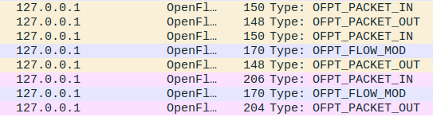
The FLOW_MOD message adds a flow entry.
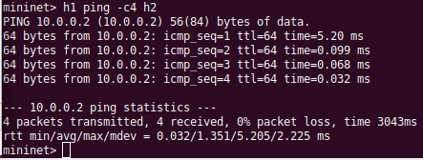
The first ping was slower due to the time needed for configuration of flow.
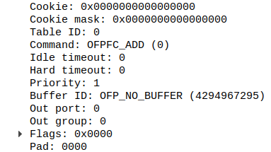
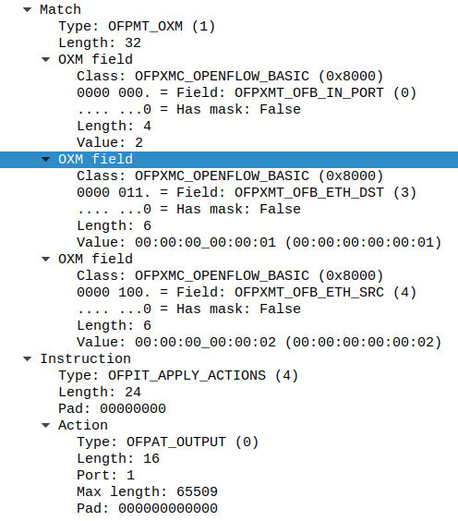
OpenFlow Extensible Match, OXM, fields specify input port of the switch, source MAC and destination MAC. The instruction field explains the action the flow rule is supposed to apply OpenFlow Protocol Action Type, OFPAT, which is output(forward). To the right is the cookie info, Table ID and Priority(1). This is the info we set manually before and got as the output of the flow dump.

Q20
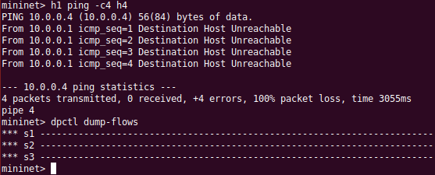
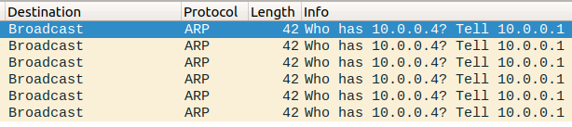
ARP frames.

Q21
ARP aims to find the Media Access Protocol, MAC, address of the device that has a specific IP address and then return that MAC address to the IP address of who asked for it. The ARPs corresponds to the packets since it never gets to know the MAC address due to no flow rules and therefore keeps asking.

Q22
The problem is when a switch recieves a broadcast from a switch and then broadcast the same request if the first switch were to broadcast again we would have an infinite loop and therefore if a switch has broadcast a request it should have only handle the request and then drop each echoed request.

Q23
We can solve this by purposefully droppping packets relating to ARP requests that has already been processed.

