Task 1
a)
The browser has sent one GET request excluding the favicon request.

b)
The second packet contains the response. The status code and phrase can be found in the top of the HTTP header.
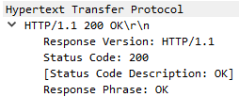

c)
4500 bytes
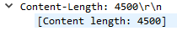

d)
4 segments. HTTP_Header_Length = 4861-4500 = 361 bytes
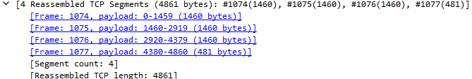

Task 2
a)
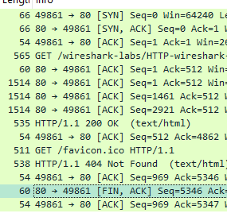
The same connection was used since the finish flag terminating the connection was used once and that was after the favicon request putting it inside the persistent connection.

b)
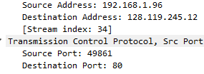
Source IP is 192.168.1.96
Source Port is 49861

c)
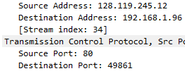
Source IP is 128.119.145.12
Source Port is 80

d)
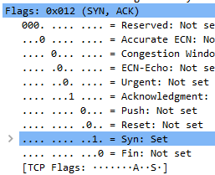
3 segments. Header flags for initiating connection SYN : SYN,ACK : ACK.
e)
The ACK to the server for receiveing the webpage and the ACK for recieving the response for the nonexistence of favicon.

Task 3
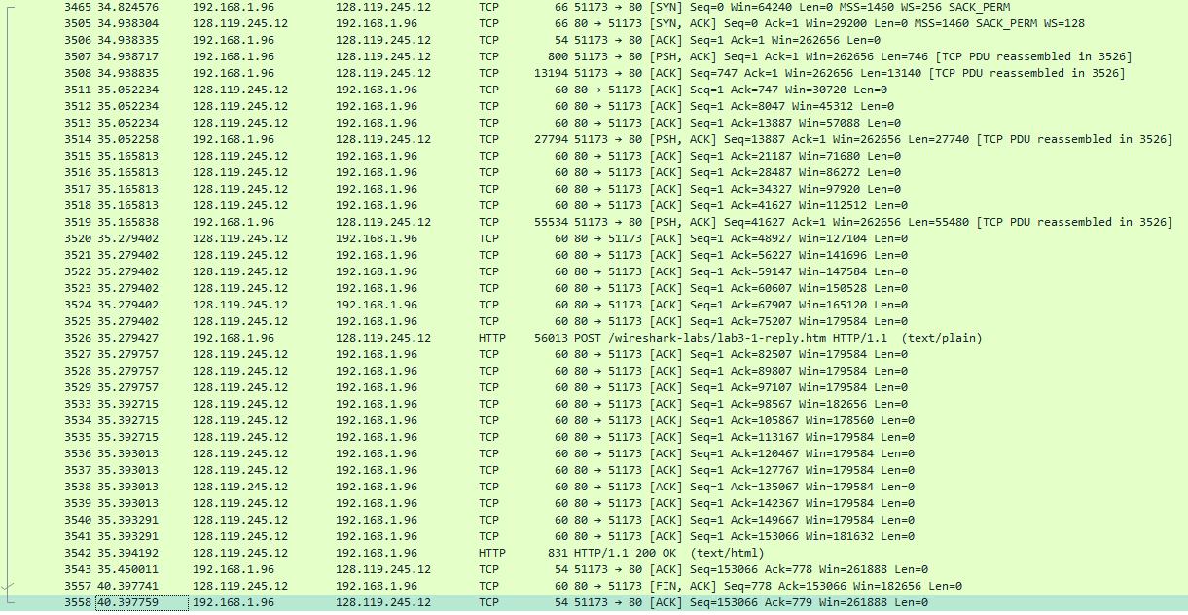
a)
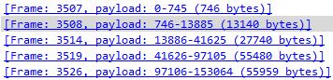
It increases with each packet. But the last two packets indicated the link handled packets with a payload of little over 55 000 bytes.

b)
The value of the Acknowledgement number of a packet is the sequence number + the length of the tcp packet it’s acknowleding.
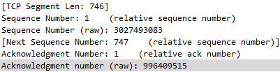
Sent PDU.
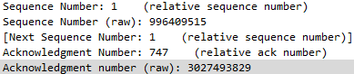
ACK. It uses the previous packets acknowledgement as sequence number (996409515). Sequence number of the PSH is 3 027 493 083. ACK number of the ack packet is 3 027 493 829. The difference between the Ack number and the previous sequence number is 746 just like the length of the tcp PSH packet.

Last ack number 3027646148. Last Ack – First sequence number = 153 065 bytes.

c)
First packet 746
Second 5800
All in the middle 7300.
Last 3399.

d)
There is only 2 closing packets captured in this instance 1 initiation from the server and one ACK from my computer. This was sent 5 seconds after the last HTTP. ( There was expected to be 4 packets to close but repeated capturing confirmed that we only captured 2).

Task 4
a)
Estimated RTT: 0.875*Estimated RTT + 0.125*RTT
No | Seq. Number | Payload Length | Time sent | Time ACKed | RTT | Estimated RTT
4 | 1 | 565 | 0,026477 | 0,053937 | 0,02746 | 0,02746
5 | 566 | 1460 | 0,041737 | 0,077294 | 0,035557 | 0,028472125
7 | 2026 | 1460 | 0,054026 | 0,124085 | 0,070059 | 0,03367048
8 | 3486 | 1460 | 0,05469 | 0,169118 | 0,114428 | 0,04376517
10 | 4946 | 1460 | 0,077405 | 0,217299 | 0,139894 | 0,05578128
11 | 6406 | 1460 | 0,078157 | 0,267802 | 0,189645 | 0,07251424

b)

No | Seq. Number | Payload Length | Time sent | Time ACKed | RTT | Estimated RTT
6 | 1 | 746 | 31,03588 | 31,14940 | 0,11352 | 0,11352
7 | 747 | 13140 | 31,03600 | 31,14940 | 0,11340 | 0,11351
11 | 13887 | 27740 | 31,14943 | 31,26299 | 0,11356 | 0,11351

Task 5
a)
no retransmission.
Retransmission would look like a drop back to a lower sequence number trying to retransmit what was lost.

b)
at 0.1242 seconds, Sequence number 7866
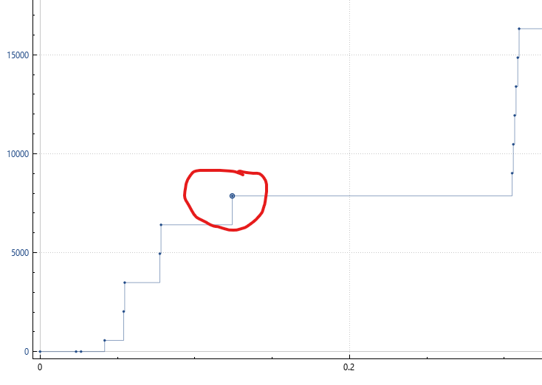
The lack of receiver buffer space throttles the sender when it can’t send at full capable speed or risk losing packets.

Task 6
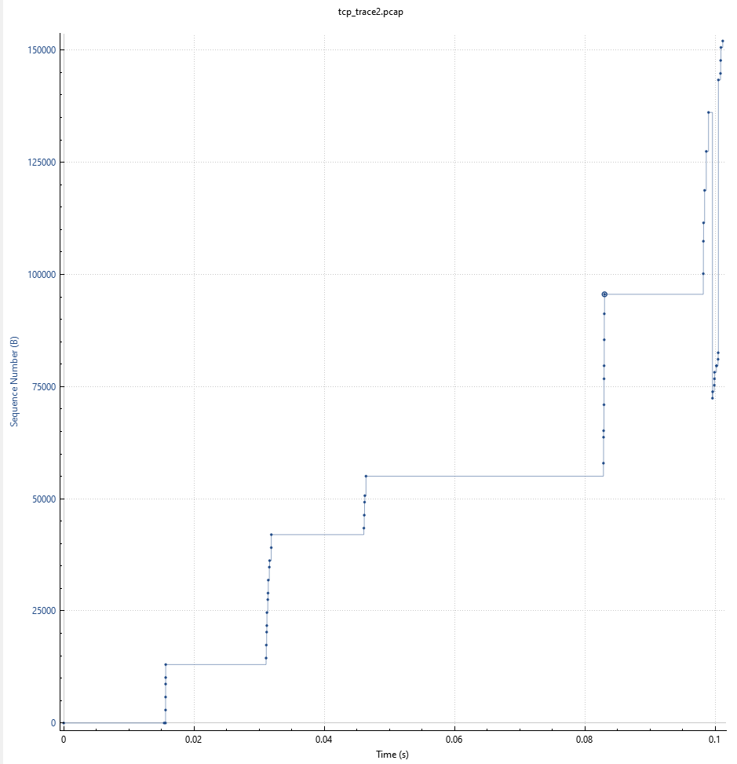
a)
A packet is lost when sequence number being transmitted becomes lower which can be seen at the end. Receiver begins sending the same ack number (dup ACK) which prompts the sender to start resending starting at the sequence number equal to the ACK number. The receiver keeps sending the same ACK number and the sender should keep retransmit all packets starting from the previously mentioned sequence number and going up. When the receiver stops sending dup ACKs it means the receiver has recieved all the packets that was lost and the sender can go back to transmitting the sequence after the one it was interupted at.
Packet with sequence number 82537 was lost. The sender noticed the loss at t = 0.0996 seconds.

b)
At 0.101194 seconds to 0.116712 seconds 28 packets are cummulatively acked and then it flags packets loss with 8 dup ACKs but then it probably changes it’s mind after recieving the packet it thought it lost and then ACKs 7 more packets and then sending an HTTP ”ok” message.

