Lab 3

Table Number
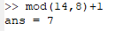

Task 1
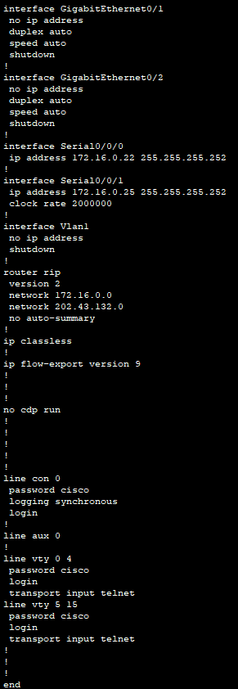
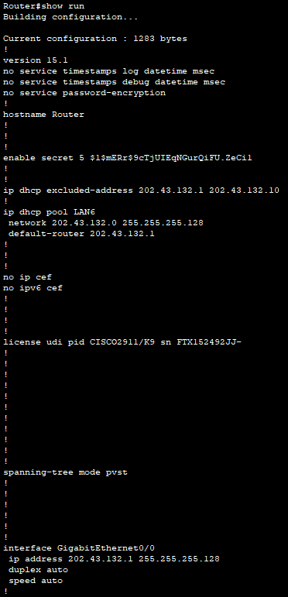
- Default-router = 202.43.132.1 which is my main gateway.
This matches with interface GigabitEthernet0/0.
- Router is connected through serial connection in the ring formation via serial port 0/0/1 and ip address 172.16.0.25
- The RIP, Routing Information Protocol, used is the RIPv2 (version 2). It is configured for the ethernet network on 202.43.132.0 as well as the Serial port network on 172.16.0.0

Task 2
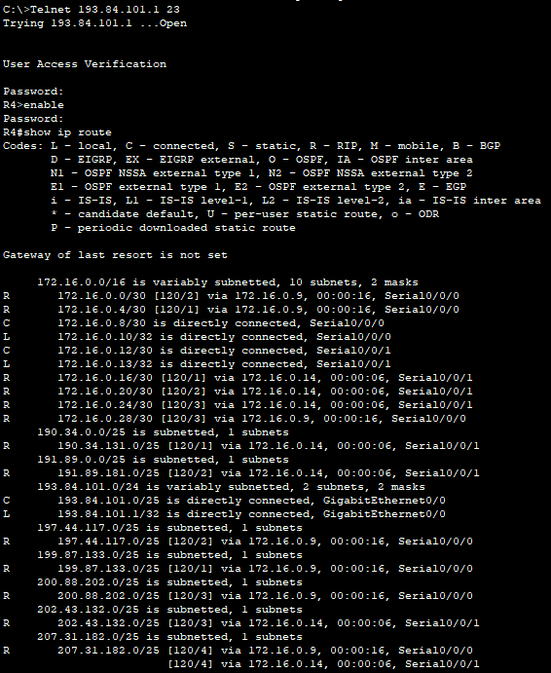
- Directly connected to: 172.16.0.8/30 Serial0/0/0, 172.16.0.12/30 Serial0/0/1, 193.84.101.0/25 GigabitEthernet0/0
- 202.43.132.0/25 is my network and the interface to get there is via 172.16.0.14. Jumping through R6, R5 and finally to R4
- 202.43.132.0/25 is my network and it takes 3 hops [120/3]. Best possible since 5 jumps in other direction.

Task 3
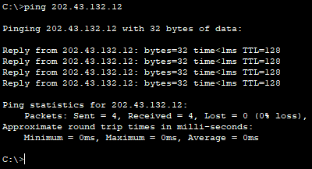

- 4 packets sent with a size of 32 bytes
- I get Amount of packets sent, recieved and the raio between these (loss ratio) as well as the Minimum, Maximum and Average RTT which is <1ms and approximates to 0ms each one
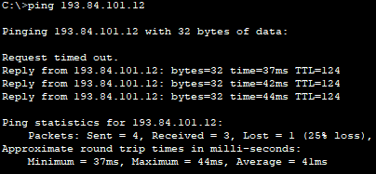
- First of all when i ping the ”neighbor” computer on table 4 the first packet is lost due to timeout resulting in a 25% loss ratio. Also the Minimum, Maximum and Average RTTs are all in the 40ms range instead of ”instant”.

Task 4
    - The same computer as previous at table 4
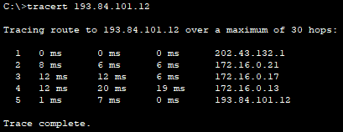

Computer 2 at table 3
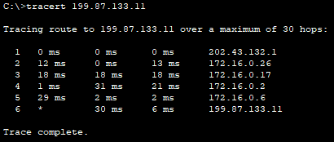

    - 5 for the first and 6 for the second. This show the hops between networks as well as routers. For instance in the first case the first hop is from computer to router the second from ethernet interface to the serial interface of the next router in the hop (router 6) and onwards. * is a lost packet.
    - It would be 1 hop. It’s over the same network, to the router and back..
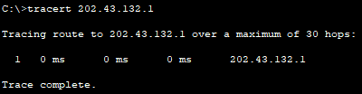

Task 5
Table 5
- The Network protocol used is ICMP, Internet Control Message Protocol, with the type 8, echo request, and code 0(no code for request).

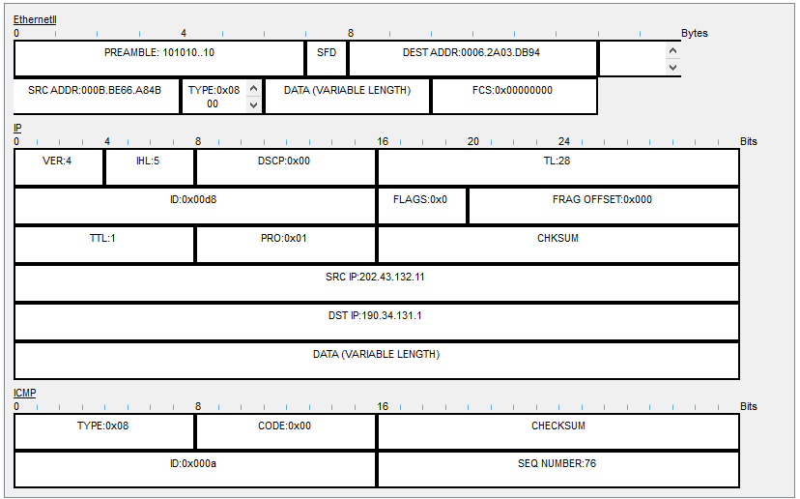
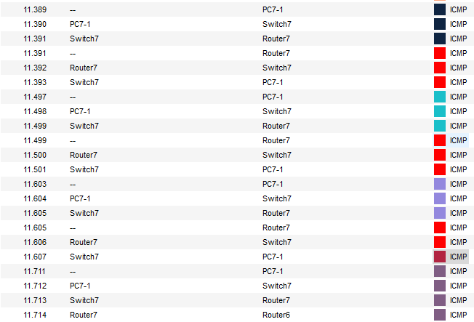
- 3 times.
- It uses the same protocol, type and code but it does one round including every hop and it repeats this 4 times only noting the time of sending and arrival not the intermediate arrival times of the hops.

Task 6
- 202.43.132.11/25 – mask is therefore 255.255.255.128
- 202.43.132.11 = 11001010 00101011 10000100 00001011
- 202.43.132 is network and 11 is the host
- 000B.BE66.A84B

Task 7
DISCLAIMER: We used our table-number here instead of our group number. We fixed this for the next question. We are confident results are the same anyways.
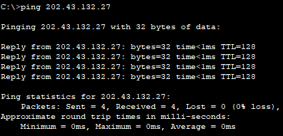
- It works. Since PC7-1 and PC7-2 are on the same subnetwork no routing is needed to listen to calls. Router doesn’t need to know the update.

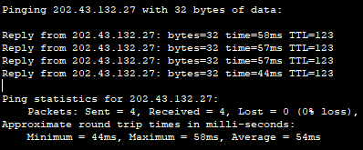

- Yes.
DISCLAIMER: We used our table-number here instead of our group number. We fixed this for the next question

Task 8

- Because the mask removes/filters out vital information.
- It is dropped after the ARP communication deems the ip address is not in the subnet. It is then dropped at our computer due to ARP timeout.
- ?
- Yes it works because now since both computer have addresses that are above the mask
(2^8-1=128) the filter/mask puts them in the same subnet. When
- It doesnt work since our router applies the mask to our ip address and therefore scrambles the result making our host address 164-128 = 36 202.43.132.36 so when the ARP tries to resolve this address it won’t find it and can’t resolve the MAC-address. It’s no longer part of the same network since the eighth bit should be 0 now it’s one (over 128)

Task 9

- Nice
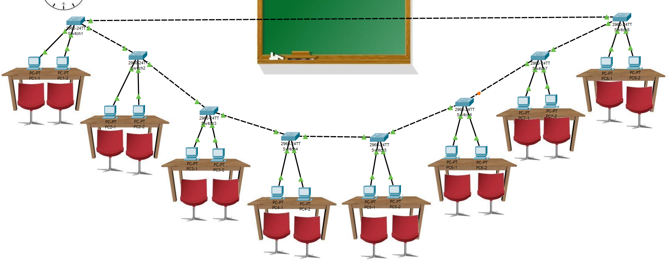
- Because a switch only distrubutes messages it doesnt route them. They are part of the same subnet. It sends a message a computer want to send and the computer thats addressed just responds and the others can ignore it.
- The purpose could be to have a central computer that handles and distributes packets that acts as a router. In this case 1 computer doesnt need to know the ip address of every computer it might need to know an alias that the user knows kind of like a DNS service and then the central computer resolves the alias and distributes the packet. It could also be to have one computer be a DHCP server to automatically assign IP addresses to computerws that doesnt have a statical one. One that acts as broadcast adress between subnets.

Task 10

- IPv4 adress is divide into 4 bytes, 32 bits. Address space is 24 bits and host space therefore 32-24=8 bits. 8 bits has 256 different configurations giving each subnet 256/8 = 32 configurations each. Therefore log2(32)=5 bits is used for host and log2(8)=3 bits are used for the subnet. 2^5+2^6+2^7=224, the subnet-mask is 255.255.255.224.

SN# | Subnet Address | Host Addresses | Broadcast Address
1 | 200.150.100.0 | 200.150.100.01 up to 200.150.100.30 | 200.150.100.31
2 | 200.150.100.32 | 200.150.100.33 up to 200.150.100.62 | 200.150.100.63
3 | 200.150.100.64 | 200.150.100.65 up to 200.150.100.94 | 200.150.100.95
4 | 200.150.100.96 | 200.150.100.97 up to 200.150.100.126 | 200.150.100.127
5 | 200.150.100.128 | 200.150.100.129 up to 200.150.100.158 | 200.150.100.159
6 | 200.150.100.160 | 200.150.100.161 up to 200.150.100.190 | 200.150.100.191
7 | 200.150.100.192 | 200.150.100.193 up to 200.150.100.222 | 200.150.100.223
8 | 200.150.100.224 | 200.150.100.225 up to 200.150.100.254 | 200.150.100.255
- When an IP adress has the host part as all zeroes it represents the network as a whole and when it is all ones is dedicated to broadcasting. Packages sent inside the network to 192.168.1.255/24 is sent to everyone in the subnet 255.255.255.0. Packages sent from another network to 192.168.1.0/24 is sent to the default gateway for resolution of for instance port addresses and appropriate port forwarding is done by for instance a router in this case.

Task 11
ICMP
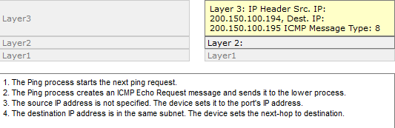
ARP
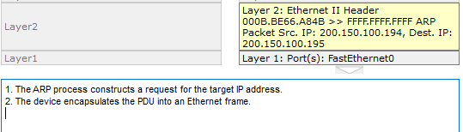

- ARP must be a broadcast (SOURCE MAC=0000.0000.0000), send to everyone, since at point of request it does not know the MAC adress of the target and sends a unicast frame. Only targets with the said IP adress responds with it’s MAC-address the others just drops the frame.
- Since they are not the owner of the IP adress it makes sense to ignore it. No response needed since ARP at the sender side is based on receiving MAC-address or time-out if no response has come.
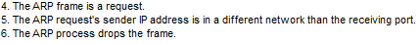

- When the switch receives an ARP frame from an IP-address it hasn’t matched with a MAC-address. In this case the neighbor computers response to the Address Resolution Protocol Request, ARP request.
- It is because each switch has updated its MAC table with the recipient of the ICMP, ping, traffic.
