
TOBB ETU
Economy & Technology University
BIL 495 / YAP 495
System Architecture Document (SAD)
Reference: IEEE 42010 / INCOSE SE Handbook 5th Ed.

Document Control Table
Document Title | Project Closure Report
Document ID | (To be assigned)
Prepared By (Author) | Kerem Kazandır
Reviewed By
Approved By
Preparation Date
Approval Date
Version / Revision | 1.0
Confidentiality Level | Internal / Restricted / Public
Reference Standards | IEEE 15288, IEEE 12207, INCOSE SE Handbook v5

Change Record (Revision History Table)
Revision | Date | Prepared By | Reviewed/Approved By | Description of Change
1.0 | (Date) | (Author) | (Approver) | Initial Release
1.1 |  |  |  | Minor editorial updates
1.2 |  |  |  | Added stakeholder feedback section

1. Introduction
2. System Context
3. Architectural Views
3.1 Logical View
3.2 Process View
3.3 Physical View
3.4 Development View
4. Design Decisions
5. Compliance and Standards
6. Appendix
7. References

1. Introduction
With Modular Monolithic architecture we aim to provide scalability, maintainability, testability. While providing these, our system will have features such as chat, event recommendation, notifications, user management and authentication.

2. System Context
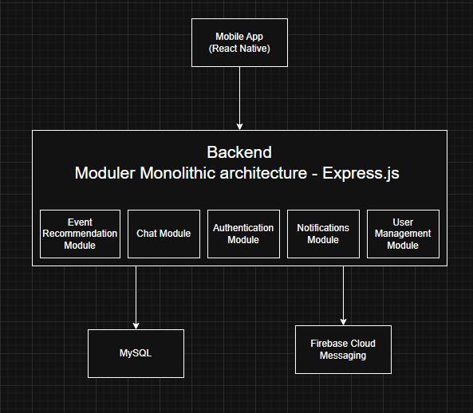

3. Architectural Views

3.1 Logical View
Event Recommendation Module: Recommend an event based on user’s attributes and past events.
Chat Module: Send and receive messages from other users.
Authentication Module: Handles User registration, login to account.
Notifications Module: Send notification to users.
User Management Module: Handles User profile, friend list, event list, take preferences.

3.2 Process View
UI Thread - Handles all user interface
Network Thread - API calls and server communication
WebSocket Thread - Real-time chat messages
Database Thread - Local data storage
Background Thread - Heavy processing tasks
Simplified Runtime:
User request (UI Thread) —> Process tasks (Background Thread) —> Network call (Network Thread) and Store data (DB Thread) —> Update UI (Back to UI Thread)

3.3 Physical View
Describe hardware deployment and communication links.

3.4 Development View
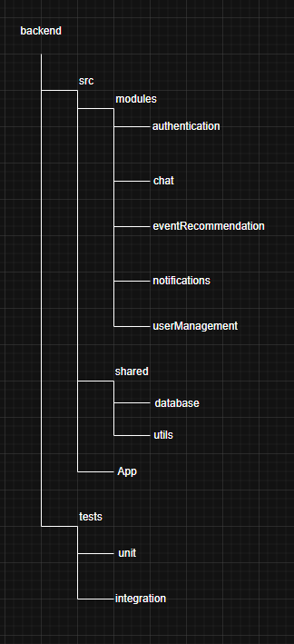
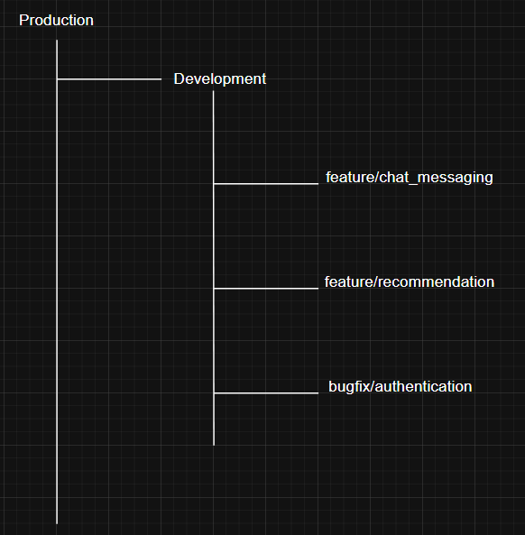

4. Design Decisions
1. Modular Monolithic Architecture
We chose this architecture because we thought our system size will be medium and our team is 4 people so it will be easier to develop and deploy. In the future if our system becomes big then we could change this architecture with microservices.
2. Websocket for Chat
We chose this architecture because we aim for instant message delivery and low latency in chat.
3. Push Notifications (FCM)
With that server we would send notifications to users reliable, fast and optimized.
Moreover with this technology we will send without needing an opened app.

5. Compliance and Standards
For security we will use KVKK and GDPR standards.

6. Appendix

7. References

