# The problem

The problem of classification is a hard problem for which there is no “best answer” to which method is the best. Specifically, we would like to know which the best classification method for classifying gene expression for the chosen dataset.

# Our Dataset

We chose the following dataset for our project:

<https://www.ncbi.nlm.nih.gov/sites/GDSbrowser?acc=GDS5801&fbclid=IwAR2YoCBZlS1p9Ef7H0dMCqSAj0rsk8ysOuIEyde_3mqnsnb51GnjKHaHNeU>

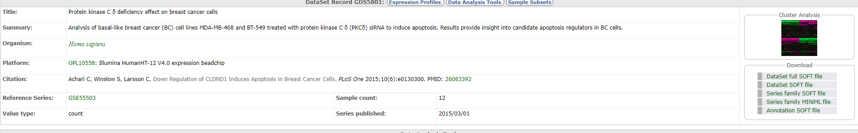

# Biological Background

To clearly understand the task, we would like to first deepen our knowledge in the following biological topics related to our dataset:

1. Breast Cancer
2. protein kinase C δ
3. Apoptosis

# Questions

Is this database the best choice for our project?