Samuel LE BERRE
TP7 : Parametric surface

Exercice 1

Code :
Vec p1 = Vec(1,2,3);
Vec p2 = Vec(6,1,3);
Vec p3 = Vec(7,6,3);
Vec p4 = Vec(13,3,3);
unsigned int i;
vector<Vec> courbe = vector<Vec>();
for(i=0; i<=10;i++){
float t = i/10.0;
courbe.push_back(p1*pow(1-t,3) + 3*p2*t*pow(1-t, 2.0) + 3*pow(t,2)*(1-t)*p3 + pow(t,3.0)*p4);
}
glColor3f(1,0,1);
glPointSize(3);
glBegin(GL_POINTS);
glVertex3fv(p1);
glVertex3fv(p2);
glVertex3fv(p3);
glVertex3fv(p4);
glEnd();
glColor3f(1,1,1);
glBegin(GL_LINE_STRIP);
for(i=0; i<courbe.size();i++){
glVertex3fv(courbe.at(i));
}
glEnd();
glFlush();

Resultat

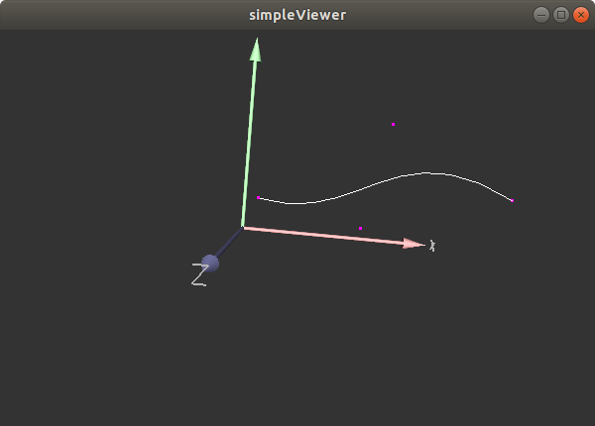
Exercice 2 :

Code :
Vec p1 = Vec(1,2,3);
Vec p2 = Vec(6,1,3);
Vec p3 = Vec(7,6,3);
Vec p4 = Vec(13,3,3);
Vec p5 = Vec(3,2,3);
Vec p6 = Vec(8,1,3);
Vec p7 = Vec(9,6,6);
Vec p8 = Vec(15,3,3);
Vec p9 = Vec(5,2,3);
Vec p10 = Vec(10,4,3);
Vec p11 = Vec(11,6,3);
Vec p12 = Vec(17,3,5);
Vec p13 = Vec(7,2,1);
Vec p14 = Vec(12,1,3);
Vec p15 = Vec(13,6,3);
Vec p16 = Vec(19,3,3);
vector<vector<Vec>> matrice = vector<vector<Vec>>();
vector<Vec> ligne0 = vector<Vec>();
ligne0.push_back(p1);
ligne0.push_back(p2);
ligne0.push_back(p3);
ligne0.push_back(p4);
vector<Vec> ligne1 = vector<Vec>();
ligne1.push_back(p5);
ligne1.push_back(p6);
ligne1.push_back(p7);
ligne1.push_back(p8);
vector<Vec> ligne2 = vector<Vec>();
ligne2.push_back(p9);
ligne2.push_back(p10);
ligne2.push_back(p11);
ligne2.push_back(p12);
vector<Vec> ligne3 = vector<Vec>();
ligne3.push_back(p13);
ligne3.push_back(p14);
ligne3.push_back(p15);
ligne3.push_back(p16);
matrice.push_back(ligne0);
matrice.push_back(ligne1);
matrice.push_back(ligne2);
matrice.push_back(ligne3);
glColor3f(1,0,1);
glPointSize(3);
glBegin(GL_POINTS);
glVertex3fv(p1);
glVertex3fv(p2);
glVertex3fv(p3);
glVertex3fv(p4);
glVertex3fv(p5);
glVertex3fv(p6);
glVertex3fv(p7);
glVertex3fv(p8);
glVertex3fv(p9);
glVertex3fv(p10);
glVertex3fv(p11);
glVertex3fv(p12);
glVertex3fv(p13);
glVertex3fv(p14);
glVertex3fv(p15);
glVertex3fv(p16);
glEnd();
vector<Vec> courbe = vector<Vec>();
for(int u=0; u<16; u++){
for(int v=0; v<16; v++){
int x=0,y=0,z=0;
for(int i=0; i<4; i++){
for(int j=0; j<4;j++){
x = x + bernstein_poly(u,4,i) * bernstein_poly(v,4,j) * matrice.at(i).at(j).x;
y = y + bernstein_poly(u,4,i) * bernstein_poly(v,4,j) * matrice.at(i).at(j).y;
z = z + bernstein_poly(u,4,i) * bernstein_poly(v,4,j) * matrice.at(i).at(j).z;
}
}
courbe.push_back(Vec(x,y,z));
}
}
glBegin(GL_POINTS);
for(unsigned int i=0; i<courbe.size();i++){
glVertex3fv(courbe.at(i));
}
glEnd();
glFlush();

Remarque :
Le problème provenant de mon code sst du à une incompréhension de l’algorithme de Bézier. U et v ne devrait pas être égale à 16 qui est le nombre de Points de Controle.

