
សាកលវិទ្យាល័យកម្ពុជា
មហាវិទ្យាល័យវិទ្យាស្តាស្ត្រនិងបច្ចេកវិទ្យា
ប្រឡងបញ្ចប់វគ្គសិក្សា
វគ្គសិក្សាទី១ ឆ្នាំសិក្សា ២០២៣-២០២៤
កូដមុខវិជ្ជា: ITE304 | ចំណងជើងមុខវិជ្ជា:​ Mobile App Development
ឈ្មោះសាស្រ្តាចារ្យ: ហង្ស យូឡាយ | ហត្ថលេខាសាស្រ្តាចារ្យ:
ព្រឹទ្ធបុរស: Teav Chhunnan | អនុប្រធានទទួលបន្ទុកសិក្សា: បណ្ឌិត អ៊ី រតនា
វេនសិក្សា: Evening | ថ្ងៃផុតកំណត់ៈ​ 28-06-2024
និស្សិតឈ្មោះ: Vorn Saran | ហត្ថលេខា:
អត្តលេខ: 65 21 00 46 | ជំនាញ: IT

Topic: Backend and Frontend Development for [WatchShops]

- Introduction

A website is a collection of many web pages, and web pages are digital files that are written using HTML(HyperText Markup Language). To make your website available to every person in the world, it must be stored or hosted on a computer connected to the Internet round a clock. Such computers are known as a Web Server.

- Benefit of using website
Using a website offers numerous benefits both for individuals and businesses:
• Accessibility: Websites provide round-the-clock access to information, products, and services from anywhere with an internet connection, making them highly convenient for users.
• Global Reach: A website allows you to reach a global audience, expanding your potential customer base beyond geographical limitations.
• Credibility: A well-designed website enhances your credibility and professionalism. It serves as a digital storefront or portfolio that can instill trust in potential customers or clients.
• Marketing: Websites are crucial for digital marketing efforts. They provide a platform for content marketing, SEO (Search Engine Optimization), and social media integration, helping to attract and engage visitors.
• Customer Support: Websites can offer customer support functionalities such as FAQs, live chat, and contact forms, improving customer service and satisfaction.
• Sales and E-commerce: For businesses, websites facilitate online sales and e-commerce transactions, enabling direct revenue generation.
• Analytics: Websites allow you to gather valuable data and analytics about your visitors and their behavior, which can inform business decisions and marketing strategies.
• Cost-Effectiveness: Compared to traditional advertising and customer outreach methods, maintaining a website can be more cost-effective over time, especially for small businesses.
• Brand Building: A website provides a platform to showcase your brand identity, values, and unique selling propositions (USPs), helping to differentiate your business in the market.
• Scalability: Websites can easily scale to accommodate growth. Whether you're adding new products, expanding services, or reaching new markets, your website can evolve with your business needs.
- Benefit of my website
Certainly! Here are some specific benefits of creating a website for a watch shop or any similar e-commerce concept:
- Ease of Use: A well-designed website makes it easy for customers to browse through your watch collections, find product details, and make purchases with intuitive navigation and a user-friendly interface.
- Availability: Unlike physical stores with limited operating hours, a website allows customers to shop at any time of the day or night, increasing convenience and accessibility.
- Fast Transactions: Online transactions are typically faster than traditional in-store purchases, reducing the time customers need to spend completing their orders. Fast Transactions: Online transactions are typically faster than traditional in-store purchases, reducing the time customers need to spend completing their orders.

II. Methodology
- In this website I use with HTML, CSS, PHP, Bootstrap, JavaScript and mysql.
- Certainly! Here's a brief overview of what each technology is used for in website development:
  - HTML (HyperText Markup Language): Defines the structure and content of web pages.
  - CSS (Cascading Style Sheets): Styles the HTML structure to control the presentation, layout, and design of web pages.
  - PHP (Hypertext Preprocessor): Server-side scripting language used to create dynamic web pages, handle forms, manage databases, and more.
  - Bootstrap: A front-end framework for designing responsive and mobile-first websites with predefined classes and components.
  - JavaScript: A client-side scripting language used to add interactivity and behavior to web pages, enabling dynamic features like animations, form validation, and more.
  - MySQL: A popular relational database management system (RDBMS) used with PHP to store and manage website data efficiently.
III. Result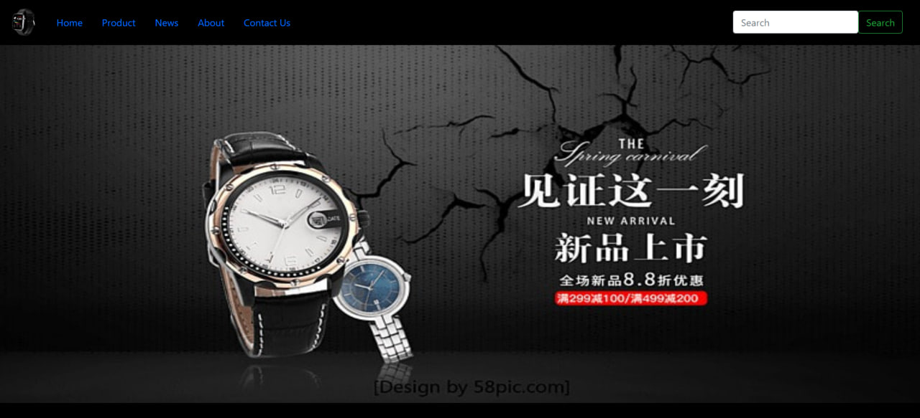
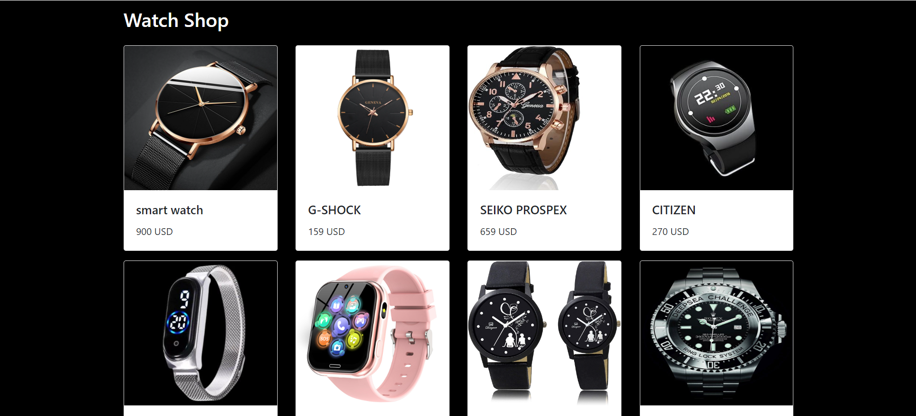
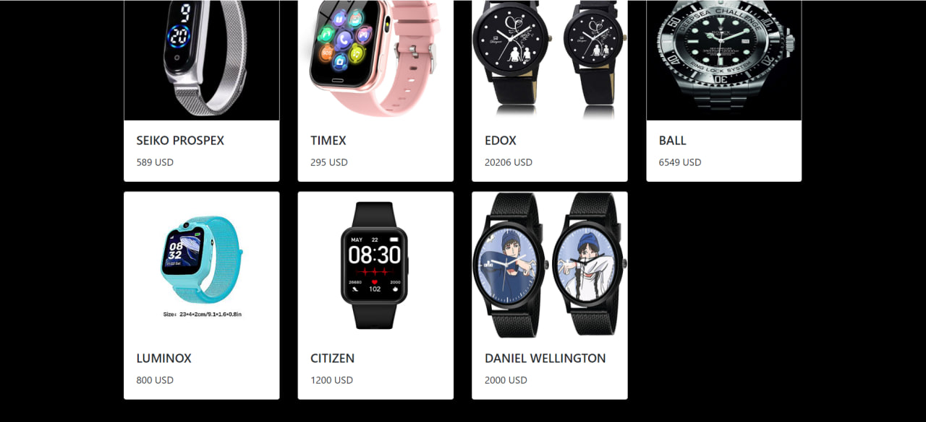


- Explain about Menu of Frontend
  - Home
    - នៅក្នុង​ home មានស្លាយបា មួយបង្ហាញអំពី banner នៃនាឡិកា
    - ហើយមាន blog មួយដែលបង្ហាញអំពីកាតនៃនាឡិកា (មានឈ្មោះ រូបភាព មានម៉ាក និង​តម្លៃ)
    - នៅខាងក្រោមរូបភាពមាន​វិដេអូដែលបង្ហាញអំពី របៀបនៃការប្រើប្រាស់​​ ប្រភេទ និងអត្ថប្រយោជន៍ផ្សេងៗរបស់នាឡិកា។
    - មាន footer ដែលបង្ហាញអំពី about us and contact us។

- Product
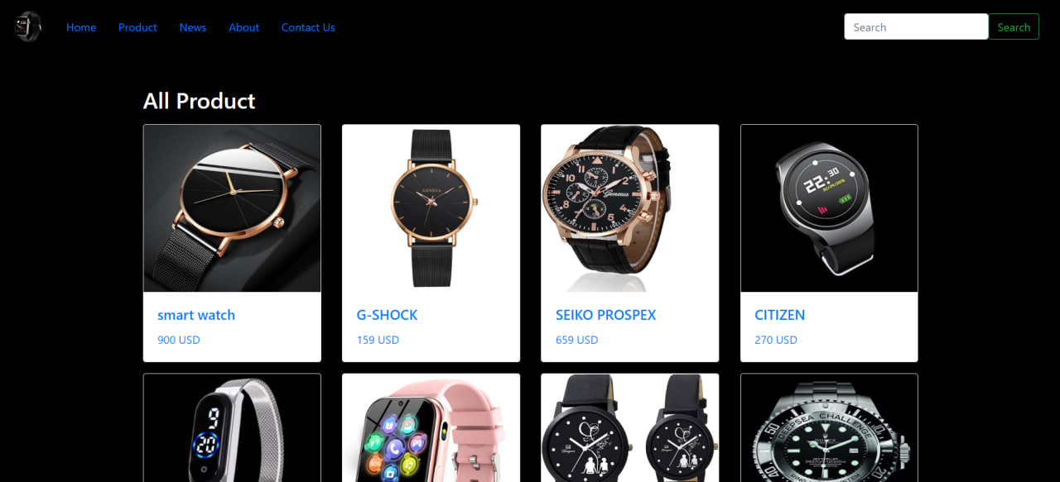
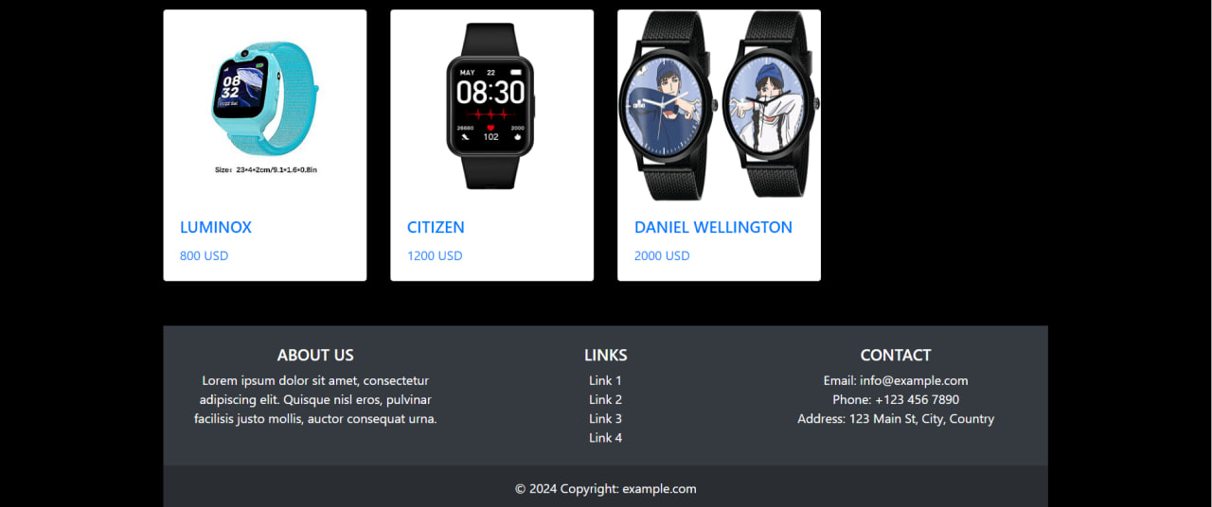
  - Product
    - នៅក្នុង product គឺមានការបង្ហាញរាល់នាឡិកាទាំងអស់ដែលយើងបានបង្កើត
    - ហើយនៅក្នុងកាតនីមួយៗអាចលីងទៅកាន់ product detail បាន
    - នៅក្នុង product detail បង្ហាញអំពី​ព័ត៌មានលម្អិតរបស់ product នីមួយៗដែលមានដូចជា ឈ្មោះ រូបភាព ម៉ាក​និង​តម្លៃ។
- Product detail
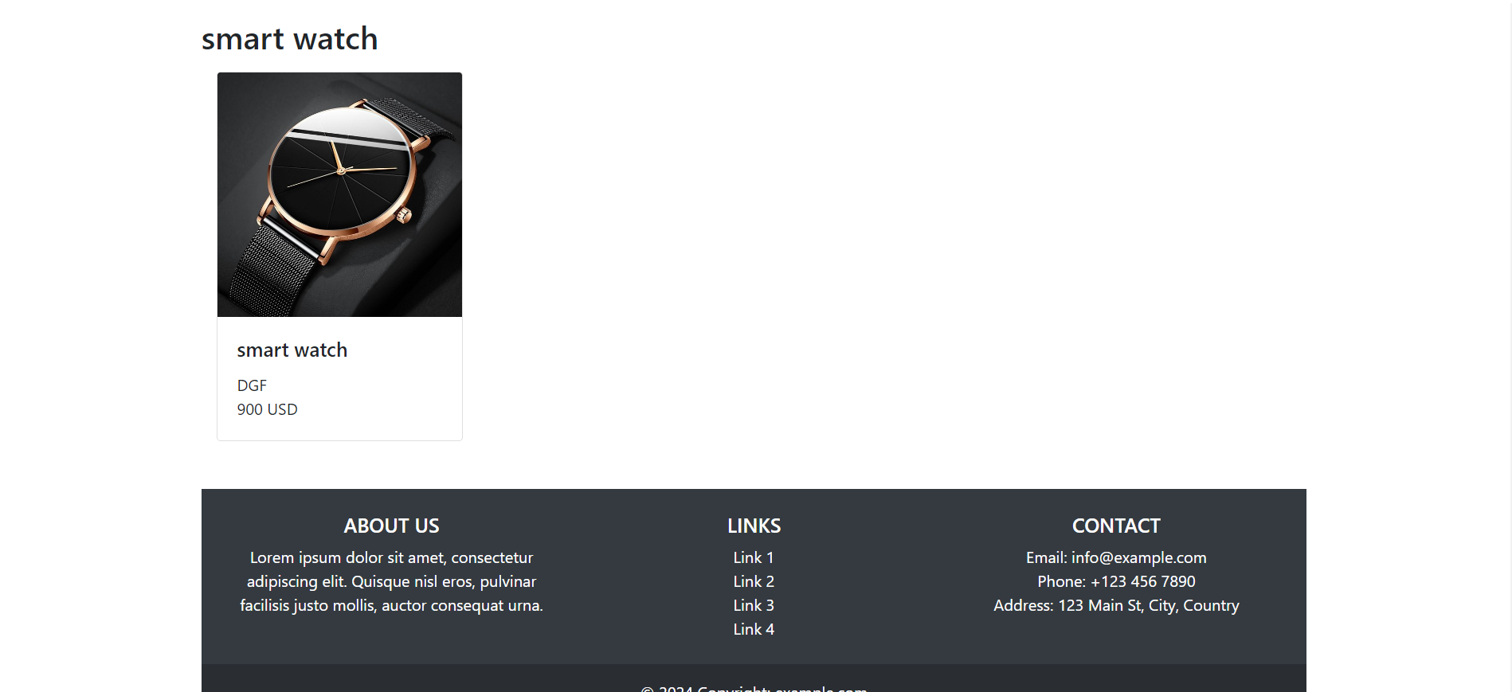

- About Page
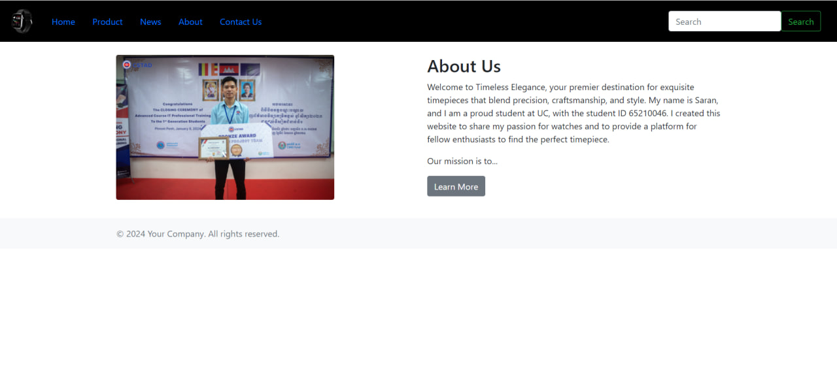
  - About us
    - បង្ហាញអំពី ជីវប្រវត្តរបស់សិស្ស និង​ មូលហេតុនៃការបង្កើត website នេះឡើង
    - និងព័ត៌មានផ្សេងៗទៀត
- Contact us
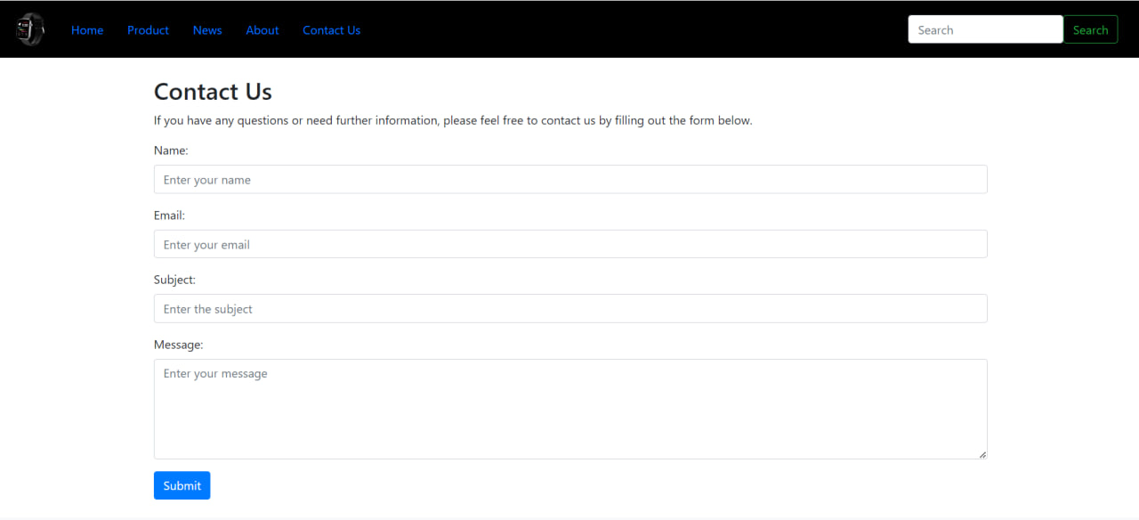

  - Contact Us
    - ប្រើដើម្បីអោយអ្នកប្រើប្រាស់ ទំនាក់ទំនងមកកាន់យើងដើម្បីក្នុងការទិញអំពី product.

- Backend
- Slide​​show
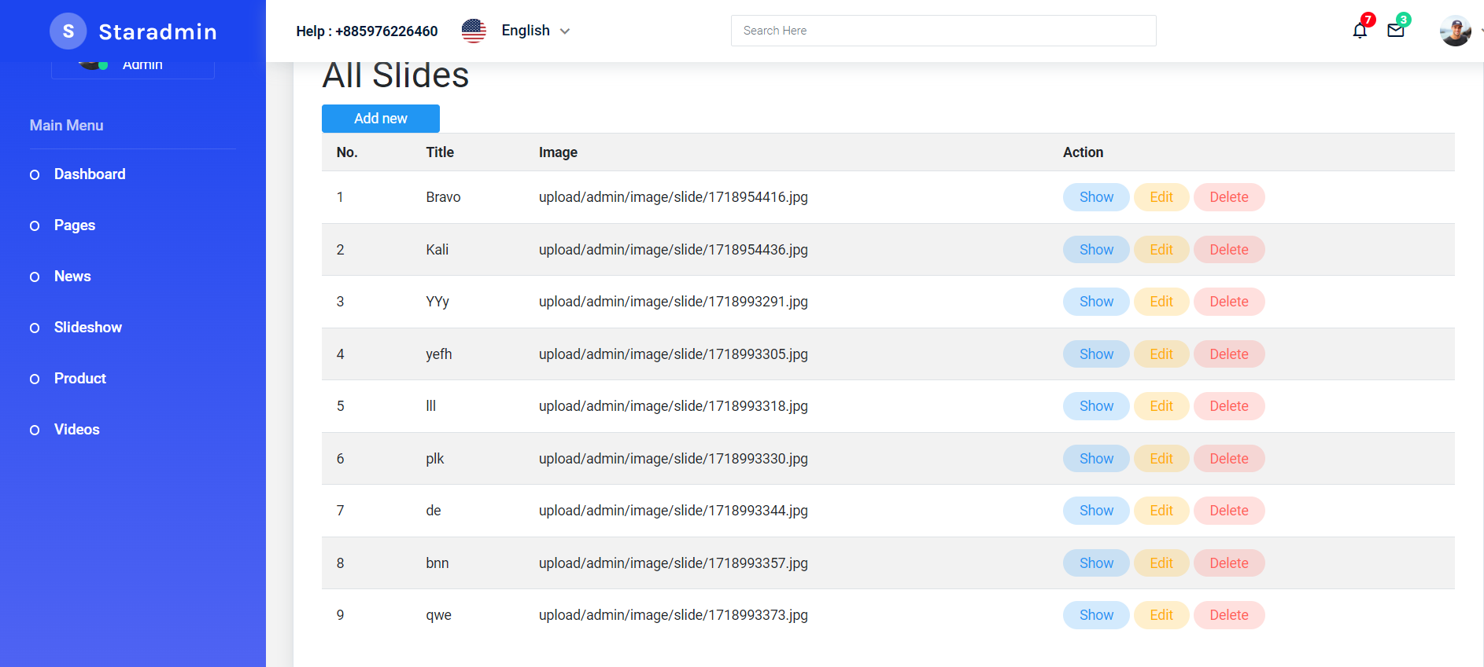
- Product
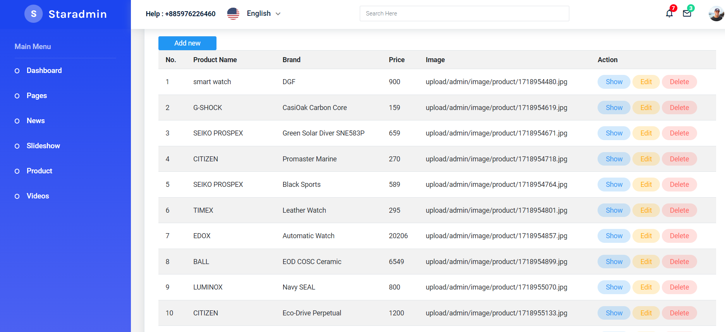

- នៅផ្នែកខាង backend ខ្ញុំបានធ្វើទាក់ទងនឹង ការបង្កើត product ពីផ្នែកនៅក្នុង​
- Slide show and product
  - In Slide show
    - ការបង្ហាញ product
    - ការ edit product
    - និង​ការ deleted product
    - នៅក្នុង​ product មានតែឈ្មោះនឹង file តែប៉ុន្នោះ
  - In Product
    - ការបង្ហាញ product
    - ការ edit product
    - និង​ការ deleted product
    - នៅក្នុង product មាន title, brand, image, price …។

