

Egypt University of Informatics

Computer and Information Systems

Data Analysis Course

The Analysis of Caffeine Effect on Students Grades

Submitted by: Seif Muhammed Wafikk

9/3/2024

# Introduction

Welcome to our data analysis journey exploring the link between caffeine and student grades. Through numbers and trends, we uncover the impact of caffeine intake on academic performance. Get ready for a concise dive into the data-driven world of student success with caffeine!

# Research Question

Does the caffeine intake affect student's grades?

# Hypothesis

I hypothesize that moderate caffeine consumption positively correlates with short-term improvements in alertness, concentration, and cognitive performance among students. However, we also anticipate an inverse relationship between excessive caffeine intake and overall academic success due to potential disruptions in sleep patterns and the masking of underlying issues related to study habits and stress management.

# Population of Interest:

Our study focuses on college and university students aged 18 to 25 years who are

actively engaged in academic pursuits. This population includes individuals from diverse educational disciplines and backgrounds, aiming to capture a representative sample of students who frequently consume caffeinated beverages, such as coffee, tea, and energy drinks. By examining this specific demographic, we aim to assess the potential impact of caffeine on academic performance within the context of higher education.

# Sampling Method:

# 

I used Convenience sampling, Convenience sampling involves selecting participants based on their easy accessibility and proximity to the researcher. In this method, individuals who are readily available and willing to participate are included in the study, often resulting in a sample that may not be fully representative of the population.

# Bias Identification:

# I ensured that survey questions were neutrally phrased and did not presuppose a particular relationship between caffeine consumption and academic performance. Questions were framed in a way that allowed participants to express their experiences and opinions without prompting specific responses.

# Survey Questions:

[Age & Gender]

[Academic Major and Level]

[How often do you drink coffee per week]

[What is your current accumulative GPA]

[Do you believe caffeine consumption affects your academic performance?]

Online survey link: <https://forms.gle/cYasUpHo4Tf9L8S49>

Number of samples collected: 58

# Analysis:

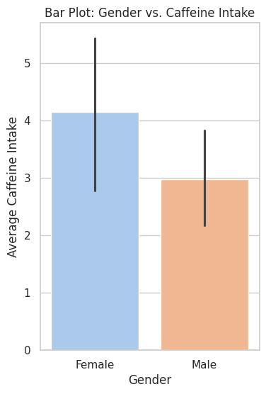

|  |
| --- |
| It was observed that females tend to consume more caffeine than their male counterparts. The bar plot comparing gender and average caffeine intake reveals a higher consumption rate among females. This finding could have implications for understanding the patterns of caffeine consumption within the surveyed population. |

|  |
| --- |
| In response to the question about caffeine's impact on academic performance, a notable trend emerged. The majority expressed uncertainty or a negative belief, while a minority believed in a positive correlation. This divergence suggests varying perspectives within the surveyed population on the relationship between caffeine intake and academic outcomes |

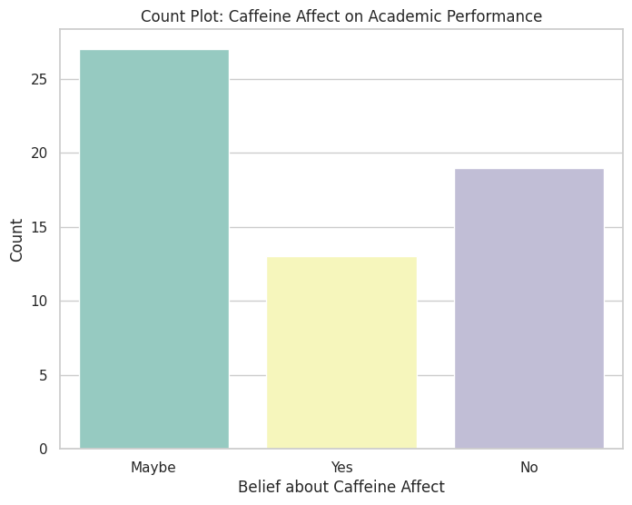

|  |
| --- |
| A small box plot comparison between Engineering and Computer Science majors revealed that students in the Computer Science major generally exhibit higher caffeine intake. This suggests a potential difference in caffeine consumption patterns between the two selected majors within the surveyed population. |

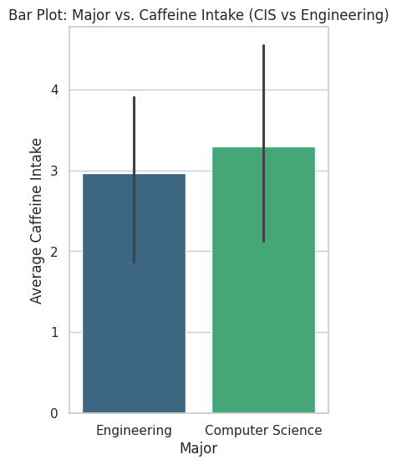

# C:\Users\Administrator\AppData\Local\Microsoft\Windows\INetCache\Content.Word\download.png

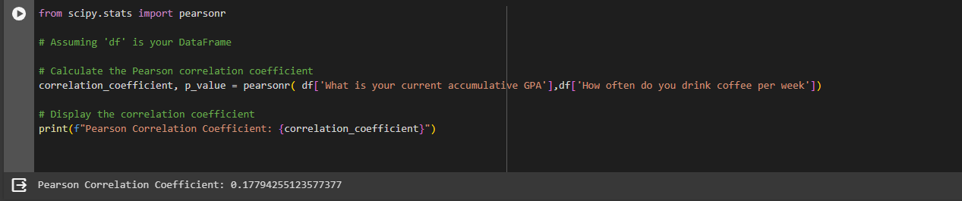

|  |
| --- |
| A scatter plot illustrating the relationship between caffeine intake and GPA revealed a Pearson correlation coefficient of 0.17. This value suggests a very weak positive correlation between the two variables within the surveyed population. |

# Conclusion

# In conclusion, our analysis found a slight link (Pearson coefficient = 0.17) between caffeine intake and GPA. Most people were unsure or didn't think caffeine affected their grades. Females tended to drink more caffeine than males. Among Engineering and Computer Science majors, Computer Science students drank more caffeine.

# These insights show potential connections within our group. Remember, just because we see links doesn't mean one thing causes another. People's habits and lifestyles may play a role.

# This analysis sparks ideas for more research on how caffeine, grades, and different factors relate. It's a starting point for discussions about how caffeine might affect academic performance.

# Any potential issues

Through this project, I learned to distinguish between quantitative and categorical data and the importance of planning visualizations before surveying. Anticipating relationships in advance proved essential, as post-collection analysis posed challenges. Additionally, I identified a bias with a majority of participants being from Computer Science and Engineering majors, underscoring the need for more diversity in future surveys.