Plant Disease Classification Project

What problem are we solving?
The purpose of this work is to apply Computer Vision techniques to distinguish and classify agricultural crop health status and pathological diseases from leaf photographs. Plant pests and diseases represent a constant, severe threat to global food security, agricultural trade, and farm livelihoods. According to the Food and Agriculture Organization, plant pests and pathogens destroy up to 40% of global food crops annually resulting in billions of dollars in economic losses and trade disruptions valued at over USD 220 billion each year.
Outbreaks affect agricultural landscapes continuously, with nearly half of emerging plant diseases spreading through international travel and trade while accelerated by climate change. Traditional manual scouting methods are labor-intensive, slow, subjective, and prone to human error, often delaying critical interventions. One of the main diagnostic challenges is that different diseases and pest infestations can share similar visual characteristics during early infection stages, such as discoloration, spots, and stippling.
For example, fungal infections like Early Blight and Late Blight present distinct concentric rings or water-soaked lesions, whereas viral pathogens like Tomato Yellow Leaf Curl Virus cause pronounced leaf curling. Pest damage such as Two-spotted spider mites creates subtle yellow stippling patterns that require fine-grained texture analysis to separate from healthy foliage or other fungal blights. Automating this detection via Convolutional Neural Networks enables rapid, scalable field diagnostics to curb widespread yield loss.

What image data do we have?
The dataset was obtained from https://www.kaggle.com/datasets/kaustubhb999/tomatoleaf , and contains 10,000 RGB leaf images spanning 10 distinct agricultural categories, including healthy foliage and 9 pathological conditions. All images are preprocessed and resized to a uniform 160x160 pixel resolution.

Class Name | Target Category | Description
Tomato___Bacterial_spot | Bacterial Pathology | Bacterial leaf spot lesions and tissue degradation.
Tomato___Early_blight | Fungal Pathology | Concentric rings and necrotic lesions characteristic of early blight.
Tomato___Late_blight | Fungal Pathology | Water-soaked large lesions and rapid blighting on foliage.
Tomato___Leaf_Mold | Fungal Pathology | Yellowish spots on upper leaf surfaces with mold growth underneath.
Tomato___Septoria_leaf_spot | Fungal Pathology | Small circular spots with dark borders and grey centers.
Tomato___Spider_mites Two-spotted_spider_mite | Pest Infestation | Two-spotted spider mite stippling and webbing damage.
Tomato___Target_Spot | Fungal Pathology | Target-like concentric rings on leaves caused by fungal infection.
Tomato___Tomato_Yellow_Leaf_Curl_Virus | Viral Pathology | Severe upward leaf curling and stunted growth symptoms.
Tomato___Tomato_mosaic_virus | Viral Pathology | Mottled light and dark green patterns across leaf blade.
Tomato___healthy | Healthy Foliage | Clean, non-pathological tomato leaves used as a control baseline.
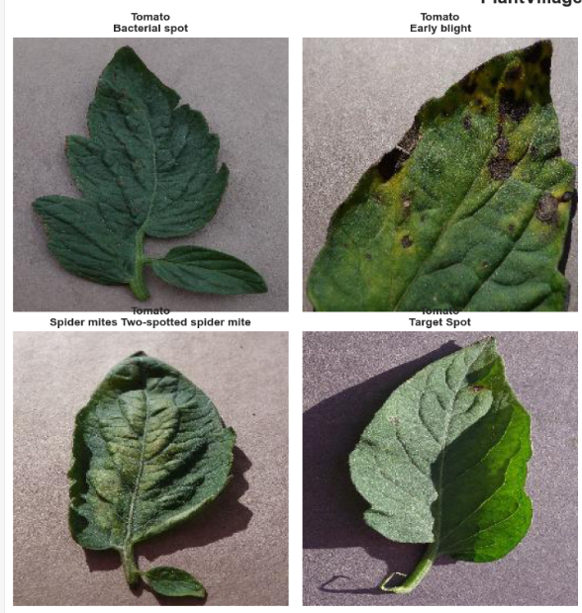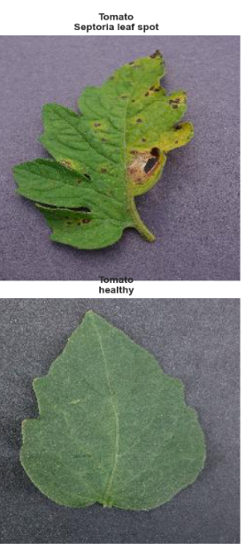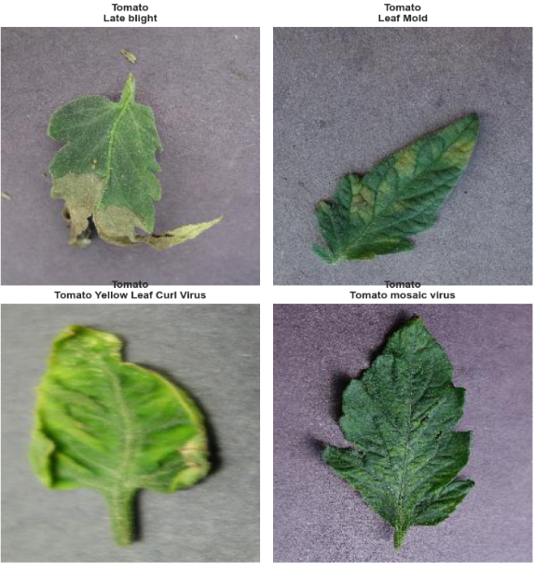

Learning Style
I am using Supervised Learning because the dataset contains annotated images mapped to specific pathological class labels. Each leaf image is associated with its correct ground-truth disease label, allowing the model to learn the relationship between visual patterns and the corresponding disease category. The main goal is to train the model to accurately predict the correct label for new, unseen leaf images.
Type | Description
Input | Digital RGB leaf images from the PlantVillage dataset (160x160 resolution).
Output | The corresponding agricultural disease or health class labels assigned to each image.

During training, the module compares the predicted label against the actual label and improves its performance through optimization. As a result, supervised learning is the most suitable approach for an image classification task.

What trade-offs matter most?
The main trade-off is between model accuracy and complexity. A larger, deeper model and more complex architecture can improve classification performance on subtle patterns like spider mites, but they also require more computational power and processing time.
In our case, computational resources and training time must be balanced. A model that is too simple can lead to underfitting, while an overly complex model without proper regularization can overfit the training images. Overall, our goal is to achieve high classification accuracy (reaching 90.00% validation accuracy) while keeping the model efficient enough to generalize well to unseen leaf images.

How should we validate and evaluate the model?
Dividing the dataset into an 80% training set and a 20% validation set establishes a rigorous evaluation pool of exactly 2,000 validation images. The training set is used to train the model weights, while the validation set helps adjust parameters, apply class weights, and evaluate generalization performance on unseen data.
In order to correctly classify leaves into their respective disease categories, metrics such as Accuracy, Precision, Recall, and F1-Score are used. A Confusion Matrix, on the other hand, is used to identify which diseases are being confused with each other (such as early-stage healthy leaves versus spider mite damage). This helps understand the strengths and weaknesses of the model and confirms that it generalizes effectively to new data.
The Problem I Found During the Assignment
During initial end-to-end testing of the FastAPI deployment, a system-wide label alignment error occurred. Specifically, uploading test images from certain categories (such as Tomato___Target_Spot) consistently triggered incorrect predictions mapped to entirely different classes (such as Tomato___Spider_mites Two-spotted_spider_mite) despite the underlying deep learning model outputting high confidence scores.
Upon investigation, this behavior was identified as a class index mapping mismatch. The prediction script and FastAPI backend rely on a lookup list (CLASS_NAMES) to translate that index back into a readable disease string. Because the manual hardcoded list of class names in main.py did not perfectly match the alphabetical sorting order established by TensorFlow’s image_dataset_from_directory during data ingestion, the category indices were systematically shifted, causing incorrect labels to display for specific folders.
The Solution
To permanently eliminate hardcoding errors and ensure strict synchronization between the training pipeline and the inference server, a dynamic class-loading mechanism was implemented:
- Automated Export: Immediately following dataset loading and preprocessing in the Jupyter Notebook, the exact, verified class list (train_dataset.class_names) is extracted and serialized directly into a JSON file (class_names.json) within the project root directory.
- Dynamic Server Ingestion: The FastAPI application (main.py) was updated to check for and load class_names.json dynamically on startup. Rather than relying on a static text array, the inference endpoint maps the model's argmax prediction index directly against this synchronized file.
- Validation: Re-testing the API with the same sample image files confirmed that the index alignment was fully restored, yielding accurate, high-confidence diagnoses corresponding precisely to the correct physical leaf condition.
