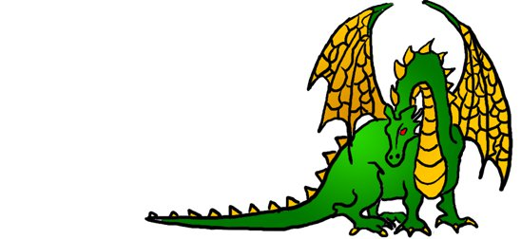
Unigames Membership
Name:__________________________________
□ UWA Guild Member
Student Number (If UWA) ________________
Email Address:__________________________
(leave blank to use UWA email address)
Phone number: _________________________
Address: ________________________________________
__________________________________________________ (this will be used to hunt you down if you don't return our books)

Interests (tick all that apply):
□ Roleplaying games  (dnd, nWoD, DH etc) | □ Wargames  (WH40K etc)
□ Board/Card games | □ Collectable card games (MTG etc)
□ Air Conditioning | □ Snacks and drinks
□ Borrowing from our Library | □ Using our clubroom

Sign:___________ Date:___________
Committee member: ___________________

