METABOLIC MISSION
From ATP to the Glyoxylate Cycle
Second-Year SBIA022 Quiz Pack - Lecturer Memo
Institution | University of Limpopo
Question set | 20 core questions + 20 challenge twins
Assessment | 100 marks if both versions are completed
Progression | Remember -> Understand -> Apply -> Analyze -> Evaluate -> Create
Think like a cell: conserve carbon, balance energy, and justify every pathway choice.
Memo use: Accept scientifically equivalent wording. For higher-order questions, award marks for a correct causal chain, not for memorising this memo verbatim.

How to use this pack
- Each numbered item contains a Core question (A) and a matched Challenge Twin (B). Together they make 40 questions.
- Questions within each topic move from lower-order recall toward application, analysis, evaluation, or creation.
- Show calculations and metabolic reasoning. A pathway name without an explanation may earn only partial credit.
- Figures are simplified learning aids; use the lecture terminology when answering.
- Suggested total: 100 marks - 50 for all A questions and 50 for all B questions. The twins can also be used as a second form, revision round, or make-up quiz.

Bloom ladder and marks
Remember (1) | Understand (2) | Apply (3) | Analyze (3-4) | Evaluate (5) | Create (5)

ENERGY LAB

1. Bioenergetics: The Cell's Energy Budget
MISSION BRIEF
A campus food-science team is designing a rapid test for whether cellular reactions can proceed. They must distinguish energy-releasing reactions from energy-requiring ones and decide when ATP coupling can make an otherwise unfavourable process proceed.
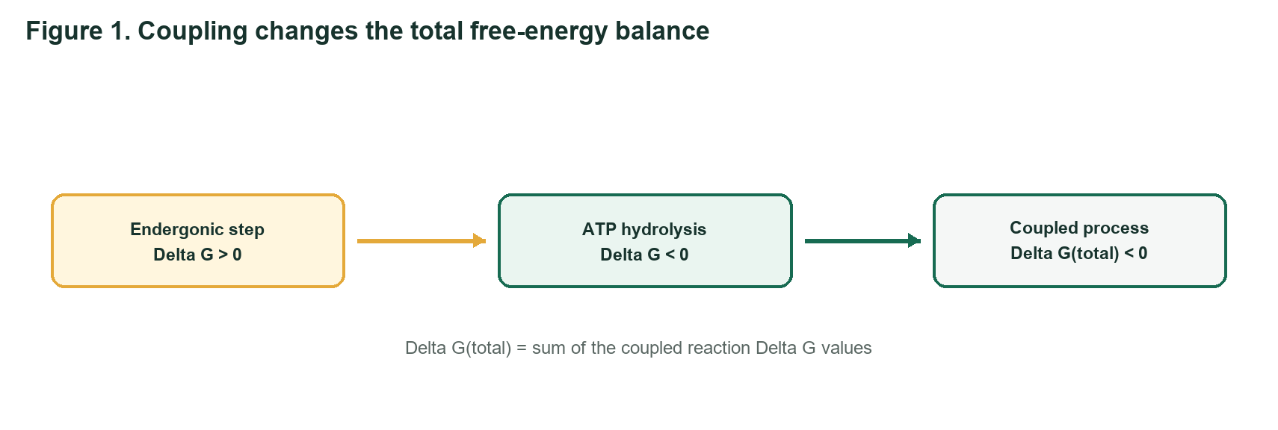
Bioenergetics learning schematic
Q1 REMEMBER | 1 mark each
A - Core: State what bioenergetics studies and identify the sign of Delta G for a spontaneous reaction.
Suggested answer: Bioenergetics studies energy flow and transformation in living systems; a spontaneous reaction has Delta G < 0.
B - Challenge Twin: State what Gibbs free-energy change predicts and identify the sign of Delta G at equilibrium.
Suggested answer: Delta G predicts reaction spontaneity/direction; at equilibrium Delta G = 0.
Q2 UNDERSTAND | 2 marks each
A - Core: Why can an anabolic reaction with a positive Delta G proceed when it is coupled to ATP hydrolysis? Answer in two sentences.
Suggested answer: ATP hydrolysis has a sufficiently negative Delta G. When the reactions are mechanistically coupled, their Delta G values add; the overall process can become negative.
B - Challenge Twin: Explain why calling ATP an 'energy currency' does not mean ATP creates energy.
Suggested answer: ATP transfers conserved chemical free energy from energy-yielding processes to energy-requiring work. It transforms and couples energy rather than creating it.
Q3 APPLY | 3 marks each
A - Core: A biosynthetic step has Delta G = +18.0 kJ/mol and is coupled to ATP hydrolysis with Delta G = -30.5 kJ/mol. Calculate the combined Delta G and predict whether the coupled process is thermodynamically favourable.
Suggested answer: Delta G(total) = +18.0 - 30.5 = -12.5 kJ/mol; the coupled process is favourable/spontaneous.
B - Challenge Twin: Transport of a solute has Delta G = +22.0 kJ/mol. It is coupled to a reaction with Delta G = -28.0 kJ/mol. Calculate the net Delta G and state what would happen if coupling were lost.
Suggested answer: Delta G(total) = +22.0 - 28.0 = -6.0 kJ/mol; coupled transport is favourable. Without coupling, the +22.0 kJ/mol transport step would be unfavourable.

SPRINT TRACK

2. Glycolysis: The Ten-Step Sprint
MISSION BRIEF
During a short, intense sprint, skeletal muscle needs ATP faster than oxygen delivery can support oxidative metabolism. Glycolysis must keep running, and its irreversible steps act as metabolic control gates.
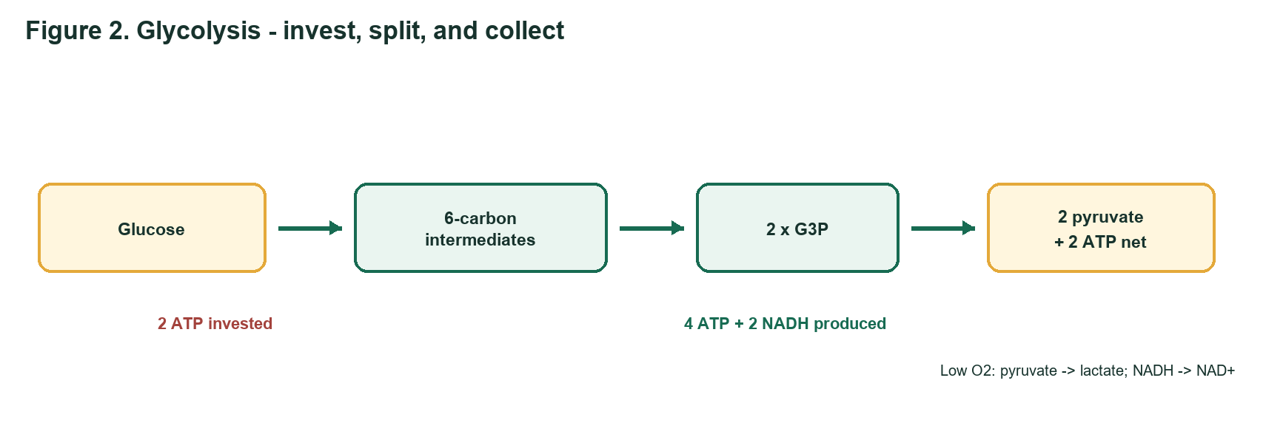
Glycolysis learning schematic
Q4 REMEMBER | 1 mark each
A - Core: Give the net products of glycolysis from one glucose molecule under standard accounting.
Suggested answer: 2 pyruvate, 2 ATP net, 2 NADH, and 2 H2O (plus 2 H+ depending on convention).
B - Challenge Twin: Name the ATP-investment and ATP-payoff amounts in glycolysis and calculate the net ATP yield.
Suggested answer: 2 ATP are invested and 4 ATP are produced; net yield = 2 ATP per glucose.
Q5 UNDERSTAND | 2 marks each
A - Core: Explain why the PFK-1 reaction is called the first committed step of glycolysis. Name one activator and one inhibitor from the lectures.
Suggested answer: PFK-1 commits fructose-6-phosphate to glycolysis by forming fructose-1,6-bisphosphate. Activators include AMP or fructose-2,6-bisphosphate; inhibitors include ATP, citrate, low pH, or fatty acids.
B - Challenge Twin: Differentiate the roles of hexokinase/glucokinase and PFK-1 in controlling glucose use. Include one regulatory feature of each.
Suggested answer: Hexokinase/glucokinase traps glucose as G6P; hexokinase is product-inhibited by G6P, while liver glucokinase has lower affinity and is not inhibited by G6P. PFK-1 controls the committed/rate-limiting step and responds to the energy state.
Q6 APPLY | 3 marks each
A - Core: Use Figure 2. During oxygen-limited sprinting, explain why pyruvate is converted to lactate and predict the immediate effect on glycolytic ATP production if lactate dehydrogenase is blocked.
Suggested answer: Lactate dehydrogenase oxidizes NADH to NAD+, allowing GAPDH and glycolysis to continue. Blocking it depletes cytosolic NAD+, slows/stops glycolysis, and rapidly lowers ATP production.
B - Challenge Twin: A red blood cell cannot use mitochondria. Explain why lactate production is essential for its continued ATP supply and identify the cofactor that is regenerated.
Suggested answer: RBCs depend on glycolysis for ATP. Conversion of pyruvate to lactate regenerates NAD+, which is required by glyceraldehyde-3-phosphate dehydrogenase.

FUEL DEPOT

3. Glycogen Metabolism: The Branched Emergency Store
MISSION BRIEF
A student athlete alternates between lectures, training, and an overnight fast. Liver glycogen supports blood glucose, while muscle glycogen is a rapid local fuel. The highly branched structure determines how quickly glucose units can be released.
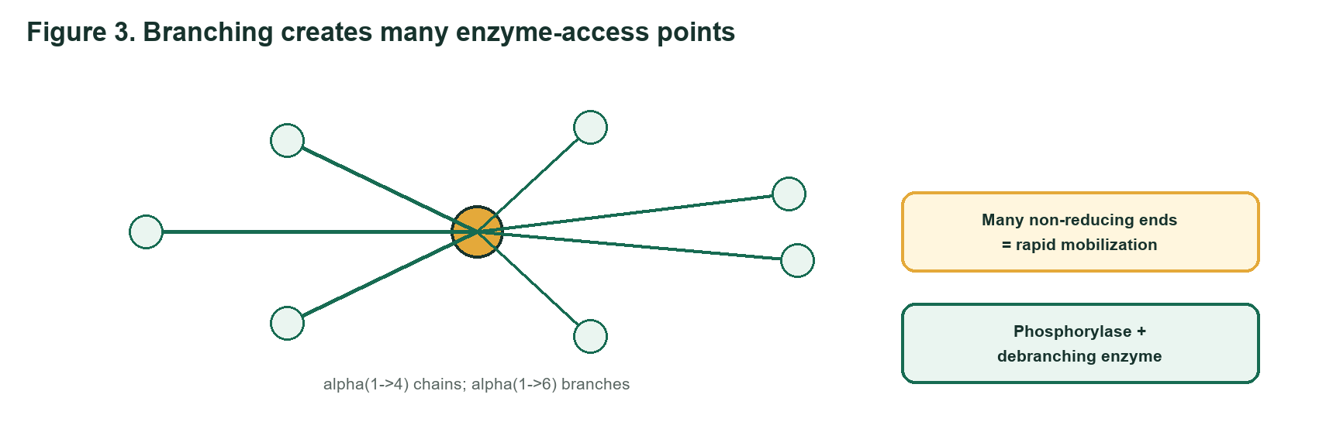
Glycogen learning schematic
Q7 REMEMBER | 1 mark each
A - Core: Identify the glycosidic bond in the linear chains and the bond at glycogen branch points.
Suggested answer: Linear chains contain alpha(1->4) bonds; branch points contain alpha(1->6) bonds.
B - Challenge Twin: What is a non-reducing end, and why do many non-reducing ends help rapid glycogen mobilization?
Suggested answer: A non-reducing end is a chain end from which glycogen-metabolizing enzymes add or remove glucose. Many ends allow many enzyme molecules to work simultaneously, increasing the rate.
Q8 UNDERSTAND | 2 marks each
A - Core: Why can liver glycogen help maintain blood glucose, whereas muscle glycogen mainly supplies the muscle itself?
Suggested answer: Liver expresses glucose-6-phosphatase and can convert G6P to free glucose for export. Muscle lacks glucose-6-phosphatase, so G6P enters glycolysis locally.
B - Challenge Twin: After glycogen phosphorylase releases glucose-1-phosphate, trace its conversion in liver until free glucose can enter the blood.
Suggested answer: G1P is converted by phosphoglucomutase to G6P; it enters the ER and glucose-6-phosphatase hydrolyses it to glucose, which is returned to the cytosol and released.
Q9 APPLY | 3 marks each
A - Core: A patient has normal glycogen phosphorylase but deficient debranching enzyme. Predict the glycogen structure that accumulates and explain why breakdown stops near branches.
Suggested answer: Short outer chains/limit-dextrin-like glycogen accumulates. Phosphorylase stops about four residues from a branch and cannot cleave alpha(1->6); transferase and alpha-1,6-glucosidase activities are needed.
B - Challenge Twin: A muscle sample lacks glycogen phosphorylase activity but has a normal debranching enzyme. Predict the effect on exercise tolerance and on release of glucose-1-phosphate from alpha(1->4) bonds.
Suggested answer: Rapid glycogen use and exercise tolerance decrease. Debranching enzyme cannot substitute for phosphorylase, so phosphorolytic release of G1P from alpha(1->4) bonds is severely impaired.

FASTING RESCUE

4. Gluconeogenesis: Rebuilding Glucose During a Fast
MISSION BRIEF
After an overnight fast, hepatic glycogen becomes limited. The liver uses lactate, glycerol, and glucogenic amino-acid carbon skeletons to rebuild glucose, paying an energy cost to bypass the irreversible steps of glycolysis.
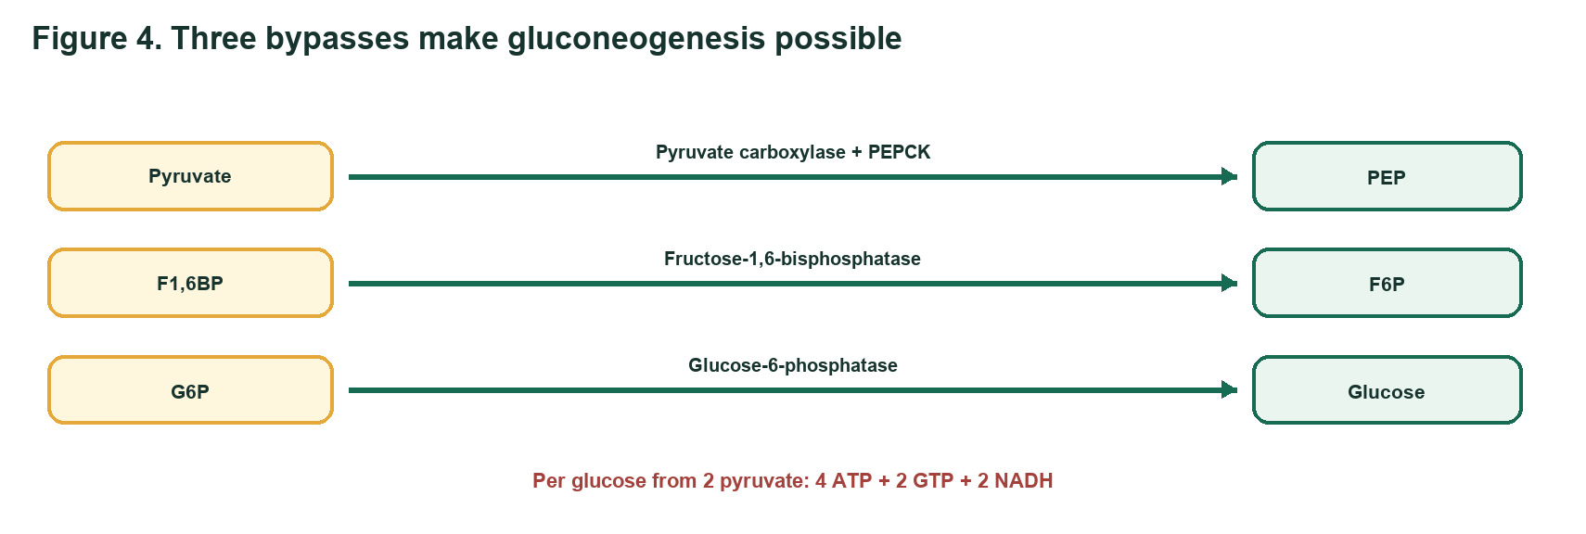
Gluconeogenesis learning schematic
Q10 REMEMBER | 1 mark each
A - Core: Name three gluconeogenic precursors and the main organ that performs gluconeogenesis.
Suggested answer: Any three: lactate, glycerol, pyruvate, alanine/other glucogenic amino acids, TCA intermediates, propionate. Main organ: liver (kidney contributes during prolonged fasting).
B - Challenge Twin: Name two tissues with a continuous need for glucose and state why gluconeogenesis becomes important after prolonged fasting.
Suggested answer: Examples include brain, RBCs, lens, adrenal medulla, and exercising muscle. As hepatic glycogen is depleted, gluconeogenesis becomes the major source maintaining blood glucose.
Q11 UNDERSTAND | 2 marks each
A - Core: Match each irreversible glycolytic enzyme with its gluconeogenic bypass enzyme(s): hexokinase, PFK-1, and pyruvate kinase.
Suggested answer: Hexokinase/glucokinase -> glucose-6-phosphatase; PFK-1 -> fructose-1,6-bisphosphatase; pyruvate kinase -> pyruvate carboxylase plus PEP carboxykinase.
B - Challenge Twin: Why is oxaloacetate commonly converted to malate before its carbon skeleton moves from mitochondrion to cytosol during gluconeogenesis?
Suggested answer: The inner mitochondrial membrane is poorly permeable to oxaloacetate. Malate can be transported and then reoxidized to oxaloacetate in the cytosol, also transferring reducing equivalents.
Q12 APPLY | 3 marks each
A - Core: Calculate the high-energy phosphate cost of producing one glucose from two pyruvate. Separate ATP and GTP, and include the NADH requirement.
Suggested answer: 4 ATP + 2 GTP = 6 high-energy phosphate equivalents, plus 2 NADH per glucose.
B - Challenge Twin: Two glucose molecules must be synthesized from pyruvate. Calculate the total ATP, GTP, and NADH required, using the lecture stoichiometry.
Suggested answer: 8 ATP, 4 GTP, and 4 NADH for two glucose molecules; 12 high-energy phosphate equivalents in total.

CONTROL ROOM

5. Reciprocal Regulation: Choosing Store, Burn, or Build
MISSION BRIEF
A hepatocyte receives different hormonal instructions after lunch, during an overnight fast, and during acute stress. Reciprocal regulation prevents glycolysis and gluconeogenesis - or glycogenesis and glycogenolysis - from running strongly at the same time.
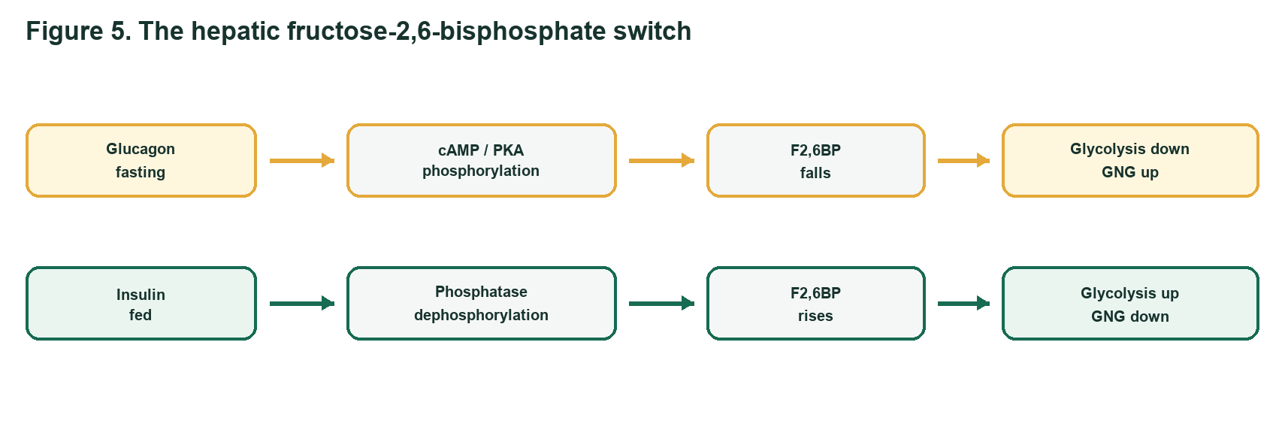
Regulation learning schematic
Q13 REMEMBER | 1 mark each
A - Core: State the main effect of insulin and of glucagon on liver glycogen metabolism.
Suggested answer: Insulin promotes glycogen synthesis; glucagon promotes liver glycogen breakdown and inhibits synthesis.
B - Challenge Twin: State the main glycogen effect of epinephrine and name the physiological situation that triggers it.
Suggested answer: Epinephrine promotes rapid glycogen breakdown during acute stress or exercise.
Q14 UNDERSTAND | 2 marks each
A - Core: Explain the reciprocal effect of fructose-2,6-bisphosphate on PFK-1 and fructose-1,6-bisphosphatase.
Suggested answer: Fructose-2,6-bisphosphate activates PFK-1, stimulating glycolysis, and inhibits FBPase-1, suppressing gluconeogenesis.
B - Challenge Twin: Why does a fall in hepatic fructose-2,6-bisphosphate during fasting reduce futile cycling between glycolysis and gluconeogenesis?
Suggested answer: Lower F2,6BP removes activation of PFK-1 and relieves inhibition of FBPase-1, coordinating lower glycolysis with higher gluconeogenesis instead of running both strongly.
Q15 ANALYZE | 3 marks each
A - Core: Use Figure 5. During fasting, trace the sequence from glucagon to PKA to the bifunctional PFK-2/FBPase-2 enzyme. Predict F2,6BP, glycolysis, and gluconeogenesis.
Suggested answer: Glucagon -> cAMP -> PKA -> phosphorylation: PFK-2 decreases and FBPase-2 increases -> F2,6BP falls -> glycolysis decreases and gluconeogenesis increases.
B - Challenge Twin: After a carbohydrate-rich meal, trace insulin action through dephosphorylation of hepatic PFK-2/FBPase-2. Predict F2,6BP and the direction of glucose metabolism.
Suggested answer: Insulin promotes phosphatase action/dephosphorylation: PFK-2 increases and FBPase-2 decreases -> F2,6BP rises -> glycolysis increases and gluconeogenesis decreases; storage is favoured.

ANTIOXIDANT SHIELD

6. Pentose Phosphate Pathway: Reducing Power and Ribose
MISSION BRIEF
Red blood cells face oxidants but have no mitochondria. Other cells may need NADPH for reductive biosynthesis or ribose-5-phosphate for nucleotide synthesis. The pentose phosphate pathway adjusts its oxidative and non-oxidative phases to those needs.
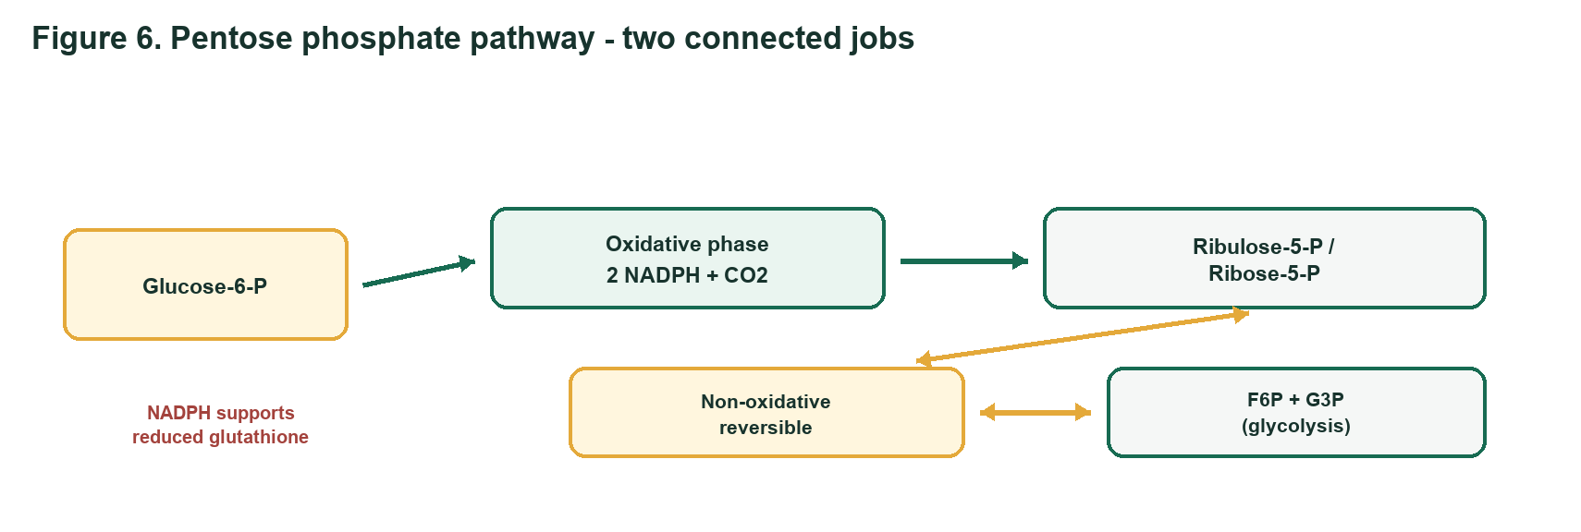
Ppp learning schematic
Q16 UNDERSTAND | 2 marks each
A - Core: Compare the main products and reversibility of the oxidative and non-oxidative phases of the pentose phosphate pathway.
Suggested answer: The oxidative phase is irreversible and produces NADPH, CO2, and ribulose-5-phosphate. The non-oxidative phase is reversible and interconverts pentose phosphates with fructose-6-phosphate and glyceraldehyde-3-phosphate.
B - Challenge Twin: A rapidly dividing cell needs ribose-5-phosphate more than NADPH. Explain how reversible non-oxidative reactions can help meet this need using glycolytic intermediates.
Suggested answer: Reversible transketolase/transaldolase reactions can run from F6P and G3P toward ribose-5-phosphate, allowing ribose production without proportionally high oxidative-phase NADPH production.
Q17 ANALYZE | 4 marks each
A - Core: A patient with low glucose-6-phosphate dehydrogenase activity develops haemolysis after oxidant-drug exposure. Build the causal chain from reduced PPP flux to red-cell membrane damage.
Suggested answer: Low G6PD -> less oxidative PPP NADPH -> reduced ability of glutathione reductase to regenerate GSH -> peroxide/ROS accumulate -> haemoglobin and membrane proteins/lipids are oxidized -> RBC damage and haemolysis.
B - Challenge Twin: Two samples are exposed to peroxide: normal RBCs and RBCs with impaired oxidative PPP activity. Predict which has the lower reduced-glutathione level and explain the roles of NADPH and glutathione reductase.
Suggested answer: The impaired-PPP RBCs have lower GSH. NADPH donates reducing power to glutathione reductase, which converts oxidized glutathione (GSSG) back to GSH for peroxide detoxification.

CARBON ROUNDABOUT

7. CAC and Glyoxylate Cycle: The Carbon-Routing Finale
MISSION BRIEF
A germinating oil seed converts stored fat into carbohydrate, while a mammalian liver cannot obtain net glucose from even-chain fatty acids. Both use acetyl-CoA, but only the seed can bypass the carbon-losing steps of the citric acid cycle through the glyoxylate cycle.
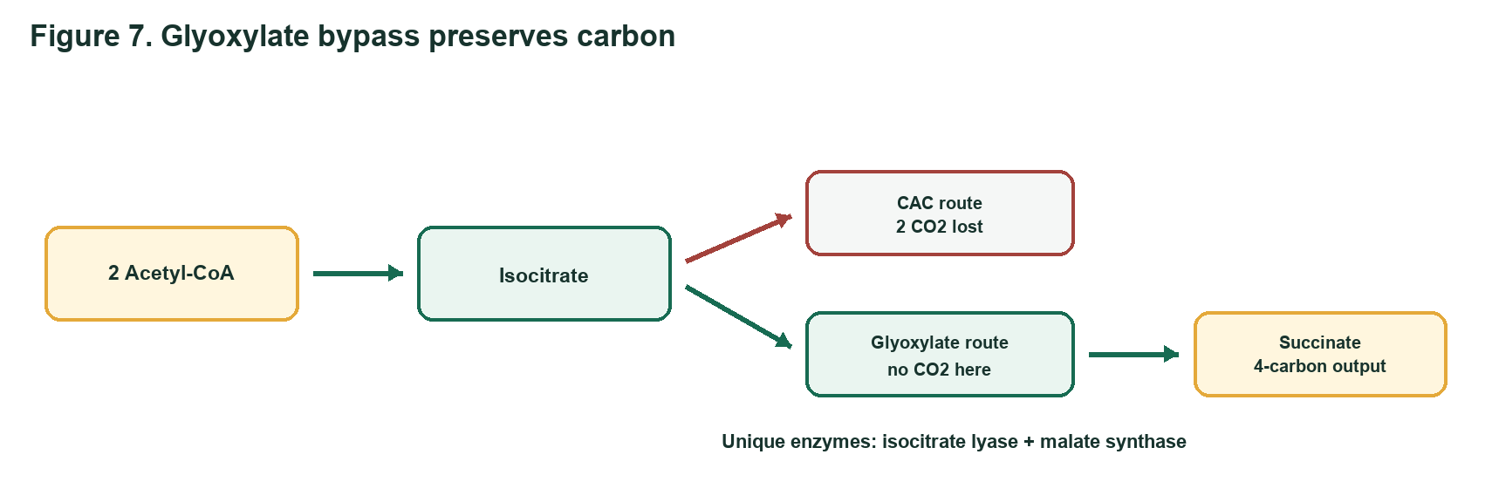
Cac Glyoxylate learning schematic
Q18 ANALYZE | 4 marks each
A - Core: For one acetyl-CoA entering the CAC, account for NADH, FADH2, GTP/ATP, and CO2. Then explain how high ATP and NADH affect cycle flux.
Suggested answer: Per acetyl-CoA: 3 NADH, 1 FADH2, 1 GTP (or ATP), and 2 CO2; about 10 ATP equivalents after oxidative phosphorylation. High ATP/NADH signal energy sufficiency and inhibit major control enzymes, reducing flux.
B - Challenge Twin: A cell has high NADH and succinyl-CoA. Identify two CAC control points likely to slow and explain the product/energy feedback involved.
Suggested answer: Isocitrate dehydrogenase is inhibited by NADH; alpha-ketoglutarate dehydrogenase is inhibited by NADH and succinyl-CoA. Citrate synthase/PDH may also slow under high-energy/product conditions.
Q19 EVALUATE | 5 marks each
A - Core: Defend this statement: 'A germinating seed can achieve net carbohydrate synthesis from acetyl-CoA, but a vertebrate cannot.' Refer to carbon loss and the two unique glyoxylate-cycle enzymes.
Suggested answer: The CAC loses two carbons as CO2, preventing net oxaloacetate gain from acetyl-CoA. The glyoxylate cycle bypasses the decarboxylations: isocitrate lyase forms succinate + glyoxylate, and malate synthase condenses glyoxylate with a second acetyl-CoA. Succinate can support carbohydrate synthesis. Vertebrates lack this pathway.
B - Challenge Twin: A researcher proposes inserting only isocitrate lyase into a mammalian cell to create a functional glyoxylate cycle. Evaluate the proposal and identify the additional enzyme and carbon-routing requirement.
Suggested answer: Isocitrate lyase alone is insufficient. Malate synthase is also needed to combine glyoxylate with acetyl-CoA, and the pathway must route isocitrate away from CAC decarboxylations while regenerating oxaloacetate and exporting a four-carbon product such as succinate.
Q20 CREATE | 5 marks each
A - Core: Design a carbon-flow plan for a fed liver cell with high ATP, abundant glucose, demand for fatty-acid synthesis, and demand for nucleotides. Route glucose among glycolysis/CAC, glycogen, and PPP; justify each choice using energy and biosynthetic signals.
Suggested answer: A strong answer routes glucose to glycogen storage; uses glycolysis to supply pyruvate/acetyl-CoA and citrate for fatty-acid synthesis but slows complete oxidation when ATP/NADH are high; directs G6P through oxidative PPP for NADPH and through non-oxidative PPP for ribose-5-P. It should mention insulin/F2,6BP favouring glycolysis and suppressing gluconeogenesis.
B - Challenge Twin: Design a carbon-flow plan for a fasting liver cell with low blood glucose and active fatty-acid oxidation. Integrate glycogenolysis, gluconeogenesis, glycolysis regulation, the CAC, and the fact that acetyl-CoA cannot give net glucose in vertebrates.
Suggested answer: A strong answer uses early liver glycogenolysis and then gluconeogenesis from lactate, glycerol, and glucogenic amino acids; glucagon lowers F2,6BP, suppressing glycolysis and activating gluconeogenesis. Fatty-acid oxidation supplies ATP/NADH and acetyl-CoA; acetyl-CoA supports energy/ketone production and activates pyruvate carboxylase but cannot provide net glucose because vertebrates lack the glyoxylate cycle.

Source lectures used
This quiz was developed from the supplied SBIA022 lecture documents by Dr KW Poopedi and colleagues. The diagrams are simplified original study schematics prepared for this quiz.
- Bioenergetics
- Glycolysis
- Glycogen Metabolism
- Gluconeogenesis
- Regulation of Carbohydrate Metabolism
- Pentose Phosphate Pathway
- CAC Regulation and the Glyoxylate Cycle
END OF METABOLIC MISSION

