METABOLIC MISSION
From ATP to the Glyoxylate Cycle
Second-Year SBIA022 Quiz Pack
Institution | University of Limpopo
Question set | 20 core questions + 20 challenge twins
Assessment | 100 marks if both versions are completed
Progression | Remember -> Understand -> Apply -> Analyze -> Evaluate -> Create
Think like a cell: conserve carbon, balance energy, and justify every pathway choice.
Student name: __________________________________________
Student number: _______________________________________
Date: ____________________ Tutorial group: _____________

How to use this pack
- Each numbered item contains a Core question (A) and a matched Challenge Twin (B). Together they make 40 questions.
- Questions within each topic move from lower-order recall toward application, analysis, evaluation, or creation.
- Show calculations and metabolic reasoning. A pathway name without an explanation may earn only partial credit.
- Figures are simplified learning aids; use the lecture terminology when answering.

Bloom ladder and marks
Remember (1) | Understand (2) | Apply (3) | Analyze (3-4) | Evaluate (5) | Create (5)

ENERGY LAB

1. Bioenergetics: The Cell's Energy Budget
MISSION BRIEF
A campus food-science team is designing a rapid test for whether cellular reactions can proceed. They must distinguish energy-releasing reactions from energy-requiring ones and decide when ATP coupling can make an otherwise unfavourable process proceed.
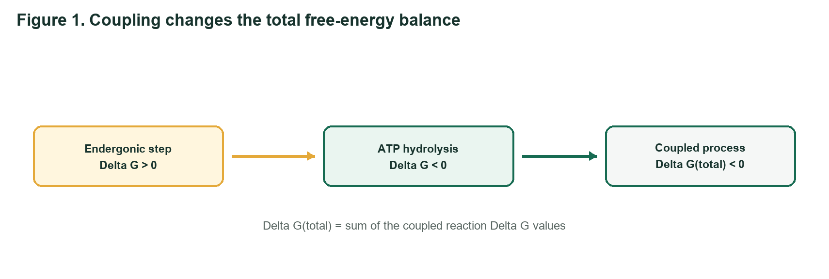
Bioenergetics learning schematic
Q1 REMEMBER | 1 mark each
A - Core: State what bioenergetics studies and identify the sign of Delta G for a spontaneous reaction.
________________________________________________________________________________
B - Challenge Twin: State what Gibbs free-energy change predicts and identify the sign of Delta G at equilibrium.
________________________________________________________________________________
Q2 UNDERSTAND | 2 marks each
A - Core: Why can an anabolic reaction with a positive Delta G proceed when it is coupled to ATP hydrolysis? Answer in two sentences.
________________________________________________________________________________
________________________________________________________________________________
B - Challenge Twin: Explain why calling ATP an 'energy currency' does not mean ATP creates energy.
________________________________________________________________________________
________________________________________________________________________________
Q3 APPLY | 3 marks each
A - Core: A biosynthetic step has Delta G = +18.0 kJ/mol and is coupled to ATP hydrolysis with Delta G = -30.5 kJ/mol. Calculate the combined Delta G and predict whether the coupled process is thermodynamically favourable.
________________________________________________________________________________
________________________________________________________________________________
B - Challenge Twin: Transport of a solute has Delta G = +22.0 kJ/mol. It is coupled to a reaction with Delta G = -28.0 kJ/mol. Calculate the net Delta G and state what would happen if coupling were lost.
________________________________________________________________________________
________________________________________________________________________________

SPRINT TRACK

2. Glycolysis: The Ten-Step Sprint
MISSION BRIEF
During a short, intense sprint, skeletal muscle needs ATP faster than oxygen delivery can support oxidative metabolism. Glycolysis must keep running, and its irreversible steps act as metabolic control gates.
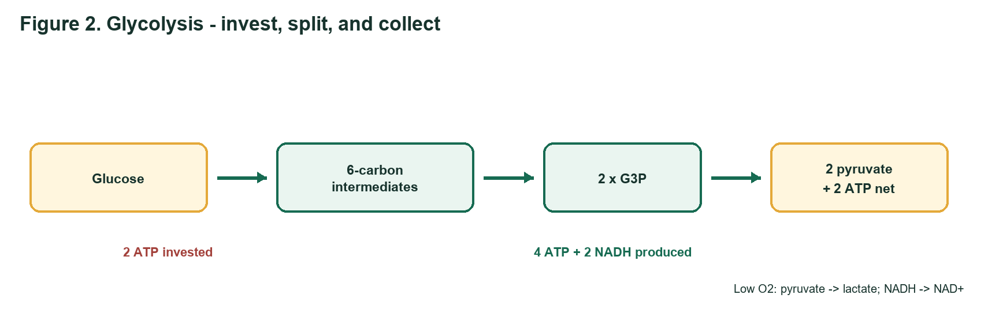
Glycolysis learning schematic
Q4 REMEMBER | 1 mark each
A - Core: Give the net products of glycolysis from one glucose molecule under standard accounting.
________________________________________________________________________________
B - Challenge Twin: Name the ATP-investment and ATP-payoff amounts in glycolysis and calculate the net ATP yield.
________________________________________________________________________________
Q5 UNDERSTAND | 2 marks each
A - Core: Explain why the PFK-1 reaction is called the first committed step of glycolysis. Name one activator and one inhibitor from the lectures.
________________________________________________________________________________
________________________________________________________________________________
B - Challenge Twin: Differentiate the roles of hexokinase/glucokinase and PFK-1 in controlling glucose use. Include one regulatory feature of each.
________________________________________________________________________________
________________________________________________________________________________
Q6 APPLY | 3 marks each
A - Core: Use Figure 2. During oxygen-limited sprinting, explain why pyruvate is converted to lactate and predict the immediate effect on glycolytic ATP production if lactate dehydrogenase is blocked.
________________________________________________________________________________
________________________________________________________________________________
B - Challenge Twin: A red blood cell cannot use mitochondria. Explain why lactate production is essential for its continued ATP supply and identify the cofactor that is regenerated.
________________________________________________________________________________
________________________________________________________________________________

FUEL DEPOT

3. Glycogen Metabolism: The Branched Emergency Store
MISSION BRIEF
A student athlete alternates between lectures, training, and an overnight fast. Liver glycogen supports blood glucose, while muscle glycogen is a rapid local fuel. The highly branched structure determines how quickly glucose units can be released.
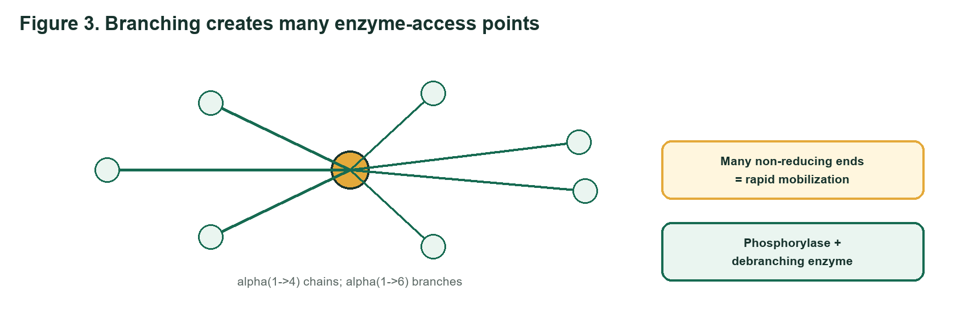
Glycogen learning schematic
Q7 REMEMBER | 1 mark each
A - Core: Identify the glycosidic bond in the linear chains and the bond at glycogen branch points.
________________________________________________________________________________
B - Challenge Twin: What is a non-reducing end, and why do many non-reducing ends help rapid glycogen mobilization?
________________________________________________________________________________
Q8 UNDERSTAND | 2 marks each
A - Core: Why can liver glycogen help maintain blood glucose, whereas muscle glycogen mainly supplies the muscle itself?
________________________________________________________________________________
________________________________________________________________________________
B - Challenge Twin: After glycogen phosphorylase releases glucose-1-phosphate, trace its conversion in liver until free glucose can enter the blood.
________________________________________________________________________________
________________________________________________________________________________
Q9 APPLY | 3 marks each
A - Core: A patient has normal glycogen phosphorylase but deficient debranching enzyme. Predict the glycogen structure that accumulates and explain why breakdown stops near branches.
________________________________________________________________________________
________________________________________________________________________________
B - Challenge Twin: A muscle sample lacks glycogen phosphorylase activity but has a normal debranching enzyme. Predict the effect on exercise tolerance and on release of glucose-1-phosphate from alpha(1->4) bonds.
________________________________________________________________________________
________________________________________________________________________________

FASTING RESCUE

4. Gluconeogenesis: Rebuilding Glucose During a Fast
MISSION BRIEF
After an overnight fast, hepatic glycogen becomes limited. The liver uses lactate, glycerol, and glucogenic amino-acid carbon skeletons to rebuild glucose, paying an energy cost to bypass the irreversible steps of glycolysis.
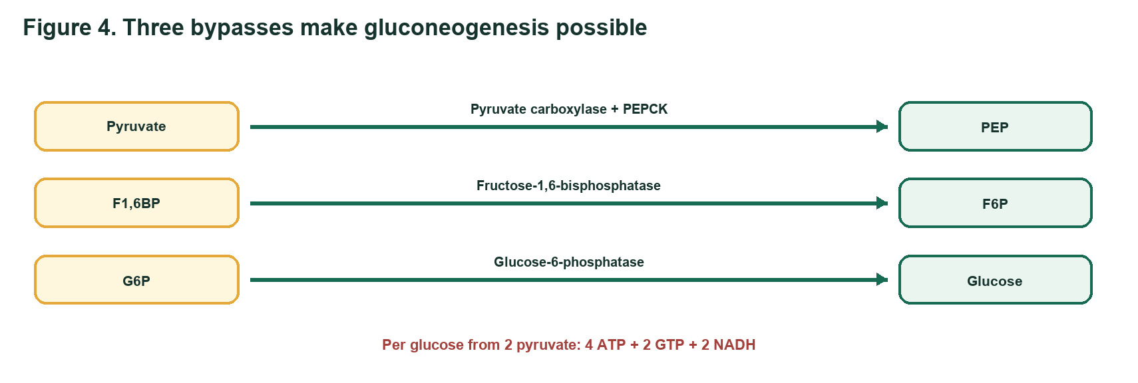
Gluconeogenesis learning schematic
Q10 REMEMBER | 1 mark each
A - Core: Name three gluconeogenic precursors and the main organ that performs gluconeogenesis.
________________________________________________________________________________
B - Challenge Twin: Name two tissues with a continuous need for glucose and state why gluconeogenesis becomes important after prolonged fasting.
________________________________________________________________________________
Q11 UNDERSTAND | 2 marks each
A - Core: Match each irreversible glycolytic enzyme with its gluconeogenic bypass enzyme(s): hexokinase, PFK-1, and pyruvate kinase.
________________________________________________________________________________
________________________________________________________________________________
B - Challenge Twin: Why is oxaloacetate commonly converted to malate before its carbon skeleton moves from mitochondrion to cytosol during gluconeogenesis?
________________________________________________________________________________
________________________________________________________________________________
Q12 APPLY | 3 marks each
A - Core: Calculate the high-energy phosphate cost of producing one glucose from two pyruvate. Separate ATP and GTP, and include the NADH requirement.
________________________________________________________________________________
________________________________________________________________________________
B - Challenge Twin: Two glucose molecules must be synthesized from pyruvate. Calculate the total ATP, GTP, and NADH required, using the lecture stoichiometry.
________________________________________________________________________________
________________________________________________________________________________

CONTROL ROOM

5. Reciprocal Regulation: Choosing Store, Burn, or Build
MISSION BRIEF
A hepatocyte receives different hormonal instructions after lunch, during an overnight fast, and during acute stress. Reciprocal regulation prevents glycolysis and gluconeogenesis - or glycogenesis and glycogenolysis - from running strongly at the same time.
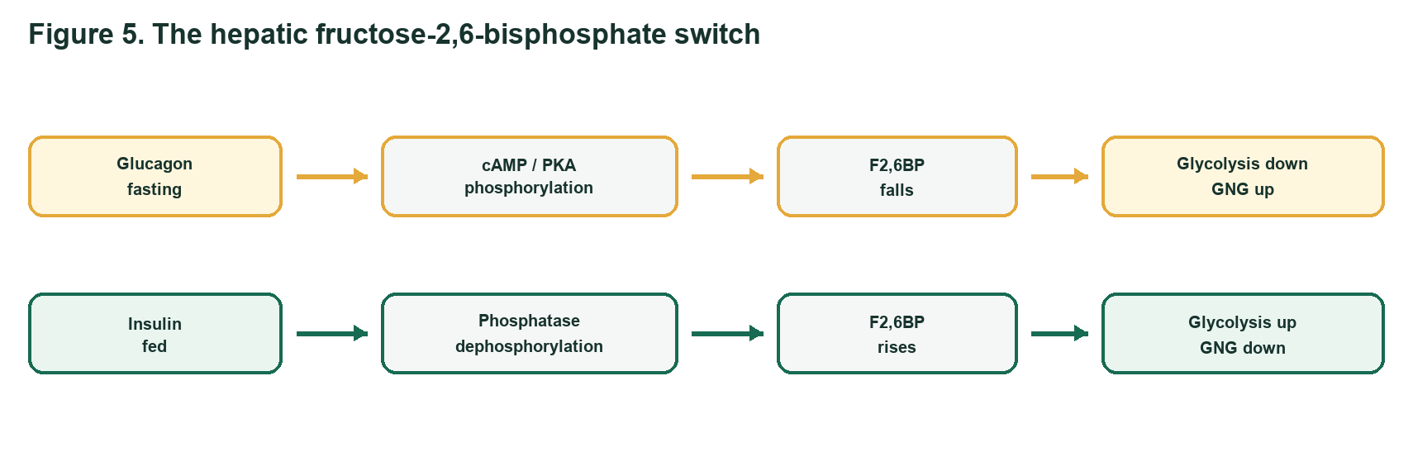
Regulation learning schematic
Q13 REMEMBER | 1 mark each
A - Core: State the main effect of insulin and of glucagon on liver glycogen metabolism.
________________________________________________________________________________
B - Challenge Twin: State the main glycogen effect of epinephrine and name the physiological situation that triggers it.
________________________________________________________________________________
Q14 UNDERSTAND | 2 marks each
A - Core: Explain the reciprocal effect of fructose-2,6-bisphosphate on PFK-1 and fructose-1,6-bisphosphatase.
________________________________________________________________________________
________________________________________________________________________________
B - Challenge Twin: Why does a fall in hepatic fructose-2,6-bisphosphate during fasting reduce futile cycling between glycolysis and gluconeogenesis?
________________________________________________________________________________
________________________________________________________________________________
Q15 ANALYZE | 3 marks each
A - Core: Use Figure 5. During fasting, trace the sequence from glucagon to PKA to the bifunctional PFK-2/FBPase-2 enzyme. Predict F2,6BP, glycolysis, and gluconeogenesis.
________________________________________________________________________________
________________________________________________________________________________
B - Challenge Twin: After a carbohydrate-rich meal, trace insulin action through dephosphorylation of hepatic PFK-2/FBPase-2. Predict F2,6BP and the direction of glucose metabolism.
________________________________________________________________________________
________________________________________________________________________________

ANTIOXIDANT SHIELD

6. Pentose Phosphate Pathway: Reducing Power and Ribose
MISSION BRIEF
Red blood cells face oxidants but have no mitochondria. Other cells may need NADPH for reductive biosynthesis or ribose-5-phosphate for nucleotide synthesis. The pentose phosphate pathway adjusts its oxidative and non-oxidative phases to those needs.
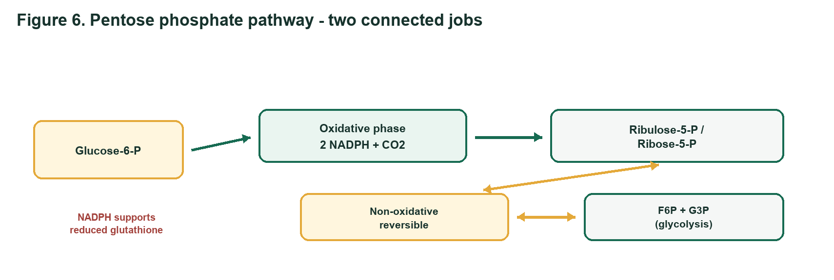
Ppp learning schematic
Q16 UNDERSTAND | 2 marks each
A - Core: Compare the main products and reversibility of the oxidative and non-oxidative phases of the pentose phosphate pathway.
________________________________________________________________________________
________________________________________________________________________________
B - Challenge Twin: A rapidly dividing cell needs ribose-5-phosphate more than NADPH. Explain how reversible non-oxidative reactions can help meet this need using glycolytic intermediates.
________________________________________________________________________________
________________________________________________________________________________
Q17 ANALYZE | 4 marks each
A - Core: A patient with low glucose-6-phosphate dehydrogenase activity develops haemolysis after oxidant-drug exposure. Build the causal chain from reduced PPP flux to red-cell membrane damage.
________________________________________________________________________________
________________________________________________________________________________
________________________________________________________________________________
B - Challenge Twin: Two samples are exposed to peroxide: normal RBCs and RBCs with impaired oxidative PPP activity. Predict which has the lower reduced-glutathione level and explain the roles of NADPH and glutathione reductase.
________________________________________________________________________________
________________________________________________________________________________
________________________________________________________________________________

CARBON ROUNDABOUT

7. CAC and Glyoxylate Cycle: The Carbon-Routing Finale
MISSION BRIEF
A germinating oil seed converts stored fat into carbohydrate, while a mammalian liver cannot obtain net glucose from even-chain fatty acids. Both use acetyl-CoA, but only the seed can bypass the carbon-losing steps of the citric acid cycle through the glyoxylate cycle.
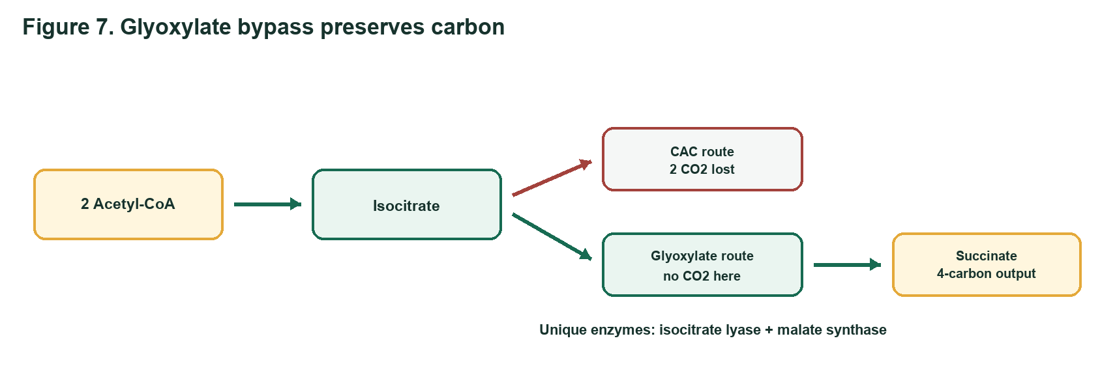
Cac Glyoxylate learning schematic
Q18 ANALYZE | 4 marks each
A - Core: For one acetyl-CoA entering the CAC, account for NADH, FADH2, GTP/ATP, and CO2. Then explain how high ATP and NADH affect cycle flux.
________________________________________________________________________________
________________________________________________________________________________
________________________________________________________________________________
B - Challenge Twin: A cell has high NADH and succinyl-CoA. Identify two CAC control points likely to slow and explain the product/energy feedback involved.
________________________________________________________________________________
________________________________________________________________________________
________________________________________________________________________________
Q19 EVALUATE | 5 marks each
A - Core: Defend this statement: 'A germinating seed can achieve net carbohydrate synthesis from acetyl-CoA, but a vertebrate cannot.' Refer to carbon loss and the two unique glyoxylate-cycle enzymes.
________________________________________________________________________________
________________________________________________________________________________
________________________________________________________________________________
B - Challenge Twin: A researcher proposes inserting only isocitrate lyase into a mammalian cell to create a functional glyoxylate cycle. Evaluate the proposal and identify the additional enzyme and carbon-routing requirement.
________________________________________________________________________________
________________________________________________________________________________
________________________________________________________________________________
Q20 CREATE | 5 marks each
A - Core: Design a carbon-flow plan for a fed liver cell with high ATP, abundant glucose, demand for fatty-acid synthesis, and demand for nucleotides. Route glucose among glycolysis/CAC, glycogen, and PPP; justify each choice using energy and biosynthetic signals.
________________________________________________________________________________
________________________________________________________________________________
________________________________________________________________________________
B - Challenge Twin: Design a carbon-flow plan for a fasting liver cell with low blood glucose and active fatty-acid oxidation. Integrate glycogenolysis, gluconeogenesis, glycolysis regulation, the CAC, and the fact that acetyl-CoA cannot give net glucose in vertebrates.
________________________________________________________________________________
________________________________________________________________________________
________________________________________________________________________________

Source lectures used
This quiz was developed from the supplied SBIA022 lecture documents by Dr KW Poopedi and colleagues. The diagrams are simplified original study schematics prepared for this quiz.
- Bioenergetics
- Glycolysis
- Glycogen Metabolism
- Gluconeogenesis
- Regulation of Carbohydrate Metabolism
- Pentose Phosphate Pathway
- CAC Regulation and the Glyoxylate Cycle
END OF METABOLIC MISSION

