Brandon de Bruyn 6854

PRG522 FA1

Title

Question 1.1 3

Organization 3

Project 3

Project Description 3

Question 1.2 4

Teams: 4

Development Team 4

Operations Team 4

Testing Team 4

Question 1.4 5

Work items 5

Configure the Development environment 5

Update the EULA file 5

Update all the help files 5

All Work Items 6

# Question 1.1

## Organization

### Project

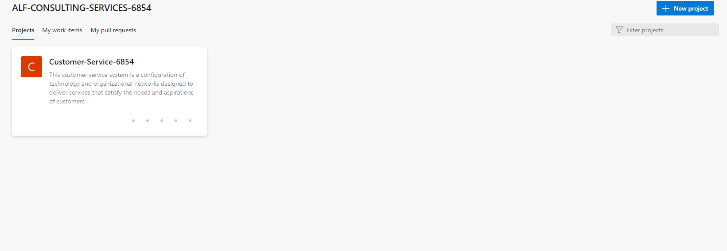

### Project Description

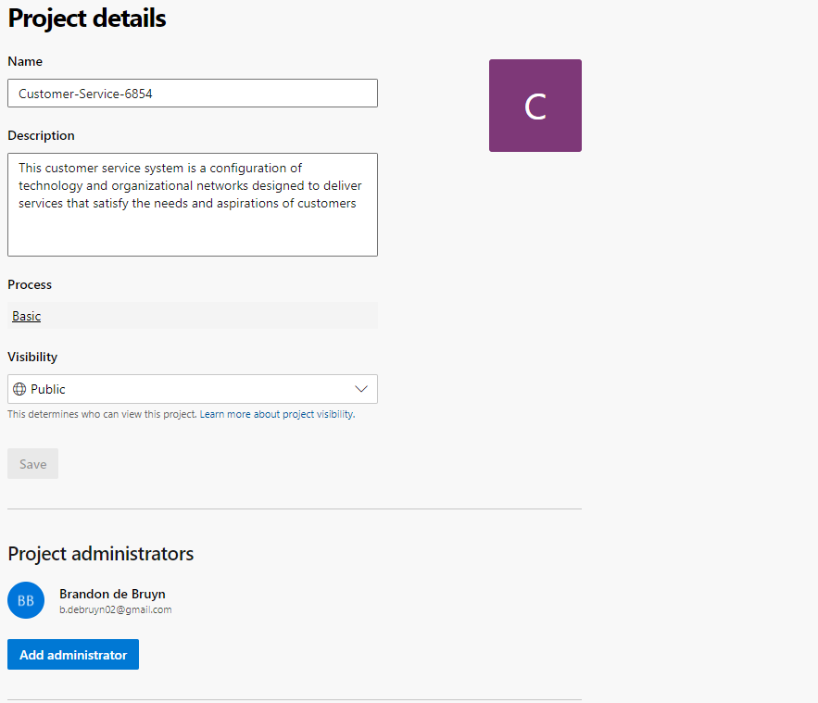

# Question 1.2

## Teams:

### Development Team

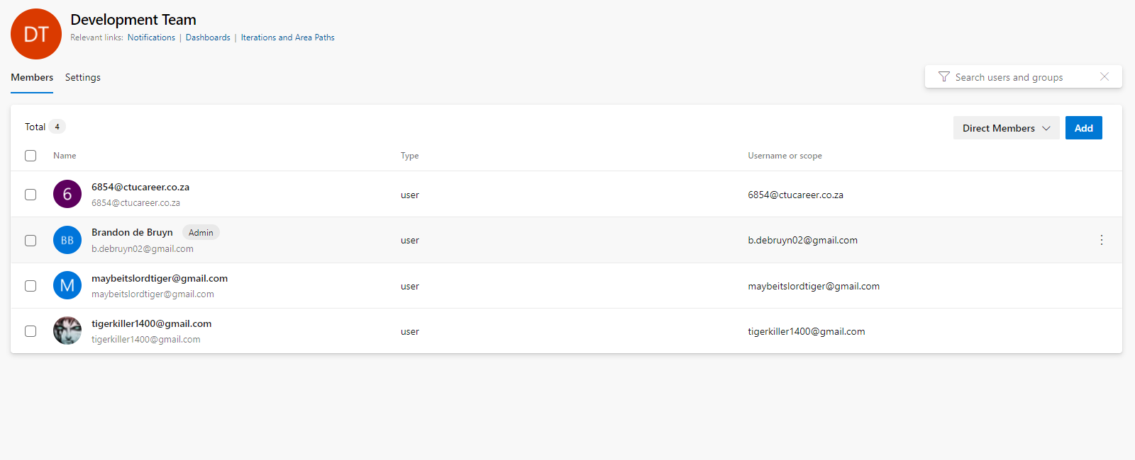

### Operations Team

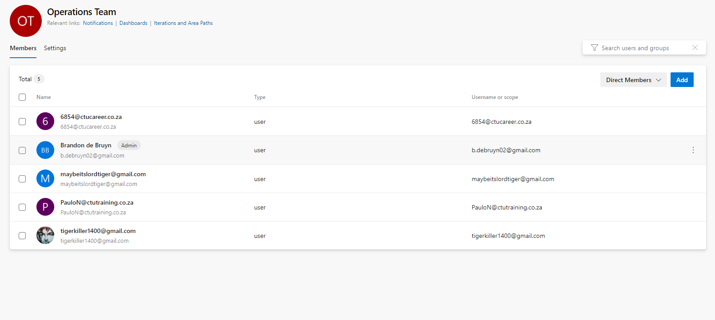

### Testing Team

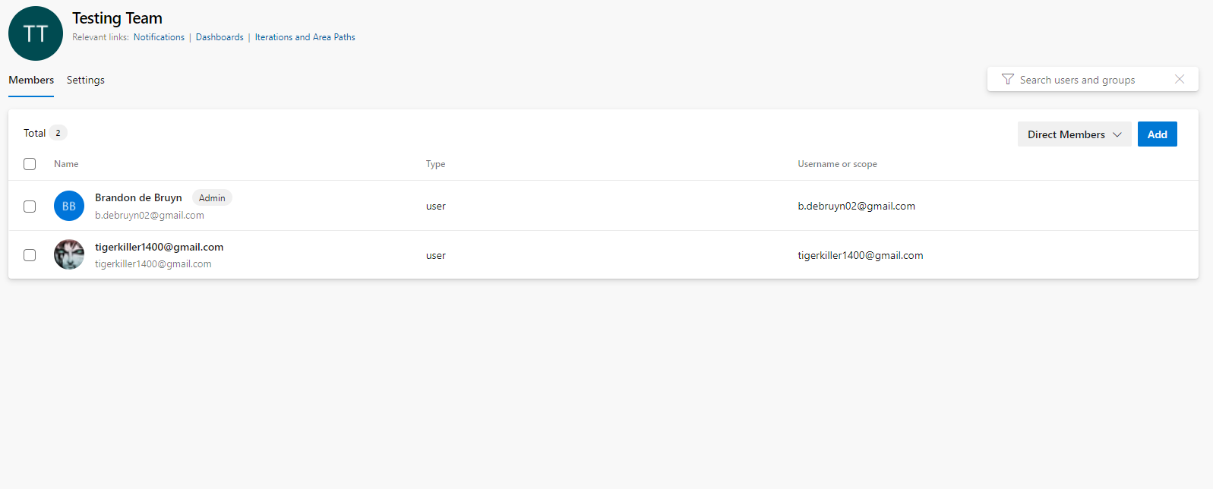

# Question 1.4

## Work items

### Configure the Development environment

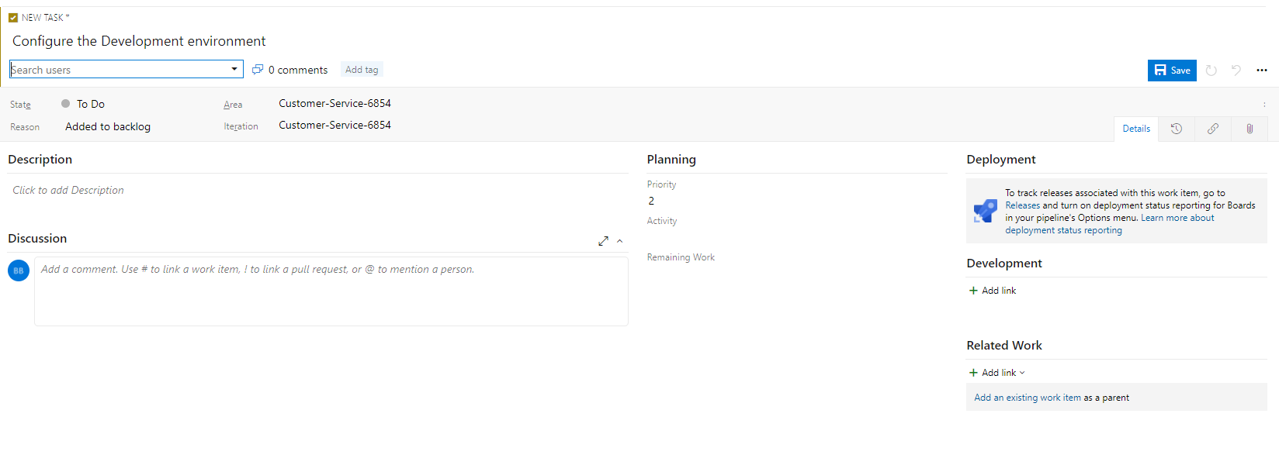

### Update the EULA file

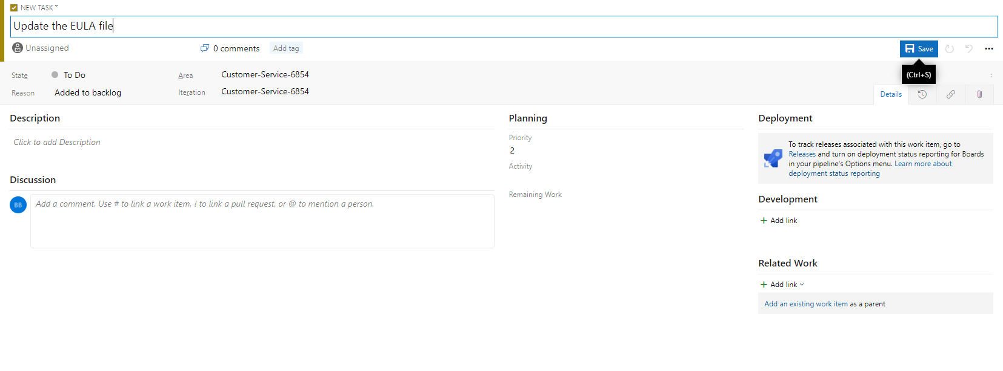

### Update all the help files

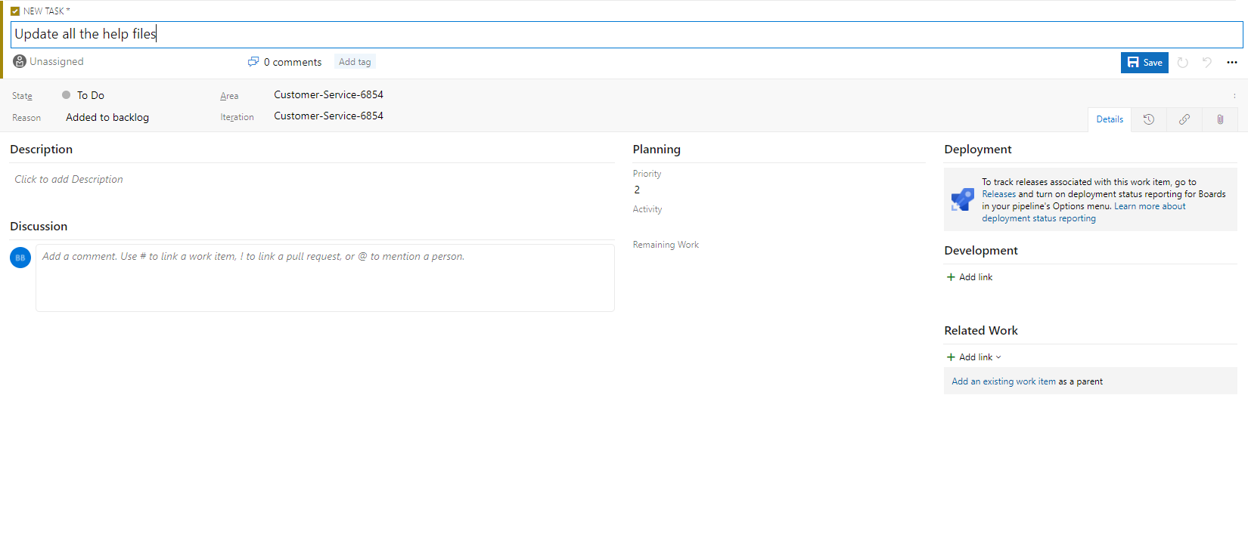

### All Work Items

