FreeEsVclComponents

1. Add “Source” folder to library path

(Tools->Options->Delphi Options->Library->Library path):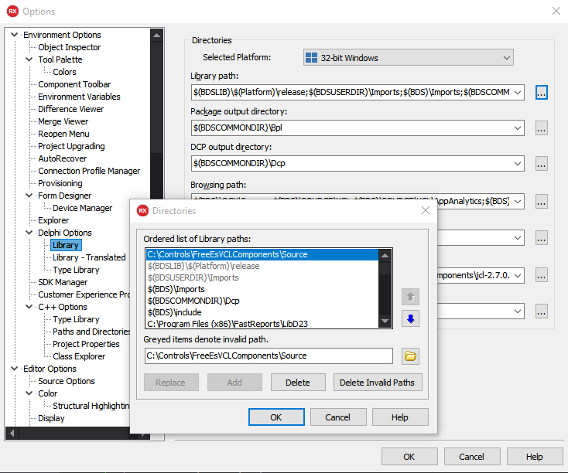

1. Open Project Group “ErrorSoftGroup”:
2. Click “Build All”:

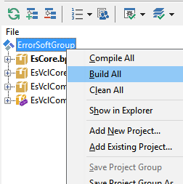

1. Select “EsVclComponentsDesign” and Click “Install”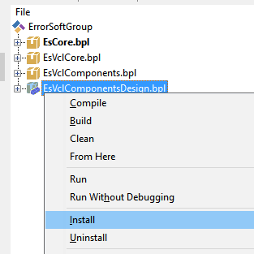
2. Done!

|  |
| --- |
| **WARNING:**  **Activate FixLoadPng in "Source/FreeEsVclComponents.inc" if you are having problems downloading PNG images in the Design time, because of some installed packages (ex: AlphaSkins)** |