# ErrorSoft Vcl Components v2.0

# Release notes

This is big release free open source library ErrorSoft Vcl Components.

## What’s new?

* Three new components: TEsRegexEdit, TEsRegexButtonedEdit, TEsRegexLabeledEdit.
* Rename some packages.
* Global refactoring.
* Util for convert dfm files. (Need only for Delphi XE2-XE6)

## Review new components:

**TEsRegexEdit, TEsRegexButtonedEdit, TEsRegexLabeledEdit** – This is input components, with validation uses RegEx. Components can indicate state uses background color. Colors automatically changes for active theme.

You can open «Samples\RegexEdit\RegExTest.dpr» for test this components.

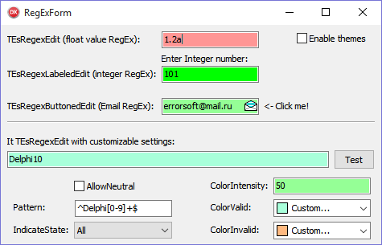

Built-in RegEx editor:

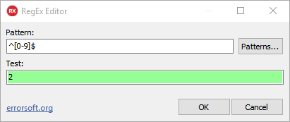

## Refactoring

Now units compiles with **{$SCOPEDENUMS ON}**, therefore now enums have not prefix.

**Sample: TImageStretch.isFit -> TImageStretch.Fit**

**Converting**

If you using Delphi XE2-XE5, then you must convert form files using **“\Converter\DfmConverter.dpr”**.

