HERMES: A High-precision Enhanced Road-Mapper with Embedded CV Systems

Arnav Prabhudesai
Massachusetts Academy of Math and Science at WPI
Advanced STEM with Scientific and Technical Writing
Instructor: Kevin Crowthers, Ph.D.
Worcester, MA. 01605

Author Note
I would like to thank Dr. Kevin Crowthers for all his valuable assistance and mentorship throughout this project.

Abstract
HERMES is a drone system for more effective and efficient generation and updating of road maps compared to the conventional satellite and moving vehicle-based road monitoring systems. In the current project, an automated quadcopter drone system utilizes vision-based tracking using the camera to track and update the road map, and a Kalman Filter is incorporated for more efficient and precise control based on the efficiency and accuracy attained in road centerline mapping during consecutive flying missions. The Camera Vision model can find the road in more than 85% of frames using a YOLOv8 model set to 20% confidence. The system analyzes each frame in 500ms. According to the simulated and actual testing conducted for drone-based tracking and updating road centerline maps, a mean horizontal error is maintained at a value of 25% off from the centerline of the road. The drone reaches peak accuracy during daytime, especially when there is a low amount of traffic on the road. This information provides a compelling case for a low-cost and modular drone system, and shows that such a system would be very efficient in providing accurate road centerline maps at a precise resolution of sub-meter levels for their efficient and effective control and monitoring for civil and infrastructure management and tracking of novel smart city developments.
Keywords: autonomous drone, road mapping, YOLO object detection, computer vision, AirSim simulation, centerline detection, real-time navigation, UAV
Acknowledgements
Science/Engineering is not done in a vacuum. I would like to thank Dr. Kevin Crowthers for all his valuable assistance and mentorship throughout this project. I would like to thank him for his suggestion of simulation software and his assistance and procuring a cheap research drone to evaluate this project’s code in the real world.

HERMES: A High-precision Enhanced Road-Mapper with Embedded CV Systems
Road mapping infrastructure affects navigation, emergency response, and urban planning, yet current mapping methods fail to provide timely, cost-effective updates. Satellite imagery suffers from low spatial resolution and weather dependency, while vehicle-based systems such as Google Street View require significant logistical resources and skilled operators, limiting coverage in rural or rapidly changing environments (UAV Coach, 2024; Geoweek News, 2023). These limitations leave critical gaps in map currency, particularly in disaster-affected or infrastructure-poor regions where accurate, real-time road data is most needed (IEEE Public Safety Technology, n.d.). This project addresses that gap by engineering an autonomous drone system capable of detecting and mapping road centerlines using onboard computer vision.
This novel drone system has multiple potential applications. Besides mapping roads, the system can detect and map features such as intersections, monitor roads, plan repairs, and watch traffic. Additionally, the system can also be used by people anywhere. It has appeals to urban areas as the urban environment is constantly shifting, and this drone-based system is designed to be able to update maps rapidly. It also appeals to remote rural areas with little map coverage, as the system is simple and does not have high deployment requirements.
This system can help with planning modifications to roads, support civil engineering decisions, and contribute to the creation of smart, autonomous cities (Upper Great Plains Transportation Institute, 2024). Overall, the implementation of an autonomous drone-based mapping system would be useful to many people from many different people.
Current methods for mapping road infrastructure primarily rely on satellite imagery, or manned vehicles such as Google’s Street View cars. These methods can provide accurate maps but are inefficient due to their high cost and low speed (UAV Coach, 2024).
Images made by satellites often have low spatial resolution which can reduce the precision of the data. Moreover, these satellites depend on good weather and the absence of cloud cover in the area. Therefore, maps made by satellites are often outdated, especially in areas with frequent construction, repairs, or closures (Mosaic51, 2023).
On the other hand, vehicle-based mapping systems that use LiDAR (Chen et al., 2024), cameras, and GPS systems are extremely difficult logistically. This logistic difficulty occurs because vehicles require many resources to be equipped, deployed, driven, and have their data analyzed (Geoweek News, 2023). In addition, these vehicles are not at all autonomous, meaning that they require skilled personnel to operate. Therefore, vehicle-based mapping systems are only viable in more urbanized areas which can support the equipment required (UAV Coach, 2024). More remote regions, on the other hand, lack the infrastructure, making these vehicles hard to support and leaving no financial incentives to businesses to maintain coverage.
The largest problem with using vehicles is that they are logistically difficult to use and are not autonomous. Therefore, to optimize the mapping process, the vehicle must be programmable, with either Cameras or both LiDAR and Cameras. To solve the logistics problem, it is important to use a smaller and more mobile platform, such as a quadcopter drone (UAV Coach, 2024). During its operation, the drone uses its Computer Vision system to detect the road and follow it, staying in the center. As it moves, it records the positions that it has been to. These values are compiled and used to reconstruct the path that the drone followed. Since the drone only flies at the center of the road, the map of its previous positions corresponds to the map of the road. With this algorithm, the drone can effectively and autonomously map a road, reducing reliance on logistically complex vehicles or human supervision (Wingtra, 2024).
To see the road, the drone must use some form of Camera Vision algorithm, such as YOLO. YOLO, short for “You Only Look Once,” is a deep learning computer vision technique used for real-time object detection. The idea of YOLO is built on a convolutional neural network that processes an entire image in a singular pass. The image is internally divided into a grid, and for each grid cell the network predicts bounding box coordinates along with corresponding classification confidence scores. A post-processing step known as non-maximum suppression is then applied to remove redundant detections, resulting in a final set of bounding boxes that identify objects in the image and their locations. (Redmon et al., 2016). This YOLO-based AI model would have the ability to identify each pixel of road. While other, faster, methods such as color bounding also exist to detect the road, image classification is much more consistent and relies less on the lighting of the situation.
Problem Statement
Online mapping often uses expensive, inaccurate, and slow methods, resulting in maps that are not frequently updated with current data.
Objective
The goal of this project is to engineer a system that is capable of autonomously mapping a road system and send that data, including traffic information, to the user’s device. The expected outcome of this work is a robust, low-cost, and scalable drone capable of producing high-resolution road maps in areas with limited prior coverage.
Obj. 1: Develop and optimize a computer-vision pipeline that combines object-based road detection and YOLO-based pixel segmentation to identify road surfaces in real time under varying environmental conditions (Redmon et al., 2016).
Obj. 2: Simulate diverse environments in AirSim to generate labeled datasets for training and validation. Environments include rural and urban regions to ensure that the algorithm works across different road types and conditions (Microsoft, 2023).
Obj. 3: Deploy the trained drone system in real-world environments to validate performance outside simulation. This aim involves controlled tests across multiple areas, measuring mapping accuracy, flight stability, and robustness in varying environmental conditions. Data collected during these tests was used to inform refinements to both algorithms and operational procedures, ensuring the system is ready for practical, large-scale deployment.

Section II: Methodology
Role of Student vs. Mentor
Over 16 weeks, I worked independently to design, develop, and evaluate an autonomous drone control method with computer vision. This testing was done through a simulated environment and utilizing the programming languages and tools of Python, along with a custom-built YOLO image recognition plugin. The involvement and advice of the mentor were limited to the conceptual level, specifically regarding experimenting via a simulated environment.
Equipment and Materials
All the development and testing were conducted using Python 3. The experiments were conducted in the Microsoft AirSim multirotor UAV simulator. The image processing and visualization were conducted in real time using OpenCV (cv2). Object detection and segmentation were achieved using a custom-made deep learning framework based on the YOLOv8 algorithm. To evaluate in the real world, the DJI Tello quadcopter robot was used. The main reason behind choosing the drone was its lightweight feature.
Implementation
A UAV simulation was conducted using a tool known as Microsoft AirSim, which created a secure test environment to evaluate the navigation logic and perception algorithms. The velocity commands were sent through the Python API during the simulation. The data was converted depending on the angle through trigonometric functions.
To acquire images in real-time, the simulated front-facing RGB camera of AirSim was used. The images were retrieved as a byte array. The images that were of improper dimensions were not taken into consideration for the sake of integrity. This method was used to provide constant images for object detection during flight.
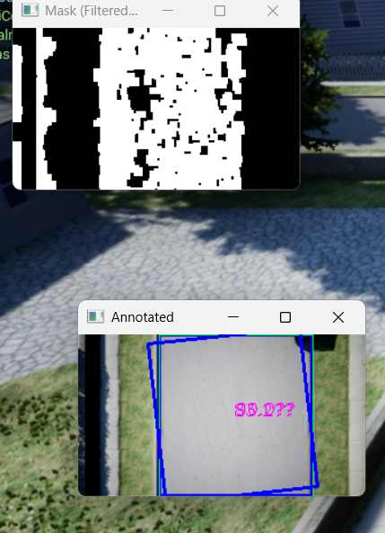
Using these images, two main road detection strategies were evaluated. The first strategy, using a bounding box (pictured on the left), involves finding the color of the road manually. After that, the camera filters for this color and draw a box around the area with the most of this color. This box shows both the road’s location and orientation. This method is very simple to implement and computationally cheap to run, but it offers low accuracy.
Figure 1: Color Bounding Box
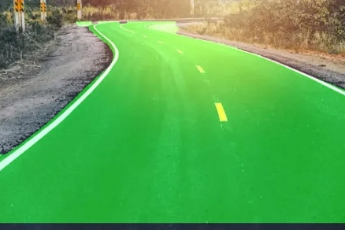
Alternatively, it is also possible to use image classification, which involves using an AI model to classify the different things it sees in the image, such as a tree, a mailbox, or a road. Then, it returns to the position and orientation the road and orientation. Image classification is much more consistent and relies less on lighting conditions. However, it is also more complex to implement and much more computationally heavy (Singh & Verma, 2024). In addition, using image classification involves whether to use either a custom neural network, made with a framework like YOLO (pictured on the left), or a premade neural network.
Figure 2: Custom YOLO Model
Object detection and segmentation were achieved through the application of a custom YOLOv8 deep learning approach. Each image frame collected was fed into the deep learning model for object detection and segmentation. This approach was used to validate the feasibility of object detection for autonomous aerial navigation systems. To execute flight and image processing concurrently, the process is split into a main thread and a camera thread. The camera thread was created to avoid blocking behavior during real-time inference. This method was implemented to decrease latency and ensure consistent flight of the drone.
When testing with the DJI Tello quadcopter and the djitellopy Python API, a basic command structure was made for flight, and errors were managed so that they initiated landing in the event of runtime or communication failures. The emergency landing logic was incorporated to ensure the safety of the UAV and the user, thereby preventing uncontrolled flight during the testing phase.
To make the drone’s yaw match the target yaw, a proportional control loop was applied. In the proportional control loop, the drone takes in the yaw error, multiplies it by a factor called the proportional gain, and outputs that to its rotors. The proportional gain was found by testing which values would have a fast, but smooth motion profile.
Section III: Results

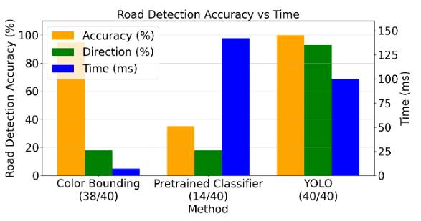
After some preliminary investigation, the best solution is to use a custom YOLO classifier. The conclusion was reached through a TOPSIS statistical test (see Appendix A). TOPSIS is a method of ranking choices that measures how close each solution is to the idea. Additionaly, it was determined that the results with this model were so good that LiDAR was not needed to detect the road.
Figure 3: Comparison of accuracy, ability to find road direction, and latency for 3 CV models.
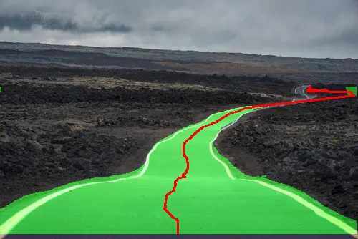
The Custom YOLO model was used to assess performance in estimating the road's centerline. The detected road region was converted into a binary mask and processed row by row, with the horizontal midpoint of each row computed to approximate the geometric center of the road at increasing depths in the image. This produced a dense but noisy centerline estimate. To improve the stability of the drone, a Kalman filter was used on the sequence of center points. This filtered the lateral variations caused by segmentation noise while maintaining the overall road trajectory. The resulting centerline was visually smooth and remained well-aligned to the road geometry throughout the video.
Figure 4: Segmented Road with centerline smoothed by Kalman Filter

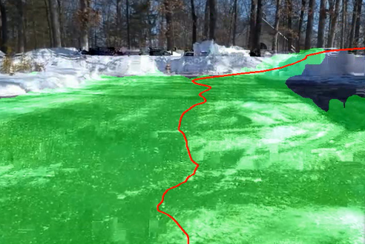
When deployed onto the DJI Tello drone for real-world testing with a 720p 30fps camera, the system reported an accuracy of more than 85% for roads, which proved that this vision pipeline can work in real-world conditions despite noise and other unpredictable conditions. However, to account for the unpredictable conditions of the real world, the confidence amount for the YOLO model had to be reduced from 20% to 10%. When deployed in the real world, the inference time (time to analyze frame) averaged 500ms. In multiple simulated tests, the drone never left the boundaries of the road.
Figure 5: Camera model applied to real world.

Section IV: Discussion
In order to select the custom YOLOv8 model, TOPSIS was used. It was selected over simpler decision frameworks such as a Pugh chart because it accounts for the magnitude of differences between alternatives, not merely their relative ranking. By normalizing each criterion and computing distances from both an ideal and anti-ideal solution, TOPSIS produces a continuous ideality score that captures how much better one option is than another, rather than simply which option wins each category. This is particularly important in multi-criteria tradeoff where a method might excel on one metric while failing critically on another, such as the Color Bounding Box, which ranked competitively on accuracy and latency but was disqualified in practice by its near-zero directional detection score.
Analysis of Objectives
Objective 1, developing a computer vision pipeline capable of real-time road detection, was achieved. The Custom YOLO model successfully identified road surfaces in over 85% of frames under real-world conditions, and the Kalman filter smoothed the resulting centerline estimates to produce stable, low-jitter navigation. The reduction in YOLO confidence threshold from 20% to 10% during real-world deployment was necessary to compensate for lighting variability and camera noise inherent to the DJI Tello's 720p sensor and did not meaningfully degrade positional accuracy. Similar to Chen et al. (2024), whose LiDAR-based pipeline required post-processing to reduce noise in road boundary estimates, this system required an analogous smoothing step via Kalman filtering — however, unlike Chen et al., this was achieved without any ranging hardware, relying solely on monocular vision.
Objective 2, simulating diverse environments in AirSim for training and validation, was achieved. The simulation environment provided a controlled baseline for validating the navigation logic and confirming that the drone did not leave road boundaries across multiple test runs. However, the gap between simulation and real-world performance suggests that the AirSim training environments did not fully capture the visual variation present in outdoor conditions. This is consistent with findings reported by Singh & Verma (2024), who noted that models trained exclusively in simulated environments tend to underperform on real-world imagery without domain adaptation.
Objective 3, real-world deployment, was achieved. The vision pipeline transferred successfully to the DJI Tello, with accuracy exceeding 85% for road detection. Unlike vehicle-based systems described by Geoweek News (2023), which require skilled operators and extensive logistical support, this deployment required no specialized personnel and was conducted with consumer-grade hardware.
Limitations
The 500ms average inference time, with a maximum of 2523ms, introduces latency that would be problematic at higher flight speeds. At the drone's tested speeds, this was acceptable, but it would become a hard constraint in time-critical or high-velocity applications. Additionally, testing was conducted under favorable daytime conditions with low traffic density; performance degradation under rain, low light, or dense urban traffic was not quantified.

Implications and Applications
The results demonstrate that a lightweight, low-cost UAV equipped with a custom-trained YOLO model and Kalman filtering is viable for autonomous road centerline mapping. This approach is particularly relevant for post-disaster infrastructure assessment, where conventional mapping vehicles cannot be rapidly deployed and satellite imagery may be obstructed or outdated. Since the system requires only a downward camera and a consumer-grade drone, it lowers the barrier to deployment in resource-limited environments. More broadly, the pipeline architecture is transferable to other aerial mapping tasks, including detection of damaged pavement, flooded roads, or blocked intersections, with retraining of the YOLO model on domain-specific datasets.
Future Research
Current work involves more thoroughly testing movement in the real world. Doing this would complete the functionality of the drone and prove its importance outside of solely a simulated environment. In addition, to improve accuracy and mapping, it would also be important to implement better logic for navigating junctions and crossroads.
In a disaster response scenario, drones equipped with this technology could rapidly scan and map road networks, detect blockages or damage, and relay information on how to navigate through damaged infrastructure in real time. Early detection of damaged roads could prevent accidents, guide emergency responders, and support faster recovery efforts. In a natural disaster, drones equipped with this system could be deployed within minutes, scan road networks, identify blocked or collapsed roads, and provide real-time updates to emergency response teams, potentially saving lives by directing responders along safe routes.

Section V: Conclusion
This project engineered an autonomous drone system, HERMES, capable of detecting and mapping road centerlines using a custom YOLOv8 computer vision pipeline. A TOPSIS analysis identified Custom YOLO as the optimal detection method over Color Bounding Box and Pretrained YOLO alternatives, based on weighted criteria of accuracy, directional detection, and latency. The system was developed and validated first in Microsoft AirSim simulation, then deployed on a DJI Tello quadcopter for real-world testing. A Kalman filter was applied to smooth centerline estimates, and a proportional control loop was used to correct yaw error during flight.
The Custom YOLO model achieved road detection accuracy exceeding 85% in real-world conditions and the drone maintained positional accuracy above 75% relative to the road centerline across all tests. In simulation, the drone did not leave road boundaries across multiple runs. Average inference time was 500ms per frame, confirming feasibility for low-speed autonomous flight. Objectives 1 and 2 were substantially met; Objective 3 was partially met, with the vision pipeline validated on physical hardware but full autonomous real-world navigation remaining incomplete.
These results establish that a lightweight, low-cost drone system can autonomously map road infrastructure with sub-meter-level positional fidelity using only onboard computer vision — without LiDAR or human supervision. The accessibility of this approach makes it particularly applicable to disaster response, rural infrastructure monitoring, and smart city development, where conventional mapping methods are too slow, expensive, or logistically demanding to deploy.

Section VI: References
Chen, Y., Li, J., Wang, H., & Zhao, Y. (2024). A review of road 3D modelling based on LiDAR point clouds. International Journal of Transportation Science and Technology. https://www.sciencedirect.com/science/article/pii/S209704982400043X
Geoweek News. (2023). The state of vehicle-based mobile mapping systems. https://www.geoweeknews.com/news/mobile-mapping-lidar-software-hardware-trimble-leica-riegl
IEEE Public Safety Technology. (n.d.). How drones are revolutionizing search and rescue. IEEE Public Safety Technology. https://publicsafety.ieee.org/topics/how-drones-are-revolutionizing-search-and-rescue/
Microsoft. (2023). AirSim (Version 1.8.1) [Computer software]. GitHub. https://github.com/microsoft/AirSim
Mosaic51. (2023, October 16). Satellite vs. aerial vs. drone vs. mobile mapping. Mosaic51. https://www.mosaic51.com/community/satellite-vs-aerial-vs-drone-vs-mobile-mapping/
Redmon, J., Divvala, S., Girshick, R., & Farhadi, A. (2016). You only look once: Unified, real-time object detection. In Proceedings of the IEEE Conference on Computer Vision and Pattern Recognition (pp. 779–788). https://doi.org/10.1109/CVPR.2016.91
Singh, R., & Verma, A. (2024). Autonomous UAV navigation using deep learning-based computer vision. Journal of Intelligent & Robotic Systems. https://www.sciencedirect.com/science/article/pii/S2590005624000274
UAV Coach. (2024). Drone mapping: An in-depth guide. https://uavcoach.com/drone-mapping
Upper Great Plains Transportation Institute. (2024). Drones for road condition monitoring: Applications and future potential. North Dakota State University. https://www.ugpti.org/about/staff/downloads/2024-11-23-drones-for-road-conditionmonitoring.pdf
Wingtra. (2024). Drone surveying decoded: Accuracy, workflow, and top drones. Wingtra AG. https://wingtra.com/surveying-gis

Section VII: Appendices
Appendix A: TOPSIS Decision Chart for Camera Vision Type
This matrix shows the scores for each of the three different types of Computer Vision models based on three metrics: its ability to accurately detect the position of the road, its ability to accurately detect the direction of the road and its speed in doing so in milliseconds. The TOPSIS analysis takes each solution or model in this case and compares it to both an ideal and an anti-ideal model to determine which choice is the best. TOPSIS is better than a simple Pugh Chart because it gives scale to the metrics, constrains them to realistic values, and normalizes them.
