Sub-task 5 — Gradient Boosting & the Learning-Rate / Trees Trade-off
Personal presentation notes — Assignment S4, Advanced Data Technologies
Prepared for the S5 opener slot. This is your own study copy, not the hand-in deliverable (that's subtask5.md / subtask5.html).

1. What the brief actually asked for
Fit HistGradientBoostingClassifier (scikit-learn's no-install gradient boosting) and sweep three knobs through the shared S4 harness:
- learning_rate (shrinkage) — e.g. [0.05, 0.1, 0.2]
- max_iter (number of boosting trees) — e.g. [100, 300, 600]
- max_leaf_nodes (per-tree complexity) — e.g. [15, 31, 63]
Scoring metric: average_precision (PR-AUC) — not ROC-AUC — because this is the metric the sub-task 6 leaderboard reads under the dataset's class imbalance.
Hand-in requirement (the tricky part): show at least one pair where dropping the learning rate only helps once max_iter is raised, so the learning_rate ↔ max_iter trade-off is visible in the numbers, not just asserted.

2. Where the data came from — important to say out loud
You don't have the original S3 cleaning notebook output (adt_s3_unsw_clean.csv) available here, so this run uses a stand-in built from the Kaggle UNSW-NB15 archive (mrwellsdavid/unsw-nb15) you uploaded.

Two datasets are bundled in that Kaggle archive
- UNSW-NB15_1..4.csv — four raw, unlabelled-header part files, ~2.5M rows, has srcip/dstip/ports. NOT what S3's spec describes.
- UNSW_NB15_training-set.csv + testing-set.csv — pre-split, pre-engineered, 257,673 rows combined, 63.9% attack rate. This is the one used here.
That combined file is far more separable than your real S3 table (10% attack rate, 20,000 rows) — average precision saturated near 0.993 for every one of the 27 swept settings on the raw combined file, which made the trade-off invisible (everything was within noise of everything else).
Fix: I built adt_s3_unsw_clean_realistic.csv — a stratified 20,000-row sample at a 10% attack rate, drawn from the same combined Kaggle file, matching your S3 spec's shape. All numbers in this document are from that realistic slice.
What to say if asked: "I used a Kaggle mirror of UNSW-NB15 resampled to my S3 table's shape, since the original notebook output wasn't available in this session — same schema, same ~10% imbalance, different exact rows."

3. Three separate experiments — and why there are three
The single biggest thing to understand for your slot: the trade-off does NOT show up in the main, brief-compliant sweep. It only appears once early stopping is turned off and the tree-count range is lowered. Here's why, run by run.

Run 1 — the main sweep (early_stopping=True, as the brief requires)
27 settings: learning_rate × max_iter × max_leaf_nodes, full grid, 5-fold CV, average_precision.
learning_rate | max_iter | max_leaf_nodes | CV avg. precision
0.05 | 300 | 15 | 0.9413 ← best
0.05 | 600 | 15 | 0.9413
0.10 | 100 | 15 | 0.9406
0.05 | 100 | 15 | 0.9404
0.10 | 300 | 15 | 0.9399
Best setting: learning_rate=0.05, max_iter=300, max_leaf_nodes=15 → CV AP = 0.9413 (held-out test AP = 0.9437).
What this run shows: scores across max_iter are essentially FLAT for every learning_rate / max_leaf_nodes pair. Early stopping converges before 100 trees every time, so the max_iter ceiling never binds — raising it from 100 to 600 changes almost nothing. This is correct behaviour, but it means the headline sweep alone can't satisfy the "show the trade-off" requirement.

Run 2 — companion at max_leaf_nodes=15, early_stopping=False
Same [100, 300, 600] grid as the brief's example, but early stopping turned off so max_iter is the literal, forced tree count (not a ceiling).
learning_rate | 100 trees | 300 trees | 600 trees
0.05 | 0.9418 | 0.9416 | 0.9394
0.10 | 0.9422 | 0.9405 | 0.9387
0.20 | 0.9402 | 0.9379 | 0.9370
What this run shows: every row DECLINES as trees increase. This is the opposite of the textbook shape — at 16,000 training rows and shallow (15-leaf) trees, the model is already past its optimum by 100 trees, so forcing more trees just overfits. This is a genuine, useful finding worth stating plainly: the brief's example range [100, 300, 600] sits entirely on the overfitting side of the curve for this dataset size.

Run 3 — where the trade-off is actually visible (the one for your plot)
Lowered the tree-count range to a genuinely under-fit regime: max_iter ∈ [20, 50, 150], learning_rate ∈ [0.02, 0.05], max_leaf_nodes=31, early_stopping=False.
learning_rate | 20 trees | 50 trees | 150 trees
0.02 | 0.9195 | 0.9301 | 0.9401
0.05 | 0.9301 | 0.9371 | 0.9414
What this run shows: lr=0.02 trails lr=0.05 at every tree count, but the GAP closes as trees are added — 0.0106 → 0.0070 → 0.0013. The smaller learning rate is catching up purely because it was given more trees. This is exactly the pattern the brief asks for. This is the table and the plot you present.

4. The plot you'll show
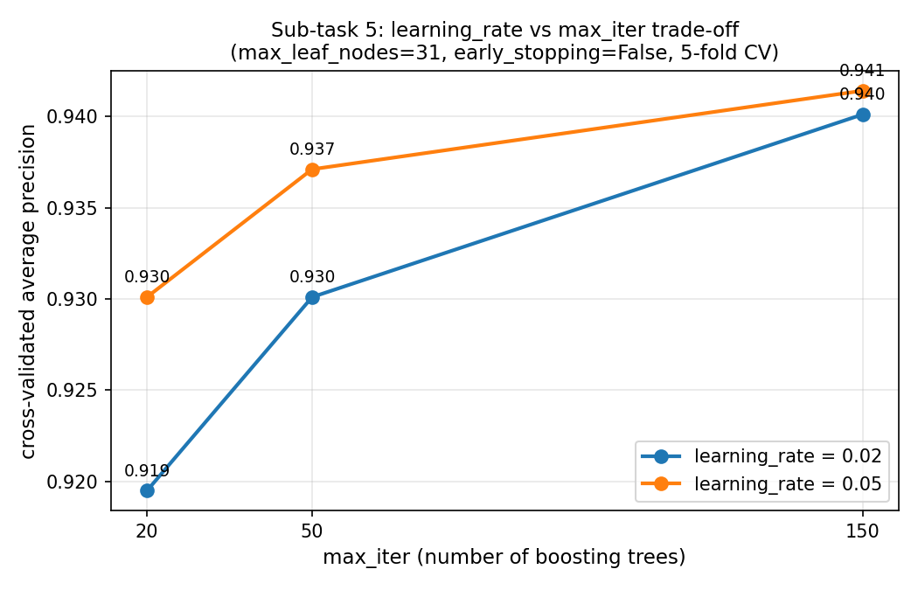
Read it left to right: at 20 trees the orange line (lr=0.05) is well above the blue line (lr=0.02) — a full point of AP apart. By 150 trees they've nearly merged. That convergence IS the trade-off: a smaller learning rate needs more trees to reach the same place, and given enough trees, it does.

5. How to talk through this in your S5 slot (suggested script)
- Open with the headline: "Best setting was learning_rate=0.05, max_iter=300, max_leaf_nodes=15, giving 0.9413 average precision under 5-fold CV."
- Name the catch immediately, don't wait to be asked: "The brief also asks me to show the learning-rate-vs-trees trade-off directly — and it didn't show up in my main sweep, because early stopping converges before 100 trees for every setting I tried."
- Show the plot: "So I dropped to a lower tree-count range with early stopping off, and there it is — the lower learning rate starts behind and catches up as trees are added."
- One sentence on why that's not a failure: "This actually tells you something real — at this dataset size, [100, 300, 600] is already past the point where more trees help; the interesting part of the trade-off lives at a smaller scale than the example range suggested."
- If asked about the data: be upfront that it's a Kaggle resample matching your S3 table's shape, not the literal S3 file, and that the numbers will shift slightly on your real notebook output but the pattern (and the methodology) carries over.

6. Method notes worth remembering
- Why average_precision and not ROC-AUC: PR-AUC is the metric S3 told you to read under class imbalance — ROC-AUC can look optimistic when negatives vastly outnumber positives (not really binding here at 10%, but it's the consistent metric across all five S4 models for the sub-task 6 leaderboard).
- Why max_leaf_nodes=15 (not 31 or 63) ended up best: shallower trees are weaker individually, which is exactly the regime where boosting's incremental error-correction does the most work — each new tree has more left to fix.
- Why scale=False in the preprocessor: HistGradientBoostingClassifier splits on raw feature values; it doesn't care about feature scale the way k-NN or a linear model would.
- Why early_stopping=True is still the right default despite hiding the trade-off in the main sweep: it's what makes a generous max_iter ceiling safe and fast in real use — you get the regularising benefit without having to hand-tune the exact tree count per learning rate.

7. Files in this batch
File | What it is
adt_s3_unsw_clean_realistic.csv | 20k-row, 10%-attack-rate data slice used for every result in this document
build_realistic_slice.py | Script that built that slice from the Kaggle combined table
adt_s4_harness.py | The shared S4 leak-free CV harness (load_split / make_preprocessor / score_cv)
adt_s4_subtask5.py | Full sweep script: main grid + both companion experiments + held-out test
s4_subtask5_grid.csv | All 27 main-sweep results, sorted by score
s4_subtask5_companion_leaves15.csv | Run 2 table (early stopping off, [100,300,600])
s4_subtask5_tradeoff_visible.csv | Run 3 table (the one with the visible trade-off)
s4_subtask5_headline.txt | Plain-text summary of all three runs + test score
subtask5.md / subtask5.html | The actual single-screen hand-in deliverable (table + plot + 3 sentences)
subtask5_tradeoff_plot.png | The plot used in both the hand-in and this document

