NEXUS
A 29-Module Browser-Based Financial Markets Terminal
Project Planning, Requirements Analysis, Estimation & Agile Project Management Report
Prepared by
Roshjens kunwar | 100007268
Kaushal Patidar | 100006891
Hossein Sadeghian | 100008133
Christin Renni Philip | 100008781
Sumanth pidishetti | 100008679
Sivapriya Prasanth | 100008274

Course: Agile Project & Risk Management
Lecturer: Daniil Tashkan
Submission Date: 13 July 2026
Repository: github.com/LordXapose/NEXUS
Trello: https://trello.com/b/UycaKS4r

Contents
1. Introduction 1
2. Background of the Project 1
3. Project Objectives 2
4. Project Scope 2
4.1 In Scope 2
4.2 Out of Scope 3
5. Functional Requirements 3
5.1 Home 3
5.2 Markets 3
5.3 Global Tracking 4
5.4 Risk & Analytics 4
5.5 New Modules 4
5.6 Intelligence 4
5.7 Fixed Income 5
5.8 Commodities 5
5.9 Portfolio 5
5.10 Global 5
5.11 Cross-Cutting Functional Requirements 5
6. Project Size & Team Estimation 6
6.1 Function Point Analysis 6
6.1.1 General System Characteristics (GSC) 6
6.1.2 Unadjusted Function Points (UFP) 6
6.1.3 Component-to-Module Mapping and Complexity Rationale7
6.1.4 Adjusted Function Points (ATFP) 7
6.2 Lines of Code (LOC) Conversion 8
6.3 Effort, Schedule and Team-Size Estimation 8
6.3.1 COCOMO I (Basic, Semi-Detached mode) 8
6.3.2 Jones First Order Model 8
6.3.3 Reconciling the Two Models 9
6.4 Team Size Justification 9
6.5 Roles and Responsibilities 9
7. Scrum Team 11
7.1 Team Roster 11
7.2 Scrum Master — Detailed Responsibilities 11
7.3 Product Backlog Overview 12
7.4 Sprint Planning Approach 13
7.5 Definition of Done 13

1. Introduction
NEXUS is a web-based financial markets terminal. This document discusses the system's background and goals, its functional range, a Function Point Analysis (FPA) using COCOMO I and Jones First Order effort estimates, and the Scrum team organization responsible for managing the product backlog. The purpose of this report is to fulfil Agile Project & Risk Management coursework requirements by showcasing that the dimensions, expenses, timeline, and team structure of a project can be systematically derived from its requirements instead of being approximated or hypothesised.
NEXUS is still an actively progressing project. Its source code, module list, and README can be found at github.com/LordXapose/NEXUS. The estimation and backlog information referenced throughout this document are obtained directly from the project requirements, stakeholder needs and User stories.

2. Background of the Project
The trend of retail and semi-professional traders trying to get the situational awareness which are mostly found only in institutional trading desk. They may include real-time prices, depth of order book, risk assessment, options pricing and macroeconomic data. But they want it without having to invest the enormous money for a Bloomberg Terminal or create their own server infrastructure. Most free platforms usually provide one of the aspects of the problem (like price chart, news feeds or portfolio management) but these sites may force the user to open multiple tabs for all the functions.
NEXUS helps to solve this problem, we provide a platform in the form of one HTML file which is capable of being opened in any modern browser without requiring installation, building process or any backend to run it. NEXUS brings 29 modules including stocks, options, fixed income, commodity, cryptocurrency, portfolio management, sentiment analysis and geopolitical risks and more in just one terminal.
Today the frontend is fully equipped and operates independently using synthetic/demo data. The upcoming phase of the project, which this report outlines, focuses on the backend: a Python service that acts as a proxy for real market-data providers (such as Polygon.io, Alpha Vantage, FRED, CoinGecko).

3. Project Objectives
● To develop a product ready backend service that acts as a proxy for external market data providers, while making sure that API keys are not exposed to the client.
● To maintain the single file, no installation for front end as a stricter requirement, allowing the terminal to remain easily portable.
● To standardise the variety payloads from the provider into a data contract already recognised by 29 current frontend modules.
● To implement rate limiting and response chasing to ensure that the terminal can provide each users Services during a realistic multiuser scenario.
● To measure the projects scope and budget using two separate estimation methods (COCOMO I and Jones First Order).
● To develop a scrum framework with estimation and product backlog in mind along with the user stories to develop a Sprint and monitor progress to the completion.
● To develop our operational support tool that includes provider health assessment, diagnostic experts, help panel and a ticketing system so that the terminal and can be effectively supported after the launch.

4. Project Scope

4.1 In Scope
- Polygon.io, Alpha Vantage, FRED, and CoinGecko backend proxy and cache services, including TTL-based caching and per-provider throttling (User Story D1).
- A normalization layer that maps the response formats of all four providers onto the contracts that the frontend's 29 modules currently anticipate (D2).
- To route all colours and typography through CSS custom properties for future re-theming, a full design-token pass is required (D4).
- Client-side error collection and alerting so that the team can see when a user's machine fails (D5).
- Home, Markets, Global Tracking, Risk & Analytics, the four New Modules, Intelligence, Fixed Income, Commodities, Portfolio, and Global (U1 - U8) are the ten navigation groups where the full end-user feature set has already been deployed.
- An in-app help panel, per-module data-unavailable message, a diagnostic snapshot exporter, a visible version string, a provider-health self-check, and a lightweight ticketing path are all examples of customer support tools (C1 - C6).

4.2 Out of Scope
- User authentication, account management and payment handling are not currently in our backlog.
- There is no mobile application the terminal targets desktop browsers only.
- It doesn't have a live broker the order book and the trading adjacent models are informational not transactional.
- Changing the way the website is built is not something we plan to do later. The current way it is built is limitation that we have to work with(D3).

5. Functional Requirements
NEXUS organizes 29 functional modules into 10 navigation groups. Each module follows the same architectural pattern, an initX() function that builds its dataset and initial render the first time it is opened, a renderX() / filterX() pair that redraws the module on filter or dropdown changes, and Chart.js canvases for visualization, so the functional requirements below are grouped by navigation area rather than listed as 29 disconnected items.

5.1 Home
Module | Functional Requirement
Overview Dashboard | The system shall display a home overview dashboard summarizing overall market activity across asset classes on a single screen.

5.2 Markets
Module | Functional Requirement
Markets Dashboard | The system shall show livestock prices, indices, currency rates and market trends for 25+ tracked assets, refreshed on a timed interval.
Order Book | The system shall display buy/sell orders, market depth and recent trade information for a selected symbol.
News & Macro | The system shall provide a consolidated feed of financial news and macroeconomic indicators relevant to current market activity.

5.3 Global Tracking
Module | Functional Requirement
All Traffic (Map) | The system shall render a global map view combining aircraft and vessel movement data relevant to market activity.
Aircraft | The system shall track and display aircraft movement data as a market-relevant logistics indicator.
Vessels | The system shall track and display maritime vessel movement data as a market-relevant logistics indicator.

5.4 Risk & Analytics
Module | Functional Requirement
Aladdin Risk | The system shall perform portfolio-level risk analysis and present key risk metrics in one view.
Stress Test | The system shall allow users to configure and run stress-test scenarios against a portfolio or position.
Compliance | The system shall monitor trading rules, transactions and regulatory requirements and flag violations.
Monte Carlo | The system shall run Monte Carlo simulations to model a range of potential portfolio outcomes.

5.5 New Modules
Module | Functional Requirement
Options Chain | The system shall display option contracts, prices, Greeks and expiry details for a selected underlying.
Dark Pool | The system shall surface dark pool print data relevant to the selected symbol.
Macro Heat Map | The system shall present a heat-map visualization of macroeconomic indicators across sectors or regions.
Correlation Lab | The system shall compute and display a correlation matrix across a user-selected set of instruments.

5.6 Intelligence
Module | Functional Requirement
Earnings Calendar | The system shall display an upcoming earnings calendar filterable by date and sector.
Short Interest Monitor | The system shall display short-interest data for tracked equities.
Insider Transactions | The system shall display recent insider buy/sell transactions for tracked equities.
Sentiment Dashboard | The system shall analyse and display market sentiment derived from news sources.
Social Sentiment | The system shall analyse and display market sentiment derived from social-media data.
Sector Rotation | The system shall visualize relative sector performance to highlight rotation trends.

5.7 Fixed Income
Module | Functional Requirement
Yield Curve | The system shall render the current yield curve and allow comparison against prior periods.
Bond Screener | The system shall allow users to filter bonds by criteria such as maturity, rating and yield.
Credit Spreads | The system shall display credit-spread data across rating bands.

5.8 Commodities
Module | Functional Requirement
Commodities Dashboard | The system shall display live prices and trends for tracked commodities.
On-Chain Analytics | The system shall display on-chain crypto-asset analytics as a commodities-adjacent data set.
Futures Curve | The system shall render the futures curve for a selected commodity or index.

5.9 Portfolio
Module | Functional Requirement
Backtester | The system shall allow users to test investment strategies against historical data and report performance.
Options P&L Calculator | The system shall model profit-and-loss for common options strategies using Black-Scholes pricing and display an interactive payoff diagram.
Tax Lot Tracker | The system shall track and manage investment tax records at the lot level.

5.10 Global
Module | Functional Requirement
Geopolitical Risk Monitor | The system shall display a geopolitical risk indicator relevant to market conditions.
Trade Flow Map | The system shall visualize global trade flow data.
FX Intervention Tracker | The system shall track and display central-bank FX intervention events.

5.11 Cross-Cutting Functional Requirements
- The system shall allow clients to browse available instruments and market data without restriction on read-only views.
- The system shall allow users to switch between all 29 modules from a persistent top/side navigation without losing application state.
- The system shall generate personalized portfolio insights based on a client's tracked holdings and back test history.
- The backend shall proxy Polygon.io, Alpha Vantage, FRED and CoinGecko so provider API keys are never exposed to the browser.
- The backend shall cache provider responses and enforce per-provider rate limits, so the terminal stays within each provider's request quota.

6. Project Size & Team Estimation
Project size was estimated using Function Point Analysis (FPA), then converted to lines of code and effort using two independent models COCOMO I and the Jones First Order model, so the final team size decision rests on more than one method.

6.1 Function Point Analysis

6.1.1 General System Characteristics (GSC)
Fourteen General System Characteristics were each rated for Degree of Influence (DI) on a 0 (no influence) to 5 (strong influence) scale, based on NEXUS's real-time data requirements, its use of four external providers, and its complex risk/options calculations.
General System Characteristic | Degree of Influence (0–5)
Data communications | 5
Distributed processing | 1
Performance | 5
Heavily used configuration | 3
Transaction rates | 5
Online data entry | 4
End-user efficiency | 5
Online updates | 3
Complex processing | 4
Reusability | 2
Installation ease | 4
Operational ease | 4
Multiple sites | 0
Facilitate change | 5
Total Degree of Influence (TDI) = 50
Value Adjustment Factor (VAF) = 0.65 + (0.01 × TDI) = 0.65 + (0.01 × 50) = 1.15

6.1.2 Unadjusted Function Points (UFP)
The five FPA components were counted against the NEXUS module set and weighted by complexity (Low / Medium / High).
Component | Low | Medium | High | Total
External Inputs | 5× 3 = 15 | 0 × 4 = 0 | 0 × 6 = 18 | 15
External Outputs | 4 × 4 = 16 | 1 × 5 = 5 | 1 × 7 = 7 | 28
External Inquiries | 4 × 3 = 12 | 1 × 4 = 4 | 0 × 6 = 0 | 16
Internal Logical Files | 3 × 7 = 21 | 1 × 10 = 10 | 0 × 15 = 0 | 31
External Interface Files | 1 × 5 = 5 | 3 × 7 = 21 | 0 × 10 = 0 | 26
Unadjusted Total Function Points (UTFP) = 15 + 28 + 16 + 31 + 26 = 116

6.1.3 Component-to-Module Mapping and Complexity Rationale
NEXUS Elements | Complexity
Order Entry, Screener Queries, Back tester Allocation Form, Options Strategy Builder, Risk Scenario Configuration | Low
Market Dashboard | High
Risk & Stress Reports, Portfolio Back test Results, Yield Curve Charts, Geopolitical Risk Monitor | Low
Sentiment Dashboard | Medium
Symbol/Ticker Lookup, Order Book Query, Bond Screener Filter, Earnings Calendar | Low
Correlation Matrix | Medium
Portfolio & Tax-Lot Database, User Portfolio Data, Risk Scenarios | Low
Back testing Configurations | Medium
Polygon.io, Alpha Vantage, FRED | Medium
CoinGecko | Low

6.1.4 Adjusted Function Points (ATFP)
ATFP = UTFP × VAF = 116 × 1.15 = 133.40
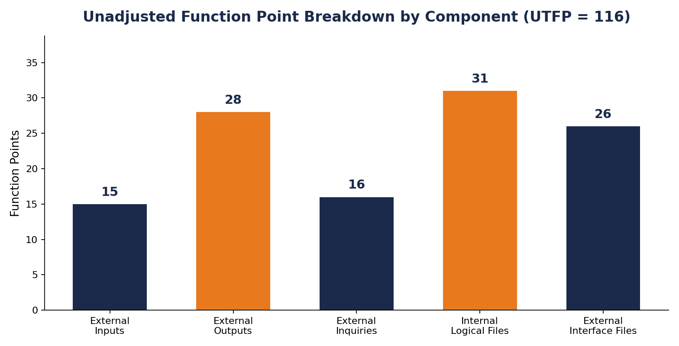
Figure 1: NEXUS Module Architecture (referenced from README) and Unadjusted Function Point Breakdown by Component

6.2 Lines of Code (LOC) Conversion
NEXUS is a mixed-language codebase (Python backend, HTML/CSS frontend). A language unit size was computed as the percentage-weighted average of each language's typical delivered lines per function point:
Language | % of Project | Language Unit Size (LOC/FP) | Weighted Contribution
Python | 90% | 50 | 45.0
HTML | 13% | 15 | 1.95
CSS | 7% | 16 | 1.12
Weighted Language Unit Size = (0.90 × 50) + (0.13 × 15) + (0.07 × 16) = 48.07 LOC/FP
Estimated Lines of Code = ATFP × Language Unit Size = 133.40 × 48.07 ≈ 6,413 LOC
Kilo Delivered Source Instructions (KDSI) = 6,413 / 1,000 ≈ 6.413

6.3 Effort, Schedule and Team-Size Estimation
Two independent estimation models were applied to the same size figures (KDSI and ATFP) so that team-size planning is not dependent on a single method.

6.3.1 COCOMO I (Basic, Semi-Detached mode)
NEXUS was classified Semi-Detached: the team has mixed experience with real-time financial data and multi-provider integration, but the frontend architecture and requirements are already well understood. The Basic COCOMO coefficients for Semi-Detached projects (a = 3.0, b = 1.12, c = 2.5, d = 0.35) give:
- Effort = 3.0 × (KDSI)^1.12 = 3.0 × (6.413)^1.12 ≈ 24.04 person-months
- Development Time = 2.5 × (Effort)^0.35 = 2.5 × (24.04)^0.35 ≈ 7.61 months
- Implied Team Size = Effort ÷ Development Time ≈ 3.16 people

6.3.2 Jones First Order Model
The Jones First Order model estimates effort directly from Adjusted Function Points for a Business-class system built by a team with Average organizational skill/ability:
- Estimated Effort ≈ 31.72 person-months
- Estimated Development Time ≈ 9.50 months
- Implied Team Size ≈ 3.34 people
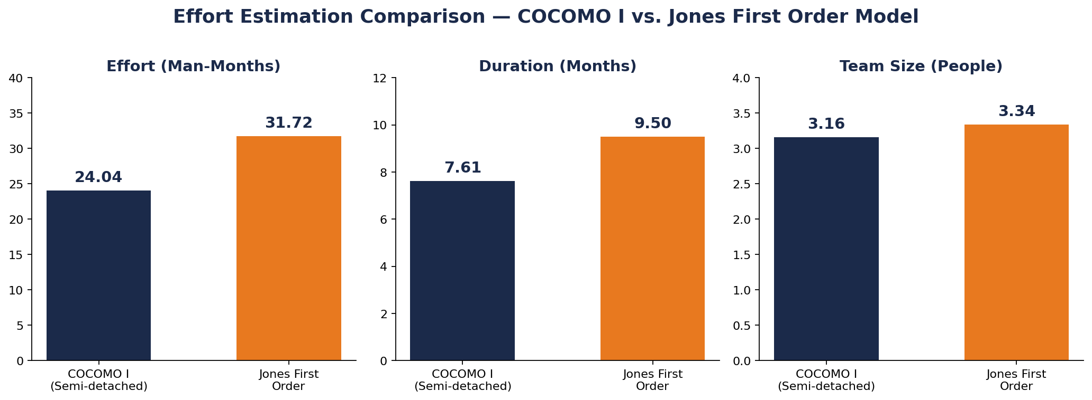
Figure 2: Effort Estimation Comparison — COCOMO I vs. Jones First Order Model

6.3.3 Reconciling the Two Models
The two models diverge by design: COCOMO I is calibrated on traditional, largely sequential software projects and tends to be optimistic for systems with many external integrations, while the Jones model weights function-point complexity more heavily and better reflects the multi-provider, real-time nature of NEXUS's backend. Jones's ≈32 person-months and ≈3.3-person implied team size is treated as the more representative baseline for planning purposes, with COCOMO's lower figures used as a best-case bound.

6.4 Team Size Justification
Despite both estimation models showing a theoretical team size of around 3–3.3 persons, this is the total effort in hours divided by calendar hours and assumes perfectly substitutable labor of generalists, which is not how software development teams operate – instead of using a 3-person team, the 6-member group was chosen, since dividing the development into backend, frontend, QA, and support/UX streams and developing them in parallel, rather than sequentially, will shorten the calendar schedule much more than merely throwing more bodies at the development, while allowing each of the developers to remain in their skillset lane without switching context from development to testing and support; furthermore, assigning Product Owner and Scrum Master roles separately from the development allows managing the project and the backlog to take place separately from the development process, the additional capacity will serve as buffer to allow the development of the two risky items in the backlog (the alerting pipeline of D5 and ticketing system of C6) and account for the fact that student contributors are not full time equivalents but partially available; all while staying well within the recommended Scrum team size of less than ten.
.

6.5 Roles and Responsibilities
Role | Responsibilities
Product Owner (Professor Daniel Tashkan) | Owns and prioritizes the product backlog; represents client and end-user interests; accepts or rejects completed work against the Definition of Done; sets release scope each sprint.
Scrum Master | Facilitates Scrum ceremonies (planning, daily stand-up, review, retrospective); removes impediments; shields the team from scope disruption; coaches the team on Agile practice.
Backend Developer | Builds the provider-proxy and caching service (D1); implements the response-normalization layer (D2); owns rate-limit and reliability engineering.
Frontend Developer | Maintains the single-file, no-build architecture (D3); implements the CSS custom-property theming pass (D4); builds and extends the 29 UI modules.
QA / Test Engineer | Writes and runs test plans across all 29 modules; validates provider-normalization correctness; verifies error-state and diagnostic-export behavior (C2, C3).
UX & Customer Support Liaison | Builds the in-app help panel (C1) and provider health-check surface (C5); owns the diagnostic snapshot and ticketing flow (C3, C6); feeds user-reported issues back into the backlog.

7. Scrum Team
NEXUS is delivered by a 6-member, cross-functional Scrum team. The team is deliberately kept small enough to avoid coordination overhead while still giving each of backend, frontend, QA and support work a clear owner (see Section 6.4 for the sizing rationale).

7.1 Team Roster
# | Name | Student ID | Scrum Role
1 | Roshjens Kunwar | 100007268 | Scrum Master
2 | Kaushal Patidar | 100006891 | Frontend Developer
3 | Hossein Sadeghian | 100008133 | Backend Developer
4 | Christin Renni Philip | 100008781 | Frontend Developer
5 | Sivapriya Prasanth | 100008274 | QA / Test Engineer
6 | Sumanth Pidishetti | 100008679 | UX & Customer Support Liaison
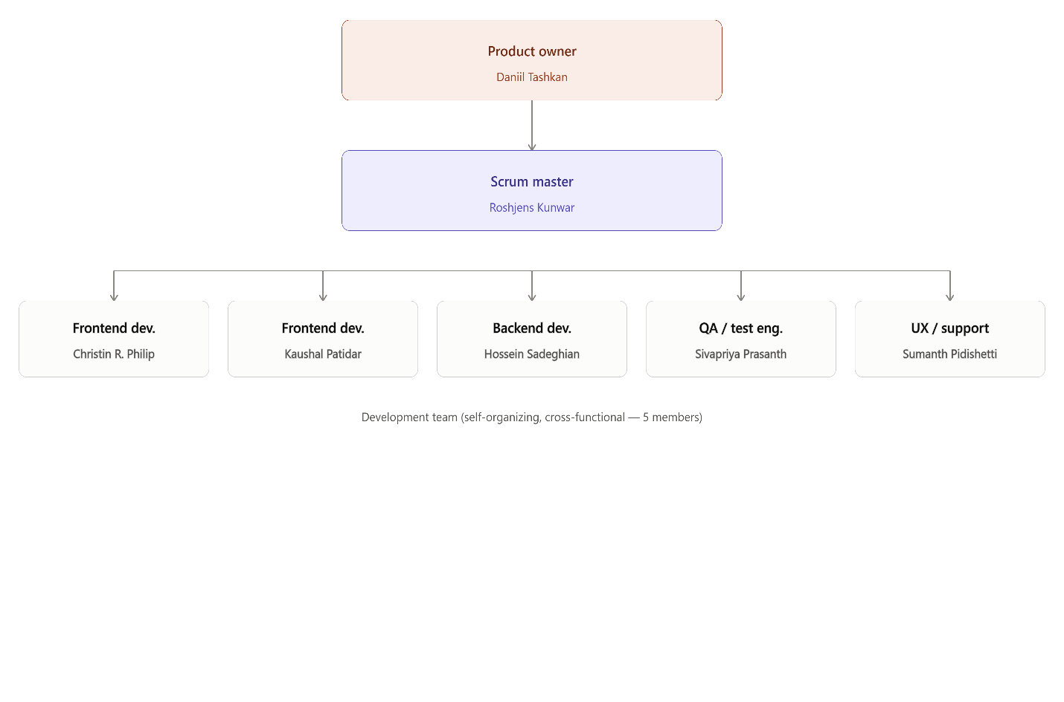
Figure 3: NEXUS Scrum Team Structure (6 Members)

7.2 Scrum Master — Detailed Responsibilities
- Plans and facilitates Sprint Planning, Daily Scrum, Sprint Review and Sprint Retrospective.
- Tracks sprint burndown and flags scope or velocity risk to the Product Owner early.
- Removes blockers — access issues, unclear acceptance criteria, cross-role dependencies — so developers stay unblocked.
- Coaches the team on Agile practice and protects the sprint backlog from mid-sprint scope changes.
- Owns this report and coordinates its assembly across the team.

7.3 Product Backlog Overview
The product backlog totals 99 story points across three requester personas — developer-facing platform needs, end-user features, and customer-support tooling — reflecting that NEXUS's backlog is not purely feature work: nearly a third of total points (30 SP) sit in support tooling needed to operate the terminal once real users depend on it.
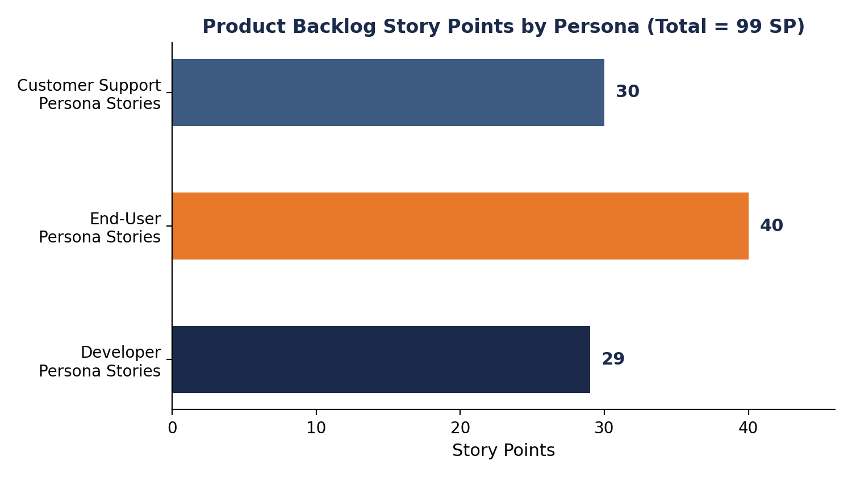
Figure 4: Product Backlog Story Points by Persona (Total = 99 SP)
ID | Persona | User Story | Points
D1 | Developer | As a developer, I want the backend to cache responses and manage rate limits, so the terminal stays within provider quotas and responds faster. | 8
D2 | Developer | As a developer, I want the backend to normalize provider responses into the shapes each module expects, so the frontend needs no changes when going live. | 8
D3 | Developer | As a developer, I want the frontend to remain one HTML file with no build step, so the terminal stays a portable download-and-run. | 2
D4 | Developer | As a developer, I want all colour and typography routed through CSS custom properties, so I can retheme by changing a handful of values. | 3
D5 | Developer | As a developer, I want to receive alerts if anything goes wrong on the user's end. | 8
U1 | User | As a user, I want to open the terminal by double-clicking one file, so I can start with no install, server, or setup. | 1
U2 | User | As a user, I want to switch modules from the top navigation, so I can move around quickly without losing my place. | 2
U3 | User | As a user, I want a live grid of 25+ assets across multiple classes, so I can watch the whole market on one screen. | 5
U4 | User | As a user, I want to view bid/ask depth for a selected symbol, so I can gauge liquidity before acting. | 5
U5 | User | As a user, I want a consolidated news and macro feed, so I can keep context on what's moving prices. | 3
U6 | User | As a user, I want an overview of portfolio exposure and key risk metrics, so I can understand my risk in one place. | 8
U7 | User | As a user, I want to model P&L for common strategies, so I can see the payoff before entering a position. | 8
U8 | User | As a user, I want to test an allocation against a benchmark, so I can judge its historical risk-adjusted performance. | 8
C1 | Customer Support | As customer support, I want a help panel explaining what each module does, so I can understand the terminal without external docs. | 3
C2 | Customer Support | As customer support, I want a clear, specific message when a module can't load live data, so I know it's a data issue, not a broken terminal. | 3
C3 | Customer Support | As customer support, I want to export a diagnostic snapshot, so I can share it when reporting a problem. | 5
C4 | Customer Support | As customer support, I want to see the terminal's version, so I can check I'm on the latest file. | 1
C5 | Customer Support | As customer support, I want a check of whether each data provider is configured and reachable, so I can self-diagnose module failures. | 5
C6 | Customer Support | As customer support, I want a ticketing system so I can solve or escalate a user's problem. | 13
Developer-persona subtotal: 29 SP
User-persona subtotal: 40 SP
Customer-Support-persona subtotal: 30 SP
Grand total: 99 SP

7.4 Sprint Planning Approach
With an average team velocity to be established over the first two sprints, the backlog is prioritized MoSCoW-style: D1–D3 and U1–U2 (core plumbing and navigation) are scheduled first since later stories depend on them; the highest-effort, highest-uncertainty items, D5 (client alerting) and C6 (ticketing), are scheduled once the team has a velocity baseline, consistent with their status as the two largest, highest-risk items in the backlog.

7.5 Definition of Done
- Code merged to main with no build-step regressions (single-file constraint preserved).
- Feature verified against synthetic data by QA, with a written test note.
- For backend stories, provider failover to synthetic demo data is confirmed working.
- Product Owner has reviewed and accepted the story against its acceptance criteria.

Sprint 1:
Goal: 11 backlog items, 29 story points.
Sprint 1: Burndown chart — Planned
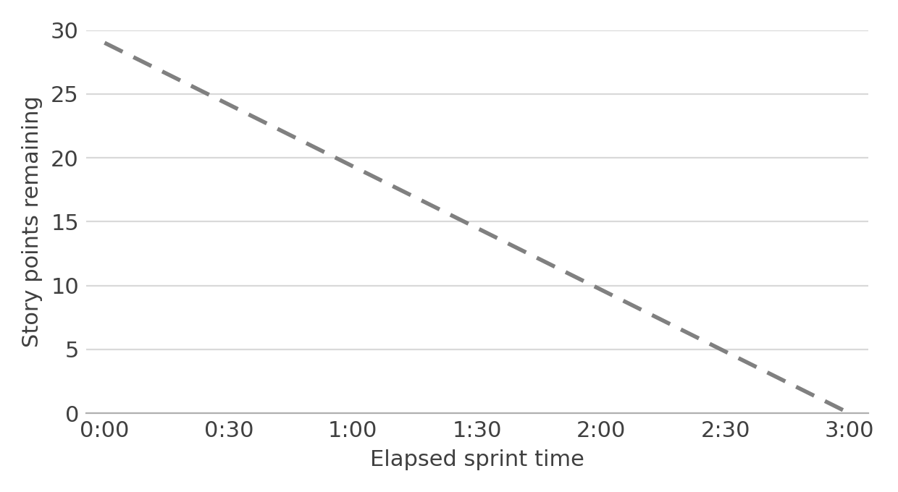
Sprint 1: Burndown chart — Achieved
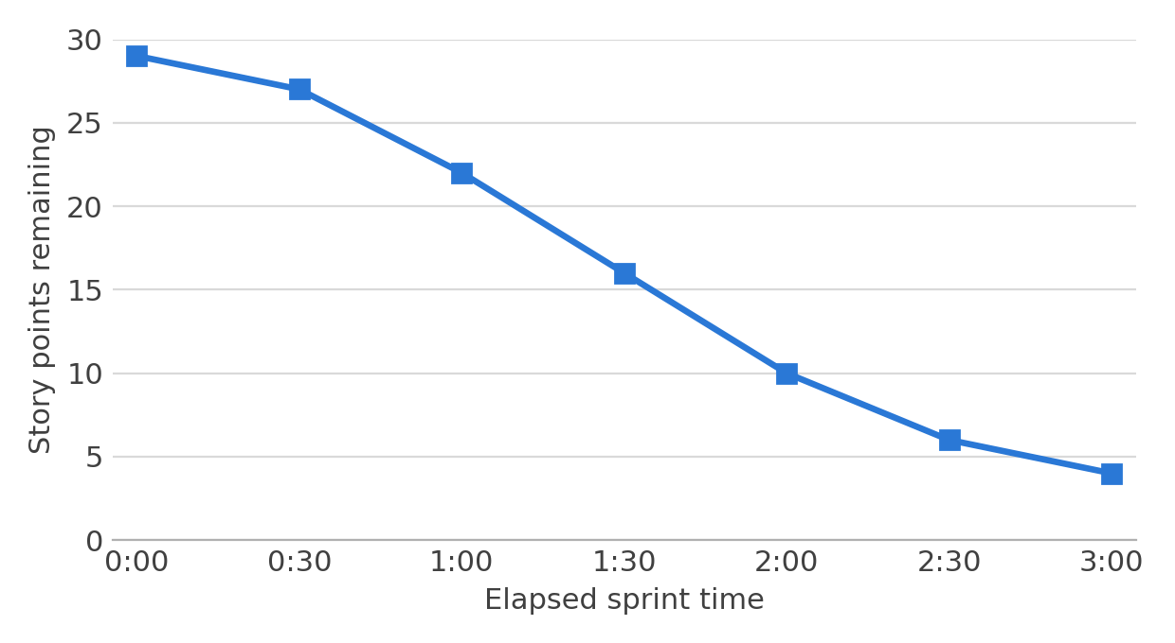
Sprint 1 (3 hours, 11 backlog items, 29 story points) we could not complete it so 4 story points from sprint 1 will be done in sprint 2.
Outcome: sprint did not fully burn down. Two cards were left To DO, and the nine cards that did move are dev-complete but still waiting for QA verification. None have formally reached Done.
Incomplete:
C2; Clear per-module data-failure messages (Must have, 3 SP) — Sumanth Pidishetti, Sivapriya Prasanth
C4; Visible version string (Should have, 1 SP) — Sivapriya Prasanth
Dev-complete, they are now in Testing column:
D3; Single file, no build frontend (2 SP)
U2; Top-navigation module switching (2 SP)
U3; Live multi-asset market grid (5 SP)
U1; Zero install start (1 SP)
D2.a to D2d; Polygon.io, Alpha Vantage, FRED, CoinGecko integration & normalization (3 SP each, 12 SP total)
D4 — Design tokens via CSS custom properties (3 SP)

Sprint 2:
Goal: close out everything Sprint 1 left open and deliver the next priority slice of the backlog.
Committed backlog — 31 story points:
Sprint 2: Burned down chart(planned):
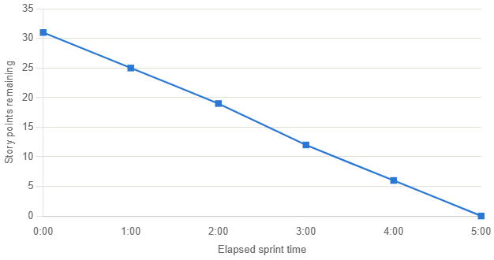
Sprint 2 (5 hours, 5 backlog items, 2 first sprint items, 31 story points)

