2. Sprint 1: Review

2.1 Scope and Outcome
Duration: 3 hours. Scope: 11 backlog items, 29 story points.
Outcome: the sprint did not fully burn down. Two cards never left To Do, and the nine cards that did move were development-complete but awaiting QA verification; none had formally reached Done by the end of the sprint.

2.2 Root Cause
Sprint 1's incomplete burndown was the result of several compounding factors rather than a single point of failure. First, the team's frontend developer was unavailable for the entire sprint, so the full backend scope fell to Hossein Sadeghian alone, including four external data-provider integrations (Polygon.io, Alpha Vantage, FRED, and CoinGecko) that each required independent research, normalization logic, and testing. Second, the sprint's time box was only three hours, the shortest of the project's three sprints, leaving no margin to absorb a reduction in capacity. Third, this was the team's first sprint working together on NEXUS: there was no established velocity baseline, no shared calibration on story-point sizing, and no prior working rhythm to draw on, so the initial estimate for an eleven-item, 29-point backlog proved optimistic once work was underway. Finally, because the board's peer-verification step had not yet been exercised by anyone on the team, the nine cards that did reach development completion still required a QA pass that the sprint had no time left to accommodate. Taken together, reduced capacity, a compressed schedule, and the absence of a team track record for estimation left the backlog oversized relative to the capacity actually available, rather than reflecting a shortfall in effort or execution quality.

2.3 Incomplete Items (carried into Sprint 2)
- C2: Clear per-module data-failure messages (Must have, 3 SP)
- C4: Visible version string (Should have, 1 SP)

2.4 Development-Complete, Pending Verification
- D3: Single-file, no-build frontend (2 SP)
- U2: Top-navigation module switching (2 SP)
- U3: Live multi-asset market grid (5 SP)
- U1: Zero install start (1 SP)
- D2.a - D2.d: Polygon.io, Alpha Vantage, FRED, CoinGecko integration & normalization (3 SP each, 12 SP total)
- D4: Design tokens via CSS custom properties (3 SP)

2.5 Burndown
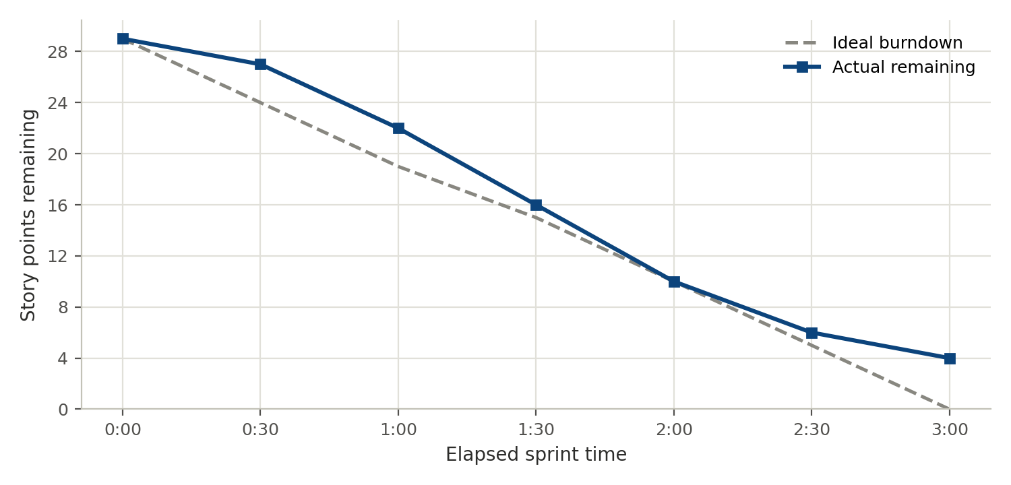
Figure 1. Sprint 1 ideal vs. actual burndown. The actual line stalls at 4 story points instead of reaching zero, reflecting the two untouched cards above.

