**Project 1: Search in Pacman**

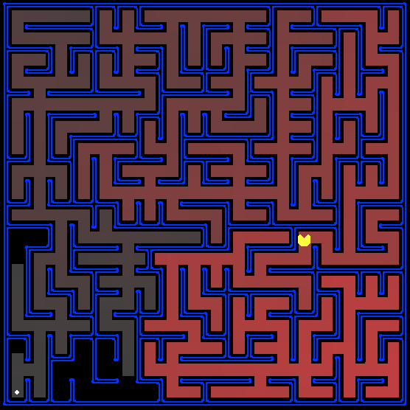

*All those colored walls,*

*Mazes give Pacman the blues,*

*So teach him to search.*

**Introduction**

In this project, your Pacman agent will find paths through his maze world, both to reach a particular location and to collect food efficiently. You will build general search algorithms and apply them to Pacman scenarios.

The code for this project consists of several Python files, some of which you will need to read and understand in order to complete the assignment, and some of which you can ignore. You can download all the code and supporting files as a zip archive (see search.zip).

**Files you'll edit:**

|  |  |
| --- | --- |
| search.py | Where all of your search algorithms will reside. |
| searchAgents.py | Where all of your search-based agents will reside. |

**Files you might want to look at:**

|  |  |
| --- | --- |
| pacman.py | The main file that runs Pacman games. This file describes a Pacman GameState type, which you use in this project. |
| game.py | The logic behind how the Pacman world works. This file describes several supporting types like AgentState, Agent, Direction, and Grid. |
| util.py | Useful data structures for implementing search algorithms. |

**Supporting files you can ignore:**

|  |  |
| --- | --- |
| graphicsDisplay.py | Graphics for Pacman |
| graphicsUtils.py | Support for Pacman graphics |
| textDisplay.py | ASCII graphics for Pacman |
| ghostAgents.py | Agents to control ghosts |
| keyboardAgents.py | Keyboard interfaces to control Pacman |
| layout.py | Code for reading layout files and storing their contents |
| autograder.py | Project autograder |
| testParser.py | Parses autograder test and solution files |
| testClasses.py | General autograding test classes |
| test_cases/ | Directory containing the test cases for each question |
| searchTestClasses.py | Project 1 specific autograding test classes |

**Files to Edit and Submit:** You will fill in portions of search.py and searchAgents.py during the assignment. You should submit these files with your code and comments. Please do not change the other files in this distribution or submit any of our original files other than these files.

**Evaluation:** Your code will be autograded for technical correctness. Please do not change the names of any provided functions or classes within the code, or you will wreak havoc on the autograder. However, the correctness of your implementation -- not the autograder's judgements -- will be the final judge of your score. If necessary, we will review and grade assignments individually to ensure that you receive due credit for your work.

**Academic Dishonesty:** We will be checking your code against other submissions in the class for logical redundancy. If you copy someone else's code and submit it with minor changes, we will know. These cheat detectors are quite hard to fool, so please don't try. We trust you all to submit your own work only.

**Discussion:** Please be careful not to post spoilers.

**Welcome to Pacman**

After downloading the code (search.zip), unzipping it, and changing to the directory, you should be able to play a game of Pacman by typing the following at the command line:

*python pacman.py*

Pacman lives in a shiny blue world of twisting corridors and tasty round treats. Navigating this world efficiently will be Pacman's first step in mastering his domain.

The simplest agent in searchAgents.py is called the GoWestAgent, which always goes West (a trivial reflex agent). This agent can occasionally win:

*python pacman.py --layout testMaze --pacman GoWestAgent*

But, things get ugly for this agent when turning is required:

*python pacman.py --layout tinyMaze --pacman GoWestAgent*

If Pacman gets stuck, you can exit the game by typing CTRL-c into your terminal.

Soon, your agent will solve not only tinyMaze, but any maze you want.

Note that pacman.py supports a number of options that can each be expressed in a long way (e.g., --layout) or a short way (e.g., -l). You can see the list of all options and their default values via:

*python pacman.py –h*

Also, all of the commands that appear in this project also appear in commands.txt, for easy copying and pasting. In UNIX/Mac OS X, you can even run all these commands in order with bash commands.txt.