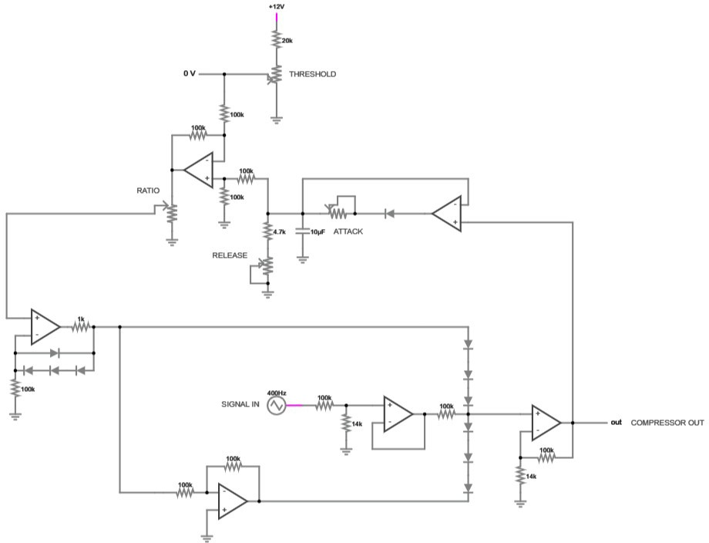

COMPRESSOR CIRCUIT

By Atae KHATBANE & Mouaad Nacer

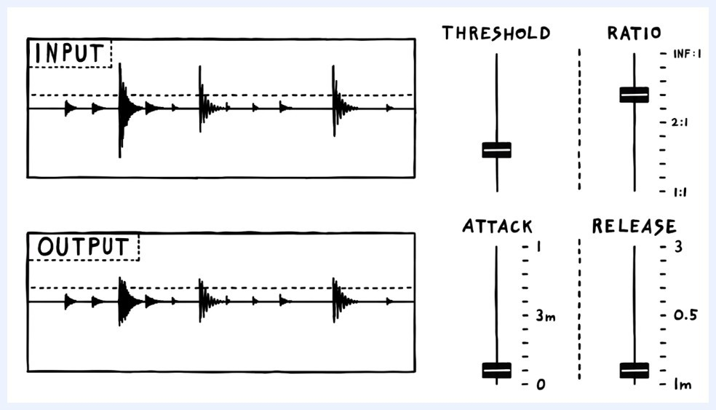

R tio: config(ures how much the si(n l is cut off p st the threshold
Atta ck: config(ures how lon( it should w it before reducin( the output si(n l
Rele se: (symmetric to tta ck) config(ures how lon( it should w it before restorin( the output si(n l
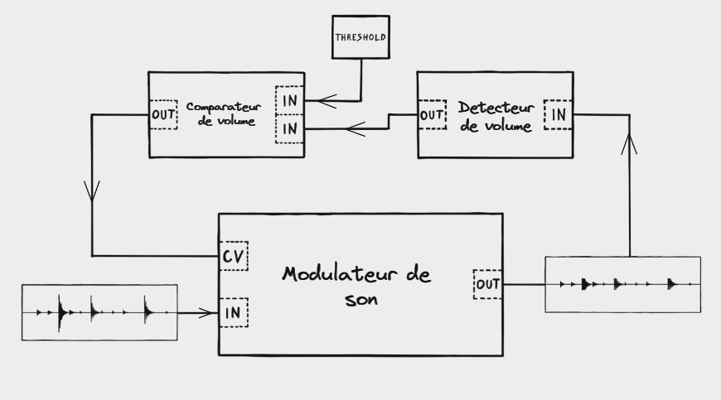

-Sound moduler: modulate the input signal.
-Volume detecor: self explanatory.
-Volume comparator: compares the volume to the threshold.
=> (in the moduler after comparison) If the input signal > threshold : lower the signal, else leave it as is.
That also means it requires at least one loop to generate a control signal, must be kept in mind so that this part does not take long, and given the technology at hand, there may be a chance the first ouput is still loud. Might not last long enough to be noticeable.

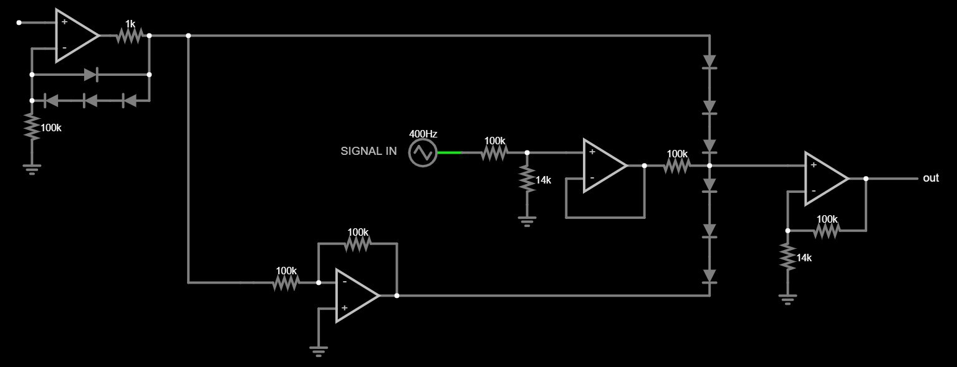
Inspired from a diode VCA I found online. Modified to fit our need.
Now to explain the previous circuit, it must be known that the functional core consists of the 6 diodes as well as the 100k resistor attached to it. Let’s simplify it with the following scheme:
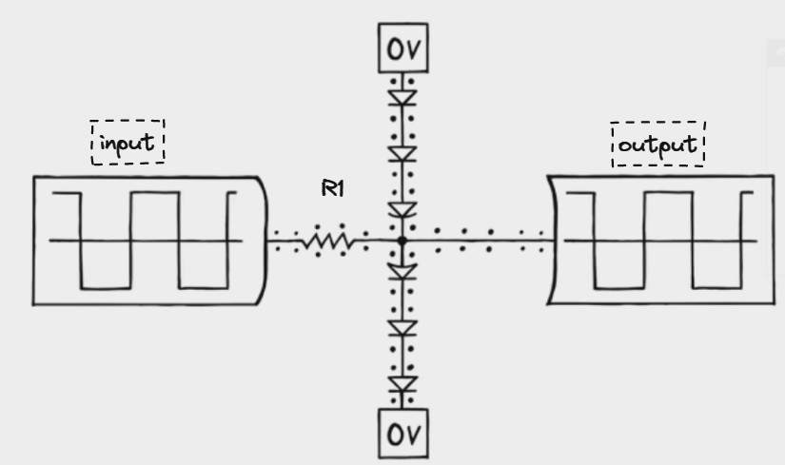
This is a central node
R1 : 100k RES Control voltage to the top, inverted voltage to the bottom We apply a scaled down version of our signal to the resistor.

- If the control voltage is 0 the output will be identical to the input because there’s no current flowing (middle line) neither through the diodes nor through the resistor since the input is not strong enough to push or pull the diodes open. (That is also why we scale down our input because if it’s too loud, it will push/pull the diodes and will create some sort of sound distorsion).

- If ov = 2v, the diodes are wide open, and a large current flows from top to bottom, and since this is a 1/2 voltage divider, the central node will sit at 0 volts exactly halfway between top to bottom voltage.

-If the input goes below or above 0v, a current will flow through R1, but since that current is considerably lower than the one flowing through the diodes, the central node will remain almost unaffected, the signal is "washed away" and the output stays silent.

Basically, the more current flows through the diodes, the more we reduce the output volume.
Back to the main circuit :
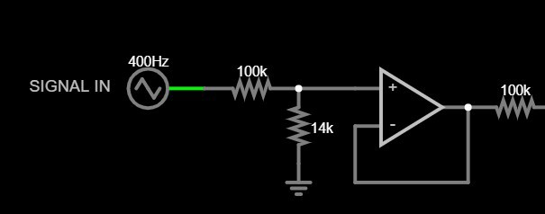

1- We scale the signal down with a voltage divider
  - Then we buffer it and apply it to the resistor
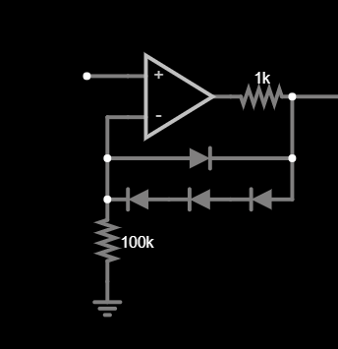
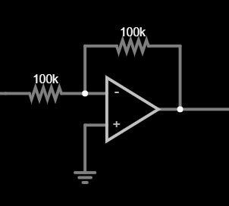

  - Then we buffer the incoming cv before inverting it, and then applying both versions to our stream of diodes

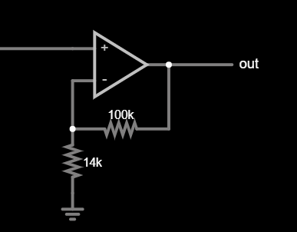
The 1k resistor in the first picture is just to limit the maximum amount of current we push through the diodes.

  - We pick the input from the central node, and amplify it to reverse the downscaling at the input
I’m using 6 diodes instead of two to keep the gain of the last amplifier as low as possible to prevent random noise from creeping into the output. Multiple diodes in series are much tougher to open meaning we can input a louder signal without risking distorsion. In turn, the output stage does not require much gain to restore the signal. Now by increasing the CV, we can decrease the output volume.

VOLUME DETECTOR:
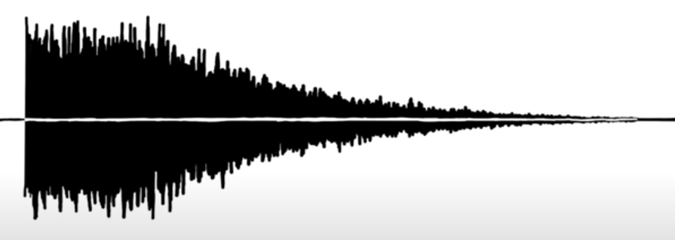
This is a sample snare sound. Normally, you’d determine the volume of this sound by measuring the height of the waveform at any given point, top to bottom, but since audio signals are often symmetrical, we can discard the lower half and consider the peak to ground as absolute volume.
Using a peak detector, we can keep measuring each peak at any given time continuously.
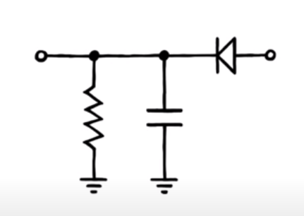

Whenever the input rises significantly above the 0v line, a large current charges the capacitor. Once the voltages on both sides are almost the same, the current flow will stop and thus we’ve sampled the voltage cap. Then when the input signal drops, the capacitor will slowly drain out into the resistor. That is how we measure a voltage level over significant period of time.
However, diodes will only let current run through if the input is significantly higher than the output, meaning our capacitor can never be charged to the input’s peak level. To fix this we can combine it with an op-amp like this:

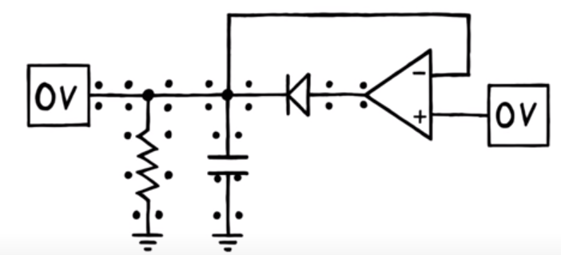

VOLUME COMPARATOR:

We need to compare our input to a certain threshold. Such can be done with a voltage subtractor.
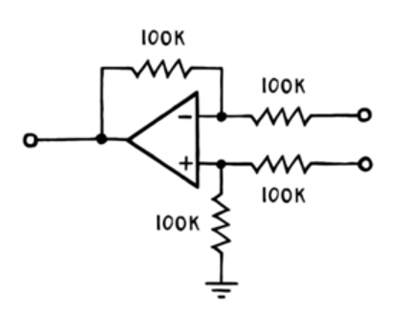

The op amp will subtract V1 from V2 and will output the result. All we will need is a valid threshold.
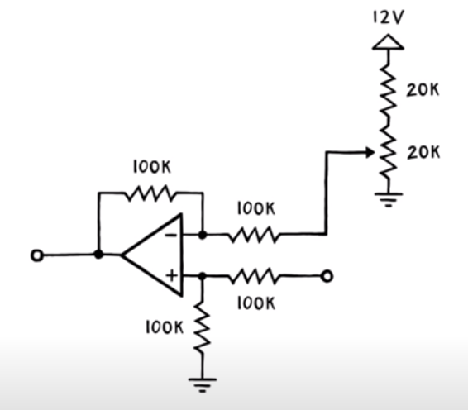

We are using a 12V potentiometer as a voltage divider, but since we do not expect our signal to peak anywhere near 12V, we restrict its range with another 20k resistor, capping the max V at 6V, which gives us a lot of freedom still since a synthesizer is not expected to reach past 5V.

Now if the output is below the threshold, the substractor sends out a negative V, which allows the signal to pass through the VCA unchanged. That is because the current cannot flow thorugh the diodes chain in reverse.

However, with our current circuit, there may be some gaps in our output since the substractor takes a bit of time to stagnate at a high enough signal for the diodes to pick it up, hence some frequencies could pass through unchanged. To remedy it, we just have to turn on the diodes instantly when the CV input starts going positive. Such can be achieved with a modded CV buffer:
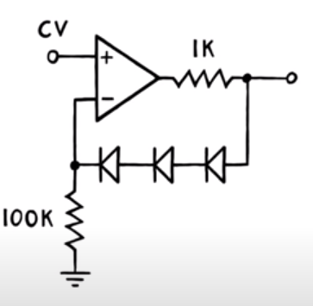

Three diodes followed by a 1K resistor to ground between it’s output and it’s inverting input. So when the inverting input rises slowly above ground level, op amp is forced to increase its output signal enough to turn on all three diodes. 3 diodes instead of 6 because our dual buffer setup doubles the voltage applied across the diode string and the turn on voltage of diodes in series gets summed up together, so 2*3Vdiodes = 6Vdiodes, but there is a small problem in this build, if the CV is below 0V, the buffer will crush in the negative rail in an attempt to pull the current, to prevent this we simply add a single diode in parallel facing the other direction.
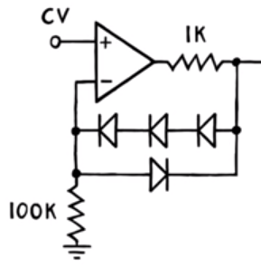

But once more, another issue arises, as I’ve tested our current circuit in an oscilloscope, the compressor reacts violently to signals. To remedy that, we just have to scaledown the feedback applied to the VCA. To implement it, adding a logarithmic part as variable voltage divider instead of a linear one should be enough as we adjust the compression ration by turning a knob.

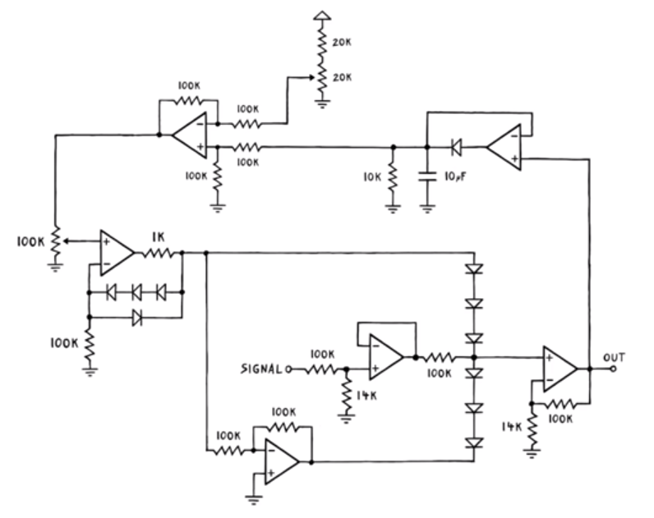
RELEASE:
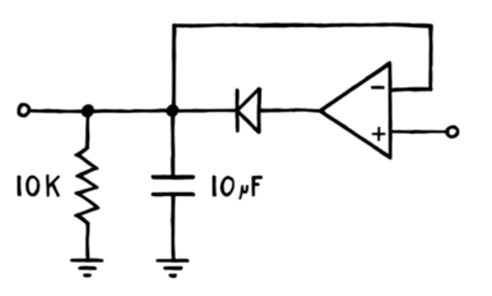

The 10k resistor delays the drop of the detected peak down to the actual output volume, and since the detected peak determines the amount of compression we apply, a direct drop there instantly results in an extended release time. We will then replace that resistor with a 100k potentiometer alongside a minimum resistance otherwise it will short circuit. A 4k7 res should be enough, according to my experience and online ressources, as going any lower would result in a shortening of the release ending in a distorsion of the output sound.

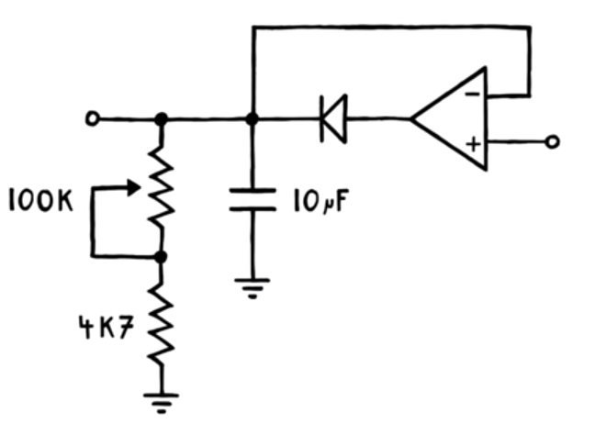

ATTACK:
The same idea applies here, if we want the compression to kick in later, we just have to increase the charging time of the capacitor using a potentiometer.

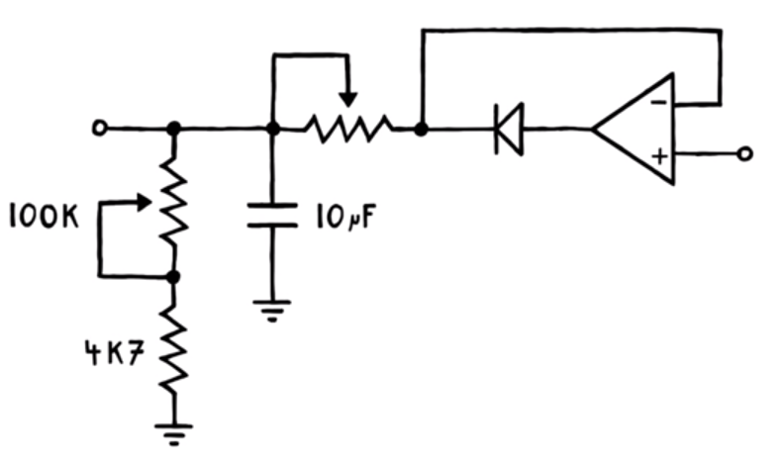

And that is what makes our circuit.
Here is the final product:
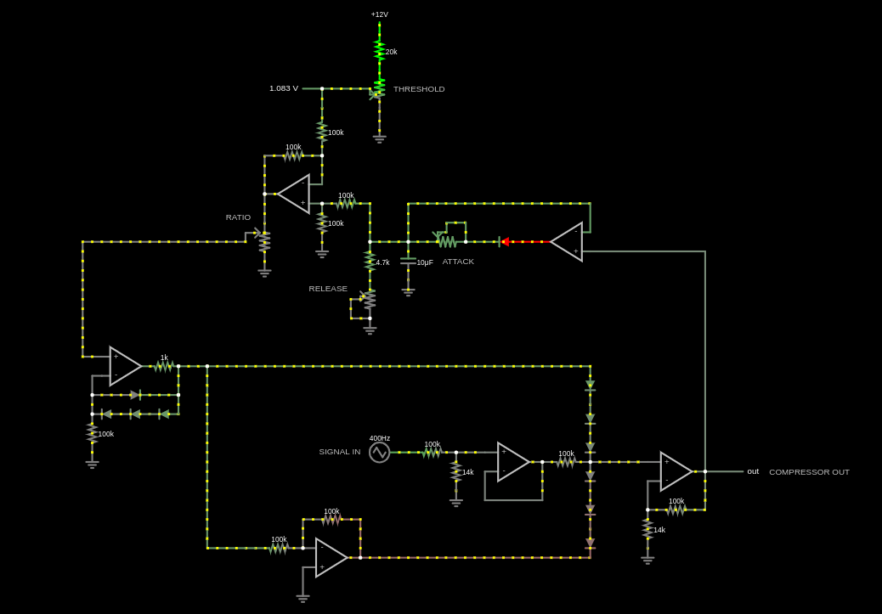

Ressources:

4 – potentiometers

11 – 1N4148 diodes

6 – op-amps

1 – 1k resistor
1 – 4.7k resistor
2 – 14k resistor
1 – 20k resistor
9 – 100k resistor

1 – 10µF capacitor

