1. The simple superheated Rankine cycle

The Standard Pump – Boiler – Turbin (HP and LP) – Condenser Cycle

1. The superheated Rankine cycle with reheat

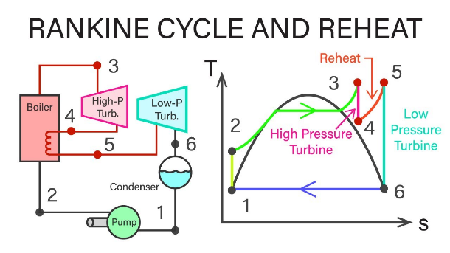

Figure : <https://www.bing.com/images/search?view=detailV2&ccid=ehVgftaj&id=B36B0DA017C5FAB2252949983F911DAD9B1834B7&thid=OIP.ehVgftajo1VJ6XvFcQo3yQHaEK&mediaurl=https%3a%2f%2fi.ytimg.com%2fvi%2fyAySar5gYOk%2fmaxresdefault.jpg&cdnurl=https%3a%2f%2fth.bing.com%2f>

Reheat. After the HP turbine, the Steam is sent to the Boiler again to be reheated.

1. The superheated regenerative Rankine cycle with a single open feed water heater
2. The gas-turbine cycle topping a simple superheated Rankine cycle
3. Isentropic efficiency
4. Turbine design point performance
5. Practical limits on plant operation