FPT UNIVERSITY HCM
SWR302 - Software Requirement



Software Requirement Specification

Group Subject: Group 7
Class: SE1917
Lecturer: Lại Đức Hùng

Thành Phố Hồ Chí Minh, ngày 25 tháng 06 năm 2026

<Logo>

AutoWash Pro
Software Requirement Specification

Project Code: SWR302
Document Code: AWP-SRS-01-v1.0

TP.Hồ Chí Minh, 21/06/2026

Record of change

*A - Added M - Modified D - Deleted
Effective Date | Changed Items | A*  M, D | Change Description | New Version
21/06/2026 | Initial | a | Create initial SRS document for AutoWash Pro | V1.0

SIGNATURE PAGE

ORIGINATOR: <Pham Duy Khanh> <Date>
<Developer>

REVIEWERS: <Name> <Date>
<Position>

<Name, if it’s needed> <Date>
<Position>

APPROVAL: Lai Đức Hùng 25/06/2026
<Position>
TABLE OF CONTENTS
1. INTRODUCTION 7
1.1. Purpose 7
1.2. Scope 7
1.3. Definitions, Acronyms, and Abbreviations 8
1.4. References 9
1.5. Overview 9
2. OVERALL DESCRIPTION 10
2.1. Product Respective 10
2.2. Product Functions 10
2.3. Operating Environment 12
2.4. Design and Implementation Constraints 12
2.5. Assumptions and Dependencies 13
2.6. Business Rules 13
2.7. System Workflow Summary 13
3. FUNCTIONAL REQUIREMENTS 15
3.1. <Use Cases Diagram> 15
3.2. <Make Reservation> 16
3.3. <Register Account > 18
4. NON-FUNCTIONAL REQUIREMENTS 22
4.1. Usability 22
4.2. Reliability 22
4.3. Performance 23
4.4. Supportability 23
4.5. Design Constraints 23
4.6. On-line User Documentation and Help System Requirements 23
4.7. Purchased Components 23
4.8. Interfaces 24
4.9. Licensing Requirements 24
4.10. Legal, Copyright, and Other Notices 24
4.11. Applicable Standards 24
5. SUPPORTING INFORMATIONS 25
5.1. Index 25
5.2. Appendices 25

INTRODUCTION

Purpose
The purpose of this Software Requirement Specification (SRS) is to define the detailed functional and non-functional requirements for the AutoWash Pro (AWP) system. This document will serve as the primary blueprint for the development team, QA testers, and project stakeholders to ensure a shared understanding of the system's capabilities, design constraints, and operational goals. AutoWash Pro is designed to digitize and streamline the workflow of modern car care centers, improving customer booking experiences while optimizing facility management.

Scope
The AutoWash Pro system is a comprehensive web-based platform tailored for car wash facilities. It eliminates traditional manual queueing and paper-based tracking by offering:

For Customers:
A digital portal to browse care packages, book time slots in advance, track loyalty points, and receive automated assistance via an integrated Chatbot.

For Staff:
A real-time operations dashboard to manage daily service queues and update vehicle status (e.g., Pending, Washing, Completed).

For Management:
Administrative tools to configure pricing policies, oversee revenue, and engage with customers through a Live Chat escalation system.

Definitions, Acronyms, and Abbreviations

Term | Meaning
AWP | AutoWash Pro
Service Package | A predefined tier of car wash service
Booking | An appointment made by a user for a specific wash time
Loyalty Points | Reward points accumulated after a successful wash session
Admin | System Administrator/ Manager
Staff | Car Wash Employee
Customer | Car Owner/Service User
Chatbot | Automated Artificial Intelligence Assistant
Live Chat | Human-operated customer support session

References
- IEEE Software Requirement Specification Standards
- SWP391 Project Requirements
- Car Wash Facility Business Requirements
- UML Modeling Standards
- Database Design Guidelines

Overview
- Section 1 describes the introduction, scope, definitions, and references.
- Section 2 describes the overall system architecture, user roles, assumptions, and constraints.
- Section 3 defines the specific functional and non-functional requirements.
- Section 4 describes system models, workflows, and use cases.
- Section 5 contains appendices and supporting materials.

OVERALL DESCRIPTION

Product Respective:

AutoWash Pro operates as an independent, cloud-hosted web application. It is designed with a responsive architecture to ensure accessibility across desktop monitors at the facility front desk and mobile devices used by customers on the go.

Product Functions

For Customers | For Car Wash Staff | For Facility Managers | For System Administrators | AI-Based Functions
View service packages | View daily wash queues | Manage service packages | Manage user accounts | Automatic FAQ responses
Book wash sessions | Update wash status | Configure pricing policies | Assign roles and permissions | Chatbot keyword recognition
Track active wash status | Answer live chat requests | View operational reports | Monitor access logs | Smart hand-over to Admin
Make online payments | Confirm cash payments | Monitor daily revenue | Maintain system security | Image attachment detection
View loyalty points | Handle customer issues | Export revenue statistics | Backup and restore data
Manage personal vehicles | Handle wash exceptions | Monitor wash queue | Backup and restore system data | Service package recommendation
View booking history | Track wash duration | Export reports and statistics | Manage audit logs | Smart chatbot suggestions
Submit feedback and support requests | Monitor individual wash bays | Manage business rules and policies | Manage authentication and authorization | Basic booking trend analysis

User Classes and Characteristics
User Class | Description
Customer / Driver | Uses the system to view wash packages, book appointments,track wash status,chat for support,make payments, and earn loyalty points.
Staff | Handles daily car wash operations, updates vehicle statuses (Pending -> Washing -> Done), and answers live customer chats.
Car Wash Manager | Manages service catalogs, pricing policies, operational reports, and car wash business activities.
System Administrator | Maintains system configuration, user accounts, role-based access control, security settings, system monitoring, backup, and recovery operations.
Chatbot Support Module | Supports intelligent customer interactions such as answering FAQs, providing service pricing, and routing complex queries to Live Admins.

Operating Environment

Client Side
- Web browser (Chrome, Edge, Firefox)
- Mobile browser support

Server Side
- Backend Framework: ASP.NET Core
- Database: SQL Server

Network
- Internet connection required
- Local network support inside car wash facilities

Design and Implementation Constraints
- The system shall comply with the following constraints:
- Role-based access control must be implemented.
- Booking status and Chat messages must support real-time synchronization.
- The system must support concurrent wash service bookings.
- Data consistency must be maintained during loyalty point transactions and wash status updates
- Sensitive information must be secured.
- Payment transactions must be validated.

Assumptions and Dependencies

Assumptions
- Users have internet access.
- Staff are trained to operate the system.
- Wash bays are uniquely identified

Dependencies
- Database server availability
- Payment gateway services
- Cloud storage for chatbot image attachments

Business Rules
- Cancellation Policy: A wash booking can only be canceled at least 30 minutes before the scheduled time. Late arrivals over 15 minutes will be marked as "No-show".
- Loyalty Points: Points are only credited to the customer's account after the wash status is marked as "Done" and payment is fully completed

- Chatbot Limitations: The automated Chatbot must immediately transfer the conversation to a Live Admin if a customer uploads an image or file.

System Workflow Summary

Booking Workflow
- The customer selects a wash service package
- The customer selects an available time slot and confirms.
- A pending booking is created

Service Execution Workflow
- The customer arrives at the facility
- Staff updates the vehicle status to “Washing”
- Staff updates the status to “Done” upon completion

Support Workflow
- The customer opens the chat widget
- The Chatbot answers FAQS automatically
- If the customer dends an image, the system transfers the chat to an Admin

FUNCTIONAL REQUIREMENTS

<Use Cases Diagram>
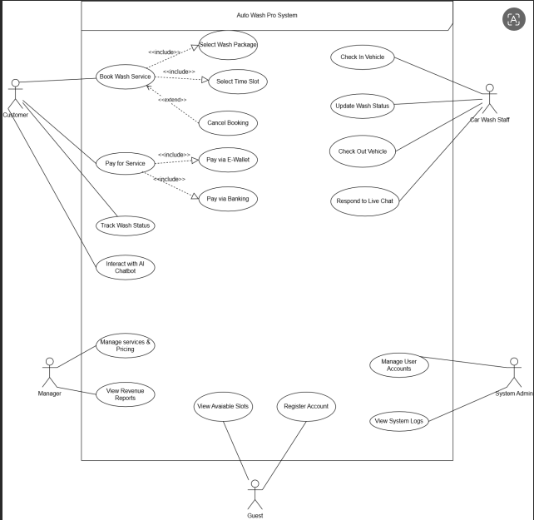

<Make Reservation>
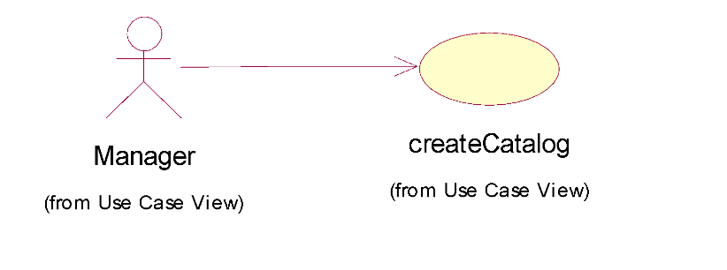
USE CASE-n SPECIFICATION

Use-case No. | UC001 | Use-case Version | 1.0
Use-case Name | Make Reservation
Author | khanh
Date | 25/06/2026 | Priority | High
Actor:
Registered Customer
Summary:
Describes the process where a logged-in customer selects a car wash service package and schedules an appointment via the platform.
Goal:
To successfully secure a booking slot for a car wash service and generate a pending booking record.
Triggers:
The custorm clicks on the “Book Now” button on a specific service package
Preconditions:
The customer has successfully registered an account and logged into the system
The system has available. Time slots for the selected date.
Post Conditions:
A new booking record is created in the database.

The booking status is set to “Pending”.
Main Success Scenario:
<List the main steps for using this case to reach the goal successfully >
Actor actions | System response
1. The customer accesses the “Booking” screen. | 2. The system displays available service packages and a calendar.
3. The customer selects a package, an empty time slot, inputs vehicle details, and clicks “Confirm”. | 4. The system validates the time slot availability and input format
5.The system saves the booking into the database
6.The system displays a success message: “Booking Confitmed!”.

Alternative Scenario:
3a. The customer wants to change the selected service package:
- 3a1. The customer clicks the “change package” button..
- 3a2. The system returns to the service selection catalog.
- 3a3. The flow returns to Step 3 of the Main Success Scenario.
Exceptions:
5a. The customer selects a time slot that was just taken by another user:
- 5a1. The system blocks the submission and displays an error message: “This time
slot is no longer available. Please select another time.”

- 5a2. The system refreshes the calendar to show the latest availability.
Relationships:
<<include>>: Login.
Business Rules:
BR01 (Cancellation Policy): A booking can only be canceled at least 30 minutes before the scheduled time.
BR02 (Late Arrival): If the customer is more than 15 minutes late without prior cancellation, the booking automatically reverts to “No-show” status.
BR03 (One Booking Policy): Each customer account is restricted to a maximum of 1 active pending booking at any given time to prevent system hoarding.

<Register Account >

USE CASE-n SPECIFICATION

Use-case No. | UC002 | Use-case Version | 1.0
Use-case Name | Register Account
Author | Khanh
Date | 25/06/2026 | Priority | High
Actor:
Unregistered Customer (Guest)
Summary:
Describes the process where a new user creates an account on the system using either their Email/Password or their existing Google account.
Goal:
To successfully create a new user account in the system database, allowing the user to log in and use premium features like booking car wash services. .
Triggers
The customer taps on the "Book Now" feature on the web application dashboard. Or clicks on the "Register" or "Sign Up" button on the interface.
Preconditions:
The user is currently an unauthenticated guest and has access to the application/website.
Post Conditions:
A new account record is created and stored in the database.
The user is automatically logged into the system.
The user is redirected to the home dashboard.

Main Success Scenario:
<List the main steps for using this case to reach the goal successfully >
Actor actions | System response
1. The user clicks the "Register" button. | 2. The system displays a rectangular modal/popup containing registration options:  - Method 1: Email and Password input fields.  - Method 2: "Continue with Google" button.
3. The user fills in their email address and a secure password, then clicks the "Submit" button. | 4. The system validates the email format and password strength.  5. The system checks if the email already exists in the database.  6. The system encrypts the password and saves the new account data into the database.  7. The system automatically logs the user in and displays a success notification: "Registration Successful!".

Alternative Scenario:
3a. The user chooses to register via Method 2 ("Continue with Google"):
3a1. The user clicks the "Continue with Google" button.
3a2. The system redirects the user to the Google Authentication secure login page.
3a3. The user signs in with their Google credentials and grants permission to the app.
3a4. Google returns a secure authentication token along with the user's basic profile info (Email, Name).
3a5. The system checks if this Google email is already registered. If not, it creates a new account automatically.
3a6. The flow proceeds to Step 7 of the Main Success Scenario.
Exceptions:
If the user enters an invalid email format or a weak password:
- The system blocks the submission and highlights the specific field with an error message (e.g., "Invalid email address" or "Password must be at least 8 characters long").
- The system keeps the rectangular registration modal open for re-entry.
If the entered email already exists in the system database:
- The system displays an error message: "This email is already registered. Please log in or use another email."
If the Google Authentication process fails or is canceled by the user:
- The system cancels the registration loop, displays an alert: "Google Sign-In canceled," and returns the user back to the rectangular registration modal.
.
Relationships:
<<extend>>: Login (The registration form usually provides a direct link to switch to the Login modal if the user realizes they already have an account).
Business Rules:
BR01 (Password Encryption): All passwords registered via Method 1 must be strictly hashed using a secure encryption algorithm (e.g., BCrypt) before being saved into the database; plain text passwords must never be stored.
BR02 (Unique Identifier): Every account in the system must be mapped to a unique email address. Duplicate emails are strictly forbidden.
BR03 (Google Token Trust): When using "Continue with Google," the system must trust Google's verification status and skip the traditional email verification code step.

NON-FUNCTIONAL REQUIREMENTS

Usability
- Training Time:
- Car Wash Staff: Maximum 30 minutes of instruction to master booking confirmation,updating wash status,and responding to live chat.
- Manager: Maximum 1 hour to become familiar with the pricing configuration interface and viewing statistical reports.
- Customer: need a period of time using the website to become familiar with it and understand how to perform operations.
- Measurable Task Times:
- The staff shall be able to manually update a vehicle’s wash status within 5 seconds
- Processing a live chat handover from the Chatbot and replying to the customer: No more than 30 seconds.
- Interface Standards:
- Web Interface (Staff, Manager): Must display correctly on desktops and tablets (Responsive).
- Web (Customer): Follows basic design rules; buttons are large and clear; supports Dark Mode for night use.

Reliability
- Availability:
- The system operates continuously 24/7 and must ensure stable operation under normal usage conditions.
- Maintenance (if needed): Performed during off-peak hours (1:00 AM – 3:00 AM) and must be announced in advance on the App.
- Degraded Mode Operations:
- When the internet is lost, the system on Staff workstations automatically switches to Offline Mode:allows recording booking arrivals and storing information locally.
- When connectivity is restored, data is automatically synchronized to the Server within 5 minutes.
- Accuracy:
- Service package pricing and loyalty points calculation must be 100% correct.
- Defect Rate:
- Critical Bug: Must not cause system crash or loss of revenue/historical data. Must be fixed within 45 minutes.
- Minor Bug: Display or UI glitches that do not affect core functions. Fixed in the next update.

Performance
- Response Time:
- API showing available slots to the Customer Web: < 500ms.
- Chatbot AI response time: < 2 seconds.
- Revenue and peak-hour report charts: Load within < 3 seconds.
- Capacity & Throughput:
- Handles vehicle flow with a minimum throughput of 50 concurrent active users during peak hours.
- Stores history of at least 200,000 wash bookings and chat logs without performance degradation.

Supportability
- Coding Standards:
- Follow clear naming conventions (e.g., CamelCase).
- Comments are required for complex functions (progressive pricing, AI chatbot logic).
- Audit Log:
- Log format: [Timestamp] - [Account] - [Action] - [Change Details].
- Logs are retained for at least 1 month for audit purposes.

Design Constraints
- Programming Languages:
- Backend: Dotnet Core API
- Frontend Web: ReactJS.
- Database: MySQL (relational, ensures transaction integrity).

On-line User Documentation and Help System Requirements
- Web (Staff/Manager): Includes a "User Guide" page with illustrated steps for vehicle entry/exit handling and wash booking exceptions.
- Web (Customer): Includes a "Help & FAQs" section answering questions about booking cancellation and payment wallet linking.

Purchased Components
- AI Chatbot: Open-source LLM or third-party API(e.g..OpenAI)

- Payment: Official SDKs provided by MoMo, ZaloPay, VNPay.

Interfaces
- User Interfaces:
- Staff: Displays the active wash queue and customer chat interface side-by-side.
- Customer:Minimalist design focused on service packages, booking calendar, and chat widget.
- Software Interfaces:
- Payment Gateway: Integrates with VNPay, MoMo, ZaloPay APIs via Webhook.
- Internal:Chat module communicates with the AI suggestion module to generate responses.
- Communications Interfaces:
- All data transmission between App/Web and Server: HTTPS.
- Real-time chat messages and booking status updates: Auto refresh every 5 seconds.

Licensing Requirements
- Prefer open-source, royalty-free libraries. Only costs incurred are for Cloud server and payment transaction fees.

Legal, Copyright, and Other Notices
- Display copyright notice at the bottom of the Web interface and in the App’s "About" section.
- The App must include a Privacy Policy stating that vehicle plate images and customer photos are used only internally for service identification purposes and are not shared externally.

Applicable Standards
- Data Format: License plates stored in the database must follow Vietnamese standard license plate format (e.g., 36A-XXXXX or 36F1-XXXXX).
- Payment Security: Payment API calls must comply with the technical specifications of the e-wallet providers, using MD5/SHA256 encryption.

SUPPORTING INFORMATIONS

Index

- LLM (Large Language Model): Advanced artificial intelligence engine utilized by the Chatbot module to comprehend customer inquiries and generate human-like responses in real-time.
- Booking Status: The state of a wash booking, categorized as Pending, Washing, Done, or No-show.
- Degraded Mode Operations: Fallback automated state switching workstation instances to local data synchronization structures when local network connectivity fails (Section 4.2).
- Pending Status: A temporary system state locking an available wash time slot upon initial booking success.
- Booking Grace Period: Explicit business constraint limiting the validity of a pending booking to 15 minutes past the scheduled arrival benchmarks.

Appendices

Appendix A: Use-case Storyboard
The following sequence visualizes the step-by-step interaction flow between the Registered Customer and the system for UC001: Book Wash Service:
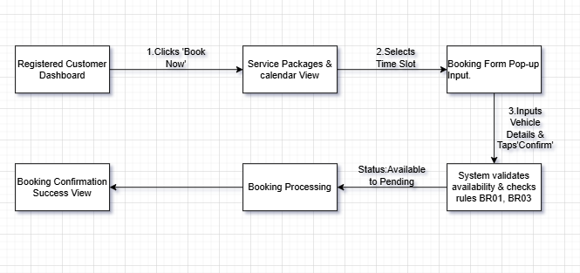

Appendix B: User-Interface Prototypes
To satisfy the non-functional requirements for Usability (responsive layouts, clear target touch-points, and high-contrast visuals), the user interfaces for the webapplication module are specified below:

UI-M-01: AutoWash Service Booking Screen.
- Purpose: Allows customers to view available washpackages,select time slots, and initialize the booking workflow.
- Design Specification: High-contrast grids, support for system Dark Mode, and target touch areas 44 x 44 dp.

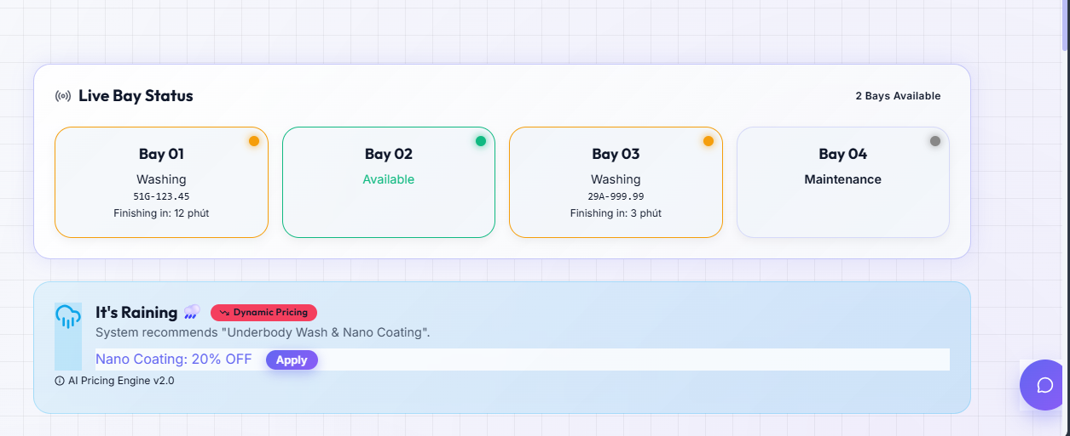

UI-M-02: Featured Services & Booking View
- Purpose: Displays premium wash packages and captures targeted metadata required to secure the booking transaction.
- Trigger: Visible on the main dashboard for all users to explore and book services.

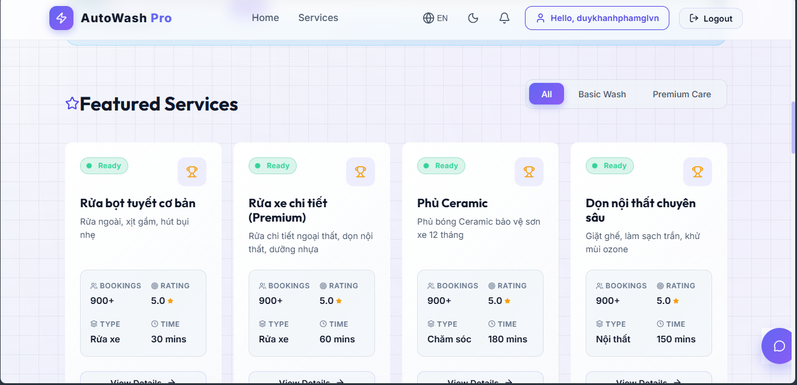

Appendix C: Requirements Traceability Matrix
Req_ID | Func-Req  Description | Use Case ID | Associated UI Component | Business Rules (BR) & Exceptions | Expected Test Case ID
FR_01 | Render real-time wash bay status and service packages | UC001 | UI-M-01 | BR01 (Accurate display of bay availability and pricing) | TC_RS_001
FR_02 | Capture vehicle details and selected service time | UC001 | UI-M-02 | BR03 (Enforce maximum of 1 active reservation per customer). | TC_RS_002
FR_03 | Transition wash booking state and hold time slot temporarily | UC001 | UI-M-01, UI-M-02 | BR02 (Execute automatic cancellation after 15-minute grace period). | TC_RS_003
FR_04 | Perform client-side validation on structural data inputs. | UC001 | UI-M-02 | Exception 5a (Block data submissions with historical timestamps). | TC_RS_004

